High-Level Design (HLD)

LLM Evaluation Harness (evalharness)
Version: 1.0 Companion docs: docs/SRS.md (requirements), docs/LLD.md (module-level detail), docs/DESIGN.md (rationale & trade-offs).

1. System Context
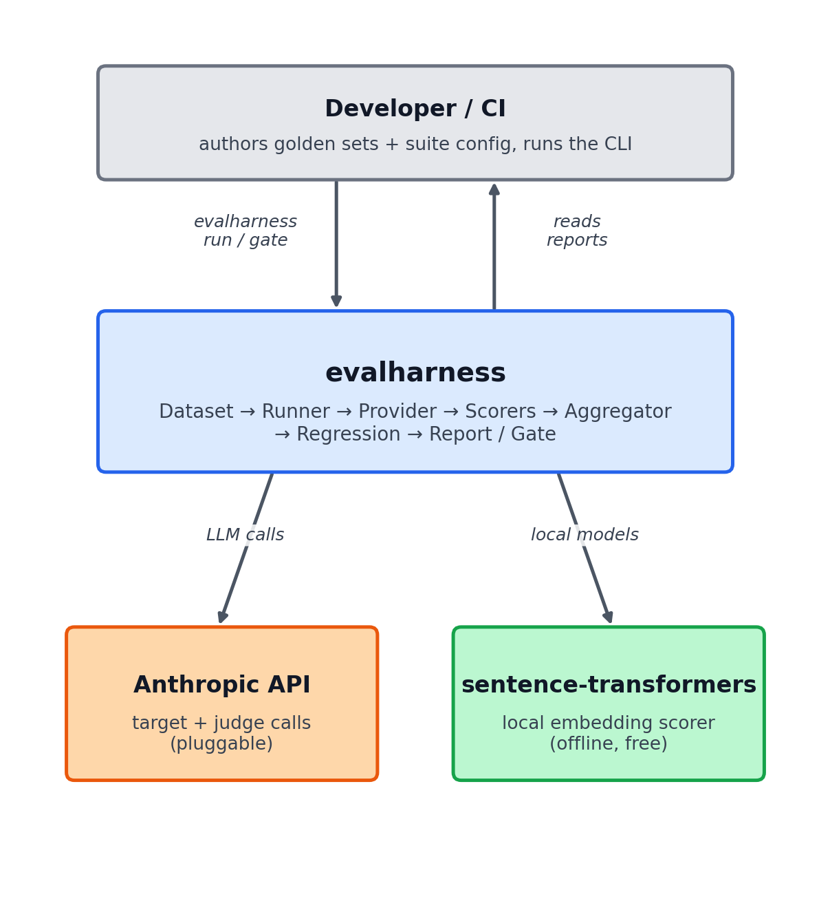
Figure: System context
The harness is the only component the team owns. It talks to an LLM backend (Anthropic first, pluggable) for the *target* and *judge* calls, and to a local embedding model for semantic scoring (Anthropic has no first-party embeddings endpoint, so keeping this local makes the scorer offline, free, and deterministic).

2. The Evaluation Pipeline
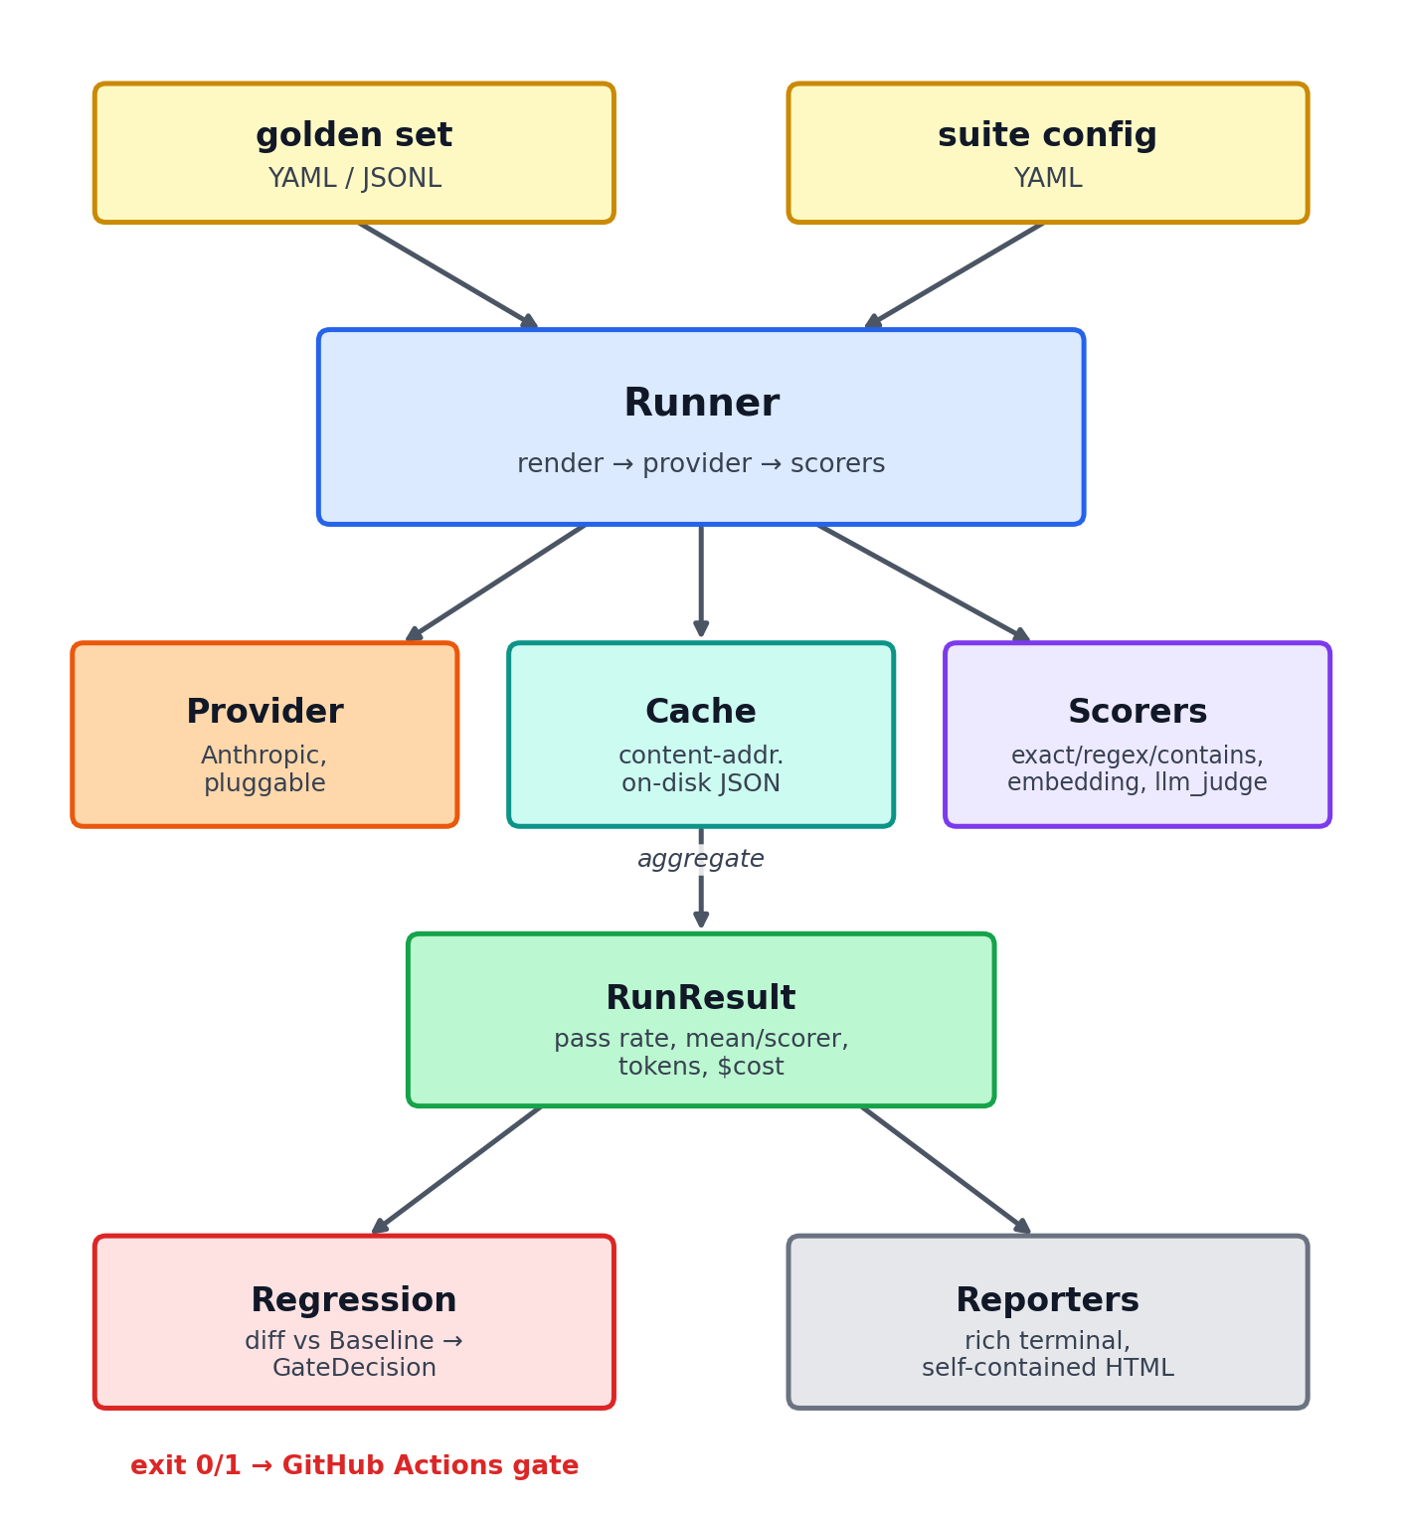
Figure: The evaluation pipeline

3. Components & Responsibilities
Component | Module | Responsibility
Data model | models.py | Immutable, typed representations of every entity (cases, results, baseline). Single source of truth for shapes.
Config | config.py | Parse & validate the suite config; resolve which provider, models, scorers, and thresholds to use.
Dataset | dataset.py | Load & validate golden sets from YAML/JSONL into GoldenSet/TestCase.
Provider | providers/ | Adapter to an LLM backend. base.py defines the interface; anthropic.py implements it; openai.py is a drop-in stub; a MockProvider powers offline tests.
Cache | cache.py | Content-addressed on-disk cache of provider responses for cheap, reproducible re-runs.
Scorers | scorers/ | Map (case, output) → ScoreResult. Deterministic scorers + local embedding scorer + LLM-judge scorer.
Runner | runner.py | Orchestrate the pipeline; bounded concurrency; error isolation; produce a RunResult.
Regression | regression.py | Diff a run against a baseline; apply thresholds; emit a GateDecision.
Reporting | report.py | Render terminal (rich) and self-contained HTML reports.
CLI | cli.py | run, baseline, report, gate; maps gate failure to a non-zero exit code.

4. Key Data Entities (overview; full shapes in LLD)
- TestCase — one input + expectations (expected, rubric) + tags/metadata.
- GoldenSet — named, versioned list of TestCase.
- ProviderResponse — output text + token usage + model id + cached flag.
- ScoreResult — scorer name, score∈[0,1], passed, detail.
- CaseResult — case id, output, list of ScoreResult, overall passed, optional error.
- RunResult — suite name, model, list of CaseResult, aggregate metrics, cost.
- Baseline — a stored RunResult + timestamp + optional git SHA.
- GateDecision — pass/fail + list of reasons (regressed cases, metric drops).

5. Control Flow of One run
- Load suite config → resolve provider, target model, scorers, thresholds.
- Load golden set → validated GoldenSet.
- For each TestCase (bounded concurrency):
a. Render the prompt template with the case input. b. Provider.complete() — checked against the cache first. c. Run each configured scorer → ScoreResults (the LLM-judge scorer itself calls the provider, also cached). d. Combine into a CaseResult.
- Aggregate into a RunResult (pass rate, per-scorer means, tokens, cost).
- Render reports; optionally save as baseline; optionally run regression → GateDecision → exit code.

6. CI Integration Story
- The team commits: the suite config, the golden set, and a baseline.json.
- .github/workflows/eval.yml:
- Installs the package.
- Runs pytest (offline, mock provider) — always.
- If ANTHROPIC_API_KEY secret is present: runs evalharness gate against the committed baseline.
- Uploads the HTML report as a build artifact.
- A prompt/model change that regresses quality makes gate exit non-zero → the PR check goes red.

7. Technology Choices & Rationale
Choice | Why
Python 3.9+ | Dominant language for LLM tooling; rich SDK ecosystem; natural pytest integration for the "test infra" framing. (Verified on 3.9; 3.11+ recommended.)
Anthropic SDK, pluggable providers | Ship a working Anthropic path now; keep the interface backend-agnostic so OpenAI/others are drop-in.
Pydantic models | Validation + serialization of golden sets, configs, and baselines for free.
`messages.parse()` for the judge | Structured, schema-validated judge verdicts instead of brittle string parsing.
Local `sentence-transformers` | Anthropic has no embeddings endpoint; local embeddings make the semantic scorer offline, free, deterministic.
On-disk response cache | Reproducible gates and near-zero re-run cost.
`rich` + inline-HTML reports | Readable locally; shareable as a CI artifact with no asset hosting.
GitHub Actions | Most common CI for portfolio/OSS; a plain non-zero exit integrates anywhere else too.

8. Extension Points
- New provider: implement Provider (complete() + usage/cost), register it; runner and scorers are unchanged.
- New scorer: implement Scorer (score(case, output) → ScoreResult), register it in the scorer registry, reference it by name in a suite config.
- New report format: add a renderer that consumes a RunResult (+ optional GateDecision).

9. Cross-Cutting Concerns
- Reproducibility: pinned model IDs + response cache + deterministic scorers where possible.
- Cost: usage surfaced per response; judge runs cheap and cached; aggregate cost in every report.
- Security: keys via env/SDK auth only; never persisted to reports/baselines.
- Resilience: bounded retries in the provider; per-case error isolation in the runner.

