**Assignment 7A**

Roll No: 33221

Batch: L-10

# Aim :

Full duplex communication between two independent processes. First process accepts sentences and writes on one pipe to be read by second process and second process counts number of characters, number of words and number of lines in accepted sentences, writes this output in a text file and writes the contents of the file on second pipe to be read by first process and displays on standard output.

# Theory :

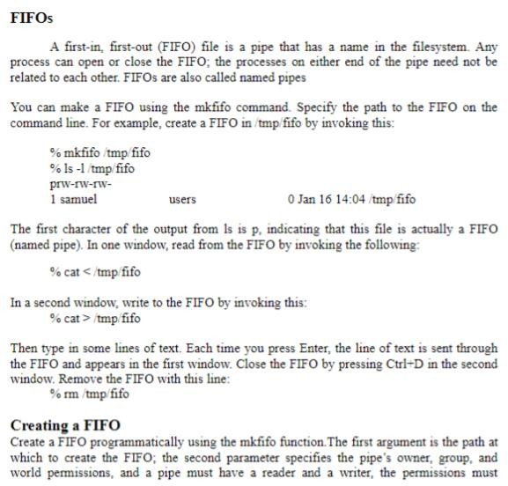

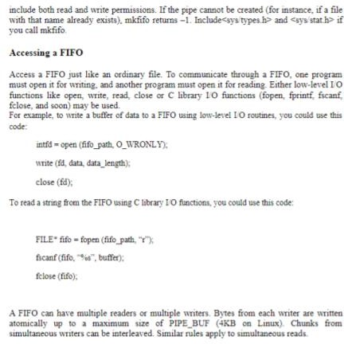

**Output :**

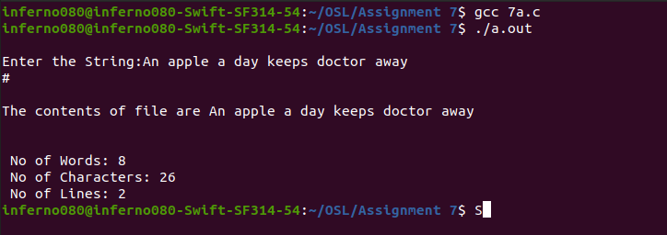

**Conclusion :**

Thus, we studied inter process communication using FIFOs.