**Assignment 7b**

Roll No: 33221

Batch: L-10

# Aim :

Client and Server Programs in which server process creates a shared memory segment and writes the message to the shared memory segment. Client process reads the message from the shared memory segment and displays it to the screen.

# Theory:

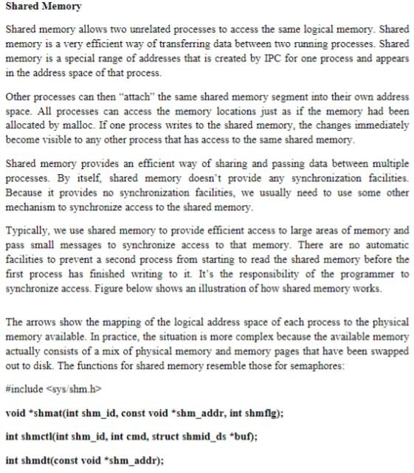

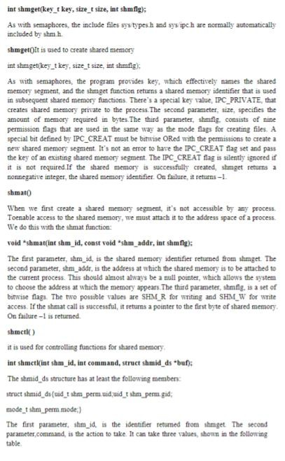

2

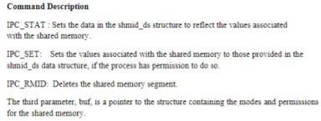

# Output :

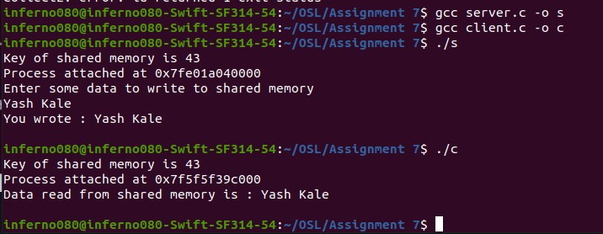

**Conclusion :**

Thus, we studied inter process communication using FIFO