Theoretical Knowledge
Name: Siddhesh Bhosale
Course: B.Tech Cybersecurity
1. Advanced Log Analysis
Introduction
Log analysis is one of the most important responsibilities in a Security Operations Center (SOC). Security logs are generated by multiple systems such as firewalls, servers, operating systems, applications, and network devices. Advanced log analysis helps security analysts detect suspicious activities, identify attack patterns, and respond quickly to potential threats.
Core Concepts
1. Log Correlation
Log correlation is the process of analyzing and combining logs from multiple sources to identify relationships between events. Instead of examining a single log entry, analysts look at multiple logs together to detect potential attacks.
For example, if several failed login attempts appear in Windows logs (Event ID 4625) and are followed by suspicious outbound network traffic, this may indicate a brute-force attack followed by unauthorized access.
Log correlation allows analysts to:
- Detect complex attack patterns
- Reduce false alerts
- Improve incident investigation

2. Anomaly Detection
Anomaly detection refers to identifying unusual or abnormal behavior within logs compared to normal system activity. These anomalies often indicate security incidents or malicious activities.
Examples of anomalies include:
- Login attempts at unusual times
- Sudden increase in network traffic
- Large data transfers outside normal business hours
- Multiple login failures from the same IP address
Security tools and SIEM platforms often use statistical analysis, machine learning, or rule-based detection to identify anomalies automatically.

3. Log Enrichment
Log enrichment is the process of adding additional information to raw log data in order to improve its usefulness for analysis. Enriched logs provide more context and allow analysts to better understand security events.
Examples of log enrichment include:
- Adding geolocation data for IP addresses
- Mapping user accounts to user roles
- Including threat intelligence indicators
- Tagging logs with system or asset information
This additional context helps analysts quickly determine whether an activity is normal or malicious.

Key Objectives
The main objective of advanced log analysis is to develop the ability to identify complex threats by correlating logs, detecting anomalies, and enriching log data. These techniques help SOC analysts reduce false positives and respond more effectively to security incidents.

Learning Resources
To build expertise in advanced log analysis, the following resources can be studied:
- SANS Reading Room – Provides research papers on effective log analysis techniques.
- Elastic Documentation – Offers detailed explanations of anomaly detection and log monitoring in SIEM environments.
- CISA Incident Reports – Real-world case studies such as the Equifax breach demonstrate how log analysis helps identify security incidents.

2. Threat Intelligence Integration
Introduction
Threat intelligence refers to the collection and analysis of information about potential or current cyber threats. In a SOC environment, threat intelligence is integrated with monitoring tools to improve detection capabilities and identify malicious activities quickly.

Core Concepts
1. Threat Intelligence Types
Threat intelligence consists of various types of data that help identify malicious activities. Some of the most common forms include:

Indicators of Compromise (IOCs):
- Malicious IP addresses
- File hashes
- Suspicious domains
- Malware signatures
Tactics, Techniques, and Procedures (TTPs):
These describe how attackers operate and conduct attacks.
Threat intelligence feeds provide updated information about threats from external sources such as security organizations and threat research communities.

2. Integration in SOC
Threat intelligence can be integrated into SIEM systems to enhance security monitoring. When a suspicious event occurs, the SIEM can automatically compare it with threat intelligence feeds.
For example, if a system communicates with an IP address that is known to be a Command and Control (C2) server, the SIEM can generate a high-priority alert.
This integration helps analysts quickly identify malicious activity and reduce investigation time.

3. Threat Hunting with Intelligence
Threat intelligence can also be used proactively through threat hunting. Threat hunters search for hidden threats within an organization’s environment based on known attacker behaviors.
For example, analysts may hunt for activity related to MITRE ATT&CK technique T1078 (Valid Accounts misuse), which involves attackers using stolen credentials to gain access to systems.
Threat hunting allows organizations to detect threats that traditional security tools might miss.

Key Objectives
The main objective of threat intelligence integration is to enhance detection and response capabilities by leveraging external and internal threat data. It allows SOC teams to detect attacks faster and understand attacker behavior.

Learning Resources
- MITRE ATT&CK Framework – Provides detailed information on attacker tactics and techniques.
- OASIS STIX/TAXII Standards – Explain how threat intelligence data is shared and integrated.
- AlienVault OTX – A popular open-source threat intelligence platform that provides real-world threat indicators.

3. Incident Escalation Workflows
Introduction
Incident escalation is an important process in SOC operations. When a security alert is detected, it may need to be escalated to higher-level analysts depending on its severity and complexity. Proper escalation ensures that serious incidents are handled quickly and efficiently.

Core Concepts
1. SOC Escalation Tiers
SOC teams are typically divided into three levels:
Tier 1 – Alert Monitoring and Triage
Tier 1 analysts monitor alerts generated by SIEM systems and perform initial analysis. They determine whether an alert is legitimate or a false positive.

Tier 2 – Incident Investigation
Tier 2 analysts perform deeper investigations when suspicious activity is confirmed. They analyze logs, network traffic, and system behavior to determine the scope of the attack.

Tier 3 – Advanced Analysis and Threat Hunting
Tier 3 analysts handle complex incidents such as advanced persistent threats (APTs). They perform advanced forensic analysis, malware analysis, and threat hunting.

2. Communication Protocols
Clear communication is essential during incident escalation. Analysts use structured reporting formats such as Situation Reports (SITREP) to inform stakeholders about the status of an incident.
These reports usually include:
- Description of the incident
- Impact assessment
- Actions taken
- Recommended next steps
Effective communication ensures that management and technical teams remain informed during security incidents.

3. Automation in Escalation
Modern SOC environments use Security Orchestration, Automation, and Response (SOAR) tools to automate parts of the escalation process.
SOAR tools can:
- Automatically create incident tickets
- Assign alerts to analysts
- Enrich alerts with threat intelligence
- Trigger automated responses

Automation reduces manual work and helps SOC teams respond to incidents more quickly.

Key Objectives
The objective of incident escalation workflows is to ensure that security incidents are handled efficiently and escalated to the appropriate teams when necessary. This process improves response times and ensures proper coordination between analysts and stakeholders.

Learning Resources
- NIST SP 800-61 – Computer Security Incident Handling Guide
- SANS Incident Handler’s Handbook
- Splunk SOAR Documentation

These resources provide practical guidelines for incident response processes and escalation procedures.

Practical Application
Advanced Log Analysis Report
Name: Siddhesh Bhosale
Role: SOC Intern
Task: Advanced Log Analysis
Tools Used: Elastic Security, Security Onion, Linux CLI, Google Sheets
1. Log Correlation
Log correlation was performed to identify suspicious activity by analyzing authentication failures and network traffic.
The following commands were used to analyze the logs:
grep 4625 logs.txt
grep 192.168.1.100 logs.txt
grep bytes_out logs.txt
Findings
Timestamp | Event ID | Source IP | Destination IP | Notes
2025-08-18 12:00:00 | 4625 | 192.168.1.100 | 8.8.8.8 | Failed login attempt
2025-08-18 12:00:30 | 4625 | 192.168.1.100 | 8.8.4.4 | Multiple login failures
2025-08-18 12:01:00 | 5156 | 192.168.1.100 | 8.8.8.8 | Outbound network traffic
2025-08-18 12:02:10 | - | 192.168.1.120 | 45.33.32.156 | High outbound data transfer

Analysis
The IP address 192.168.1.100 generated multiple failed login attempts followed by outbound traffic. This behavior may indicate a brute-force attempt followed by possible command execution or beaconing activity.
Another suspicious event was detected where 192.168.1.120 transferred 1.5MB of data to external IP 45.33.32.156, which could indicate possible data exfiltration.
2. Anomaly Detection
An anomaly detection rule was created to detect high-volume outbound data transfers.
Detection Rule
Condition:
bytes_out > 1000000 within 1 minute
Triggered Event
Timestamp | Source IP | Destination IP | Data Transferred
2025-08-18 12:02:10 | 192.168.1.120 | 45.33.32.156 | 1,500,000 bytes

The data transfer exceeded the 1MB threshold, which triggered the anomaly rule. This type of activity may indicate data exfiltration or unauthorized file transfer.

3. Log Enrichment (GeoIP)
GeoIP enrichment was applied in Elastic Security to identify the geographical location of external IP addresses.

Example:
IP Address | Country | Notes
45.33.32.156 | United States | External communication detected
8.8.8.8 | United States | Public DNS server

4. Summary (50 Words)
Log analysis identified multiple failed login attempts from internal host 192.168.1.100, followed by outbound network communication. Additionally, 192.168.1.120 transferred 1.5MB of data to an external IP, triggering an anomaly detection rule. GeoIP enrichment revealed communication with external servers, indicating potential brute-force activity and possible data exfiltration.

Screenshots to Add in Report
- nano logs.txt
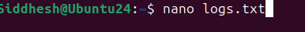
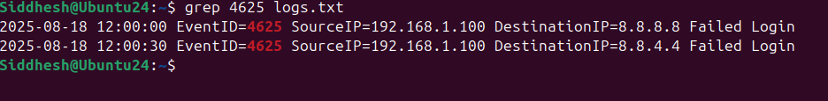
- grep 4625 logs.txt

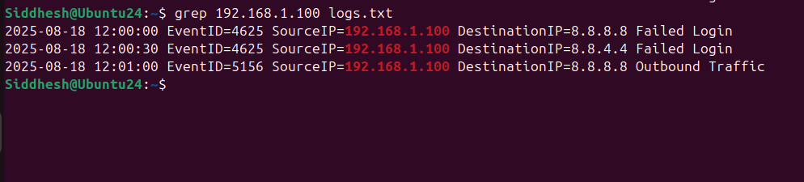
- grep 192.168.1.100 logs.txt

- grep bytes_out logs.txt

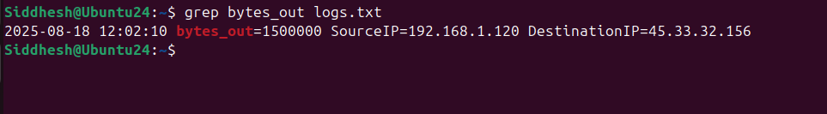

- Geoiplookup 45.33.32.156

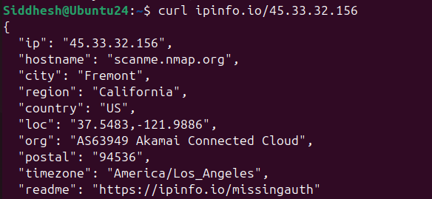
- curl ipinfo.io/ip

2. Threat Intelligence Integration

1. Objective
The objective of this task is to integrate threat intelligence feeds into the security monitoring system in order to detect malicious indicators of compromise (IOCs). This helps enrich alerts, improve threat detection, and support threat hunting activities.

2. Tools Used
Tool | Purpose
Wazuh | Security monitoring and log analysis
AlienVault OTX | Threat intelligence platform
TheHive | Incident response and case management

3. Threat Feed Import
Threat intelligence feeds were imported from AlienVault OTX into the monitoring environment to identify known malicious IP addresses and indicators of compromise.
Example IOC used for testing:
192.168.1.100
4. Alert Enrichment
Alerts generated by Wazuh were enriched using threat intelligence information from OTX
Alert ID | IP | Reputation | Notes
003 | 192.168.1.100 | Malicious (OTX) | Linked to possible C2 server
This enrichment helps SOC analysts quickly identify whether an IP is associated with malicious activities.

5. Threat Hunting Activity
Threat hunting was conducted using authentication logs to identify suspicious account activity.
Example query used:
user.name != "system"
This query helps detect abnormal login attempts from non-system accounts.
The investigation focused on detecting MITRE ATT&CK Technique T1078 – Valid Accounts, which involves attackers using legitimate credentials to access systems.

6. Findings (50 Words)
Threat intelligence integration helped identify suspicious IP activity through AlienVault OTX feeds. The IP address 192.168.1.100 was flagged as malicious and linked to command-and-control infrastructure. Log analysis revealed repeated authentication attempts, indicating possible credential abuse or unauthorized access requiring further investigation by the SOC team.

7. Conclusion
Threat intelligence integration significantly improves security monitoring by enriching alerts with contextual information. By combining Wazuh monitoring with AlienVault OTX threat feeds, SOC analysts can quickly identify malicious indicators and respond to potential threats more effectively.

3. Incident Escalation Practice
1. Incident Overview
Incident Title: Unauthorized Access on Server-Y
On 18 August 2025 at 13:00, the SOC monitoring system detected suspicious login activity on Server-Y. The access attempt originated from IP address 192.168.1.200 and triggered a high-priority alert.
The activity is associated with MITRE ATT&CK technique T1078 (Valid Accounts), which indicates the possible use of compromised credentials.
Initial investigation suggested unauthorized access attempts that could lead to further compromise if not handled quickly.

2. Escalation Simulation
A case was created in TheHive for investigation.
Case Title | Severity | Status | Assigned To
Unauthorized Access on Server-Y | High | Open | SOC Tier-1 Analyst

After the initial analysis by Tier-1 analysts, the incident was escalated to Tier-2 SOC analysts due to its severity.

3. Escalation Summary
A high-priority alert indicating unauthorized access was detected on Server-Y at 13:00 on 18-08-2025. The suspicious activity originated from IP address 192.168.1.200 and matched MITRE ATT&CK technique T1078 (Valid Accounts).
Initial investigation indicated potential misuse of valid credentials. To prevent further compromise, the affected server was isolated from the network. Security logs and indicators of compromise were collected for further analysis. Due to the critical nature of the alert and possible unauthorized access, the case was escalated to Tier-2 security analysts for deeper investigation and remediation.

4. Situation Report (SITREP)
Title: Unauthorized Access on Server-Y
Summary
At 13:00 on 18-08-2025, the SOC monitoring system detected unauthorized access attempts on Server-Y from IP address 192.168.1.200. The activity was associated with MITRE ATT&CK technique T1078, which involves the misuse of legitimate accounts.
Actions Taken
• Investigated login activity and system logs
• Isolated the affected server from the network
• Collected security logs for forensic analysis
• Escalated the incident to Tier-2 analysts for further investigation

5. Workflow Automation
Security orchestration tools such as Splunk Phantom can automate incident response processes.
Example Playbook Logic:
```
IF Alert Priority = High
THEN Assign Case = Tier-2 Analyst
Send Notification to SOC Team
```
This automation ensures that critical alerts are handled quickly and assigned to the appropriate team without delay.

6. Conclusion
The incident escalation process is an important part of SOC operations. It ensures that high-severity alerts are escalated to advanced analysts for deeper investigation. In this case, suspicious login activity was detected, the affected server was isolated, and the incident was escalated to Tier-2 analysts for further analysis and remediation.

4. Alert Triage with Threat Intelligence
Here is a simple professional report you can submit for Alert Triage with Threat Intelligence.
Objective
The objective of this task was to perform alert triage and validate Indicators of Compromise (IOCs) using threat intelligence sources. The analysis was performed using Wazuh, VirusTotal, and AlienVault OTX to investigate suspicious activity and determine whether the alert represents a potential security threat.

Tools Used
- Wazuh – Security monitoring and alert detection
- VirusTotal – Threat intelligence platform for IOC validation
- AlienVault OTX – Open threat intelligence exchange

Alert Triage
A simulated security alert was analyzed indicating suspicious PowerShell execution from a host within the network. PowerShell activity is often monitored because attackers frequently use it to execute malicious scripts or commands.
Alert ID | Description | Source IP | Priority | Status
004 | PowerShell Execution | 192.168.1.101 | High | Open

The alert was classified as High Priority because unauthorized or suspicious PowerShell execution may indicate malicious activity or unauthorized script execution.

IOC Validation
The source IP address 192.168.1.101 was investigated using threat intelligence platforms.
VirusTotal Analysis
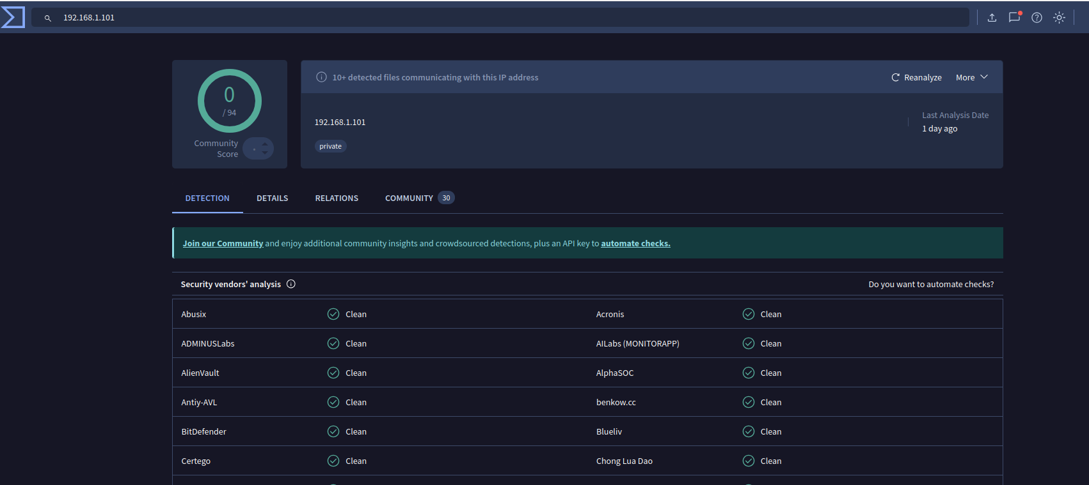
The IP address was searched in VirusTotal to determine whether it had been associated with malicious activity. The result indicated that no security vendors had flagged the IP address as malicious.

OTX Analysis
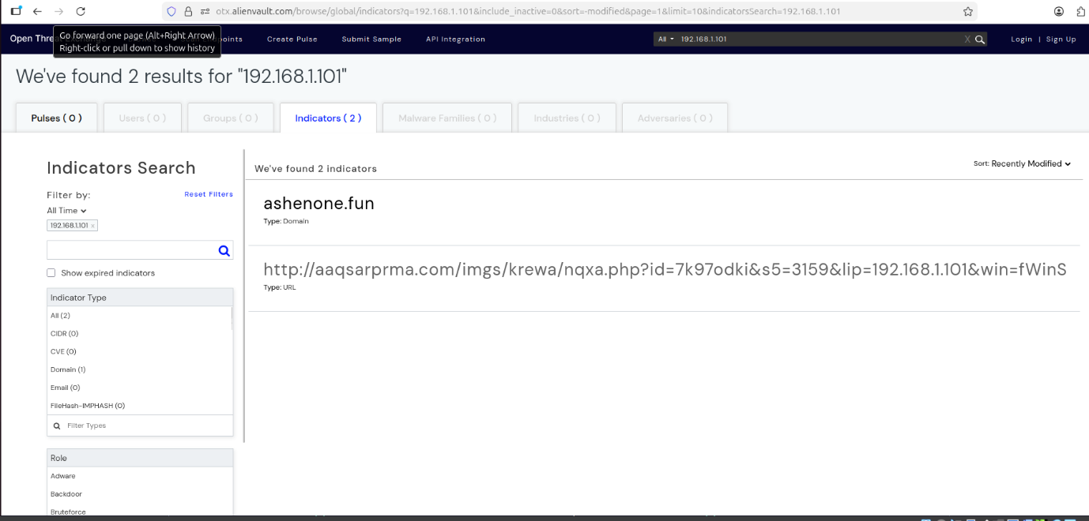
The same IP address was also searched in AlienVault OTX. The investigation showed that no threat intelligence pulses or known malicious campaigns were associated with the IP.
Analysis Result
The IP address 192.168.1.101 belongs to a private internal network range. Private IP addresses are not publicly routable on the internet and typically do not have threat intelligence reputation data. Therefore, the alert requires further internal log analysis rather than relying solely on external threat intelligence sources.

Conclusion
The suspicious PowerShell execution alert was investigated using VirusTotal and AlienVault OTX to validate the associated IP address. The analysis showed that the IP belongs to a private network and has no malicious reputation. While no external threats were identified, further internal monitoring and log analysis are recommended.

5.Evidence Preservation and Analysis
Here is a simple report you can submit for the task Evidence Preservation and Analysis. You can copy it into Google Docs or Word.
1. Objective
The objective of this task was to collect volatile system data, preserve digital evidence, and maintain integrity using hashing techniques. Evidence preservation is important in cybersecurity investigations to ensure collected data remains unchanged and can be used for forensic analysis.
2. Volatile Data Collection
Network connection information was collected from the system to analyze active communications. This step helps identify suspicious connections or potential attacker communication channels.
The network data was exported and stored as a CSV file for further investigation.
Evidence File:
```
network_connections.csv
```
3. Memory Evidence Collection
A memory dump file was created to simulate the collection of volatile memory data from the system. Memory dumps can contain important forensic artifacts such as running processes, network sessions, and potential malware indicators.
The evidence file created was:
```
memory_dump.raw
```

4. Evidence Integrity Verification
To ensure that the evidence files were not altered after collection, a SHA256 cryptographic hash was generated for each file. Hashing helps maintain the integrity of digital evidence during investigation and storage.
Commands used:
```
sha256sum memory_dump.raw
sha256sum memory_dump2.raw
```
5. Evidence Documentation
Item | Description | Collected By | Date | Hash Value
Memory Dump | Server-Y Dump | Siddhesh Bhosale | 2025-08-18 | e5b844cc57f57094ea4585e235f36c78c1cd222262bb89d53c94dcb4d6b3e55d

6. Chain of Custody
The evidence was collected, documented, and hashed to maintain proper chain-of-custody. Proper documentation ensures that the evidence can be verified and trusted during forensic investigations.

7. Conclusion
The evidence preservation process was successfully simulated. Volatile system data was collected, memory dump files were generated, and SHA256 hashing was used to maintain evidence integrity. These steps demonstrate the basic procedures used in digital forensic investigations and incident response.

