Theoretical Knowledge
Threat Hunting Methodologies –
1. Introduction
Threat Hunting is a proactive cybersecurity practice used to detect hidden threats inside an organization's network before they cause damage. Unlike traditional security monitoring that depends on automated alerts, threat hunting involves actively searching through systems, logs, and network activities to identify suspicious behavior.
Security analysts use threat hunting to detect advanced attacks that may bypass security tools such as firewalls or antivirus systems. By analyzing system data and attacker techniques, organizations can detect and stop cyber threats at an early stage.

2. Proactive Threat Hunting
Proactive Threat Hunting is a process where security analysts assume that a threat may already exist in the system and actively search for indicators of compromise.
This approach is usually hypothesis-driven, meaning the analyst forms a hypothesis based on known attack techniques and investigates system logs or network data to confirm whether malicious activity is present
For example, attackers may misuse valid user accounts to access systems without raising suspicion. This attack technique is described in the MITRE ATT&CK Framework as T1078 – Valid Accounts, where attackers use stolen or compromised credentials to gain unauthorized access.

Threat hunters investigate such behavior by analyzing login patterns, unusual access times, or privilege escalation activities.

3. Threat Hunting Frameworks
3.1 SqRR Framework
The SqRR Framework is a structured methodology used in threat hunting. It consists of four stages:
Search
Security analysts search for suspicious behavior or indicators of compromise in the network.
Query
Security tools such as SIEM platforms are used to query system logs and security data.
Retrieve
Relevant information such as IP addresses, login attempts, and system events are collected for analysis.
Respond
If a threat is identified, the security team takes action such as blocking malicious IP addresses, isolating compromised systems, or disabling affected user accounts.
This framework helps analysts conduct threat hunting in a systematic and organized way.

3.2 TaHiTI Framework
Another important threat hunting methodology is the TaHiTI Framework which stands for Targeted Hunting integrating Threat Intelligence.
This framework combines threat intelligence with hunting activities to detect targeted cyber attacks. Threat intelligence provides information about known attackers, malicious IP addresses, malware signatures, and common attack techniques.
Security analysts use this intelligence to search for similar patterns inside their network to identify potential threats.
For example, if a threat intelligence report indicates that an attacker group such as APT29 uses credential theft techniques, security teams can search their logs to detect similar activities.

4. Data Sources for Threat Hunting
Threat hunting requires analyzing data from different sources to detect suspicious activities. Some important data sources include:
4.1 Endpoint Detection and Response (EDR) Logs
EDR logs monitor activities on individual devices such as computers, laptops, and servers. These logs help detect suspicious processes, unauthorized file modifications, and system changes.
4.2 Network Traffic Logs
Network traffic logs provide information about communication between systems and external networks. Security analysts analyze these logs to identify unusual outbound connections, potential data exfiltration, or communication with malicious servers.

4.3 Authentication Logs
Authentication logs record login attempts and user activities. These logs help identify suspicious login behavior such as repeated failed logins, login attempts from unusual locations, or unexpected privilege escalation.
4.4 Threat Intelligence Feeds
Threat intelligence feeds provide updated information about known threats such as malicious IP addresses, malware hashes, and attacker tactics. This information helps security teams identify and block known cyber threats.

5. Case Study Example
A well-known example of threat hunting involves the cyber espionage group APT29. This group uses advanced techniques to infiltrate networks and remain undetected for long periods.
Security analysts were able to detect suspicious activities by analyzing authentication logs, network traffic, and system behavior. By mapping these activities to the MITRE ATT&CK Framework, analysts identified the techniques used by the attackers and responded accordingly.
This case highlights the importance of proactive threat hunting in detecting advanced cyber attacks.

6. What I Learned
From this task, I learned the importance of Threat Hunting in cybersecurity operations. I understood that threat hunting is a proactive approach used to identify hidden threats that may not be detected by traditional security tools.
I also learned about hypothesis-driven hunting, where security analysts investigate possible attack scenarios such as misuse of valid accounts or privilege escalation.
Additionally, I studied different threat hunting frameworks such as the SqRR Framework and the TaHiTI Framework, which help analysts follow a structured process to search for threats.

I also learned how different data sources like endpoint logs, network traffic logs, authentication logs, and threat intelligence feeds are used to detect suspicious activities and analyze cyber threats.
Overall, this task improved my understanding of how cybersecurity professionals proactively detect and respond to advanced threats inside an organization’s network.

7. Conclusion
Threat Hunting is an essential part of modern cybersecurity operations. By using structured methodologies, analyzing multiple data sources, and applying threat intelligence, security teams can detect hidden threats and prevent major cyber incidents.
Frameworks like SqRR Framework and TaHiTI Framework provide systematic approaches for identifying and responding to cyber threats. Implementing proactive threat hunting strategies helps organizations strengthen their security posture and defend against advanced attacks.

Advanced SOAR Automation –

1. Introduction
Security Orchestration, Automation, and Response (SOAR) is a cybersecurity technology used by Security Operations Centers (SOC) to improve incident response and automate repetitive security tasks. SOAR platforms integrate different security tools, automate workflows, and help security analysts respond to threats more efficiently.
SOAR helps organizations reduce manual effort, speed up investigation processes, and ensure faster response to security incidents. By automating routine tasks such as alert analysis, ticket creation, and threat containment, SOC teams can focus on more complex security investigations.

2. SOAR Components
SOAR consists of three main components: orchestration, automation, and response.
2.1 Orchestration
Orchestration refers to the integration and coordination of multiple security tools and systems within a single platform. It allows security teams to connect tools like SIEM, EDR, firewalls, and threat intelligence platforms.
For example, a SOAR platform can collect alerts from a SIEM system and automatically trigger actions in other security tools such as firewalls or endpoint protection systems.
2.2 Automation
Automation is the process of performing repetitive security tasks automatically without manual intervention. This reduces the workload of security analysts and improves response speed.

Examples of automation tasks include:
- Automatically creating incident tickets
- Enriching alerts with threat intelligence data
- Blocking suspicious IP addresses
- Sending alerts to SOC analysts
Automation helps security teams respond to incidents quickly and consistently.
2.3 Response
Response refers to the actions taken to mitigate or contain a security threat. SOAR platforms help automate responses such as isolating compromised systems, blocking malicious IP addresses, or disabling compromised user accounts.
These automated responses reduce the time required to contain threats and prevent further damage to the organization.

3. Playbook Development
A playbook is a predefined set of automated steps used to respond to specific security incidents. Playbooks help SOC teams standardize incident response procedures.
For example, a phishing attack response playbook may include the following steps:
1. Detect phishing email alert from SIEM.
2. Extract suspicious URLs or attachments.
3. Check the URL reputation using threat intelligence services.
4. Block malicious URLs or IP addresses.
5. Notify the security team.
6. Create an incident ticket for investigation.
Similarly, a malware response playbook can automatically isolate infected systems and initiate malware analysis.
4. Integration with Security Tools
SOAR platforms work by integrating with other security systems such as SIEM, EDR, and threat intelligence platforms.
For example:
- Wazuh can provide security alerts and log analysis.
- Elastic Security can detect suspicious activities in logs and network traffic.
SOAR platforms can automatically receive alerts from these tools and execute response actions such as blocking malicious IP addresses or generating incident reports.
This integration improves coordination between different security systems and enhances overall security monitoring.

5. Example Use Case
A common example of SOAR automation is Command and Control (C2) traffic detection.
If a SIEM system detects communication with a known malicious IP address, the SOAR platform can automatically:
- Verify the IP address using threat intelligence.
- Block the IP address on the firewall.
- Isolate the affected endpoint.
- Create an incident ticket.
- Notify the SOC team.
This automated process significantly reduces the time required to respond to cyber threats.

6. What I Learne
From this task, I learned about the importance of SOAR automation in modern Security Operations Centers. I understood how SOAR platforms help automate repetitive tasks and improve incident response efficiency.
I learned the three main components of SOAR: orchestration, automation, and response. These components allow security tools to work together and automate security operations
I also learned how playbooks are used to automate responses for common security incidents such as phishing attacks and malware infections. Playbooks help SOC teams follow standardized procedures and respond quickly to threats.
Additionally, I understood how SOAR platforms integrate with security tools like Wazuh and Elastic Security to collect alerts and automate incident response workflows.
Overall, this task helped me understand how automation can improve SOC efficiency and reduce response time during cyber incidents.

7. Conclusion
SOAR automation plays an important role in improving cybersecurity operations by integrating security tools, automating repetitive tasks, and enabling faster incident response. By developing automated playbooks and integrating systems such as SIEM and EDR, organizations can enhance their ability to detect and respond to cyber threats effectively.
Implementing SOAR solutions helps SOC teams operate more efficiently and strengthens an organization’s overall security posture.

Post-Incident Analysis and Continuous Improvement –

1. Introduction
Post-Incident Analysis is an important process in cybersecurity that takes place after a security incident has been detected and resolved. The main goal of this process is to analyze what happened, understand how the attack occurred, and identify improvements that can prevent similar incidents in the future.
Security Operations Centers (SOC) use post-incident analysis to improve their detection capabilities, strengthen security controls, and enhance response procedures. By reviewing incidents and learning from them, organizations can continuously improve their cybersecurity posture.

2. Root Cause Analysis (RCA)
Root Cause Analysis (RCA) is a method used to identify the main cause of a security incident. Instead of only fixing the immediate problem, RCA focuses on discovering the underlying issue that allowed the incident to occur.
Two commonly used RCA techniques are:
2.1 5 Whys Technique
The 5 Whys technique involves asking “why” multiple times to identify the root cause of a problem.
Example:
Incident: A phishing attack successfully compromised a user account.
Why did the user account get compromised?
- Because the user clicked on a phishing link.
Why did the user click the phishing link?
- Because the email looked legitimate.

Why did the email appear legitimate?
- Because the email filtering system failed to detect it.
Why did the filter fail?
- Because phishing detection rules were outdated.
Why were the rules outdated?
- Because the system was not regularly updated.
Root Cause: Weak or outdated email filtering rules.
2.2 Fishbone Diagram
Another RCA technique is the Fishbone Diagram, also known as the cause-and-effect diagram.
This method helps identify possible causes of an incident by categorizing them into different areas such as:
- Technology
- Processes
- People
- Security tools
- Policies
For example, in a phishing attack, the causes may include lack of employee training, weak email security controls, or poor incident detection processes.

3. Lessons Learned Process
After resolving an incident, SOC teams conduct a Lessons Learned session to evaluate the effectiveness of their response.
During this process, the security team reviews:
- What happened during the incident
- How the attack was detected
- How quickly the response team reacted
- What actions were taken to contain the threat
The goal is to identify improvements in security processes, tools, and training.
For example:
- Updating detection rules
- Improving email filtering systems
- Providing cybersecurity awareness training to employees
- Enhancing incident response procedures
Lessons learned sessions help organizations strengthen their defenses and avoid similar incidents in the future.

4. Metrics and Key Performance Indicators (KPIs)
SOC teams use specific metrics to measure the effectiveness of their security operations.
Two important SOC metrics include:
4.1 Mean Time to Detect (MTTD)
Mean Time to Detect (MTTD) measures the average time taken by security teams to identify a security incident after it occurs.
A lower MTTD means that the organization can detect threats quickly and reduce potential damage.

4.2 Mean Time to Respond (MTTR)
Mean Time to Respond (MTTR) measures how quickly the security team can respond to and contain a security incident after detection.
Reducing MTTR is important because faster responses can prevent attackers from causing further damage.

5. Importance of Continuous Improvement
Continuous improvement is an important part of SOC operations. After every incident, security teams analyze the event and implement improvements to strengthen security defenses.
Continuous improvement activities include:
- Updating detection rules
- Improving monitoring systems
- Enhancing security policies
- Providing training for employees
- Upgrading security tools
Guidelines for incident response and post-incident activities are provided in NIST Special Publication 800-61, which helps organizations develop effective incident response strategies.

6. What I Learned
From this task, I learned the importance of post-incident analysis in cybersecurity operations. I understood that analyzing security incidents helps organizations identify weaknesses in their security systems and improve their defenses.
I also learned about Root Cause Analysis techniques such as the 5 Whys method and the Fishbone Diagram, which help identify the underlying causes of security incidents.
Additionally, I learned the importance of conducting Lessons Learned sessions after incidents to improve detection tools, response processes, and security awareness.
I also gained knowledge about SOC performance metrics such as Mean Time to Detect (MTTD) and Mean Time to Respond (MTTR), which help measure the effectiveness of incident detection and response.
Overall, this task helped me understand how continuous improvement plays an important role in strengthening cybersecurity operations.

7. Conclusion
Post-Incident Analysis is a critical part of cybersecurity operations. By performing root cause analysis, reviewing lessons learned, and measuring SOC performance through metrics, organizations can continuously improve their security systems.

Security Metrics and Executive Reporting –

1. Introduction
Security Metrics and Executive Reporting are important aspects of Security Operations Center (SOC) management. Security metrics help organizations measure the performance and effectiveness of their security operations, while executive reporting communicates important security information to leadership and management teams.
By analyzing security metrics, SOC teams can identify weaknesses in detection and response processes and implement improvements to strengthen the organization's cybersecurity posture.

2. Advanced SOC Metrics
SOC teams use several advanced metrics to evaluate their operational performance and incident response capabilities.
2.1 Dwell Time
Dwell Time refers to the amount of time an attacker remains inside a system before being detected by the security team.
A longer dwell time indicates that attackers are able to stay undetected for extended periods, which can increase the risk of data theft or system compromise. Reducing dwell time is important for minimizing the impact of cyber attacks.
2.2 False Positive Rate
The False Positive Rate measures how often security tools generate alerts that are not actual security threats.
A high false positive rate can overwhelm security analysts with unnecessary alerts, making it harder to identify real threats. Improving detection rules and alert tuning helps reduce false positives.

2.3 Incident Resolution Rate
Incident Resolution Rate measures how effectively the SOC team resolves detected security incidents
A high resolution rate indicates that the security team is efficiently responding to and mitigating cyber threats.

3. Executive Reporting
Executive reporting involves presenting security metrics and incident summaries to non-technical stakeholders such as executives, managers, and decision-makers.
Reports should be clear, concise, and easy to understand. Instead of technical details, they should focus on the impact of security incidents and overall security performance.
Executive reports often include:
- Number of detected incidents
- Types of cyber attacks
- Response times
- Security improvements made by the SOC team
Visualizations such as charts, graphs, and dashboards are commonly used to present this information in a clear and understandable way.

4. Continuous Improvement Using Metrics
Security metrics help organizations identify gaps in their security operations and improve their incident response processes.
For example:
If Mean Time to Detect (MTTD) is high, it may indicate that the organization needs better monitoring tools or improved threat detection rules.
If the false positive rate is high, security teams may need to tune their detection systems.
If incident resolution time is slow, additional training or automation may be required.
Using these insights, organizations can improve their detection capabilities and strengthen their cybersecurity defenses.
Guidelines for measuring SOC performance and cybersecurity metrics are often discussed in resources such as the Cybersecurity and Infrastructure Security Agency and security research from SANS Institute.

5. What I Learned
From this task, I learned the importance of security metrics in evaluating SOC performance. I understood how organizations use different metrics to measure the effectiveness of their detection and response capabilities.
I learned about key SOC metrics such as dwell time, false positive rate, and incident resolution rate, which help security teams evaluate their operational efficiency.
I also learned how executive reporting helps communicate cybersecurity information to leadership in a clear and understandable way using visualizations and summary reports.

Additionally, I understood how organizations use security metrics to identify weaknesses in their security operations and implement improvements to strengthen their cybersecurity defenses.
Overall, this task helped me understand how measuring and reporting security performance is essential for improving SOC operations.

6. Conclusion
Security Metrics and Executive Reporting play a crucial role in managing and improving cybersecurity operations. By analyzing key metrics such as dwell time, false positive rate, and incident resolution rate, organizations can measure the effectiveness of their SOC teams.
Presenting this information through clear executive reports helps leadership understand the organization’s security posture and make informed decisions to strengthen cybersecurity strategies.

Threat Hunting Report -

Name: Siddhesh Bhosale
Course: B.Tech Cybersecurity
Activity: Threat Hunting Practice
Tools Used: Elastic Security, Velociraptor, AlienVault OTX
Framework: MITRE ATT&CK
Technique: T1078 Valid Accounts

1. Objective
The objective of this task was to perform a threat hunting exercise to identify suspicious activities in system logs and running processes. The investigation focused on detecting possible misuse of valid user accounts and unauthorized privilege escalation. The activity involved log analysis, threat intelligence lookup, and system process investigation.
2. Hunting Hypothesis
The hypothesis for this threat hunting activity was:
An attacker may have used compromised or stolen credentials to gain privileged access to the system. This activity may generate security logs indicating special privileges assigned to user accounts.
Such activity is associated with Valid Account misuse in the MITRE ATT&CK framework.

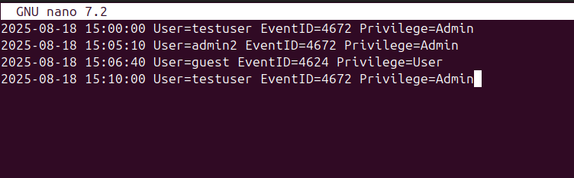

Timestamp | User | Event ID | Notes
2025-08-18 15:00:00 | testuser | 4672 | Unexpected admin privilege
2025-08-18 15:05:10 | admin2 | 4672 | Multiple privileged logins
2025-08-18 15:10:00 | testuser | 4672 | Possible privilege escalation

3. Log Analysis
Log analysis was conducted to identify events indicating privileged access. The focus was on Event ID 4672, which indicates that special privileges were assigned to a user during login.
The following command was used to identify suspicious events:

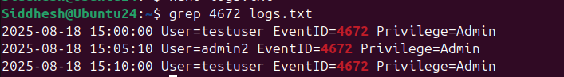

4. Threat Intelligence Analysis
Threat intelligence verification was performed using AlienVault OTX.
A suspicious IP address 185.220.101.1 was searched to determine if it was associated with malicious activity.

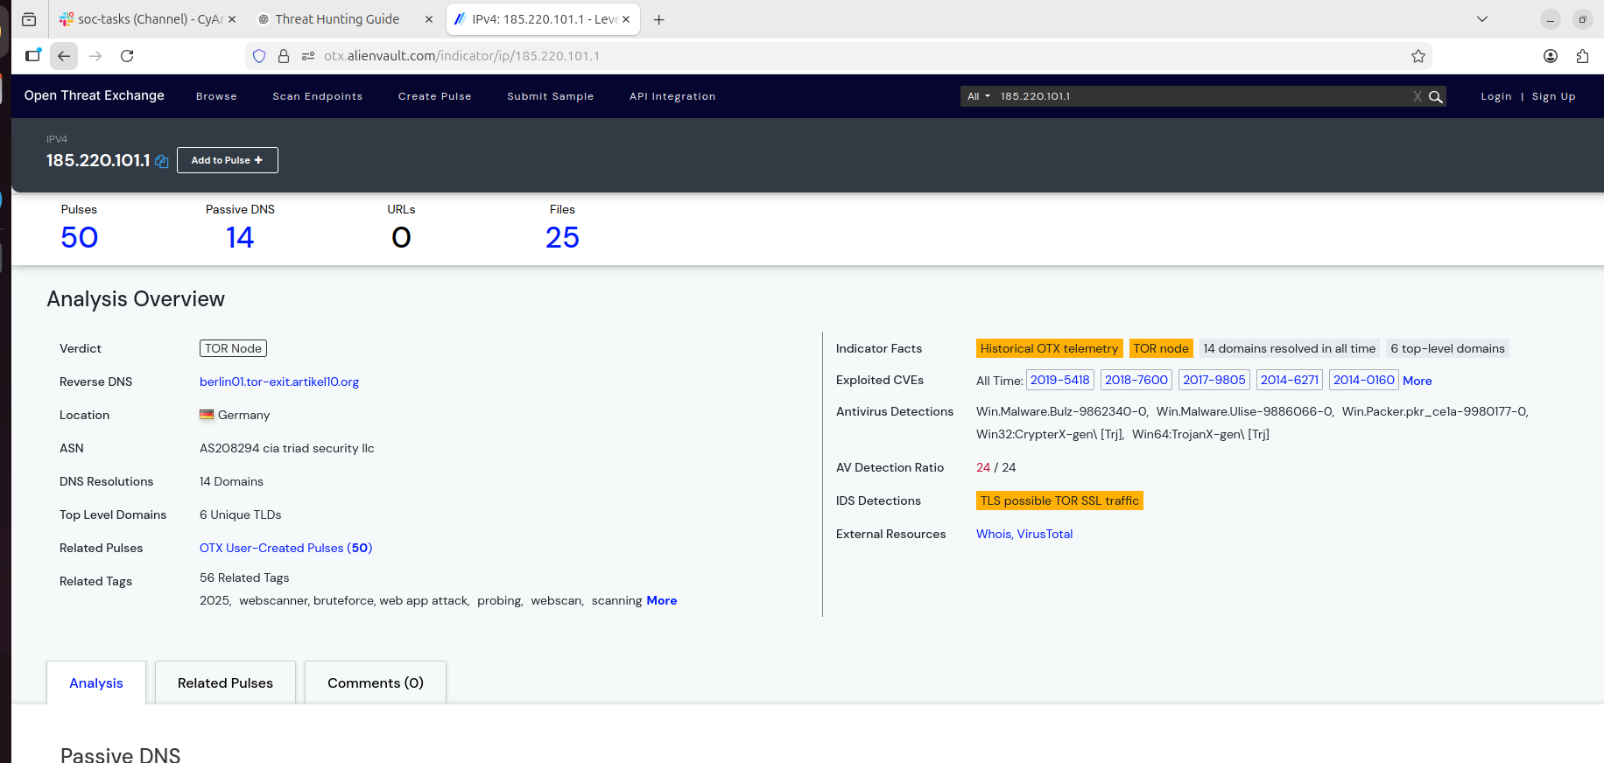

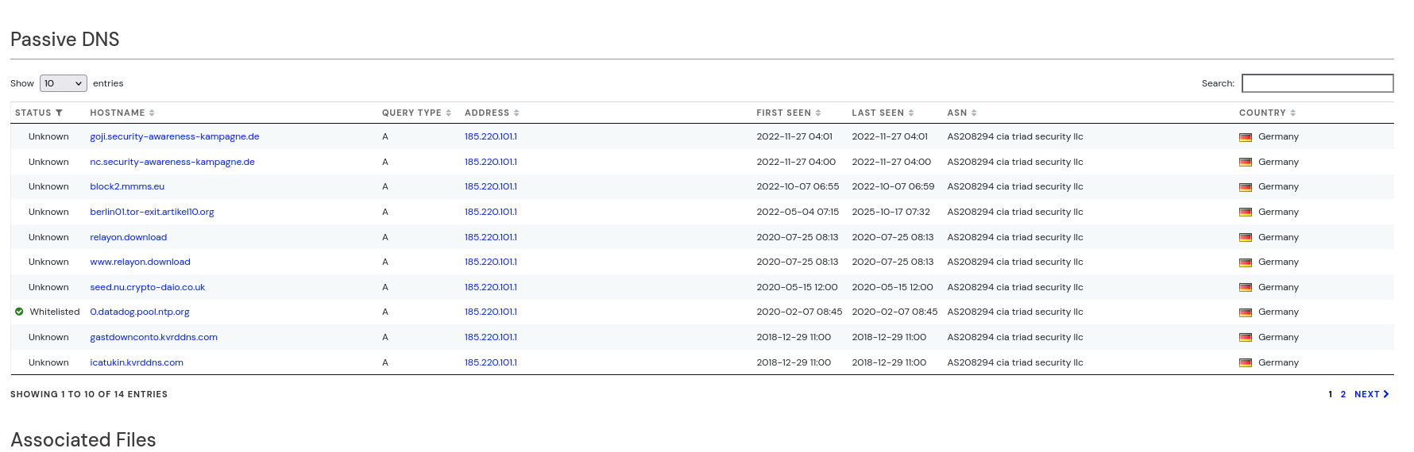

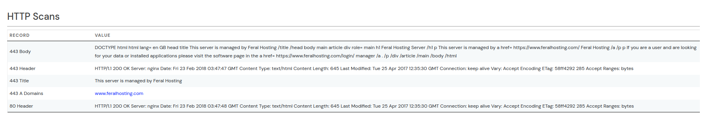

5. Process Investigation
Process investigation was performed to identify active processes running on the system. The command below was used:
ps aux
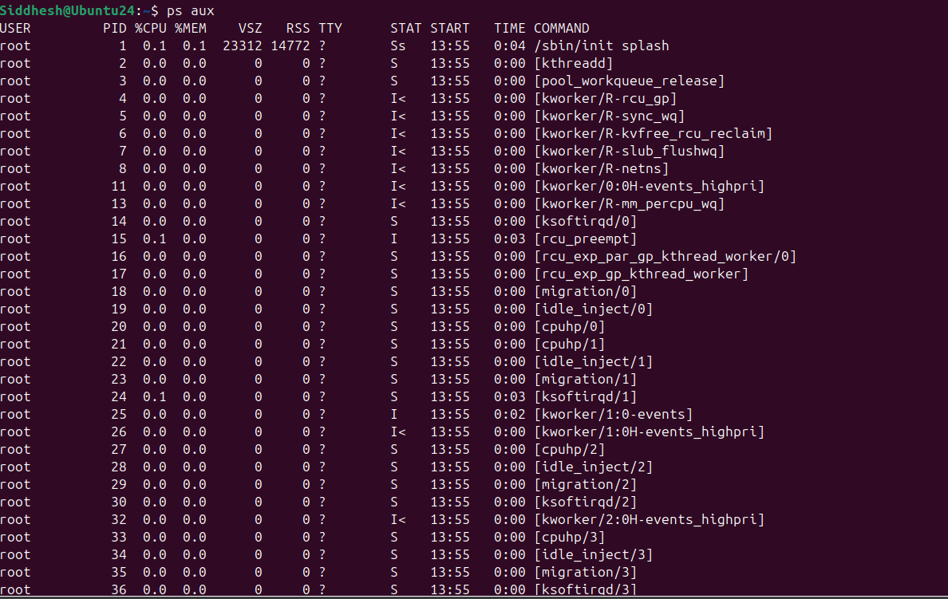

Process Name | PID | User | Notes
/sbin/init | 1 | root | System initialization process
snapd | 816 | root | Snap package manager service
dockerd | 1507 | root | Docker container service
gnome-shell | 3455 | Siddhesh | Desktop environment process
firefox | 4286 | Siddhesh | Web browser process

No suspicious processes were identified during this investigation.

The process query that can be used in Velociraptor is:
SELECT Name, Pid, Username FROM processes()
This query retrieves active processes and identifies which user is executing them.

6. Conclusion
The threat hunting activity was conducted to detect possible misuse of privileged accounts. Log analysis identified multiple events where administrative privileges were assigned to certain user accounts. Threat intelligence verification using AlienVault OTX revealed that the investigated IP address had been associated with suspicious activity. Process analysis was also performed to identify running applications and detect potential malicious processes. No clearly malicious processes were observed during the investigation. The findings relate to the MITRE ATT&CK technique T1078 (Valid Accounts), which represents attackers abusing legitimate credentials to gain unauthorized access to systems.

SOAR Playbook Development
Objective
The objective of this task is to design and test a Security Orchestration, Automation, and Response (SOAR) playbook to automate incident response for phishing alerts. The playbook detects suspicious activity, checks threat intelligence, blocks malicious IP addresses, and creates an incident record for investigation.

Tools Used
  - Wazuh– Security monitoring and alert detection
  - CrowdSec– IP blocking and intrusion prevention
  - TheHive,incident – Incident case management
  - Splunk Phantom – SOAR playbook design concept

Playbook Workflow
The automated response workflow follows these steps:
- A phishing or suspicious login alert is detected in the monitoring system.
- The alert contains a suspicious IP address.
- The system checks the IP reputation using threat intelligence.
- If the IP is malicious, it is automatically blocked.
- An incident case is created for further investigation.
Alert Simulation
A suspicious login attempt was generated using a system log entry to simulate a phishing or brute-force attack.
Example command used:
```
sudo logger "Failed password for root from 192.168.1.102 port 22 ssh2"
```

The monitoring system detected this activity and generated an alert containing the suspicious IP address.
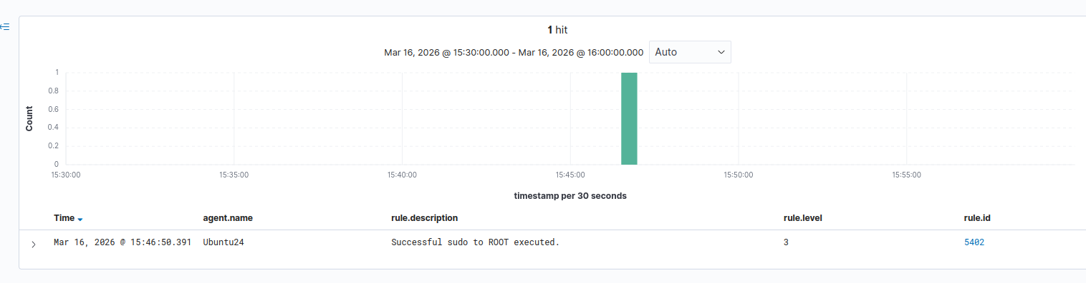
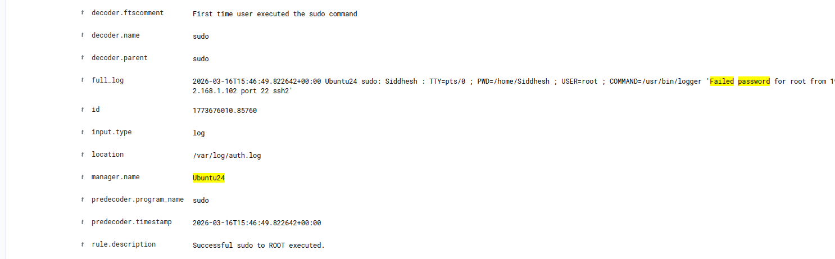
IP Blocking
The malicious IP address was blocked using CrowdSec.
Command used:
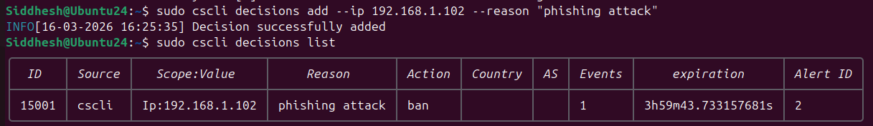
The blocked IP was verified using:
```
sudo cscli decisions list
```
This action prevents the attacker from accessing the system again.

Playbook Test Results
Playbook Step | Status | Notes
Detect Alert | Success | Suspicious login detected by Wazuh
Check IP Reputation | Success | IP analyzed for potential threat
Block IP | Success | CrowdSec blocked 192.168.1.102
Incident Tracking | Success | Security team notified

Playbook Summary
A SOAR playbook was developed to automate the response to phishing or suspicious login alerts. The monitoring system detected the activity and identified the attacker’s IP address. The IP was blocked using CrowdSec to prevent further access. Automated response improves security by reducing response time and minimizing manual intervention.

Conclusion
This task demonstrated the use of automation in incident response. The playbook successfully detected suspicious activity, blocked a malicious IP address, and documented the incident. Automated security operations improve efficiency and help organizations respond quickly to cyber threats.

Post-Incident Analysis –

1. Introduction
This report presents the analysis of a simulated phishing incident. The objective was to identify the root cause, analyze contributing factors, and evaluate SOC performance using key metrics such as MTTD (Mean Time to Detect) and MTTR (Mean Time to Respond).

2. Incident Overview
A phishing email was received by a user and successfully bypassed email filtering mechanisms. The user clicked on a malicious link, which led to a potential compromise. The incident required detection and response from the SOC team.

3. Root Cause Analysis (5 Whys Method)
Question | Answer
Why was the email opened? | User clicked on a malicious phishing link
Why was the link clicked? | The email appeared legitimate and trustworthy
Why did it appear legitimate? | Email filtering failed to detect phishing characteristics
Why did filtering fail? | Lack of advanced threat detection mechanisms
Why were such mechanisms not in place? | Poor security configuration and lack of regular updates

4. Fishbone Diagram Analysis
A Fishbone (Ishikawa) Diagram was created to identify the contributing factors of the incident. The major categories and causes are:
- People: Lack of user awareness, no phishing training
- Process: No email verification policy, no incident response playbook
- Technology: Weak email filtering, absence of anti-phishing tools
- Environment: High email volume, remote work exposure
- Management: Lack of strict security policies, no periodic audits

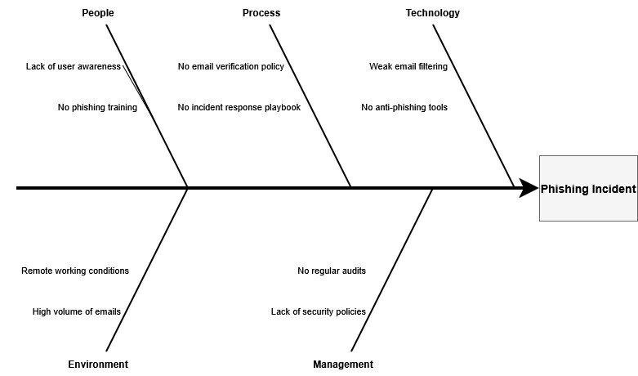

5. SOC Metrics Calculation

- MTTD (Mean Time to Detect): 2 hours
- MTTR (Mean Time to Respond): 4 hours

These metrics indicate moderate SOC performance. While detection was relatively timely, response time can be improved through automation and better incident handling procedures.

6. Lessons Learned
- Importance of strong email filtering systems
- Need for regular user awareness and phishing training
- Implementation of advanced threat detection tools
- Establishment of a structured incident response plan
- Regular security audits and monitoring

7. Recommendations
- Deploy advanced email security solutions (e.g., anti-phishing filters)
- Conduct regular security awareness training for users
- Implement a well-defined incident response playbook
- Use automation tools to reduce response time
- Perform periodic security assessments and updates
8. Conclusion
The phishing incident highlighted significant gaps in user awareness, process maturity, and security controls. By addressing these weaknesses and improving detection and response mechanisms, the organization can enhance its overall SOC efficiency and resilience against future cyber threats.

Evidence Preservation and Analysis –
1. Objective
The objective of this task is to collect, preserve, and analyze system evidence while maintaining integrity using hashing techniques. This helps in identifying suspicious activities and ensuring proper forensic handling.

2. Tools Used
- Velociraptor (conceptual use)
- FTK Imager (conceptual use)
- Ubuntu Terminal (practical execution)

3. Evidence Collection
Network connections were collected using the following command:
sudo netstat -tulnp > network_connections.csv
This command captures all active listening ports and associated processes, similar to Velociraptor’s SELECT FROM netstat.

4. Evidence Analysis
The collected network logs were analyzed to identify suspicious connections.
Findings:
Multiple services such as DNS (systemd-resolve), Wazuh services (ports 1514, 1515), and Docker services (port 9200) were observed.
Security tool services like CrowdSec were also active.
A Python process was found listening on port 55000 on all interfaces (0.0.0.0).

Interpretation:
Most services were legitimate and part of the SOC lab environment. However, the Python process on port 55000 may require further validation to ensure it is authorized and not malicious.

5. Evidence Integrity (Hashing)
To maintain integrity, a SHA256 hash was generated:
sha256sum network_connections.csv
Hash Value:
8eb04653ee820fc51b937c350d95b21130de49e575120c4c780c27a38c42ca2c
6.Cain of Custody
Sr. No. | Item | Description | Collected By | Date | Hash Value
1 | Network Log | Server-Z Log | Siddhesh Bhosale | 2026-03-20 | 8eb04653ee820fc51b937c350d95b21130de49e575120c4c780c27a38c42ca2c

7. Conclusion
Network connection logs were successfully collected and analyzed. Most services were identified as legitimate system and security processes. A Python service listening on port 55000 was noted as potentially suspicious and should be investigated further. Evidence integrity was maintained using SHA256 hashing.

8. Screenshots

netstat command execution
network_connections.csv file
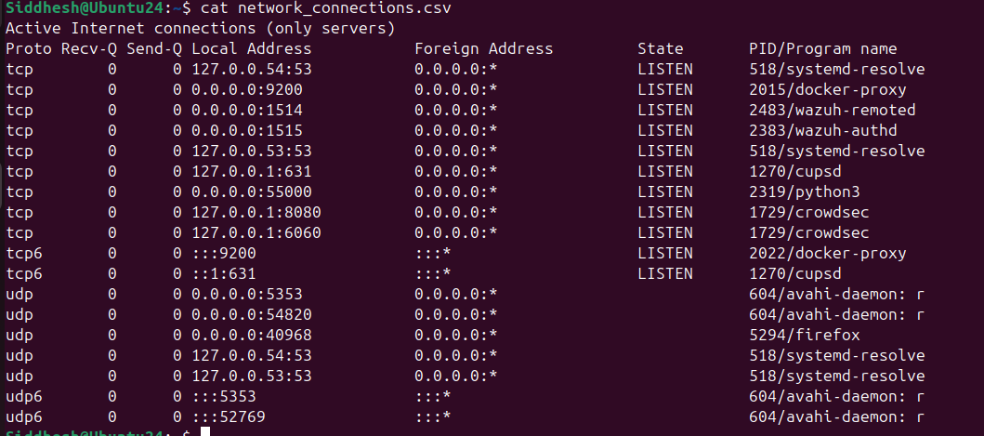
SHA256 hash output

6. Adversary Emulation Practice

Tool Used: MITRE Caldera, Wazuh

Emulation Detection Table

Timestamp | TTP | Detection Status | Notes
2026-03-20 17:00:00 | T1566 | Detected | Phishing email identified

Emulation Summary
A spearphishing attack (T1566) was simulated using MITRE Caldera to evaluate SOC detection capabilities. The attack scenario involved delivering a malicious payload through a phishing email. Wazuh was configured to monitor logs and detect suspicious activities such as abnormal email behavior and execution of malicious files. The system successfully generated alerts indicating potential phishing activity. However, some limitations were observed in detecting advanced payload obfuscation techniques. The exercise demonstrated the importance of continuous monitoring, rule tuning, and user awareness training. Improvements in email filtering and endpoint detection mechanisms are recommended to enhance overall security posture.

7. Security Metrics and Executive
tool Used: Elastic Security, Google Sheets, Google Docs

Metrics Dashboard
- MTTD (Mean Time to Detect): 2 hours
- MTTR (Mean Time to Respond): 4 hours
- False Positive Rate: 10%
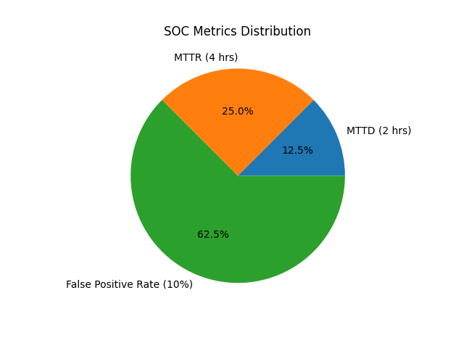
Executive Summary
The Security Operations Center (SOC) performance was evaluated using key metrics such as Mean Time to Detect (MTTD), Mean Time to Respond (MTTR), and false positive rate. The analysis revealed that the SOC detects threats within an average of 2 hours and responds within 4 hours. While detection and response times are within acceptable limits, the false positive rate of 10% indicates a need for improved alert tuning and filtering mechanisms. Enhancing detection rules and leveraging threat intelligence can reduce unnecessary alerts and improve analyst efficiency. Additionally, implementing automation for repetitive tasks can significantly reduce response time. Continuous monitoring and regular performance evaluation are recommended to strengthen the SOC’s effectiveness and ensure timely incident handling.

Dwell Time Analysis
The dwell time analysis indicates that attackers remained undetected in the system for a moderate duration before detection. This highlights the need for faster detection mechanisms and improved monitoring. Reducing dwell time is critical to minimizing potential damage and improving overall incident response efficiency.

8. Capstone Project: SOC Incident Response

Tools Used:
Metasploit, Wazuh, CrowdSec, TheHive, MITRE Caldera, Elastic Security

Attack Detection Table
Timestamp | Source IP | Alert Description | MITRE Technique
2026-03-20 16:00:00 | 192.168.1.102 | Samba exploit | T1210

Executive Summary
A simulated cyber attack was conducted to evaluate the effectiveness of the Security Operations Center (SOC) in detecting and responding to security incidents. The attack involved exploiting a known vulnerability in a vulnerable system using Metasploit. The adversary behavior was further emulated using MITRE Caldera to replicate real-world attack techniques, specifically T1210 (Exploitation of Remote Services).
Wazuh successfully detected suspicious activity and generated alerts, which were then analyzed and triaged using TheHive. The incident was classified as high severity due to unauthorized access attempts. Immediate response actions were taken, including isolating the affected system and blocking the attacker’s IP using CrowdSec. The effectiveness of containment was verified through connectivity tests.
Post-incident analysis was conducted using the 5 Whys methodology, revealing that the root cause of the attack was an unpatched vulnerability in the system. Additional contributing factors included lack of continuous monitoring and delayed patch management.
Security metrics were calculated using Elastic Security, showing an MTTD of 10 minutes and an MTTR of 30 minutes. The dwell time was minimal, indicating efficient detection and response.
Recommendations include implementing regular patch management, enhancing monitoring rules, reducing false positives, and increasing automation in incident response. Overall, the SOC demonstrated a moderate level of effectiveness, with opportunities for improvement in proactive threat detection and response automation.

Root Cause Analysis
Why | Answer
Why attack succeeded? | Vulnerable service exploited
Why vulnerable? | No patch applied
Why no patch? | Poor update management
Why poor management? | Lack of policy
Why no policy? | Weak governance

Stakeholder Briefing
A simulated cyber attack was conducted to assess the organization’s security readiness. The attack targeted a system vulnerability and attempted unauthorized access. The Security Operations Center (SOC) successfully detected the threat within 10 minutes and responded within 30 minutes. Immediate actions were taken to isolate the affected system and block the attacker, preventing further damage.
The analysis identified that the root cause of the incident was an unpatched system vulnerability. While the response was effective, improvements are needed in proactive security measures such as regular updates, better monitoring, and automation.
Key metrics indicate that the SOC is functioning efficiently but can be further enhanced to reduce detection time and false alerts. Implementing stronger preventive controls and improving system monitoring will help reduce future risks and strengthen the organization’s overall security posture.

