- Theoretical Knowledge

- SOC Fundamentals and Operations :

- National Institute of Standards and Technology
https://www.nist.gov/cyberframework
- MITRE ATT&CK Framework
https://attack.mitre.org/
- IBM SOC Overview
https://www.ibm.com/solutions
- Microsoft SOC Documentation
https://learn.microsoft.com/en-us/security/
I have use these Sites only for understanding concepts And Watch Videos .

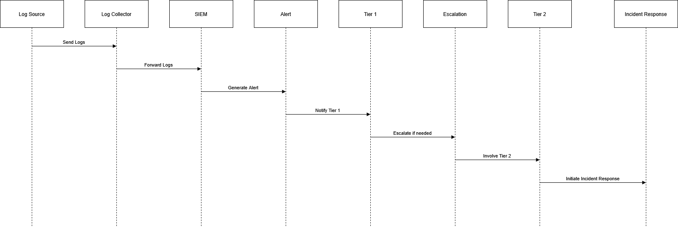
- SOC Workflow Diagram

- Tier 1 – Alert Monitoring & Triage
Tier 1 analysts are the first level of security team.
They continuously monitor security tools like SIEM, firewall, and EDR.

What Tier 1 does:
- Monitor security alerts
- Check if alert is real or false positive
- Collect basic details (IP address, username, time, system)
- Follow predefined SOP (Standard Operating Procedure)
- Escalate serious alerts to Tier

Simple example:
If there are 10 failed login attempts:
- Tier 1 checks if user forgot password
- Or if it is brute force attack
- If suspicious → send to Tier

Main goal:
Filter alerts and detect possible threats quickly.

- Tier 2 – Incident Investigation
Tier 2 analysts handle deeper analysis of escalated alerts.
They investigate whether the activity is a real cyber attack.

What Tier 2 does:
- Analyze logs in detail
- Correlate multiple events
- Identify attack technique
- Check affected systems
- Suggest containment actions

Simple example:
If brute force attack is confirmed:
- Check if attacker logged in successfully
- Check if new account was created
- Check if sensitive data was accessed

Main goal:
Confirm incident and understand full impact.

- Tier 3 – Threat Hunting & Advanced Analysis
Tier 3 analysts are experienced security experts.
They work in a proactive way, not waiting for alerts.

What Tier 3 does:
- Search for hidden threats in network
- Use threat intelligence
- Create new detection rules
- Improve SOC security controls

Simple example:
If new ransomware is spreading globally:
- Tier 3 checks if similar behavior exists in company network
- Even if no alert was generated
Main goal:
Find advanced or hidden attacks before they cause damage.

- Security Monitoring Basics :
Security monitoring means continuously watching network and systems to detect suspicious activity.

1. Detect Anomalies
An anomaly means unusual behaviour.
Example:
- User logs in at 3 AM (normally logs in at 9 AM)
- Sudden large data transfer
- This could indicate compromise.

2. Detect Unauthorized Access
This means someone tries to access system without permission.
Example:
- Multiple failed login attempts (brute force)
- Login from unknown country
- Access to admin panel without authorization

3. Detect Policy Violations
This means employees breaking company security rules.
Example:
- Installing unauthorized software
- Using USB devices when restricted
- Accessing blocked websites
- Goal:
Identify threats before they become major incidents.

- Tools Used in Security Monitoring

SIEM (Security Information and Event Management)
Examples:
- Splunk
- Elastic Stack
- What SIEM does:
- Collect logs from multiple sources
- Normalize logs
- Correlate events
- Generate alerts
Example:
Firewall + Windows logs + Antivirus logs → Combined in one dashboard.

Network Traffic Analyzer
Example:
- Wireshark
What it does:
- Capture live network packets
- Analyze suspicious traffic
- Identify scanning, brute force, or malware communication
Example filter:
tcp.flags.syn == 1 && tcp.flags.ack == 0
→ Detects possible SYN scan.

  - Key Metrics in Security Monitoring

- False Positive
Alert generated but no real attack.
Example:
Employee mistyped password 5 times → Alert triggered.

- False Negative
Real attack happened but no alert generated.
This is dangerous because SOC failed to detect attack.

- MTTD (Mean Time To Detect)
Time taken to detect an attack.
Example:
Attack started at 10:00 AM
SOC detected at 10:20 AM
MTTD = 20 minutes
Lower MTTD = Better SOC performance.

- Log Management Fundamentals :
Log Management means handling logs properly so they can be used for security monitoring and investigation.
- Log Management Process (Short)
- Collection
Gather logs from different systems into one place.
Sources: Windows, Linux, Firewalls, Web servers, Applications
Tools: Fluentd, Logstash
Example: /var/log/auth.log
Goal: Centralized monitoring.

- Normalization
Convert different log formats into a standard format (like JSON or CEF).
Example:
Before:
Failed password for root from 192.168.1.10
After (JSON):
{
"event_type": "Failed Login",
"username": "root",
"source_ip": "192.168.1.10"
}

- Storage
Store logs securely for fast searching.
Stored in: SIEM, Cloud, Log server

- Retention
Defines how long logs are kept.
- Critical logs → 1 year
- Normal logs → 90 days
Important for forensics & compliance.

- Analysis
SOC analysts analyze logs to detect:
- Brute force attacks
- Malware activity
- Suspicious behavior

- Common Log Types (Short)
- Windows Event Logs
- 4624 → Successful login
- 4625 → Failed login
Used for brute force & unauthorized access detection.
- Linux Syslog (/var/log/auth.log)
Used to detect SSH attempts & privilege escalation.

- HTTP Server Logs (Apache/Nginx)
Contains IP, URL, status code
Used to detect SQL injection & web attacks.

- Practice Tasks:

- Log Collection Pipeline:
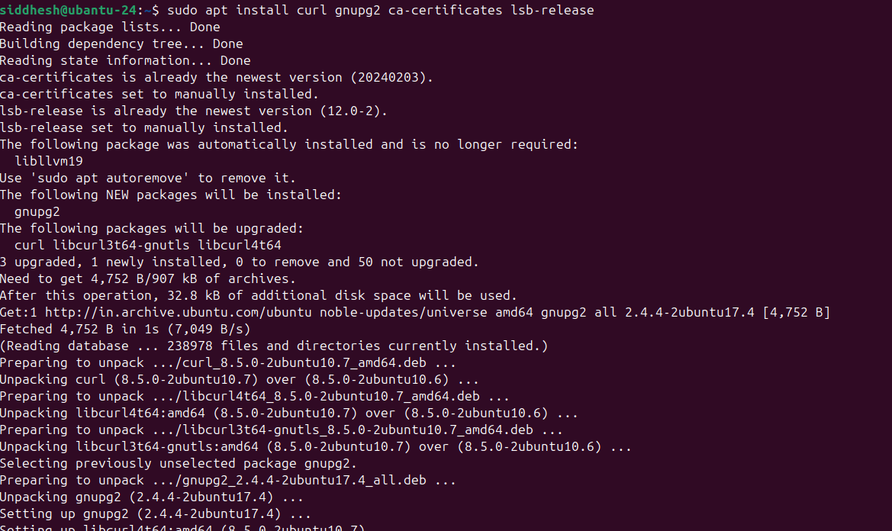
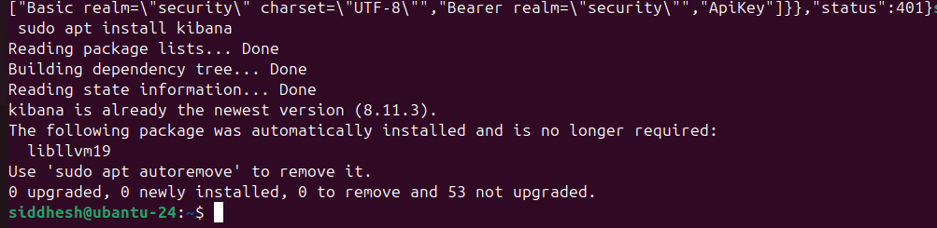
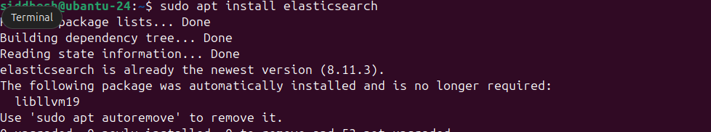

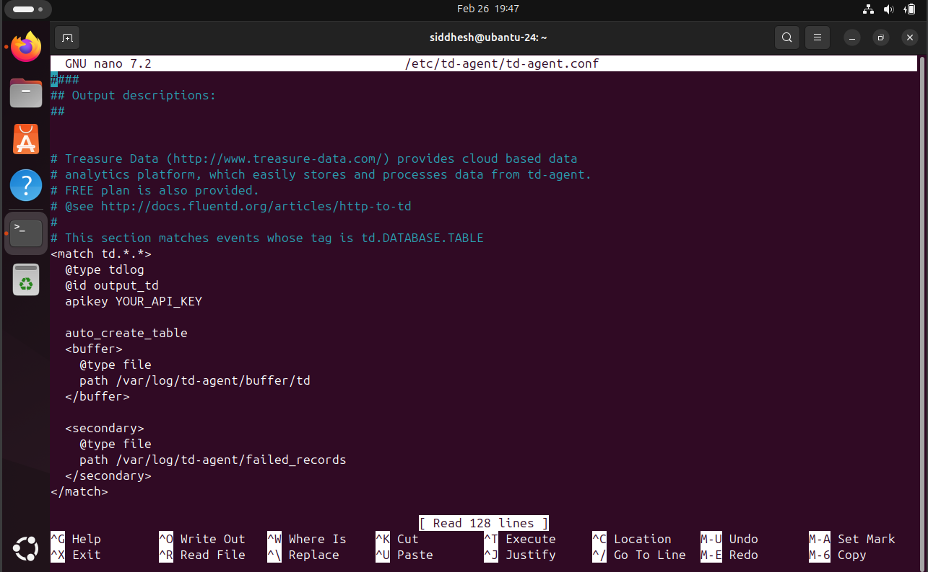
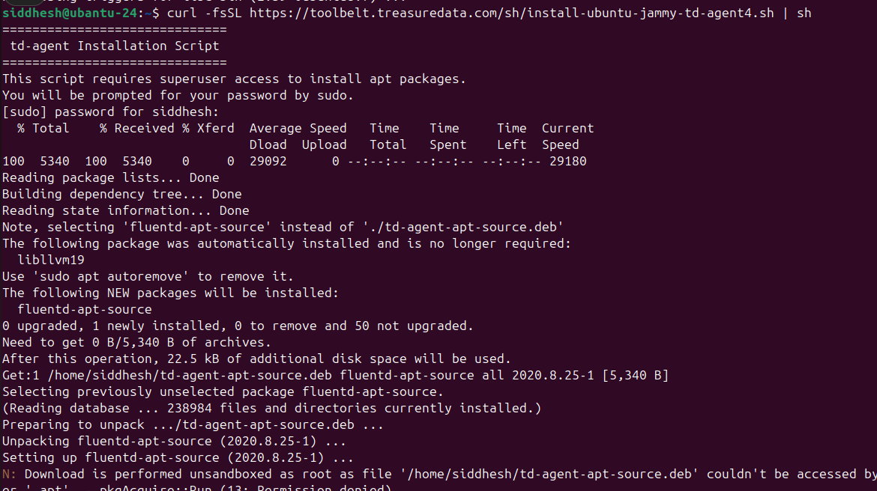

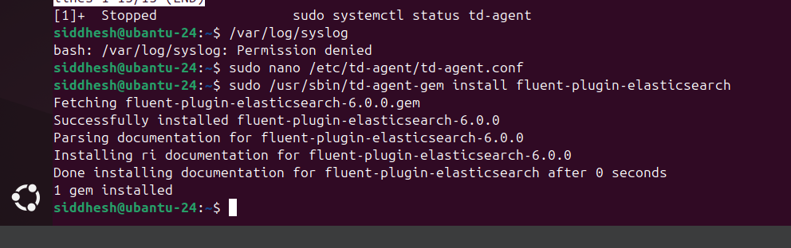

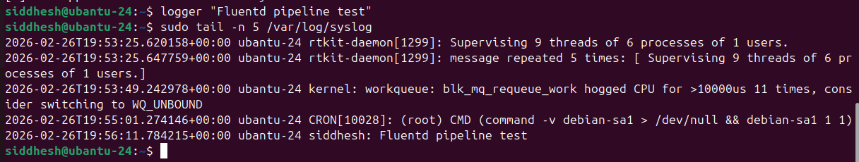
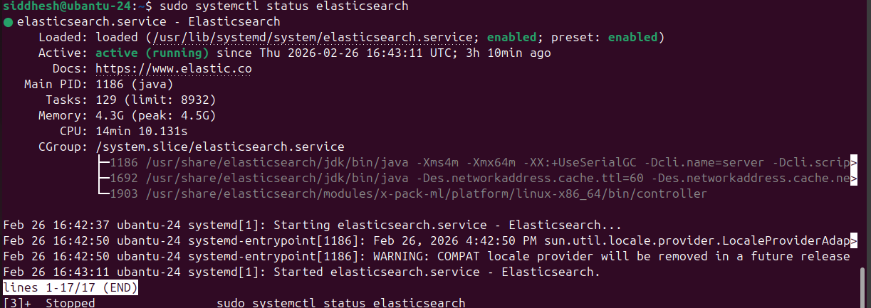

- Basic Security Concepts

1. CIA Triad
    - Confidentiality
Protect data from unauthorized access.
✔ Encryption
✔ Access control
✔ Authentication
Example: Password-protected database.

    - Integrity
Ensure data is not altered or tampered.
✔ Hashing (SHA-256)
✔ Digital signatures
✔ File integrity monitoring
Example: Detecting modified system files.

    - Availability
Ensure systems/data are accessible when needed.
✔ Backups
✔ Redundancy
✔ DDoS protection
Example: Website uptime during heavy traffic.

2. Threat vs Vulnerability vs Risk
    - Threat
Anything that can cause harm.
Example: Hacker, malware, insider attack.
    - Vulnerability
Weakness in system.
Example: Unpatched software.

    - Risk
Likelihood of threat exploiting vulnerability.
Formula:
Risk = Threat × Vulnerability × Impact
Example:
Unpatched server (vulnerability) + attacker (threat) → data breach (risk).

3. Defense-in-Depth
Multiple security layers to protect systems.
Example layers:
- Firewall
- IDS/IPS
- Antivirus
- MFA
- SIEM monitoring
If one fails → others protect.

4. Zero Trust Model
“Never trust, always verify.”
✔ Every user/device must authenticate
✔ Least privilege access
✔ Continuous monitoring
Example:
Even internal employees must use MFA.

    - Case Study Example
Equifax Breach (2017)
- Cause: Unpatched Apache Struts vulnerability
- Impact: 147 million records exposed
- Lesson:
  - Patch management is critical
  - Vulnerability ≠ Risk until exploited
  - Poor defense-in-depth increases impact

- Security Operations Workflow
1. Detection
Alerts generated from:
- SIEM (Splunk, Wazuh, Elastic)
- EDR (CrowdStrike, Defender)
- IDS/IPS (Snort)
- User reports (phishing email)
Goal: Identify suspicious activity.
Example:
SIEM alert → “Multiple failed logins (4625)”

2. Triage
SOC Tier-1 checks:
- Severity (Low / Medium / High / Critical)
- False positive?
- Affected asset (critical server or normal user PC?)
- IOC reputation (VirusTotal, Threat Intel)
Goal: Decide priority & escalate if needed.

3. Investigation
SOC Tier-2 / Tier-3:
- Correlate logs (SIEM + Firewall + EDR)
- Check IOCs (IP, domain, hash)
- Timeline creation
- Identify root cause
Goal: Confirm compromise.

4. Response
Actions:
- Containment (isolate endpoint)
- Eradication (remove malware)
- Recovery (restore system)
- Lessons learned
Goal: Stop attack & prevent recurrence.

    - Phishing Email Incident Workflow (Flowchart)

User reports phishing email
↓
SIEM/Email alert triggered
↓
Triage:
- Check sender domain
- Check attachment/hash
- Check URL reputation
↓
If malicious?
YES → Investigate
NO → Close as false positive
↓
Investigation:
- Check if user clicked link
- Check endpoint logs
- Check unusual login activity
↓

Compromised?
YES → Isolate device
Reset password
Block domain/IP
Scan endpoint
NO → Block sender
Awareness email
↓
Close incident + Report

- Simulate workflows using incident response platforms (e.g., TheHive).
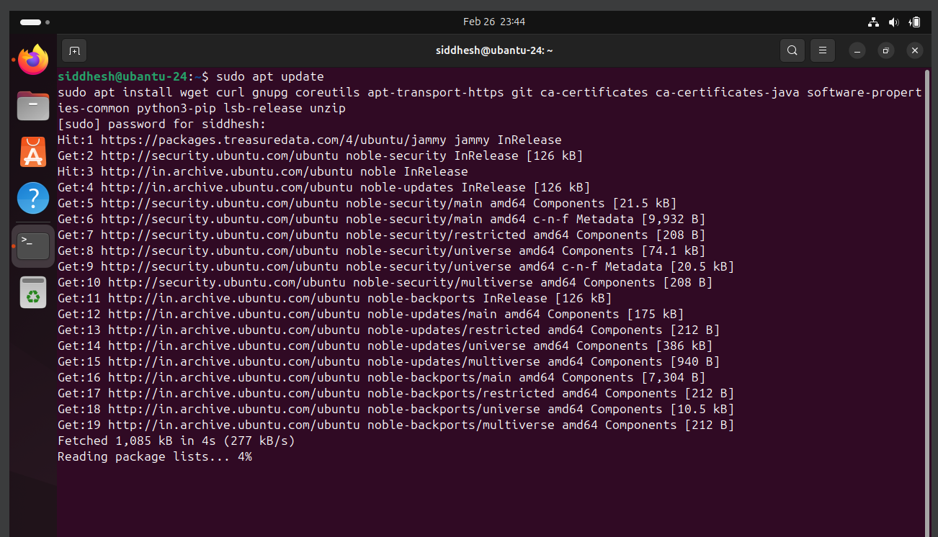
- Create a flowchart for a phishing email incident.

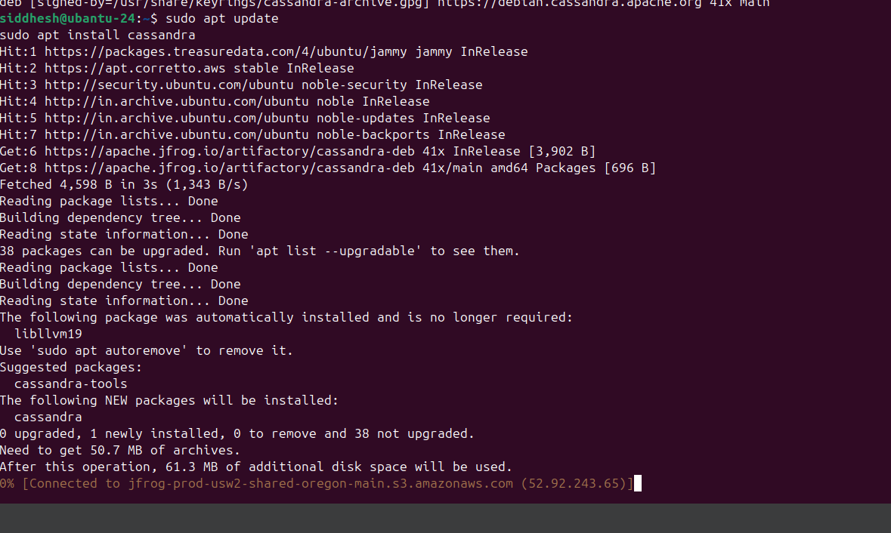
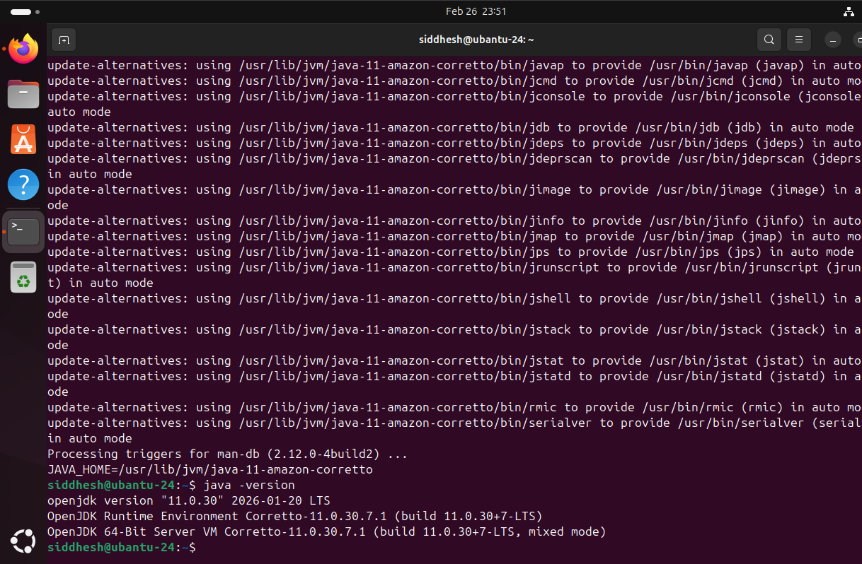

SOC Practical Application Report
Document Version: 1.0

Document Information
Item | Details
Assessment Type | SOC Monitoring and Brute-Force Detection using SIEM
Tools Used | Windows Event Viewer, Splunk, Wazuh SIEM, Elastic SIEM, LogParser Lizard
Target Scope | Windows10VM-(192.168.1.9)  Ubuntu VM-(192.168.1.8)
Report Prepared By | Siddhesh Bhosale
Date | 27-02-2026

Introduction
This report documents the practical implementation of Security Operations Center (SOC) monitoring activities conducted within a controlled lab environment. The objective of this exercise was to simulate real-world security monitoring scenarios, including brute-force detection, log analysis, browser artifact investigation, dashboard creation, and alert rule configuration.
The lab environment was built using Windows and Ubuntu virtual machines integrated with SIEM platforms. The exercises demonstrate how SOC analysts detect, investigate, and document suspicious authentication attempts and system-level activities using structured workflows and standardized monitoring tools.
This documentation serves as academic evidence of practical SOC capability and understanding of detection engineering concepts.

1. Log Analysis Practice
1.1 Windows Event Log Monitoring
Windows Event Viewer was used to monitor security-related logs.
The following Event IDs were analyzed:
- Event ID 4625 – Failed Login Attempt
- Event ID 7045 – New Service Creation

Procedure:
- Open Event Viewer
- Navigate to: Windows Logs → Security
- Apply filter for Event ID 4625
- Review login failure patterns
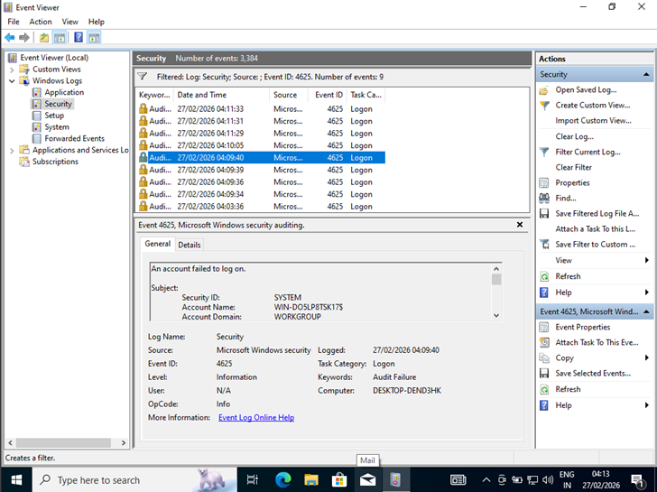
Observations:
Multiple failed log in attempts from the same source IP within a short time period were identified. This pattern indicates a potential brute-force authentication attack.
Event ID 7045 was also reviewed to detect unauthorized service installations that may indicate persistence mechanisms.

1.2 Browser History Analysis
Browser artifacts were analyzed using Eric Zimmerman’s forensic tool (LECmd).
Objective:
To detect visits to a test URL
Procedure:
- Located Chrome history database file
- Parsed file using LECmd
- Extracted visited URLs and timestamps

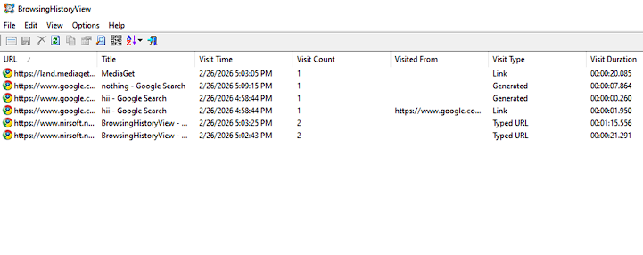
Outcome:
The test URL was successfully identified in the browser history output, demonstrating forensic investigation capability within endpoint monitoring scenarios.

1.3 Advanced Task: Brute Force Detection
Failed login attempts were generated in a Windows Virtual Machine using repeated incorrect password entries.
The security logs were:
1. Filtered using Event Viewer for Event ID 4625
2. Exported into CSV format
3. Analyzed for brute-force attack indicators

Steps Performed:
- Generated repeated login failures
- Filtered logs using Event ID 4625
- Observed timestamps and source IP
- Exported filtered logs into CSV format
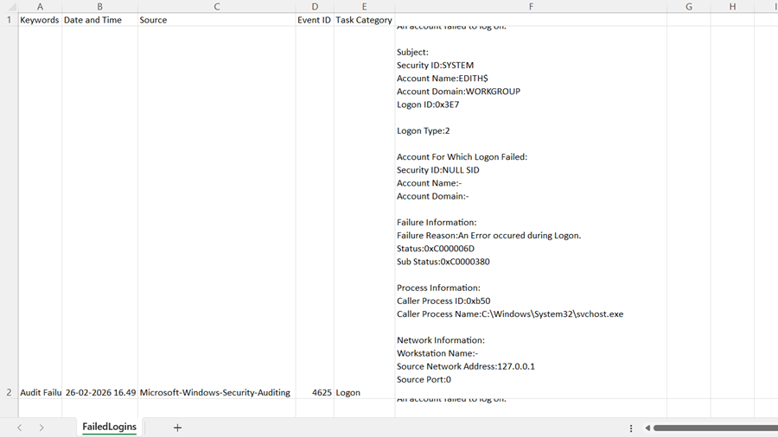
Result:
The exported logs clearly showed multiple authentication failures originating from the same IP address within a short time frame, confirming brute-force behavior.

2. Security Event Documentation
Security events were recorded using a structured SOC documentation template to maintain consistency in log tracking and incident analysis.
Security events were documented using the following template:
Date | Source ip | Event ID | Description | Action Taken
27-02-26 | 192.168.1.9 | 4625 | Multiple Failed Login Attempts | Alert Reviewed & Logged

Importance of Documentation:
- Maintains investigation timeline
- Ensures audit compliance
- Supports incident response tracking
- Assists in future forensic review

3. Monitoring Dashboard Setup
Security monitoring dashboards were configured in Splunk to visualize authentication patterns.
1. Top 10 Source IPs Generating Alerts
Displayed IP addresses with highest failed login attempts.
2. Frequency of Critical Event IDs
Tracked repeated occurrences of Event ID 4625.
Outcome:
The dashboards provided visual insight into abnormal login trends and helped quickly identify suspicious IP activity.
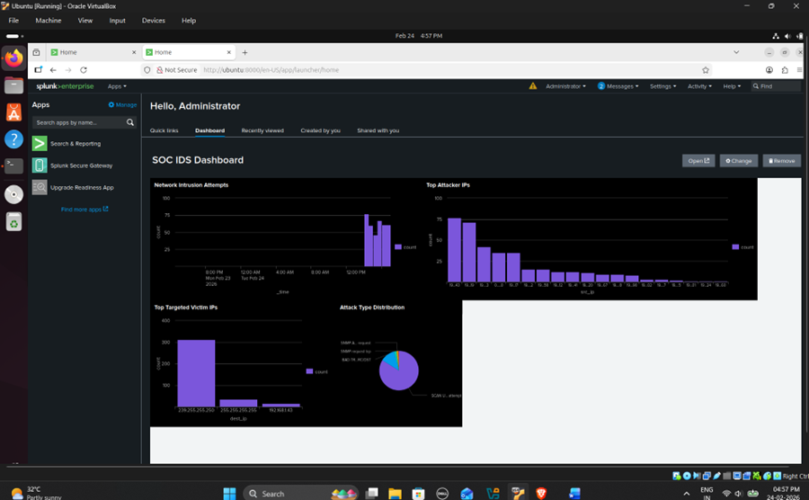

4. Alert Rule Configuration
4.1 Splunk Alert Rules Configuration
Snort Rule Created: Detect 5+ failed logins in 5 minutes
Index: security-login-*
Condition: count > 5
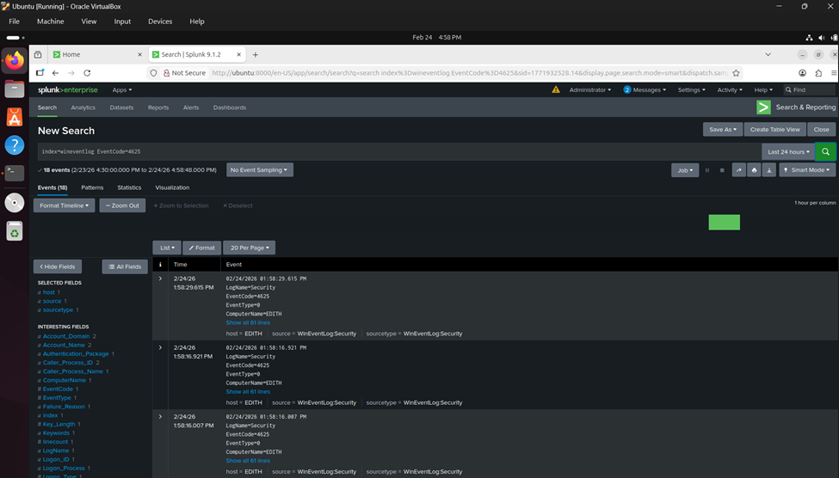

4.2 Advanced Task: SSH Brute Force Detection using Wazuh SIEM
A simulated SSH brute-force attack was performed from a Windows host to an Ubuntu server using invalid login credentials.
The Wazuh SIEM platform was configured to monitor authentication logs from:
• /var/log/auth.log (Ubuntu Endpoint)
Repeated unauthorized login attempts generated security events which were successfully detected by the built-in Wazuh rule.
The generated alert details are as follows:
- Rule ID: 5710
- Description: sshd: Attempt to login using a non-existent user
- Agent Name: ubuntu
- Severity Level: 5
- Source IP: 192.168.0.8
This indicates multiple unauthorized SSH login attempts which may represent brute-force credential attacks.
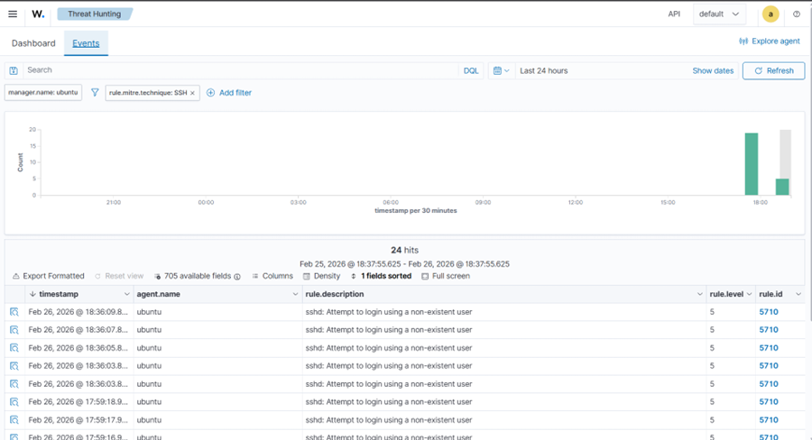

5. MITRE ATT&CK Mapping
Detected brute-force activity was mapped to:
- Tactic: Credential Access
- Technique: T1110 – Brute Force
This mapping confirms that repeated authentication failures align with adversarial brute-force techniques commonly used in real-world attacks.
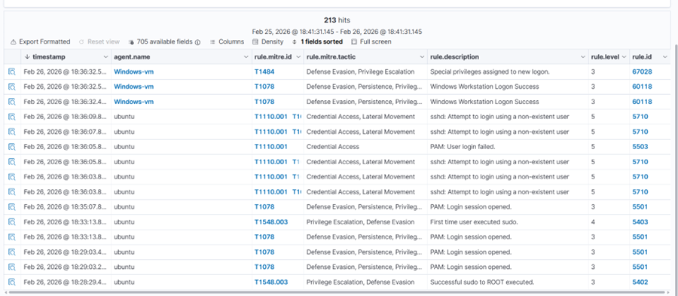

6. SOC Workflow Implementation
The following SOC workflow was followed during the exercise:
- Detection – Alert triggered in SIEM
- Triage – Verified repeated failed login pattern
- Investigation – Correlated logs and timestamps
- Response – Documented event and monitored source IP
- Reporting – Exported logs and recorded findings
This structured workflow ensures consistent incident handling procedures.

Conclusion
The practical SOC lab successfully demonstrated:
- Log filtering and analysis
- Brute-force attack simulation
- Alert rule creation and validation
- Dashboard visualization
- Browser forensic artifact analysis
- Structured security documentation
The exercises replicate real-world SOC monitoring operations and provide foundational experience in threat detection, investigation, and reporting within a controlled environment.

References
- Splunk Documentation
- Wazuh Documentation
- MITRE ATT&CK Framework

