To_Find_10_Most_
Asked_Questions

A Project Submitted
for internship

by

Siddhesh Sharma

to

https://exampreparationonline.com/

DATASET

Initially, We are given with two files 500_questons.csv and topic_dataset.csv. Our final task is to find the most asked questions among the given 500 questions based on topic.

topic_dataset.csv contains:
No_of_Columns | 3 | Id,topic,subject
No of Rows | 20 | Including heading row
Null Values | No

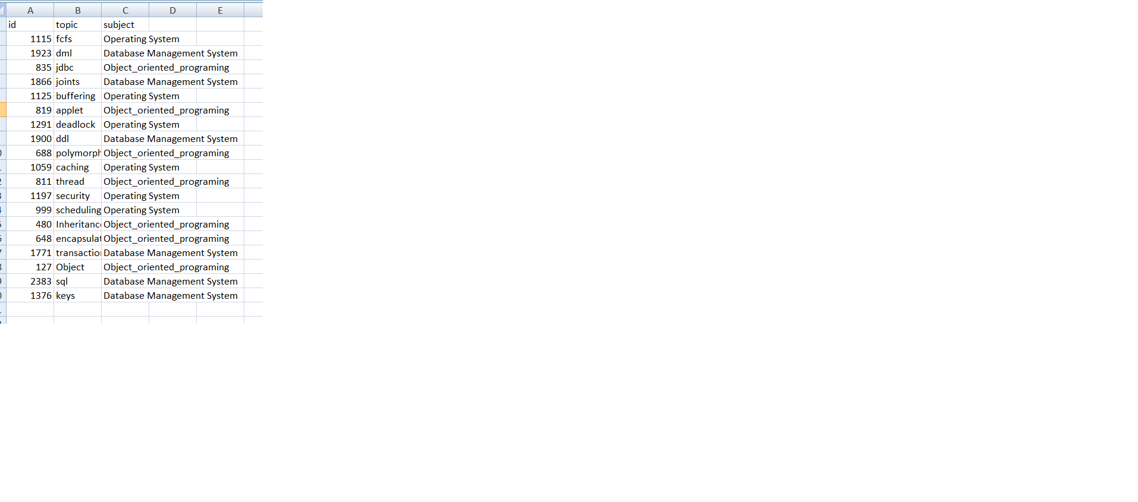

Similarly 500_questions.csv contains
No_of_columns | 2 | Id,question
No_of_Rows | 500 | Including header row
Null_values | No

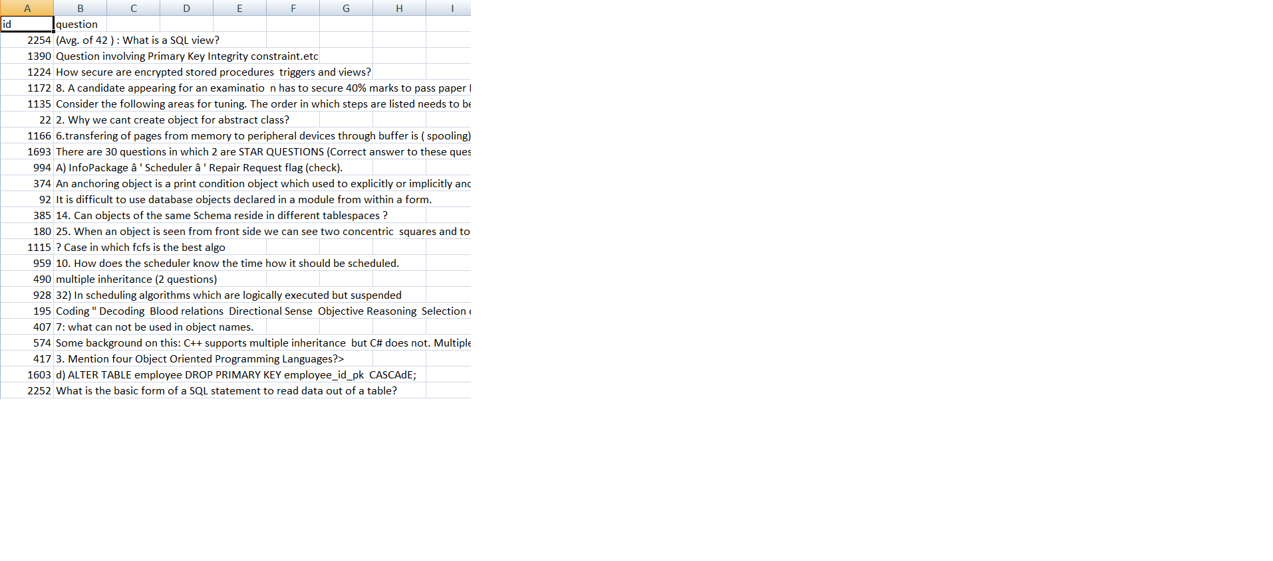
Steps Required

- Understanding the data and output needed
- Data preprocessing
- Training the model(Doc2Vec)
- Saving output

Understanding The Data:

By observing the Dataset, It was totally clear that the Dataset does not contain any repeated questions.
Hence, Problem was not about to find most repeated questions.
Problem was about to find most similar questions
For ex. 1) Please explain full-form of Sql.
2) Please Define full-form of Sql.
Here both the questions meant the same thing but computer will analyze them as two separate question but they come in same category. Hence we needed to use some NLTK model which not just store counts of words but also their semantic relations.
So, I came to a conclusion that We can either use Doc2Vec or Word2Vec as they store words as vectors along with their semantic information. Since i applied for this internship at 19th of December 2018, due to only 3 days of availability as submission day is 22nd December 2018, I have only made a model based on Doc2Vec.

Data Preprocessing:

I did the basic Data-preprocessing on text data using nltk and regular expressions.
It involved as follows
- removing stopwords and alphanumeric characters.
- removing digits and numbers
- removing punctuations except + and # , Since data was related to Computer Science.I was expecting C++,C#.
- removing spaces, tabs and lowercasing everything

Training the Data:

finally i trained the data using Doc2Vec,It only took 28 sec to completely train all the data. My main aim was to find the similar sentences (based on cosine similarity) for each and every sentence. I created a list of similar sentences for each question in the Dataset.

eg......
question1:What is a sql_view?
so my list_of_similar_questions will contain all the similar questions to this question which i can see.

list_of_similar_question is created based on Doc2Vec taking the consideration of cosine vectors ie. using model.dovecs_most_similar function.

Now the second important thing, I created a Dictionary based on the topics.
if the topic_word exist in question then add the question

example: 1) what is sql?
2) define fcfs?
3) please explain sql query

In the dictionary d {sql:['what is sql?' , 'please explain sql query'],fcfs:[define fcfs?]}

So a dictionary is created based on all the 19 topics fcfs,polymorphism,sql,keys such that topic name acts as key and questions acts as list_of_values.

It helped me to know which topics contains less than 10 questions such as fcfs,dml,jdbc,joints etc
They all have less than 10 questions available in dataset, Hence I quickly decided not to work on them, Due to lack availability of questions on these topics.

So now I needed to search most similar questions among the topics having more than 10 questions such as sql, security, polymorphism. Hence I quickly added them to a list m_c_n_c.

list m_c_n_c [questions containg words sql ,
questions containg word polymorhism.......]

In this was m_c_n_c was created.

Now I used m_c_n_c to fetch questions having required topic word, Then for that each question I find the most similar questions in the dataset
ex list of questions containg sql [q1,q2,q3,q4.......,q20]

q34,
q36,
q100
q 499,q34,q10...

Like here q1 fetched from m_c_n_c is similar to q34,36 and 10 and q20 is similar to q499,q34,q10.

Finally i created the list of all these similar questions for each topic and found the most repeated questions among them.

Saving Output:

Finally I created the Dataframe out of these questions and converted that dataframe to required csv.
Name: Siddhesh Sharma

Contact Number: 9409699988

linkedin profile: https://www.linkedin.com/in/siddhesh-sharma-a1903911b/

Hackerearth profile: https://www.hackerearth.com/challenge/competitive/deep- learning-challenge-4/leaderboard/

I exist at 29th rank on this leaderboard as siddhesh sharama

Hackerrank profile : https://www.hackerrank.com/sidd10

Currently having 2 bronze medals on my profile of Hackerrank.

THANK YOU

^_^

