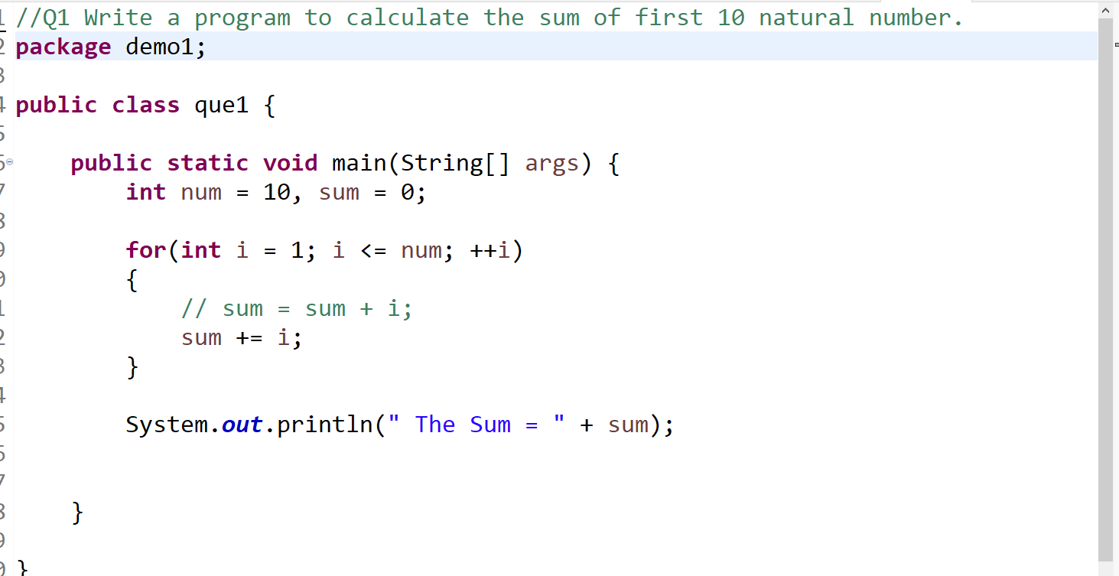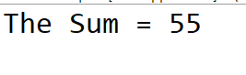

//Q 2 Write a program that prompts the user to input a positive integer. It should then print the multiplication table of that number.

**package** demo1;

**import** java.util.Scanner;

**public** **class** que2 {

**public** **static** **void** main(String[] args) {

Scanner scan = **new** Scanner(System.***in***);

System.***out***.print("Enter a positive integer: ");

**int** num = scan.nextInt();

**while** (num < 0){

System.***out***.println("Please only enter positive numbers!");

num = scan.nextInt();

}**for** (**int** i = 0; i <= 10; i++){

System.***out***.println(num*i);

}

}

}

Enter a positive integer: 15

0

15

30

45

60

75

90

105

120

135

150

//Q 3 Write a program that prompts the user to input an integer and then

//outputs the number with the digits reversed. For example,

//if the input is 12345, the output should be 54321.

**package** demo1;

**import** java.util.Scanner;

**public** **class** que3 {

**public** **static** **void** main(String[] args) {

**int** num=0, rev=0;

Scanner sc=**new** Scanner(System.***in***);

System.***out***.println("Enter a number");

num=sc.nextInt();

**while**(num !=0)

{**int** digit= num % 10;

rev=rev*10+digit;

num/=10;

}

System.***out***.println("reversed number="+rev);

sc.close();

}

}

Enter a number

112

reversed number=211

//Q 4 Write a do-while loop that asks the user to enter two numbers.

//The numbers should be added and the sum displayed.

//The loop should ask the user whether he or she wishes to perform the operation again. If so, the loop should repeat; otherwise it should terminate.(while loop)

**package** demo1;

**import** java.util.Scanner;

**public** **class** que4 {

**public** **static** **void** main(String[] args) {

Scanner sc=**new** Scanner(System.***in***);

String d;

**do** {

System.***out***.print("Enter First Number: ");

**int** a=sc.nextInt();

System.***out***.print("Enter second Number: ");

**int** b=sc.nextInt();

**int** add=a+b;

System.***out***.println("Addition Of The Two Numbers is:"+add);

System.***out***.println("");

System.***out***.println("You want perform addition again then write YES and to exit write NO");

d=sc.next();

}**while**(d.equalsIgnoreCase("yes"));

System.***out***.println("End of Program");

sc.close();

}

}

Enter First Number: 12

Enter second Number: 25

Addition Of The Two Numbers is:37

You want perform addition again then write YES and to exit write NO

YES

Enter First Number: 12

Enter second Number: 65

Addition Of The Two Numbers is:77

You want perform addition again then write YES and to exit write NO

NO

End of Program

//Q 5 Write a program to print out all Armstrong numbers between 1 and 500. If sum of cubes of each digit of the number is equal to the number itself, then the number is called an Armstrong number.

//For example, 153 = ( 1 * 1 * 1 ) + ( 5 * 5 * 5 ) + ( 3 * 3 * 3 )

package demo1;

public class Que5 {

public static void main(String[] args) {

int rem=0,add=0;

System.out.println("Armstrong Numbers From 1 to 500");

for(int i=1;i<=500;i++)

{

int j=i;

add=0;

while(j>0)

{

rem=j%10;

j=j/10;

add=add+(rem*rem*rem);

}

if(i>1 && add==i)

{

System.out.println(" "+add); }

}

}

}

Armstrong Numbers From 1 to 500

153

370

371

407

//Q 6 Write a program to print Fibonacci series of n terms where n is input by user :

//0 1 1 2 3 5 8 13 24 ....

package demo1;

import java.util.Scanner;

public class Que6 {

public static void main(String[] args) {

Scanner sc=new Scanner(System.in);

String d;

do

{

System.out.print("Enter Number for Fibonacci Serise: ");

int x=sc.nextInt();

int a=0,b=1;

System.out.print(""+a);

System.out.print(" "+b);

int count=0;

for(int i=1;i<=x-2;i++)

{

count=a+b;

a=b;

b=count;

System.out.print(" "+count);

}

System.out.println("");

System.out.println("If You Want Print Another Febonnaci Serise Write YES and for Exit NO");

d=sc.next();

}while(d.equalsIgnoreCase("yes"));

System.out.print("exit");

sc.close();

}

}

Enter Number for Fibonacci Serise: 6

0 1 1 2 3 5

If You Want Print Another Febonnaci Serise Write YES and for Exit NO

YES

Enter Number for Fibonacci Serise: 5

0 1 1 2 3

If You Want Print Another Febonnaci Serise Write YES and for Exit NO

No

exit

**package** demo1;

**public** **class** Que7_1 {

**public** **static** **void** main(String[] args) {

**for**(**int** j=1;j<=4;j++)

{

**for**(**int** i=1;i<=10;i++)

System.***out***.print("*");

System.***out***.println("");

}

}

}

**********

**********

**********

**********

**package** demo1;

**public** **class** que7_2 {

**public** **static** **void** main(String[] args) {

**for**(**int** j=4;j>=1;j--)

{

**for**(**int** i=j;i<=4;i++)

System.***out***.print("*");

System.***out***.println("");

}

}

}

*

**

***

****

**package** demo1;

**public** **class** Que7_3 {

**public** **static** **void** main(String[] args) {

**for**(**int** i=1;i<=5;i++)

{

**for**(**int** j=i;j<=5;j++)

{

System.***out***.print(" ");

}

**for**(**int** j=1;j<=i;j++)

{

System.***out***.print("* ");

}

System.***out***.println();

}

}}

*

* *

* * *

* * * *

* * * * *

**package** demo1;

**public** **class** Que7_4 {

**public** **static** **void** main(String[] args) {

**int** a=0;

**for**(**int** i=1;i<=9;i=i+2)

{ a=a+1;

**for**(**int** j=a;j<5;j++)

{

System.***out***.print(" ");

}

**for**(**int** j=1;j<=i;j++)

{

System.***out***.print("*");

}

System.***out***.println();

}

}}

*

***

*****

*******

*********

**package** demo1;

**public** **class** Que7_5 {

**public** **static** **void** main(String[] args) {

// **TODO** Auto-generated method stub

**int** a=0;

**for**(**int** i=1;i<=9;i=i+2)

{ a=a+1;

**for**(**int** j=a;j<5;j++)

{

System.***out***.print(" ");

}

**for**(**int** j=1;j<=i;j++)

{

System.***out***.print(a);

}

System.***out***.println();

}

}}

1

222

33333

4444444

555555555

**package** demo1;

**public** **class** Que7_6 {

**public** **static** **void** main(String[] args) {

**int** z=71,space=-1;

**char** x='F';

**for**(**int** i=1;i<=5;i++)

{ z--;

**for**(**char** a='A';a<z;a++)

{

System.***out***.print(a);

}

space++;

**for**(**int** v=2;v<=space+1;v++)

{

System.***out***.print(" ");

}

**for**(**int** v=2;v<=space+1;v++)

{

System.***out***.print(" ");

}

x--;

**for**(**char** b=x;b>='A';b--)

{

System.***out***.print(b);

}

System.***out***.println();

}

}

}

ABCDEEDCBA

ABCD DCBA

ABC CBA

AB BA

A A

Q 8 Write a program in java to find the sum of the even and odd digits of the number which is given as inpu**package** demo1;

**import** java.util.Scanner;

**public** **class** Que8 {

**private** **static** Scanner *sc*;

**public** **static** **void** main(String[] args)

{Scanner sc=**new** Scanner(System.***in***);

System.***out***.println("Enter Number");

**int** a=sc.nextInt();

**int** even=0,odd=0;

**do**

{

**int** p=a%10;

a=a/10;

**if**(p%2==0) {

even=even+p;

}

**else**

{

odd=odd+p;

}

}**while**(a!=0);

System.***out***.println("Sum Of The Even Numbers: "+even);

System.***out***.println("Sum Of The odd Numbers: "+odd);

sc.close();

}

}

Enter Number

15632

Sum Of The Even Numbers: 8

Sum Of The odd Numbers: 9

Q9 Write a program to check if given number is prime or not**package** demo1;

**import** java.util.Scanner;

**public** **class** Que92 {

**public** **static** **void** main(String[] args) {

Scanner s=**new** Scanner(System.***in***);

System.***out***.print("Enter Number:");

**int** a=s.nextInt();

**for**(**int** i=2;i<a;i++)

{

**if**(a%i==0)

{

System.***out***.print("You Enter Number is Not Prime Number:");

System.***out***.println();

**break**;

}

**else** **if**(i==a-1) {

System.***out***.println("Entered number is Prime Number");

**break**;

}

}

s.close();

}

}

Enter Number:14

Enter Number:7

Entered number is Prime Number

You Enter Number is Not Prime Number:

//Q 10 write a program to print prime numbers between 2 to 20.

**package** demo1;

**public** **class** Que10 {

**public** **static** **void** main(String[] args) {

System.***out***.println("THE PRIME NUMBERS FROM 2TO 20 ARE..");

**for** ( **int** i = 1; i <= 20; i++) {

**for**(**int** j =2; i<=20; i++) {

**if**(i!=j&& i%j!=0) {

System.***out***.print(i);

System.***out***.print(",");

**break**;}

}}}}

THE PRIME NUMBERS FROM 2TO 20 ARE..

1,3,5,7,9,11,13,15,17,19,

//Q 11 Write program to find largest among three numbers

**package** demo1;

**import** java.util.Scanner;

**public** **class** Que11 {

**public** **static** **void** main(String[] args) {

**int** n1,n2,n3;

System.***out***.println("Enter three number..");

Scanner s=**new** Scanner(System.***in***);

n1=s.nextInt();

n2=s.nextInt();

n3=s.nextInt();

System.***out***.println((n1>n2 && n1>n3) ?"n1 is greater="+n1:(n2>n1 && n2>n3)?"n2 is greater="+n2:"n3 is greater="+n3);

}

Enter three number..

25

36

69

n3 is greater=69

Enter three number..

25

12

10

n1 is greater=25

//Q 20 Write a program to find sum of all integers greater than 100 and less than 200 that are divisible by 7

**package** demo1;

**public** **class** Que12 {

**public** **static** **void** main(String[] args) {

**int** a=0;

**for**(**int** i=100;i<=200;i++)

{

**if**(i%7==0)

{

a=a+i;

}

}System.***out***.println("Sum of all integers greater than 100 and less than 200 that are divisible by 7 is"+a);

}

}

Sum of all integers greater than 100 and less than 200 that are divisible by 7 is2107

**package** demo1;

**public** **class** Que13 {

**public** **static** **void** main(String[] args) {

System.***out***.println("folling numbers are divisible by 3 and 5 are::");

**for**(**int** i=1;i<100;i++)

{

**if**(i%3==0 && i%5==0)

System.***out***.print(i+",");

}

}

}}

the numbers are divisible by 3 and 5 are::

15,30,45,60,75,90,

**package** demo1;

**import** java.util.Scanner;

**public** **class** Que14 {

**public** **static** **void** main(String[] args) {

Scanner sc=**new** Scanner(System.***in***);

System.***out***.println("Enter a numbers");

**int** a=sc.nextInt();

**int** b=sc.nextInt();

System.***out***.println("Menu 0exit\n1 1 Add\n 2 Sub\n 3 Mul\n 4 div");

**int** s=sc.nextInt();

**switch**(s)

{

**case** 1:System.***out***.println("add="+(a+b));

**break**;

**case** 2:System.***out***.println("sub="+(a-b));

**break**;

**case** 3:System.***out***.println("mul="+(a*b));

**break**;

**case** 4:System.***out***.println("div="+(a/b));

**break**;

}

sc.close();

}

}

1 1 Add

2 Sub

3 Mul

4 div

1

add=39

//Q 23 Write a program to display first 1 to 20 even number on screen . Terminate the program when number 16 is found using break command .

**package** demo1;

**public** **class** Que15 {

**public** **static** **void** main(String[] args) {

System.***out***.println("THE EVEN NUMBERS FROM 1 TO 20 ARE:");

**for**(**int** i=1;i<=20;i++)

{

**if**(i%2==0&&i!=16)

{

System.***out***.print(i+",");

}

**else** **if**(i==16)

{

**break**;

}

}

}

}

THE EVEN NUMBERS FROM 1 TO 20 ARE:

2,4,6,8,10,12,14,

/Q 24 Write a Java program that accepts two double variables and test if both strictly between 0 and 1 and false otherwise.

//Hint n1 > 0 && n1 < 1 && n2 > 0 && n2 < 1

package demo1;

import java.util.Scanner;

public class Que16 {

public static void main(String[] args) {

Scanner sc=new Scanner(System.in);

System.out.println("Enter anumbers");

double num1=sc.nextDouble();

double num2=sc.nextDouble();

if((num1>0&&num2>0)&&(num1<1&&num2<1))

{

System.out.println("Entered number is in between 0 to 1");

}

else

{

System.out.println("Entered number is not in between 0 to 1");

}

}

}

Enter anumbers

0.2

0.2

Entered number is in between 0 to 1