Answer 01 - Siddhesh Shinde
# Load required packages
library(tidyverse)
## ── Attaching core tidyverse packages ──────────────────────── tidyverse 2.0.0 ──
## ✔ dplyr 1.1.4 ✔ readr 2.1.5
## ✔ forcats 1.0.1 ✔ stringr 1.6.0
## ✔ ggplot2 4.0.0 ✔ tibble 3.3.1
## ✔ lubridate 1.9.4 ✔ tidyr 1.3.2
## ✔ purrr 1.2.1
## ── Conflicts ────────────────────────────────────────── tidyverse_conflicts() ──
## ✖ dplyr::filter() masks stats::filter()
## ✖ dplyr::lag() masks stats::lag()
## ℹ Use the conflicted package (<http://conflicted.r-lib.org/>) to force all conflicts to become errors
library(knitr)
library(kableExtra)
##
## Attaching package: 'kableExtra'
##
## The following object is masked from 'package:dplyr':
##
## group_rows
library(moments)
library(ggplot2)
library(dplyr)
library(seedhash)
# Set reproducible seed
gen <- SeedHashGenerator$new("Siddhesh")
seeds <- gen$generate_seeds(5)
set.seed(seeds[2])

The structure of the data and a preview of the data.
iris_data <- read.csv("iris_exams.csv")
# Display basic information
cat("Dataset successfully loaded!\n")
## Dataset successfully loaded!
cat("Number of rows:", nrow(iris_data), "\n")
## Number of rows: 300
cat("Number of columns:", ncol(iris_data), "\n")
## Number of columns: 6
# Structure of the data
str(iris_data)
## 'data.frame': 300 obs. of 6 variables:
## $ id : chr "S001" "S002" "S003" "S004" ...
## $ Species : chr "setosa" "setosa" "setosa" "setosa" ...
## $ Sepal.Length: num 4.75 5.07 5.24 5.48 4.9 ...
## $ Sepal.Width : num 3.3 3.68 3.44 3.96 2.81 ...
## $ Petal.Length: num 1.44 1.21 1.59 1.53 1.49 ...
## $ Petal.Width : num 0.235 0.111 0.405 0.272 0.345 ...
cat("\nColumn names:\n")
##
## Column names:
print(names(iris_data))
## [1] "id" "Species" "Sepal.Length" "Sepal.Width" "Petal.Length"
## [6] "Petal.Width"
cat("\nData types summary:\n")
##
## Data types summary:
sapply(iris_data, class)
## id Species Sepal.Length Sepal.Width Petal.Length Petal.Width
## "character" "character" "numeric" "numeric" "numeric" "numeric"
# First 6 rows
head(iris_data) %>%
kable(caption = "First 6 Rows of Iris Dataset")
First 6 Rows of Iris Dataset
id | Species | Sepal.Length | Sepal.Width | Petal.Length | Petal.Width
S001 | setosa | 4.746510 | 3.301532 | 1.441511 | 0.2348507
S002 | setosa | 5.072022 | 3.678133 | 1.208144 | 0.1114255
S003 | setosa | 5.241044 | 3.442049 | 1.585426 | 0.4054026
S004 | setosa | 5.475311 | 3.960215 | 1.533434 | 0.2724266
S005 | setosa | 4.900481 | 2.806450 | 1.486378 | 0.3452578
S006 | setosa | 5.580621 | 3.857734 | 1.875316 | 0.3060997
# Last 6 rows
tail(iris_data) %>%
kable(caption = "Last 6 Rows of Iris Dataset")
Last 6 Rows of Iris Dataset
 | id | Species | Sepal.Length | Sepal.Width | Petal.Length | Petal.Width
295 | S295 | virginica | 6.420805 | 2.605291 | 5.438116 | 1.901885
296 | S296 | virginica | 6.718278 | 3.046628 | 5.997826 | 2.097364
297 | S297 | virginica | 6.398033 | 2.889845 | 5.206807 | 1.977526
298 | S298 | virginica | 6.965135 | 3.010309 | 5.946944 | 2.422499
299 | S299 | virginica | 6.253522 | 2.558635 | 5.585143 | 1.732517
300 | S300 | virginica | 5.449870 | 2.400979 | 5.001774 | 1.596633

Frequency Distribution. (Frequency Tables & Plots for each variable in the dataset (Barplots/Histograms)). Make sure to capture the skewness and kurtosis. - Provide an interpretation in one paragraph (no more than 300 words) explaining the distribution of the data.
# Frequency table
if("Species" %in% names(iris_data)) {
species_freq <- table(iris_data$Species)
cat("\nFrequency Table for Species:\n")
print(species_freq)
species_freq_df <- as.data.frame(species_freq)
colnames(species_freq_df) <- c("Species", "Frequency")
species_freq_df %>%
kable(caption = "Frequency Distribution of Species")
}
##
## Frequency Table for Species:
##
## setosa versicolor virginica
## 100 100 100
Frequency Distribution of Species
Species | Frequency
setosa | 100
versicolor | 100
virginica | 100
# Histogram
numeric_cols <- names(iris_data)[sapply(iris_data, is.numeric)]
for(col in numeric_cols) {
p <- ggplot(iris_data, aes_string(x = col)) +
geom_histogram(bins = 20, fill = "steelblue", color = "white", alpha = 0.8) +
geom_density(aes(y = ..count..), color = "red", linewidth = 1) +
labs(title = paste("Distribution of", col),
x = col,
y = "Frequency") +
theme_minimal() +
theme(plot.title = element_text(hjust = 0.5, face = "bold"))
print(p)
}
## Warning: `aes_string()` was deprecated in ggplot2 3.0.0.
## ℹ Please use tidy evaluation idioms with `aes()`.
## ℹ See also `vignette("ggplot2-in-packages")` for more information.
## This warning is displayed once per session.
## Call `lifecycle::last_lifecycle_warnings()` to see where this warning was
## generated.
## Warning: The dot-dot notation (`..count..`) was deprecated in ggplot2 3.4.0.
## ℹ Please use `after_stat(count)` instead.
## This warning is displayed once per session.
## Call `lifecycle::last_lifecycle_warnings()` to see where this warning was
## generated.
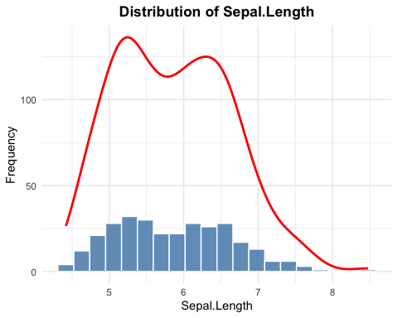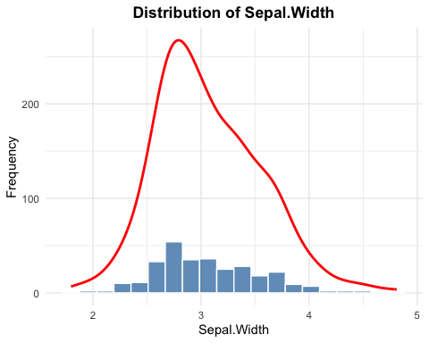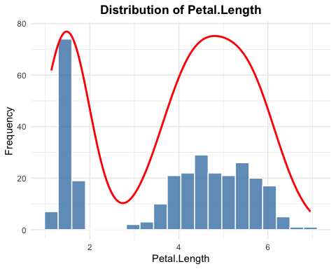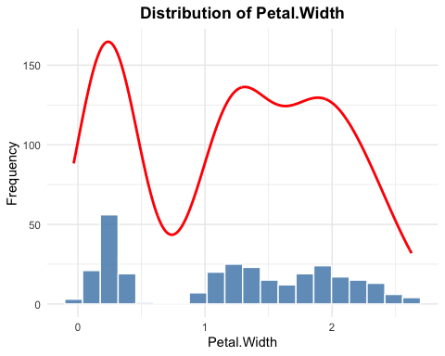
# Barplot
if("Species" %in% names(iris_data)) {
ggplot(iris_data, aes(x = Species, fill = Species)) +
geom_bar(alpha = 0.8) +
geom_text(stat = 'count', aes(label = ..count..), vjust = -0.5) +
labs(title = "Frequency Distribution of Species",
x = "Species",
y = "Count") +
theme_minimal() +
theme(plot.title = element_text(hjust = 0.5, face = "bold"),
legend.position = "none") +
scale_fill_brewer(palette = "Set2")
}
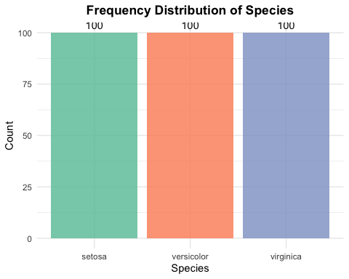
# Skewness and Kurtosis
skew_kurt_results <- data.frame(
Variable = numeric_cols,
Skewness = sapply(numeric_cols, function(col) skewness(iris_data[[col]], na.rm = TRUE)),
Kurtosis = sapply(numeric_cols, function(col) kurtosis(iris_data[[col]], na.rm = TRUE))
)
rownames(skew_kurt_results) <- NULL
skew_kurt_results %>%
kable(caption = "Skewness and Kurtosis Statistics", digits = 3)
Skewness and Kurtosis Statistics
Variable | Skewness | Kurtosis
Sepal.Length | 0.322 | 2.511
Sepal.Width | 0.506 | 3.299
Petal.Length | -0.274 | 1.559
Petal.Width | -0.061 | 1.653
for (i in 1:nrow(skew_kurt_results)) {
var_name <- skew_kurt_results$Variable[i]
skewness_val <- skew_kurt_results$Skewness[i]
kurtosis_val <- skew_kurt_results$Kurtosis[i]
cat("\n", var_name, ":\n", sep = "")
# Skewness interpretation
cat("Interpretation:",
ifelse(abs(skewness_val) < 0.5, "Approximately Symmetric",
ifelse(skewness_val > 0, "Right-skewed (Positive)", "Left-skewed (Negative)")), "\n")
# Kurtosis interpretation
cat("Interpretation:",
ifelse(kurtosis_val > 3, "Leptokurtic (heavy tails)",
ifelse(kurtosis_val < 3, "Platykurtic (light tails)", "Mesokurtic (normal)")), "\n")
cat("\n")
}
##
## Sepal.Length:
## Interpretation: Approximately Symmetric
## Interpretation: Platykurtic (light tails)
##
##
## Sepal.Width:
## Interpretation: Right-skewed (Positive)
## Interpretation: Leptokurtic (heavy tails)
##
##
## Petal.Length:
## Interpretation: Approximately Symmetric
## Interpretation: Platykurtic (light tails)
##
##
## Petal.Width:
## Interpretation: Approximately Symmetric
## Interpretation: Platykurtic (light tails)

Summary Statistics of the Data at least including mean, quartiles, min/max, and standard deviation.
summary(iris_data)
## id Species Sepal.Length Sepal.Width
## Length:300 Length:300 Min. :4.417 Min. :1.796
## Class :character Class :character 1st Qu.:5.209 1st Qu.:2.720
## Mode :character Mode :character Median :5.844 Median :2.992
## Mean :5.857 Mean :3.064
## 3rd Qu.:6.448 3rd Qu.:3.375
## Max. :8.478 Max. :4.810
## Petal.Length Petal.Width
## Min. :1.135 Min. :-0.03371
## 1st Qu.:1.566 1st Qu.: 0.30278
## Median :4.228 Median : 1.28776
## Mean :3.738 Mean : 1.19830
## 3rd Qu.:5.205 3rd Qu.: 1.87452
## Max. :6.955 Max. : 2.62487
# More detailed summary by species
iris_detailed <- iris_data %>%
group_by(Species) %>%
summarise(
N = n(),
Mean_Sepal_Length = mean(Sepal.Length),
SD_Sepal_Length = sd(Sepal.Length),
Mean_Sepal_Width = mean(Sepal.Width),
SD_Sepal_Width = sd(Sepal.Width),
Mean_Petal_Length = mean(Petal.Length),
SD_Petal_Length = sd(Petal.Length)
) %>%
mutate(across(where(is.numeric), ~round(., 2)))
iris_detailed %>%
kable(caption = "Detailed Summary by Species")
Detailed Summary by Species
Species | N | Mean_Sepal_Length | SD_Sepal_Length | Mean_Sepal_Width | SD_Sepal_Width | Mean_Petal_Length | SD_Petal_Length
setosa | 100 | 5.09 | 0.31 | 3.55 | 0.39 | 1.48 | 0.14
versicolor | 100 | 5.99 | 0.55 | 2.72 | 0.29 | 4.22 | 0.50
virginica | 100 | 6.49 | 0.61 | 2.93 | 0.32 | 5.51 | 0.50

DISTRIBUTION INTERPRETATION:
The given Iris dataset contains measurements of flower characteristics across 3 different species (Setosa, Versicolor and Virginica). The numerical variables (Sepal Length, Sepal Width, Petal Length, and Petal Width) show varying degrees of skewness and kurtosis. Based on the frequency distribution histogram, the variable Sepal Width is the only variable with single peak whereas rest of the variables have multipeaks. As for the skewness and kurtosis test, the Sepal Width variable was again an odd man out with being right-skewed and having heavy tails whereas rest all variables have approximitly symmetric skewness and light tails.

