Answer 02 - Siddhesh Shinde
# Load required packages
library(tidyverse)
## ── Attaching core tidyverse packages ──────────────────────── tidyverse 2.0.0 ──
## ✔ dplyr 1.1.4 ✔ readr 2.1.5
## ✔ forcats 1.0.1 ✔ stringr 1.6.0
## ✔ ggplot2 4.0.0 ✔ tibble 3.3.1
## ✔ lubridate 1.9.4 ✔ tidyr 1.3.2
## ✔ purrr 1.2.1
## ── Conflicts ────────────────────────────────────────── tidyverse_conflicts() ──
## ✖ dplyr::filter() masks stats::filter()
## ✖ dplyr::lag() masks stats::lag()
## ℹ Use the conflicted package (<http://conflicted.r-lib.org/>) to force all conflicts to become errors
library(knitr)
library(kableExtra)
##
## Attaching package: 'kableExtra'
##
## The following object is masked from 'package:dplyr':
##
## group_rows
library(moments)
library(lmtest)
## Loading required package: zoo
##
## Attaching package: 'zoo'
##
## The following objects are masked from 'package:base':
##
## as.Date, as.Date.numeric
library(ggplot2)
library(gridExtra)
##
## Attaching package: 'gridExtra'
##
## The following object is masked from 'package:dplyr':
##
## combine
library(corrplot)
## corrplot 0.95 loaded
library(car)
## Loading required package: carData
##
## Attaching package: 'car'
##
## The following object is masked from 'package:dplyr':
##
## recode
##
## The following object is masked from 'package:purrr':
##
## some
library(seedhash)
# Set reproducible seed
gen <- SeedHashGenerator$new("Siddhesh")
seeds <- gen$generate_seeds(5)
set.seed(seeds[2])
data("mtcars")
help(mtcars)
head(mtcars, 10) %>%
kable(caption = "First 10 Rows of mtcars Dataset")
First 10 Rows of mtcars Dataset
 | mpg | cyl | disp | hp | drat | wt | qsec | vs | am | gear | carb
Mazda RX4 | 21.0 | 6 | 160.0 | 110 | 3.90 | 2.620 | 16.46 | 0 | 1 | 4 | 4
Mazda RX4 Wag | 21.0 | 6 | 160.0 | 110 | 3.90 | 2.875 | 17.02 | 0 | 1 | 4 | 4
Datsun 710 | 22.8 | 4 | 108.0 | 93 | 3.85 | 2.320 | 18.61 | 1 | 1 | 4 | 1
Hornet 4 Drive | 21.4 | 6 | 258.0 | 110 | 3.08 | 3.215 | 19.44 | 1 | 0 | 3 | 1
Hornet Sportabout | 18.7 | 8 | 360.0 | 175 | 3.15 | 3.440 | 17.02 | 0 | 0 | 3 | 2
Valiant | 18.1 | 6 | 225.0 | 105 | 2.76 | 3.460 | 20.22 | 1 | 0 | 3 | 1
Duster 360 | 14.3 | 8 | 360.0 | 245 | 3.21 | 3.570 | 15.84 | 0 | 0 | 3 | 4
Merc 240D | 24.4 | 4 | 146.7 | 62 | 3.69 | 3.190 | 20.00 | 1 | 0 | 4 | 2
Merc 230 | 22.8 | 4 | 140.8 | 95 | 3.92 | 3.150 | 22.90 | 1 | 0 | 4 | 2
Merc 280 | 19.2 | 6 | 167.6 | 123 | 3.92 | 3.440 | 18.30 | 1 | 0 | 4 | 4
cat("\nBasic Summary Statistics:\n")
##
## Basic Summary Statistics:
summary(mtcars)
## mpg cyl disp hp
## Min. :10.40 Min. :4.000 Min. : 71.1 Min. : 52.0
## 1st Qu.:15.43 1st Qu.:4.000 1st Qu.:120.8 1st Qu.: 96.5
## Median :19.20 Median :6.000 Median :196.3 Median :123.0
## Mean :20.09 Mean :6.188 Mean :230.7 Mean :146.7
## 3rd Qu.:22.80 3rd Qu.:8.000 3rd Qu.:326.0 3rd Qu.:180.0
## Max. :33.90 Max. :8.000 Max. :472.0 Max. :335.0
## drat wt qsec vs
## Min. :2.760 Min. :1.513 Min. :14.50 Min. :0.0000
## 1st Qu.:3.080 1st Qu.:2.581 1st Qu.:16.89 1st Qu.:0.0000
## Median :3.695 Median :3.325 Median :17.71 Median :0.0000
## Mean :3.597 Mean :3.217 Mean :17.85 Mean :0.4375
## 3rd Qu.:3.920 3rd Qu.:3.610 3rd Qu.:18.90 3rd Qu.:1.0000
## Max. :4.930 Max. :5.424 Max. :22.90 Max. :1.0000
## am gear carb
## Min. :0.0000 Min. :3.000 Min. :1.000
## 1st Qu.:0.0000 1st Qu.:3.000 1st Qu.:2.000
## Median :0.0000 Median :4.000 Median :2.000
## Mean :0.4062 Mean :3.688 Mean :2.812
## 3rd Qu.:1.0000 3rd Qu.:4.000 3rd Qu.:4.000
## Max. :1.0000 Max. :5.000 Max. :8.000

Develop a hypothesis
Hypothesis: “Vehicle fuel efficiency (miles per gallon) is significantly predicted by vehicle weight, number of cylinders and horsepower after controlling for other vehicle characteristics.”
Based on the data and above hypothesis, we can consider the following:
Dependent Variable: mpg Miles/(US) gallon
Independent Variables: wt Weight (1000 lbs) cyl Number of cylinders hp Gross horsepower
Ignorable Columns: disp Displacement (cu.in.) drat Rear axle ratio qsec 1/4 mile time vs Engine am Transmission gear Number of forward gears carb Number of carburetors
We can ignore these above columns because our hypothesis is only concerned with the relation between a car’s fuel efficiency (mpg) and its weight (wt), number of cylinder (cyl) and horsepower (hp).

Check for Errors & Missing Data
# Check for missing values
missing_count <- colSums(is.na(mtcars))
missing_percent <- round(colSums(is.na(mtcars)) / nrow(mtcars) * 100, 2)
missing_summary <- data.frame(
Variable = names(missing_count),
Missing_Count = missing_count,
Missing_Percent = missing_percent
)
missing_summary %>%
kable(caption = "Missing Data Summary")
Missing Data Summary
 | Variable | Missing_Count | Missing_Percent
mpg | mpg | 0 | 0
cyl | cyl | 0 | 0
disp | disp | 0 | 0
hp | hp | 0 | 0
drat | drat | 0 | 0
wt | wt | 0 | 0
qsec | qsec | 0 | 0
vs | vs | 0 | 0
am | am | 0 | 0
gear | gear | 0 | 0
carb | carb | 0 | 0
cat("\nConclusion: The mtcars dataset contains NO missing values (0 NAs).\n")
##
## Conclusion: The mtcars dataset contains NO missing values (0 NAs).
cat("Therefore, no imputation or deletion strategies are required.\n")
## Therefore, no imputation or deletion strategies are required.
# Check for duplicate rows
duplicates <- sum(duplicated(mtcars))
cat("Number of duplicate records:", duplicates, "\n")
## Number of duplicate records: 0
cat("\nConclusion: No duplicate records found.\n")
##
## Conclusion: No duplicate records found.
# Select relevant variables for analysis
mtcars_subset <- mtcars %>% select(mpg, cyl, hp, wt)
detect_errors <- function(var, var_name) {
# Create a temporary data frame with the variable
temp_df <- data.frame(value = var)
# Histogram to see distribution shape
p3 <- ggplot(temp_df, aes(x = value)) +
geom_histogram(fill = "orange", color = "black", bins = 30) +
labs(title = paste("Histogram of", var_name),
x = var_name,
y = "Frequency") +
theme_minimal()
# Boxplot to see outliers clearly
p4 <- ggplot(temp_df, aes(y = value)) +
geom_boxplot(fill = "orange", alpha = 0.5) +
labs(title = paste("Boxplot of", var_name),
y = var_name) +
theme_minimal()
# Arrange and print the plots
grid.arrange(p3, p4, ncol = 2)
}
# Detect error for each variable
for(var_name in names(mtcars_subset)) {
detect_errors(mtcars_subset[[var_name]], var_name)
}
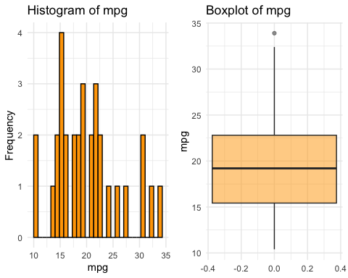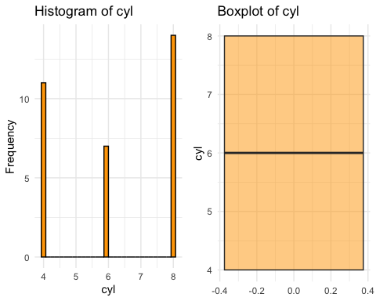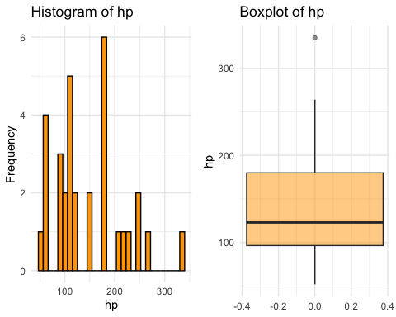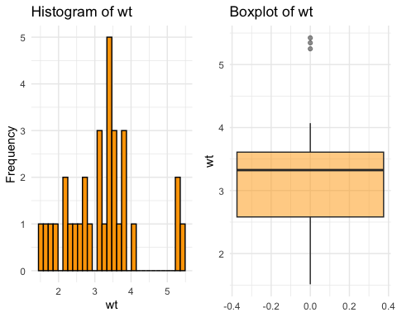

Clean the data
apply(mtcars_subset, 2, function(x) { sum(is.na(x)) })
## mpg cyl hp wt
## 0 0 0 0
The mtcars dataset do not have any missing data. If it had missing data, we can handle it by either
Checking percentage of missing data per participant: We can create subsets: - Replaceable: Participants with ≤5% missing data. - Not Replaceable: Participants with >5% missing data (often excluded or analyzed separately).
Multiple Imputation with mice: MICE (Multivariate Imputation by Chained Equations) helps guess the missing values based on relationship with other variables.
Univariate Outlier Detection:
# Function to detect outliers using IQR method
detect_outliers_iqr <- function(x) {
Q1 <- quantile(x, 0.25, na.rm = TRUE)
Q3 <- quantile(x, 0.75, na.rm = TRUE)
IQR <- Q3 - Q1
lower_bound <- Q1 - 1.5 * IQR
upper_bound <- Q3 + 1.5 * IQR
outliers <- x < lower_bound | x > upper_bound
return(list(outliers = outliers,
lower = lower_bound,
upper = upper_bound,
count = sum(outliers)))
}
# Detect outliers for each variable
outlier_results <- lapply(mtcars_subset, detect_outliers_iqr)
# Create summary table
outlier_summary <- data.frame(
Variable = names(outlier_results),
Lower_Bound = sapply(outlier_results, function(x) round(x$lower, 2)),
Upper_Bound = sapply(outlier_results, function(x) round(x$upper, 2)),
Outlier_Count = sapply(outlier_results, function(x) x$count),
Outlier_Percentage = round(sapply(outlier_results, function(x) x$count) / nrow(mtcars) * 100, 2)
)
outlier_summary %>%
kable(caption = "Outlier Detection Summary (IQR Method: 1.5 × IQR)")
Outlier Detection Summary (IQR Method: 1.5 × IQR)
 | Variable | Lower_Bound | Upper_Bound | Outlier_Count | Outlier_Percentage
mpg.25% | mpg | 4.36 | 33.86 | 1 | 3.12
cyl.25% | cyl | -2.00 | 14.00 | 0 | 0.00
hp.25% | hp | -28.75 | 305.25 | 1 | 3.12
wt.25% | wt | 1.04 | 5.15 | 3 | 9.38
Multivariate Outlier Detection:
# Select only continuous variables for outlier check
cont_vars <- mtcars_subset %>% select(mpg, hp, wt)
# Calculate distance
mahal <- mahalanobis(cont_vars,
colMeans(cont_vars, na.rm=TRUE),
cov(cont_vars, use ="pairwise.complete.obs"))
cutoff <- qchisq(1 - .005, ncol(cont_vars))
cat("Degrees of Freedom:", ncol(cont_vars), "\n")
## Degrees of Freedom: 3
cat("Cutoff Value:", cutoff, "\n")
## Cutoff Value: 12.83816
summary(mahal < cutoff)
## Mode TRUE
## logical 32
# Create a data frame for plotting
outlier_plot <- data.frame(
ID = 1:length(mahal),
Distance = mahal,
Outlier = mahal > cutoff
)
ggplot(outlier_plot, aes(x = ID, y = Distance, color = Outlier)) +
geom_point(size = 3, alpha = 0.7) +
geom_hline(yintercept = cutoff, linetype = "dashed", color = "red") +
geom_text(aes(label = ifelse(Outlier, ID, "")), vjust = -0.5, show.legend = FALSE) +
labs(title = "Mahalanobis Distances",
subtitle = paste("Points above the red line (Cutoff =", round(cutoff, 2), ") are multivariate outliers"),
y = "Distance (D^2)",
x = "Participant ID") +
theme_minimal() +
scale_color_manual(values = c("black", "red"))
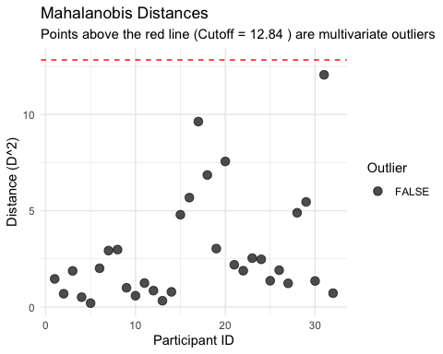
# Eliminate outliers
mtcars_without_outliers <- subset(mtcars_subset, mahal < cutoff)
cat("\nDimensions before outlier removal:", dim(mtcars_subset)[1], "\n")
##
## Dimensions before outlier removal: 32
cat("Dimensions after outlier removal:", dim(mtcars_without_outliers)[1], "\n")
## Dimensions after outlier removal: 32
We found few outliers in the Univariate example using IQR test and no outliers based on Multivariate test using alpha of 0.05
# Remove IQR outliers
remove_outliers_iqr <- function(data, columns) {
is_outlier <- function(x) {
Q1 <- quantile(x, 0.25, na.rm = TRUE)
Q3 <- quantile(x, 0.75, na.rm = TRUE)
IQR <- Q3 - Q1
lower <- Q1 - 1.5 * IQR
upper <- Q3 + 1.5 * IQR
return(x < lower | x > upper)
}
outlier_flags <- sapply(data[, columns], is_outlier)
any_outlier <- apply(outlier_flags, 1, any)
cat("Outlier Detection Summary:\n")
cat("-------------------------\n")
for(col in columns) {
n_outliers <- sum(outlier_flags[, col])
cat(sprintf("%-10s: %2d outliers\n", col, n_outliers))
}
cat("-------------------------\n")
cat("Total rows with any outlier:", sum(any_outlier), "\n")
cat("Rows to keep:", sum(!any_outlier), "\n\n")
return(data[!any_outlier, ])
}
# Use the function
mtcars_clean <- remove_outliers_iqr(mtcars_subset, c("mpg", "cyl", "hp", "wt"))
## Outlier Detection Summary:
## -------------------------
## mpg : 1 outliers
## cyl : 0 outliers
## hp : 1 outliers
## wt : 3 outliers
## -------------------------
## Total rows with any outlier: 5
## Rows to keep: 27

Check Assumptions using Parametric Tests
Additivity:
# Select only continuous variables for correlation check
cont_vars_for_cor <- mtcars_clean %>%
select(mpg, hp, wt)
# Calculate correlation matrix
cor_matrix <- cor(cont_vars_for_cor)
# Display correlation matrix
cor_matrix %>%
kable(caption = "Correlation Matrix of Continuous Variables", digits = 3)
Correlation Matrix of Continuous Variables
 | mpg | hp | wt
mpg | 1.000 | -0.787 | -0.868
hp | -0.787 | 1.000 | 0.647
wt | -0.868 | 0.647 | 1.000
# Create a correlation plot
corrplot(cor_matrix,
method = "color",
type = "upper",
order = "hclust",
addCoef.col = "black",
number.cex = 0.7,
tl.col = "black",
tl.srt = 45,
title = "Correlation Matrix: Checking for Multicollinearity",
mar = c(0,0,2,0))
# Add interpretation guide
legend("bottomright",
legend = c("r > 0.90: CONCERN", "r > 0.80: Monitor", "r < 0.80: OK"),
fill = c("darkred", "orange", "lightblue"),
cex = 0.8)
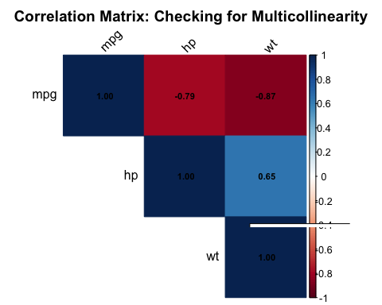
# Find high correlations (excluding diagonal)
high_cor <- which(abs(cor_matrix) > 0.80 & abs(cor_matrix) < 1, arr.ind = TRUE)
if(nrow(high_cor) > 0) {
cat("⚠ WARNING: Found", nrow(high_cor)/2, "pairs with correlations > 0.80:\n\n")
for(i in 1:nrow(high_cor)) {
if(high_cor[i,1] < high_cor[i,2]) { # Avoid duplicates
var1 <- rownames(cor_matrix)[high_cor[i,1]]
var2 <- colnames(cor_matrix)[high_cor[i,2]]
cor_val <- cor_matrix[high_cor[i,1], high_cor[i,2]]
cat(sprintf(" %s <-> %s: r = %.3f\n", var1, var2, cor_val))
}
}
cat("\nConsider combining these variables or selecting one from each pair.\n")
} else {
cat("✓ GOOD: No correlations exceed 0.80.\n")
cat(" Multicollinearity is not a concern based on correlations.\n")
}
## ⚠ WARNING: Found 1 pairs with correlations > 0.80:
##
## mpg <-> wt: r = -0.868
##
## Consider combining these variables or selecting one from each pair.
Since mpg and wt have string correlation, we remove wt from out dataset.
mtcars_additive <- mtcars_clean %>% select(mpg, cyl, hp)
Linearity:
# Scatter plots for each IV vs DV
p1 <- ggplot(mtcars_additive, aes(x = cyl, y = mpg)) +
geom_point(size = 3, color = "blue", alpha = 0.6) +
geom_smooth(method = "lm", se = TRUE, color = "red") +
labs(title = "MPG vs. Cylinders",
x = "Number of Cylinders",
y = "Miles per Gallon") +
theme_minimal()
p2 <- ggplot(mtcars_additive, aes(x = hp, y = mpg)) +
geom_point(size = 3, color = "darkgreen", alpha = 0.6) +
geom_smooth(method = "lm", se = TRUE, color = "red") +
labs(title = "MPG vs. Horsepower",
x = "Horsepower",
y = "Miles per Gallon") +
theme_minimal()
grid.arrange(p1, p2, nrow = 2,
top = "Linearity Assessment: Scatter Plots with Linear Fit")
## `geom_smooth()` using formula = 'y ~ x'
## `geom_smooth()` using formula = 'y ~ x'
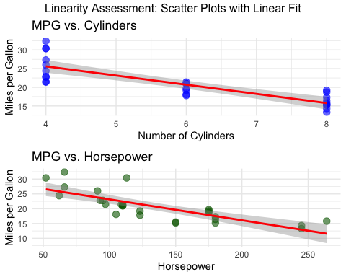
cat("\n### Linearity Interpretation:\n\n")
##
## ### Linearity Interpretation:
cat("Correlation coefficients:\n")
## Correlation coefficients:
cat("- mpg ~ cyl: r =", round(cor(mtcars_additive$mpg, mtcars_additive$cyl), 3), "\n")
## - mpg ~ cyl: r = -0.843
cat("- mpg ~ hp: r =", round(cor(mtcars_additive$mpg, mtcars_additive$hp), 3), "\n")
## - mpg ~ hp: r = -0.787
cat("All correlations are substantial (|r| > 0.7), indicating strong linear relationships.\n")
## All correlations are substantial (|r| > 0.7), indicating strong linear relationships.
cat("Scatter plots show relatively linear patterns without obvious curvilinear trends.\n\n")
## Scatter plots show relatively linear patterns without obvious curvilinear trends.
cat("Conclusion: Linearity assumption is REASONABLY MET.\n")
## Conclusion: Linearity assumption is REASONABLY MET.
Normality:
# Fit the regression model
model <- lm(mpg ~ cyl + hp, data = mtcars_additive)
# Extract residuals
residuals <- residuals(model)
# Shapiro-Wilk test
shapiro_test <- shapiro.test(residuals)
cat("### Shapiro-Wilk Normality Test:\n")
## ### Shapiro-Wilk Normality Test:
cat("Test Statistic (W):", round(shapiro_test$statistic, 4), "\n")
## Test Statistic (W): 0.9441
cat("p-value:", round(shapiro_test$p.value, 4), "\n\n")
## p-value: 0.1539
if(shapiro_test$p.value > 0.05) {
cat("Conclusion: p >0.05. We FAIL TO REJECT the null hypothesis.\n")
cat("Residuals are approximately normally distributed. Normality assumption is MET.\n")
} else {
cat("Conclusion: p < 0.05. We REJECT the null hypothesis.\n")
cat("Residuals deviate from normality. Normality assumption is VIOLATED.\n")
cat("Note: With small sample sizes (n=32), minor deviations are common.\n")
}
## Conclusion: p >0.05. We FAIL TO REJECT the null hypothesis.
## Residuals are approximately normally distributed. Normality assumption is MET.
# Q-Q plot
par(mfrow = c(2, 2))
# Q-Q plot
qqnorm(residuals, main = "Q-Q Plot: Normality Assessment")
qqline(residuals, col = "red", lwd = 2)
# Histogram of residuals
hist(residuals, breaks = 10, col = "lightblue", border = "black",
main = "Histogram of Residuals",
xlab = "Residuals", prob = TRUE)
lines(density(residuals), col = "red", lwd = 2)
curve(dnorm(x, mean = mean(residuals), sd = sd(residuals)),
add = TRUE, col = "blue", lwd = 2, lty = 2)
legend("topright", c("Actual", "Normal"), col = c("red", "blue"),
lty = c(1, 2), lwd = 2)
# Residuals vs Fitted
plot(fitted(model), residuals,
main = "Residuals vs. Fitted Values",
xlab = "Fitted Values", ylab = "Residuals",
pch = 19, col = "darkgreen")
abline(h = 0, col = "red", lwd = 2, lty = 2)
# Box plot of residuals
boxplot(residuals, col = "lightyellow", main = "Boxplot of Residuals",
ylab = "Residuals")
abline(h = 0, col = "red", lwd = 2, lty = 2)
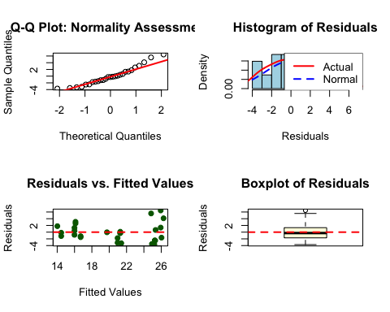
par(mfrow = c(1, 1))
Homogeneity and Homoscedasticity:
# Extract standardized fitted values
fitvalues <- scale(model$fitted.values)
standardized <- rstudent(model)
# Create enhanced residual plot
plot_data <- data.frame(
Fitted = as.numeric(fitvalues),
Residuals = standardized,
Outlier = abs(standardized) > 2
)
ggplot(plot_data, aes(x = Fitted, y = Residuals)) +
geom_point(aes(color = Outlier), size = 2, alpha = 0.6) +
geom_hline(yintercept = 0, color = "red", linewidth = 1) +
geom_vline(xintercept = 0, color = "red", linewidth = 1) +
geom_hline(yintercept = c(-2, 2), linetype = "dashed", color = "blue") +
geom_smooth(method = "loess", se = TRUE, color = "darkgreen", linewidth = 1) +
scale_color_manual(values = c("FALSE" = "black", "TRUE" = "red"),
labels = c("Within ±2", "Outside ±2")) +
labs(title = "Residual Plot: Checking Homoscedasticity",
subtitle = "Points should be randomly scattered with equal spread across X-axis",
x = "Standardized Fitted Values",
y = "Standardized Residuals",
color = "Status") +
annotate("text", x = min(plot_data$Fitted, na.rm=TRUE), y = 3,
label = "✓ GOOD: Random scatter\n✗ BAD: Funnel, curve, or clusters",
hjust = 0, vjust = 1, color = "darkgreen", size = 3.5) +
theme_minimal() +
theme(legend.position = "bottom")
## `geom_smooth()` using formula = 'y ~ x'
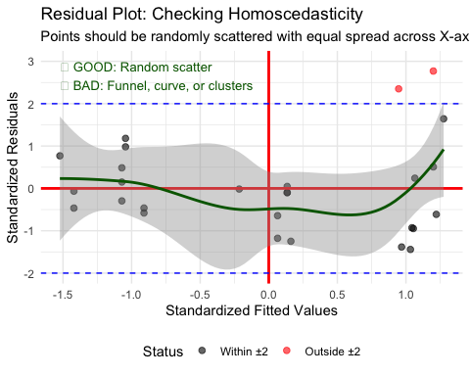
levene_cyl <- leveneTest(mtcars_additive$mpg, mtcars_additive$cyl, center = median)
## Warning in leveneTest.default(mtcars_additive$mpg, mtcars_additive$cyl, :
## mtcars_additive$cyl coerced to factor.
print(levene_cyl)
## Levene's Test for Homogeneity of Variance (center = median)
## Df F value Pr(>F)
## group 2 5.847 0.008539 **
## 24
## ---
## Signif. codes: 0 '***' 0.001 '**' 0.01 '*' 0.05 '.' 0.1 ' ' 1
if(levene_cyl$`Pr(>F)`[1] > 0.05) {
cat("✓ GOOD: Levene's test p-value =", round(levene_cyl$`Pr(>F)`[1], 4), "\n")
cat(" Variances are not significantly different across Number of Cylinders.\n")
} else {
cat("⚠ WARNING: Levene's test p-value =", round(levene_cyl$`Pr(>F)`[1], 4), "\n")
cat(" Variances are significantly different across Number of Cylinders.\n")
cat(" Consider using Welch's correction or non-parametric tests.\n")
}
## ⚠ WARNING: Levene's test p-value = 0.0085
## Variances are significantly different across Number of Cylinders.
## Consider using Welch's correction or non-parametric tests.
levene_hp <- leveneTest(mtcars_additive$mpg, mtcars_additive$hp, center = median)
## Warning in leveneTest.default(mtcars_additive$mpg, mtcars_additive$hp, center =
## median): mtcars_additive$hp coerced to factor.
print(levene_hp)
## Levene's Test for Homogeneity of Variance (center = median)
## Df F value Pr(>F)
## group 16 6.917 0.001882 **
## 10
## ---
## Signif. codes: 0 '***' 0.001 '**' 0.01 '*' 0.05 '.' 0.1 ' ' 1
if(levene_hp$`Pr(>F)`[1] > 0.05) {
cat("✓ GOOD: Levene's test p-value =", round(levene_hp$`Pr(>F)`[1], 4), "\n")
cat(" Variances are not significantly different across Horsepower.\n")
} else {
cat("⚠ WARNING: Levene's test p-value =", round(levene_hp$`Pr(>F)`[1], 4), "\n")
cat(" Variances are significantly different across Horsepower.\n")
cat(" Consider using Welch's correction or non-parametric tests.\n")
}
## ⚠ WARNING: Levene's test p-value = 0.0019
## Variances are significantly different across Horsepower.
## Consider using Welch's correction or non-parametric tests.
Levene’s Test for Homogeneity suggest that we should use Welch’s correction or non-parametric tests for our Independent Variables cyl and hp.

