

**Single Page Web Dashboard**

[https://yourboard.github.io](https://yourboard.github.io/)

Project By Siddhesh Patil

**Synopsis Approval Proforma**

|  |  |
| --- | --- |
| Name | Patil Siddhesh Ramchandra |
| PRN | 2019016401994093 |
| Roll No. | TYIT16 |
| Email | [sidpatil1770@gmail.com](mailto:sidpatil1770@gmail.com) |
| Course | BSc in Information Technology (Third Year) |
| Project Guide | Prof. Manisha Kasar |
| College Name | St. Wilfred’s College of Arts, Science and Commerce |
| Title of Project | Single Page Web Dashboard |
| Github Repo Link | <https://github.com/yourboard/yourboard.github.io> |

**Project Guide** **Co-ordinator**

**Date - / / 2021**

**Contents of The Synopsis**

|  |  |
| --- | --- |
| **Content** | **Page** |
| Introduction | **03** |
| Scope |  |
| Objective |  |
| Application of The Project |  |
| Overview of Features |  |
| Survey of Technologies |  |
| API – Schema |  |
| Planning and Scheduling |  |
| Flow of System Architecture |  |
| Production Requirements |  |
| Data Privacy |  |
| Testing and Preview |  |
| Deployment |  |
| Future of the Projects |  |
| References |  |

**Introduction**

For day-to-day activities on web browser, we use lots of web apps like calendar, mail, and much more. But have you thought, How much RAM your Browser is consuming for those tabs.

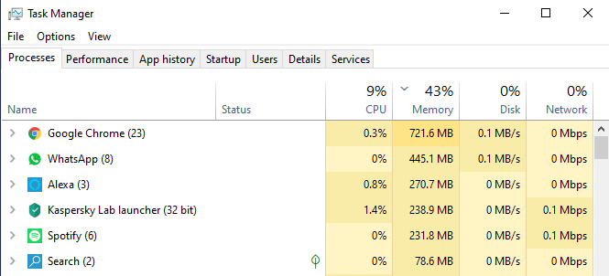

As you can see in above image Google Chrome(Web Browser) is using 721 MB of RAM for just five tabs, but do not worry this project aims to encounter this issue by reducing number of tabs we need to just one master tab which will use comparatively less memory and CPU.