**Introduction**

**Waterfall model** is a sequential flow which is used in developing particular software.

This helps us to guide through the making of software/application.

It consists of **five phases** which are as follows:

1. Requirement Analysis.
2. Designing of software.
3. Implementation of software.
4. Testing/Working of the software.
5. Deployment of the software.

Diagrammatic representation of Waterfall model.

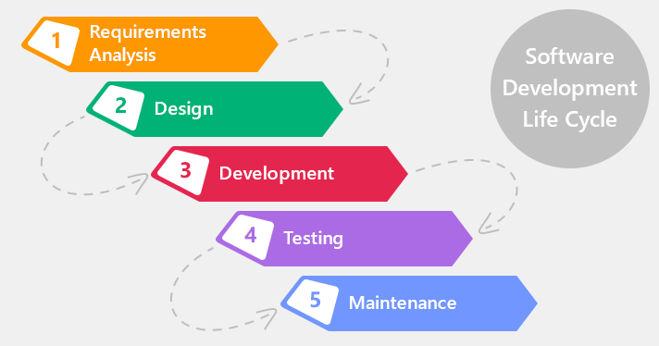

**Benefits:**

* The main purpose of this model is that it is one time process.
* When you proceed to next phase you can't go back to the previous phase so once you have completed one phase checking thoroughly and moving to next phase is a smart move.
* The use of this model allows to early design of the software in the planning phase then in modeling phase which it is only implemented.
* Tasks of this model to various group of people is easy to manage and co-ordinate.
* Once you have all the requirements needed it is easy to make the software/application.
* As the model is sequential and linear the working of well working software can be divided into group as per the phases.
* The final process or results or output are well log maintained which means it is well documented.

**Why I choose this waterfall model for my software/application?**

As my software/application has all the requirements analyze at the start of making the software it is easy for this model to proceed.

The root of making this software is clear and stable from beginning which means no sudden changes will be done.

Customer/Client using the final software will not be involved in making of the software.