Print Generator level particle decay scheme from NanoAOD MC simulation files

# Set up CMS NanoAOD toolkit

NanoAOD postprocessing tool:

[https://twiki.cern.ch/twiki/bin/view/CMSPublic/WorkBookNanoAOD#Quickly\_make\_plots\_with\_Nano\_AN1](https://twiki.cern.ch/twiki/bin/view/CMSPublic/WorkBookNanoAOD" \l "Quickly_make_plots_with_Nano_AN1)

cmsrel CMSSW\_9\_4\_11\_cand1

cd CMSSW\_9\_4\_11\_cand1/src

cmsenv

git cms-init #not really needed unless you later want to add some other cmssw stuff

git clone https://github.com/cms-nanoAOD/nanoAOD-tools.git PhysicsTools/NanoAODTools

scram b

voms-proxy-init -voms cms

cd PhysicsTools/NanoAODTools/python/postprocessing/examples/

python exampleAnalysis.py

# Get list of NanoAOD files to process:

Lets say we want to analyze list of selected events stored in file

/home/ssawant/hhAnalysis/2016/20210129\_hh\_2lss\_0tau\_2016\_Datacards\_wUpdatedZveto\_3/cfgs/hh\_2lss/Tight\_SS/W4JetsToLNu/central/analyze\_W\*JetsToLNu\_Tight\_SS\_central\_1\_cfg.py

for W4JetsToLNu sample from 2016.

1. Name of the miniAOD file of the sample:  
   Search for “W4JetsToLNu” in <https://raw.githubusercontent.com/HEP-KBFI/tth-htt/master/python/samples/tthAnalyzeSamples_2016_base.py>

MiniAOD file name: /W4JetsToLNu\_TuneCUETP8M1\_13TeV-madgraphMLM-pythia8/RunIISummer16MiniAODv3-PUMoriond17\_94X\_mcRun2\_asymptotic\_v3-v2/MINIAODSIM

1. Get NanoAOD file:
   1. Search for the miniAOD file in DAS:  
      <https://cmsweb.cern.ch/das/request?view=list&limit=50&instance=prod%2Fglobal&input=%2FW4JetsToLNu_TuneCUETP8M1_13TeV-madgraphMLM-pythia8%2FRunIISummer16MiniAODv3-PUMoriond17_94X_mcRun2_asymptotic_v3-v2%2FMINIAODSIM>
   2. Click on “Children” link of the sample:
   3. 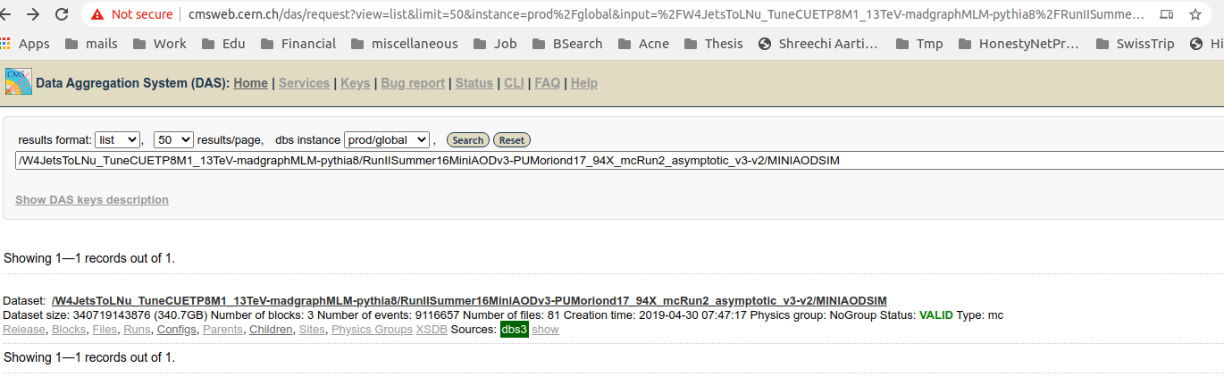This opens list of NanoAOD samples processed from that miniAOD sample. Choose NanoAOD-v7 sample:

<https://cmsweb.cern.ch/das/request?instance=prod/global&input=child+dataset%3D%2FW4JetsToLNu_TuneCUETP8M1_13TeV-madgraphMLM-pythia8%2FRunIISummer16MiniAODv3-PUMoriond17_94X_mcRun2_asymptotic_v3-v2%2FMINIAODSIM>

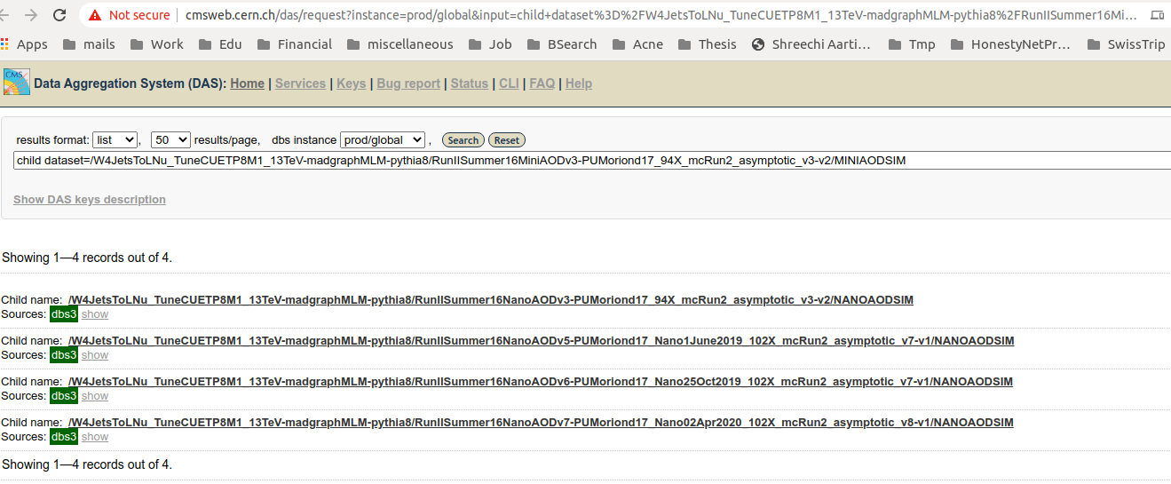

* 1. Open NanoAOD v7 sample and click on “Files” tab of the nanoAOD sample:

<https://cmsweb.cern.ch/das/request?input=dataset%3D%2FW4JetsToLNu_TuneCUETP8M1_13TeV-madgraphMLM-pythia8%2FRunIISummer16NanoAODv7-PUMoriond17_Nano02Apr2020_102X_mcRun2_asymptotic_v8-v1%2FNANOAODSIM&instance=prod/global>

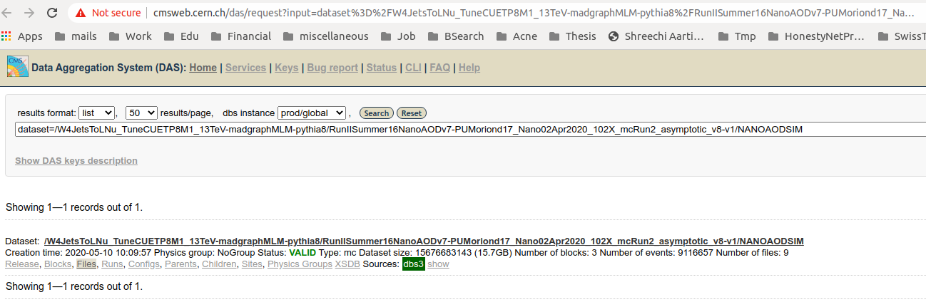

* 1. This open the list of NanoAOD files: <https://cmsweb.cern.ch/das/request?instance=prod/global&input=file+dataset%3D%2FW4JetsToLNu_TuneCUETP8M1_13TeV-madgraphMLM-pythia8%2FRunIISummer16NanoAODv7-PUMoriond17_Nano02Apr2020_102X_mcRun2_asymptotic_v8-v1%2FNANOAODSIM>

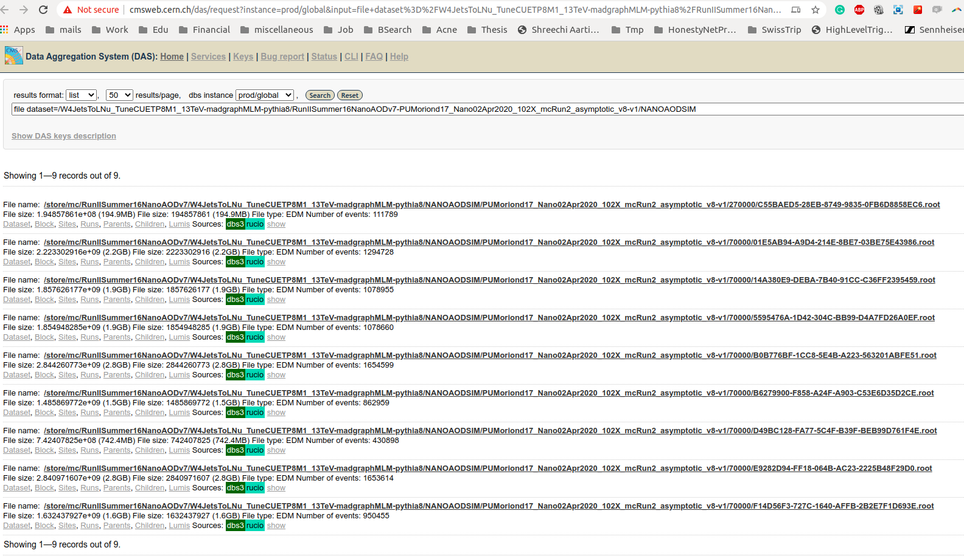

# Run printGenEventFromNanoAOD macro

1. A code that print generator level particle decay chain in a form of family tree is at <https://github.com/siddhesh86/myCodes/blob/d4d30c2f26f24c8756fda62bec3bb81b6a530f75/python/CMSNanoAOD/printGenEventsFromNanoAOD/anaGenEventsFromNanoAOD.py>
2. It takes input from <https://github.com/siddhesh86/myCodes/blob/d4d30c2f26f24c8756fda62bec3bb81b6a530f75/python/CMSNanoAOD/printGenEventsFromNanoAOD/anaGenEventsFromNanoAOD_inputs_cfg.json> json file.

Put all of the NanoAOD files as list into the json file under "NanoAOD\_PostProc" variable. Prepend “root://cms-xrd-global.cern.ch:1094/” to the NanoAOD file path that needs to include in the "NanoAOD\_PostProc" list.

Provide path+name of the file, containing run:lumi:event number of the events which needs to run from the NanoAOD file, to "runOnSelectedEventsList" variable in the json file.

1. Run anaGenEventsFromNanoAOD.py with command:

python anaGenEventsFromNanoAOD.py anaGenEventsFromNanoAOD\_inputs\_cfg.json

1. Example of the outpu is given at <https://github.com/siddhesh86/myCodes/blob/d4d30c2f26f24c8756fda62bec3bb81b6a530f75/python/CMSNanoAOD/printGenEventsFromNanoAOD/anaGenEventsFromNanoAOD_W4JetsToLNu.log>
2. Generator level praticle decay chain is printed in the following format:

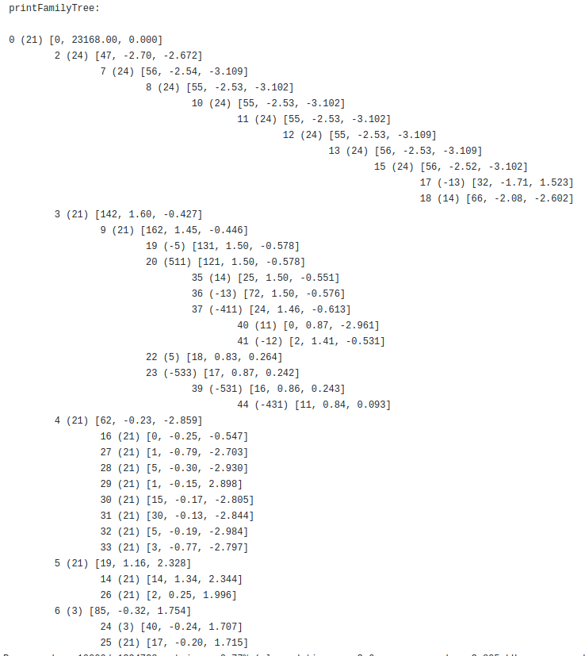

24(W+) -> -13(μ-) 14(νμ)

Each particle is printed in the following format:

<particle index in GenParticleCollection> (<pdgID>) [<pt>, <eta>, <phi>]

for e.g. 2 (24) [47, -2.70, -2.672] : 2 is particle index in GenParticleCollection, 24 is pdgID of W+, and 47, -2.70, -2.672 are pT, eta and phi of W+.

Particle decay chain is shown in the following order:

* Column represents generation of the particle family
* Rows in a given column represents ‘sibling particles’ in a family.

Particle pdgID can be found at <https://pdg.lbl.gov/2007/reviews/montecarlorpp.pdf>