

Approach Document

ARM Automation

**Requestor**

|  |  |
| --- | --- |
| Requestor: Abhimanyu Bhateja | Date: 29-12-2017 |
| Reviewer: Suryakant Ankolekar | Department: Applications |

**Revision History**

|  |  |  |  |  |
| --- | --- | --- | --- | --- |
| Document/Dept. Owner: | Suryakant Ankolekar | | | |
| Created By: | Suryakant Ankolekar | | Date: | 29-12-2017 |
| Revised By | | Date Revised | New Version # | |
| Suryakant Ankolekar | | 29/12/2017 | V1 | |
| Abhimanyu Bhateja | | 02/01/2018 | V2 | |
| Abhimanyu Bhateja | | 04/01/2018 | V3 | |
| Abhimanyu Bhateja | | 05/01/2018 | V4 | |
| Abhimanyu Bhateja | | 05/01/2018 | V5 | |

Table of Contents

Introduction 4

Approach 5

Bulk Upload 6

Document Verification Screen 7

Collated Docs 9

Vendor Details Addition/Selection Screen 10

Vendor Screen 11

Loan Status Screen 12

Vendor Comments 15

Loan Summary Report (pdf format) 16

# Introduction

The purpose of this document is to provide an overview of the IT Team’s approach for application related to ARM (Asset and Risk Management) and how to proceed with automating the existing workflow.

Currently, all the documents pertaining to Loan applications are collected by the Branches and sent to RBL NOC Team bundled together in Files (Hard Copies). The individual documents from these files are scanned and uploaded to a web portal of the Bank.

Each document is then eye-balled and if required, then they are sent to Field based vendors for verification via Email. Vendor then perform the verification checks and reverts back with a pdf containing remarks related to the applicant’s document. This pdf is then mailed back to RBL NOC Team.

Mandatory and Hold documents are sent to Vendors for Field Verification via Email

File is eye-balled and sampled

Document File received from Branches

Final decision is taken by RBL NOC Team on Loan application

This pdf is mailed back to RBL NOC Team

Vendor performs the field check and prepares a pdf with remarks related to applicant’s document

# Approach

The IT Development Team will take on the following automation tasks:

1. Automation of sending sampled documents to Specified Vendor(s). One document can go to more than one vendor also.
2. Creating a UI for the Vendor to receive documents where it can download them.
3. Create functionality for the Vendor to upload comments against the document received for verification.
4. Receive all the Vendor inputs at RBL and generate a detailed analyses report in PDF format, basis which decision on Loan processing can be taken.

As a first step, we will configure the details which are constant and required for all the applications. These configurations include:

1. Vendor Details
2. Document Types
3. Status
4. Workflows

# Bulk Upload

This screen will be used to upload documents for single/multiple Loan applications at once.

All documents will be stored in a zip file and placed at a specified directory.

* The naming convention for the zip file should be: <Loan Number>_docs.zip

This zip file contains all the documents in a single pdf (one document per page).

Once the bulk loading is complete, the application takes the user back to Collated Docs screen where a loan number can be queried for and the page numbers specified.

After specifying the page numbers, user should click on Update button.

This Screen will be available for the NOC users who uploads the Loan data to be verified by the team/Vendor

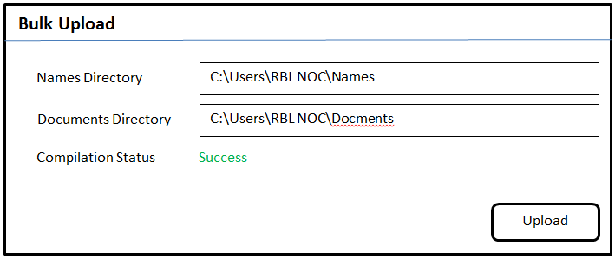

* Names Directory is the place to pick file containing loan applicant names (one application per row)
* Documents Directory contains the zip files w.r.t Loan Applicants with common prefix
* When the names are correctly validated against their documents, Compilation Status will become “SUCCESS”

Ex:

* C:\Users\RBL_NOC\Loans\bulk_preonboarding_ddmmyyyy.csv 🡪 csv containing document numbers and name.
* C:\Users\RBL_NOC\Loans\bulk_preonboarding_ddmmyyyy.zip 🡪 zip containing all the PDFs of the account numbers to be processed.

After Bulk upload, each document needs to be processed in Collated docs’ screen

Users can upload same zip files multiple times (say after correction or changes). Application will not restrict same loan numbers being shown multiple times In the MIS.

Every record in the upload will be treated as a fresh case.

# Document Verification Screen

After the excel file containing Loan details is uploaded and the pdf file page number is marked in the ‘collated docs’ screen, Document Verification screen will be the next stage. In this screen, all documents will be uploaded after eye-balling them. Basis initial visualization, Status will be decided.

For Field Verification purpose, Vendors will be allocated. Multiple Vendors can be selected. To allocate the vendor, select the document type and click on Vendors button. This will take the user to Vendors screen where one/multiple vendors can be selected

* Submit button will be activated only when all the documents are uploaded
* A single pdf file with all the documents (one document per page) can also be uploaded using Collated Docs button. Page number for corresponding document needs to be specified
* Save button will save the current state without performing any action.

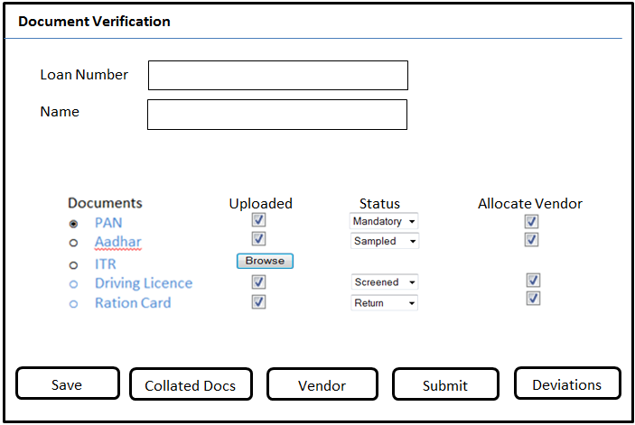

Deviations button is to upload revisions of documents (if earlier document is not found to be satisfactory after viewing it)

**Deviations**

PAN

Document Type

Loan Number

Document History

1. PAN_abhi.pdf 04-01-2018

2. PAN_abhi2.pdf 05-01-2018

Ver Document File Name Upload Date



Upload new Deviation

Cancel Comments

Submit Comments

A Pop-up will open up to ensure confirmation before submitting the documents to Vendor.

Are you sure you want to submit

Cancel Comments

Yes Comments

The data in Document Verification screen will be loaded only when the files have been processed in the ‘collated docs’ screen.

Attachment functionality will be provided in this screen, where-in deviation mails can be attached against each documents.

# Collated Docs

Once the Collated Doc file is uploaded through collated docs option or bulk upload option, the respective documents will be segregated out of the file from specified pages.

The results from Collated Doc screen will then reflect in Document Verification Screen.

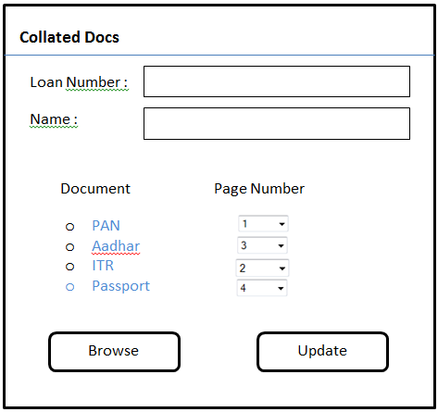

This screen will contain data uploaded using ‘Collated docs’ option – which is single upload facility and also contain data uploaded using ‘Bulk Upload’ option.

Processing of each doc and PDF is necessary in this screen before the record lands up in document verification screen.

# Vendor Details Addition/Selection Screen

This screen will be used to enter Vendor Details. Details include:

* Vendor Name
* Vendor Location
* A code name/Serial for the Vendor
* Activation Status (Active/Disabled)
* Vendor addition/modification rights will be granted to only those users which have admin rights. Other users can only select/view vendors.

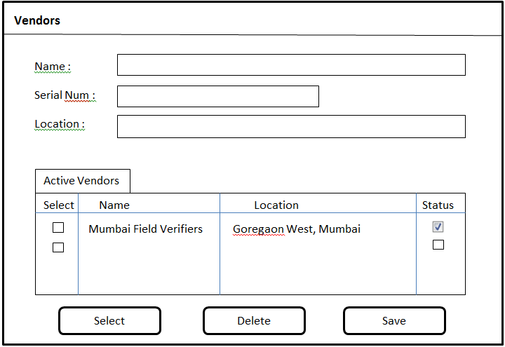

# Vendor Screen

This screen will be used by the vendor to enter comments related to their verification results.

Once the Vendor enters comments for all the documents assigned to them, the results will be fed back to ARM application and can be seen in Loan status and Vendor comments screen

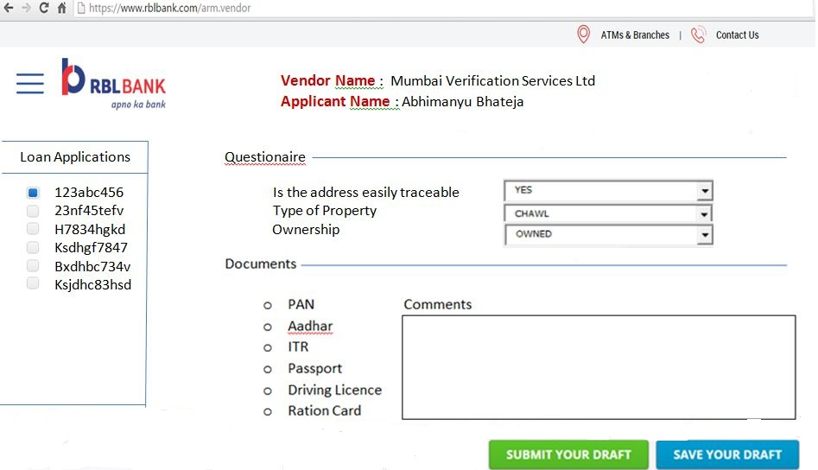

Vendor is expected to have more than one user working in the environment. Application will not allow picking of the files for more than one user.

For each document status option will be provided, Viz.

* + Positive
  + Negative
  + Fraud
  + Referred

Basis this, an overall status of the application will be derived. This will be Vendors feedback on the document and the overall status.

# Loan Status Screen

Once all documents are uploaded, the status for Loan application can be seen in Loan Status Screen. This screen will show whether Vendor comments are received or are still pending.

To view Vendor Comments, select the Loan application number and click on Vendor Comments. Clicking on View Report button will display a summary of comments in a pdf format.

Basis Vendor comments and NOC Team’s own investigation, Loan status can be set in the Status Drop-Down.

Clicking on Submit button will complete the Loan Automation process.

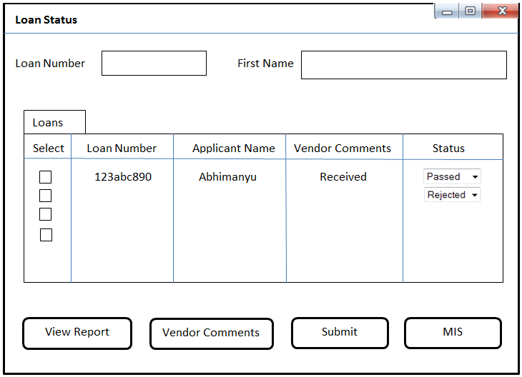

If a loan is rejected, then Loan Rejection screen will open. Here we can enter Loan rejection comments which will then be sent back to the respective vendors.

If a Loan application is deemed ‘Passed’, then an email will be triggered to the underwriters with Loan details mentioned in it. Their emails can be configured in a separate Underwriters screen.

For each Product Type AND Location AND For Status, we can define underwriters. Whenever a status is set for a loan application, email will be triggered to the defined underwriter.

**Underwriters**

Name



Name Email Product Location For Status

Location

Product

For Status

Save

Email

**Loan Rejection**

First Name

Loan Number



Vendor

Rejection Comments

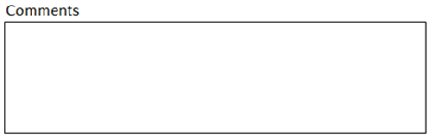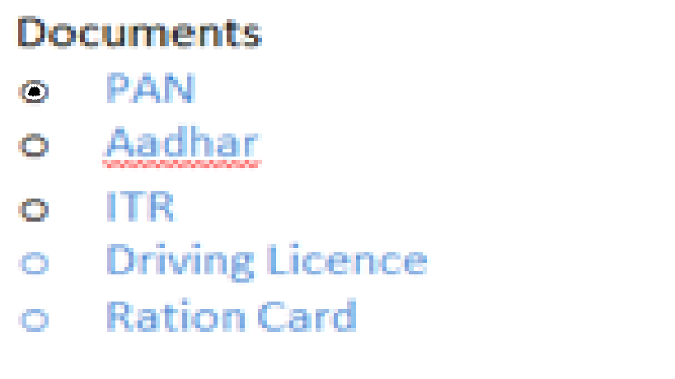



On Clicking MIS button, a detailed report of Loan applications will be sent as Email in pdf format to desired person. This report will include :

* All Loan applications successfully passed
* All Loan applications set as Fraud (with their respective comments from Vendors)
* All Loan applications still in pending state
* By default, Previous One month reporting will be done. Later in next phase, it can be made more dynamic

**MIS**



Report Contents

Report Period

abhimanyu@gmail.com

Email Address



# Vendor Comments

Once the vendor enters the comments for respective documents sent to them, they can be seen in Vendor Comments screen. This screen shows all comments entered by the selected Vendor for a given Loan application number.

* 

Show

Vendor

* PAN
* Aadhar
* ITR

Comments

**Vendor Comments**

# Loan Summary Report (pdf format)

Loan Summary

Loan Number: abc123xyz

Applicant Details:

|  |  |  |  |  |
| --- | --- | --- | --- | --- |
| Name | DOB | Loan Amount | Loan Purpose | PAN Number |
| abcd | 10-11-1987 | Rs. 50000 | Home Loan |  |

Document Verification

* PAN – NOC Verified
* Aadhar – Vendors Verified
* ITR – NOC Verified

Vendor Comments

Vendor Name: Mumbai Field Verification Service

PAN

Aadhar

ITR

Vendor Name: Delhi Field Verification Service

Ration Card