MCA — MINI PROJECT REPORT
on
GROCERY STORE CUSTOMER
SATISFACTION AI
Python · Machine Learning (Random Forest) · Streamlit
Submitted in partial fulfilment of the requirements for the degree of
MASTER OF COMPUTER APPLICATIONS (MCA)
Submitted by
[Student Name]
Roll No / PRN: [Roll Number]
Class: [MCA – Year / Semester]
Under the guidance of
[Guide Name], [Designation]
[College / Institute Name]
[University Name]
Academic Year: [20XX – 20XX]

CERTIFICATE

This is to certify that the mini project entitled “Grocery Store Customer Satisfaction AI” is a bonafide work carried out by [Student Name] (Roll No. [Roll Number]) of MCA, [College / Institute Name], in partial fulfilment of the requirements for the award of the degree of Master of Computer Applications, [University Name], during the academic year [20XX – 20XX].
The work embodied in this report is original and has not been submitted elsewhere for the award of any degree or diploma.

______________  Project Guide | ______________  Head of Department | ______________  External Examiner

Date: ____ / ____ / ________ Place: [City]

ACKNOWLEDGEMENT
I would like to express my sincere gratitude to my project guide, [Guide Name], for the valuable guidance, constant encouragement and constructive suggestions that helped me complete this mini project successfully.
I am thankful to the Head of the Department, the faculty members of the MCA Department and the management of [College / Institute Name] for providing the laboratory facilities and a supportive academic environment.
I also thank the open-source communities behind Python, pandas, scikit-learn and Streamlit, whose well-documented libraries made this project possible. Finally, I thank my family and friends for their continuous support and motivation.

[Student Name]

INDEX
Chapter No | Details | Page No
1 | Introduction | 4
 | 1.1 Abstract | 4
 | 1.2 Existing System and Need for System | 4
 | 1.3 Scope of System | 5
 | 1.4 Operating Environment – Hardware and Software | 5
 | 1.5 Brief Description of Technology Used | 6
2 | Proposed System | 7
 | 2.1 Study of Similar Systems | 7
 | 2.2 Objectives of Proposed System | 7
 | 2.3 Users of System | 8
3 | Analysis and Design | 9
 | 3.1 System Requirements (Functional & Non-Functional) | 9
 | 3.2 Entity Relationship Diagram (ERD) | 9
 | 3.3 Table Structure | 10
 | 3.4 Use Case Diagrams | 11
 | 3.5 Class Diagram | 12
 | 3.6 Activity Diagram | 13
 | 3.7 Deployment Diagram | 13
 | 3.8 Sample Input & Output Screens | 14
4 | Coding | 19
 | 4.1 Algorithms | 19
 | 4.2 Code Snippets | 20
5 | Limitations of Proposed System | 24
6 | Proposed Enhancements | 25
7 | Conclusion | 26
8 | Bibliography | 27

Chapter 1: Introduction

1.1 Abstract
Customer satisfaction is one of the most important indicators of a retail store’s success. In a grocery store, where customers visit frequently and have many alternatives, even small problems such as long billing queues, poor staff behaviour, unclean aisles or low product quality can push customers towards competitors. Most grocery stores, however, still measure satisfaction manually through paper feedback forms or occasional surveys, and they react only after customers have already left.
This mini project, “Grocery Store Customer Satisfaction AI”, applies supervised Machine Learning to predict whether a customer is Satisfied or Dissatisfied based on ten attributes: age, gender, shopping frequency, amount spent, product quality rating, staff behaviour rating, store cleanliness rating, waiting time, billing experience rating and number of complaints. A Random Forest classifier (250 decision trees) is trained on a dataset of 1,000 customer records using a scikit-learn Pipeline that combines One-Hot Encoding for categorical fields with the numeric fields. On a held-out test set of 200 records the model achieves an accuracy of 87%.
The trained model is deployed through an interactive Streamlit web application which lets a store manager enter a customer’s details, obtain an instant prediction together with a confidence score, and explore a dashboard showing the overall satisfaction distribution and average ratings. The whole system runs on a single local computer using Python and can be launched with a single batch file.
Keywords: Customer Satisfaction, Machine Learning, Random Forest, Classification, scikit-learn, Streamlit, Grocery Retail.

1.2 Existing System and Need for System

Existing System
In the traditional approach, a grocery store collects customer opinion through suggestion boxes, paper feedback forms, verbal complaints at the billing counter or occasional online surveys. The store owner reads these responses manually and forms an impression about customer happiness.
Drawbacks of the existing system:
- Feedback collection is manual, slow and covers only a small percentage of customers.
- Analysis is subjective; there is no systematic way to find which factor (quality, staff, waiting time, etc.) matters most.
- The system is reactive: problems are noticed only after customers complain or stop visiting.
- No prediction is possible for customers who did not fill any feedback form.
- Results are not stored in an analysable format, so trends and comparisons are difficult.

Need for the Proposed System
A data-driven system is needed that can learn from past customer experiences, predict satisfaction instantly, highlight the factors that influence it and present the results visually. Such a system helps the management take preventive action, such as opening an extra billing counter when waiting time is high or training staff when behaviour ratings are low, thereby improving customer retention and revenue.

1.3 Scope of System
The scope of the present project is as follows:
- Prediction of customer satisfaction (binary classification: Satisfied / Dissatisfied) from ten input attributes.
- Display of the model confidence (probability of the predicted class) for each prediction.
- A dashboard showing total customers, number of satisfied customers, satisfaction rate, satisfaction distribution, average ratings and a sample of the dataset.
- Automated data preprocessing and model training through a reusable scikit-learn pipeline, including model evaluation (accuracy, classification report, confusion matrix).
- A browser-based user interface requiring no programming knowledge from the end user.
Out of scope: real-time data capture from billing software, user authentication, multi-store management, text-based (review) sentiment analysis and cloud deployment. Some of these are listed as proposed enhancements in Chapter 6.

1.4 Operating Environment – Hardware and Software

Hardware Requirements
Component | Minimum | Recommended
Processor | Intel Core i3 / AMD Ryzen 3 (2 GHz) | Intel Core i5 / AMD Ryzen 5 or higher
RAM | 4 GB | 8 GB or more
Hard disk | 1 GB free space | 2 GB free space (SSD)
Display | 1366 × 768 | 1920 × 1080
Network | Needed only for first-time package installation | Broadband for installation

Software Requirements
Software | Details
Operating system | Windows 10 / 11 (batch launcher provided); also runs on Linux and macOS using the manual commands
Programming language | Python 3.9 or higher
Libraries | pandas ≥ 2.0, numpy ≥ 1.24, scikit-learn ≥ 1.3, joblib ≥ 1.3, streamlit ≥ 1.30, matplotlib ≥ 3.7, seaborn ≥ 0.12
Web browser | Google Chrome, Microsoft Edge or Mozilla Firefox (latest version)
Editor / IDE | VS Code, PyCharm or IDLE
Dataset format | CSV (customer_satisfaction.csv)

1.5 Brief Description of Technology Used
- Python: A high-level, general-purpose programming language widely used for data science. Its simple syntax and rich ecosystem make it ideal for rapid ML development.
- pandas and NumPy: pandas provides the DataFrame structure used to load the CSV file, separate features from the target and compute summary statistics. NumPy provides fast numerical arrays used internally by pandas and scikit-learn.
- scikit-learn: The machine-learning library used for splitting data (train_test_split), preprocessing (ColumnTransformer, OneHotEncoder), modelling (RandomForestClassifier), chaining steps (Pipeline) and evaluation (accuracy_score, classification_report, confusion_matrix).
- Random Forest: An ensemble learning algorithm that builds many decision trees on random subsets of the data and features and combines their votes. It handles mixed data types, resists over-fitting and provides feature-importance scores.
- joblib: Used to serialise (save) the trained pipeline into a .pkl file and load it back inside the web application so that training is not repeated.
- Streamlit: An open-source Python framework that turns scripts into interactive web applications. It provides widgets (sliders, select boxes, buttons), metrics, charts and caching decorators (@st.cache_resource, @st.cache_data).
- Matplotlib and Seaborn: Visualisation libraries listed in the project requirements for plotting evaluation results.
- Batch scripting: LAUNCH_PROJECT.bat installs the packages, trains the model and starts the application in a single click on Windows.

Chapter 2: Proposed System

2.1 Study of Similar Systems
Before designing the system, several existing approaches for measuring customer satisfaction were studied:
System / Approach | Description | Limitation relative to this project
Paper / online survey forms | Customers rate the store manually; averages are calculated in spreadsheets. | Reactive, low response rate, no prediction for non-respondents.
Net Promoter Score (NPS) tools | Single-question survey (“How likely are you to recommend us?”) with a score. | Gives one score but does not explain which factors drive satisfaction.
SERVQUAL model | Academic questionnaire measuring service quality gaps across five dimensions. | Manual, questionnaire-heavy and not automated.
Commercial CRM / analytics suites | Enterprise platforms with feedback dashboards and analytics. | Expensive and complex for a small grocery store.
Sentiment analysis of reviews | NLP applied to online reviews and social media text. | Needs large amounts of text data; unsuitable for walk-in grocery customers.

The study shows that most existing systems either only collect and display feedback or are too costly. The proposed system fills this gap with a low-cost, automated and predictive tool built entirely on open-source technology.

2.2 Objectives of Proposed System
- To build a machine-learning model that predicts whether a grocery customer is Satisfied or Dissatisfied from structured shopping and service-experience data.
- To automate preprocessing and training using a scikit-learn Pipeline so that the same transformations are applied during training and prediction.
- To evaluate the model using accuracy, precision, recall, F1-score and confusion matrix.
- To provide a simple, interactive web interface for entering customer data and viewing predictions with confidence.
- To provide a dashboard that summarises satisfaction statistics and average ratings for quick decision making.
- To identify the factors that most influence satisfaction (feature importance) so that management can prioritise improvements.
- To make the system easy to install and launch with one click.

2.3 Users of System
User | Role / Interaction
Store Manager / Owner | Primary user. Enters customer details, views predictions, confidence and the dashboard to make decisions.
Customer-service staff | Uses the prediction page to quickly assess experience of a customer after billing or after a complaint.
Data analyst / Developer | Updates the dataset, retrains the model, checks evaluation metrics and maintains the application.
Academic evaluator | Reviews the working of the system and the quality of the model as part of the MCA mini project.

Chapter 3: Analysis and Design

3.1 System Requirements (Functional & Non-Functional)

Functional Requirements
ID | Requirement
FR1 | The system shall load the customer dataset (CSV) and the trained model at start-up.
FR2 | The system shall display total customers, number of satisfied customers and satisfaction rate.
FR3 | The system shall accept customer age (18–100), gender, shopping frequency, amount spent, waiting time, number of complaints and four ratings (1–5).
FR4 | The system shall predict the satisfaction class when the “Predict Satisfaction” button is clicked.
FR5 | The system shall display the predicted class (green for Satisfied, red for Dissatisfied) and the model confidence in percentage.
FR6 | The system shall display a bar chart of satisfaction distribution and a bar chart of average ratings.
FR7 | The system shall display the first 20 records of the dataset.
FR8 | The training module shall split data 80:20 (stratified), train the pipeline, print accuracy, classification report and confusion matrix, and save the model file.

Non-Functional Requirements
ID | Category | Requirement
NFR1 | Performance | A prediction shall be returned in under 2 seconds; the model is cached after the first load.
NFR2 | Usability | Interface uses sliders, select boxes and a single button; no technical knowledge needed.
NFR3 | Reliability | Input widgets restrict values to valid ranges, preventing invalid data entry; unseen categories are ignored safely (handle_unknown="ignore").
NFR4 | Portability | Runs on any OS with Python 3.9+; Windows users can use the one-click launcher.
NFR5 | Maintainability | Modular scripts (train_model.py, app.py); retraining only requires replacing the CSV and running one command.
NFR6 | Reproducibility | Fixed random_state=42 gives identical results on every training run.
NFR7 | Privacy | No personal identifiers (name, phone, address) are stored; data runs locally on the user’s machine.
NFR8 | Scalability | Model can be retrained on larger datasets without code changes.

3.2 Entity Relationship Diagram (ERD)
Although the implemented system stores data in a flat CSV file, the logical data model below shows the entities involved and their relationships. This conceptual design can be directly converted into a relational database (for example MySQL) when the system is extended.
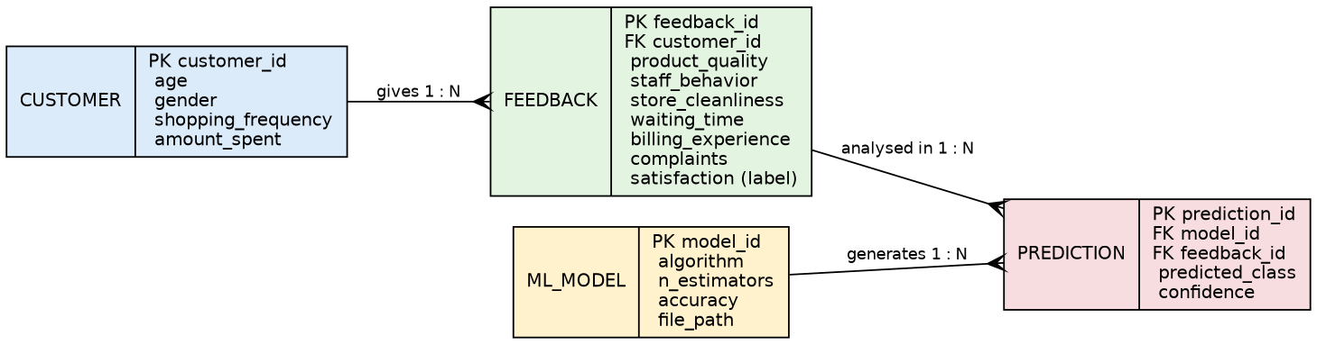
Figure 3.1: Entity Relationship Diagram
A CUSTOMER can give many FEEDBACK records (1:N). Each FEEDBACK record can be analysed in many PREDICTION records, and one ML_MODEL generates many PREDICTION records (1:N).

3.3 Table Structure
Table 3.1 shows the structure of the dataset file customer_satisfaction.csv (1,000 records, 11 columns, no missing values). The first ten columns are input features; Satisfaction is the target label.
Column | Data Type | Kind | Description / Valid Values
Age | Integer | Numeric | Customer age in years (observed 18–65)
Gender | String | Categorical | Male, Female, Other
Shopping_Frequency | String | Categorical | Daily, Weekly, Monthly, Rarely
Amount_Spent | Integer | Numeric | Bill amount in ₹ (observed 300–5,597)
Product_Quality | Integer | Numeric (rating) | 1 (very poor) to 5 (excellent)
Staff_Behavior | Integer | Numeric (rating) | 1 to 5
Store_Cleanliness | Integer | Numeric (rating) | 1 to 5
Waiting_Time | Integer | Numeric | Waiting time in minutes (observed 1–60)
Billing_Experience | Integer | Numeric (rating) | 1 to 5
Complaints | Integer | Numeric | Number of complaints (observed 0–5)
Satisfaction | String | Target label | Satisfied or Dissatisfied

Table 3.2 gives the descriptive statistics of the numeric attributes.
Attribute | Min | Max | Mean | Std. Dev.
Age | 18 | 65 | 41.65 | 13.85
Amount_Spent | 300 | 5597 | 2247.98 | 1055.06
Product_Quality | 1 | 5 | 2.96 | 1.39
Staff_Behavior | 1 | 5 | 3.02 | 1.4
Store_Cleanliness | 1 | 5 | 3.02 | 1.37
Waiting_Time | 1 | 60 | 15.88 | 10.2
Billing_Experience | 1 | 5 | 2.99 | 1.42
Complaints | 0 | 5 | 0.74 | 0.87

Table 3.3 lists the logical tables derived from the ERD (for future database implementation).
Table | Attributes (PK = primary key, FK = foreign key)
CUSTOMER | customer_id (PK), age, gender, shopping_frequency, amount_spent
FEEDBACK | feedback_id (PK), customer_id (FK), product_quality, staff_behavior, store_cleanliness, waiting_time, billing_experience, complaints, satisfaction
ML_MODEL | model_id (PK), algorithm, n_estimators, accuracy, file_path
PREDICTION | prediction_id (PK), model_id (FK), feedback_id (FK), predicted_class, confidence

3.4 Use Case Diagrams
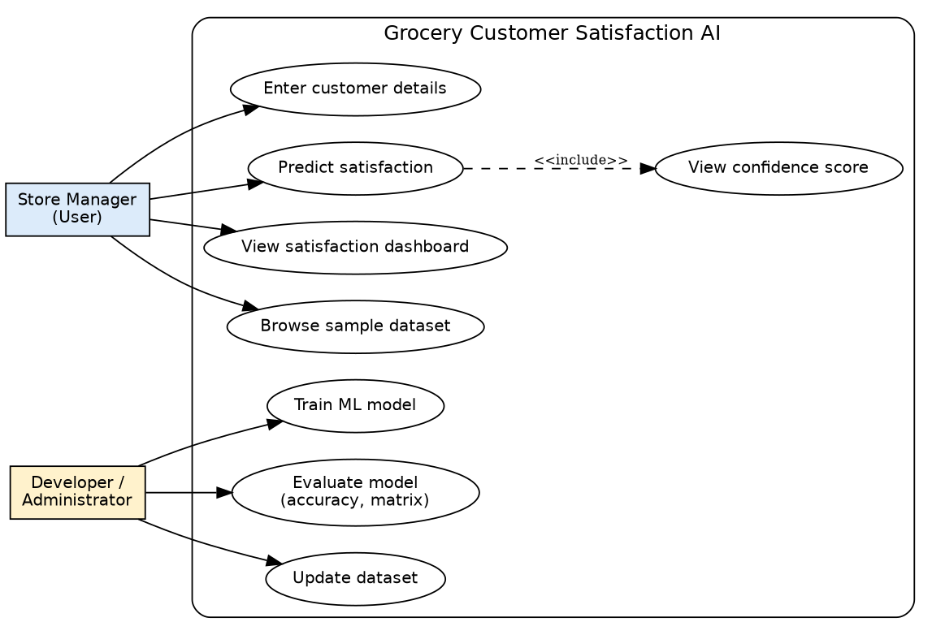
Figure 3.2: Use Case Diagram
Use Case | Actor | Description
Enter customer details | Store Manager | Sets age, gender, frequency, spend, ratings, waiting time and complaints using widgets.
Predict satisfaction | Store Manager | Clicks the button; the model returns the class.
View confidence score | Store Manager | Shows probability of the predicted class (included in prediction).
View satisfaction dashboard | Store Manager | Views metrics and charts of the dataset.
Browse sample dataset | Store Manager | Views first 20 records in a table.
Train ML model | Developer | Runs train_model.py to fit and save the pipeline.
Evaluate model | Developer | Reads accuracy, classification report and confusion matrix.
Update dataset | Developer | Replaces the CSV with new survey data and retrains.

3.5 Class Diagram
The project is implemented as simple scripts, but its logical structure can be represented by the following classes and their relationships.
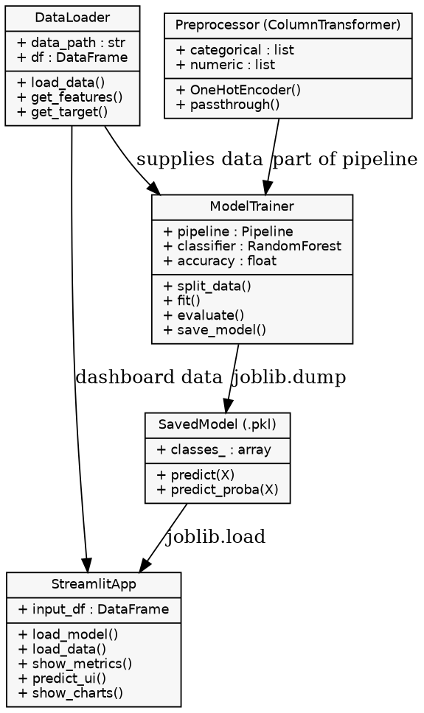
Figure 3.3: Class Diagram

3.6 Activity Diagram
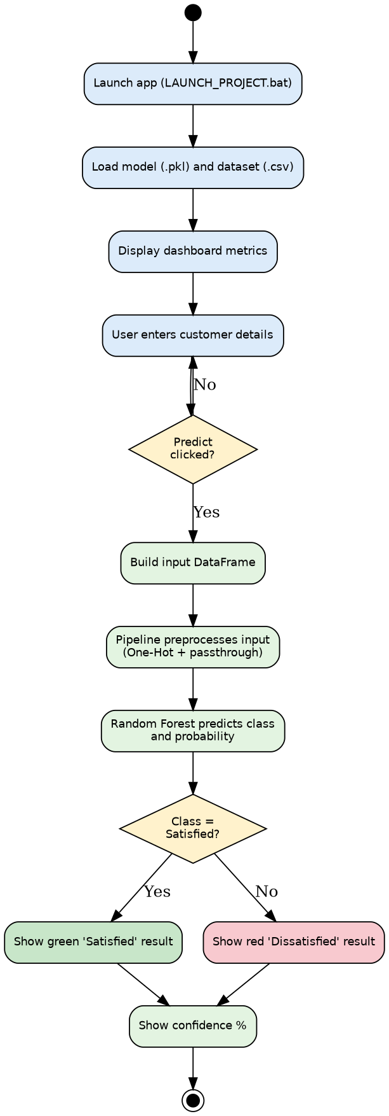
Figure 3.4: Activity Diagram – Prediction Flow

3.7 Deployment Diagram
The system is deployed on a single local machine. The browser communicates with the Streamlit server over HTTP (default port 8501). The server loads the pickled model and CSV from the project folders.
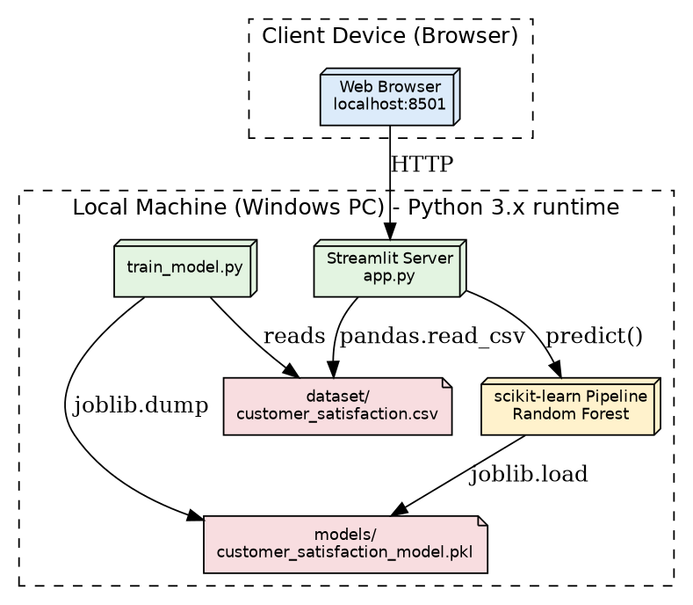
Figure 3.5: Deployment Diagram

3.8 Sample Input & Output Screens
The following screens and reports were generated from the actual dataset and trained model of this project. (Replace the placeholder boxes with screenshots of your running Streamlit application before final submission.)

Screen 1: Dashboard Metrics (Output)
Metric | Value
Total Customers | 1000
Satisfied | 409
Dissatisfied | 591
Satisfaction Rate | 40.9%
Records in dataset sample table | 20 (first 20 rows)
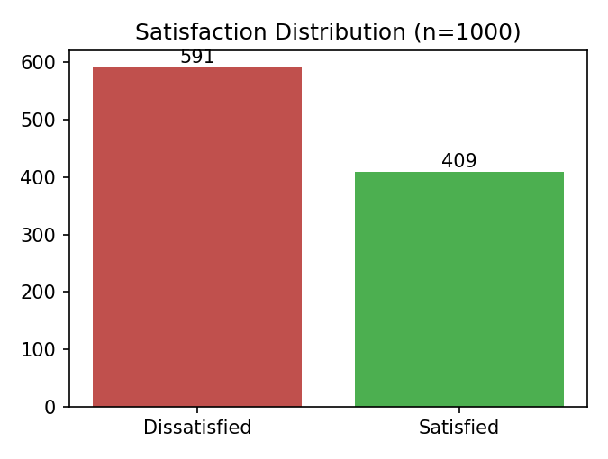
Figure 3.6: Satisfaction Distribution chart (dashboard)

Screen 2: Prediction Input Form (Input)
Field | Widget | Default Value
Customer Age | Number input (18–100) | 25
Gender | Select box | Male / Female / Other
Shopping Frequency | Select box | Daily / Weekly / Monthly / Rarely
Amount Spent (₹) | Number input (0–100000) | 2000
Product Quality | Slider (1–5) | 4
Staff Behavior | Slider (1–5) | 4
Store Cleanliness | Slider (1–5) | 4
Waiting Time (minutes) | Number input (0–180) | 10
Billing Experience | Slider (1–5) | 4
Number of Complaints | Number input (0–20) | 0

Screen 3: Prediction Output – Sample Records (6 records)
# | Age | Gender | Freq. | ₹ Spent | Qual | Staff | Clean | Wait | Bill | Compl. | Prediction | Conf.
1 | 59 | Female | Monthly | 2369 | 1 | 3 | 4 | 23 | 4 | 0 | Satisfied | 74.8%
2 | 63 | Male | Weekly | 3323 | 4 | 4 | 3 | 22 | 2 | 0 | Dissatisfied | 79.2%
3 | 22 | Female | Rarely | 300 | 3 | 4 | 2 | 39 | 1 | 0 | Dissatisfied | 92.0%
4 | 64 | Male | Monthly | 2028 | 4 | 3 | 2 | 31 | 3 | 0 | Satisfied | 78.8%
5 | 51 | Female | Weekly | 848 | 3 | 5 | 3 | 5 | 3 | 0 | Satisfied | 89.6%
6 | 40 | Male | Daily | 2484 | 3 | 1 | 2 | 8 | 5 | 1 | Dissatisfied | 91.6%
Table 3.4: Sample predictions made by the trained model (all six match the actual label in the dataset)
Output messages in the application: “😊 Prediction: Satisfied” (green box) or “☹️ Prediction: Dissatisfied” (red box), followed by the metric “Model Confidence”.
[ Paste screenshot of Prediction page here ]

Report 1: Customer Dataset Sample (10 records)
Age | Gender | Freq. | ₹ Spent | Qual | Staff | Clean | Wait | Bill | Compl. | Satisfaction
22 | Female | Monthly | 1786 | 2 | 4 | 5 | 6 | 3 | 2 | Dissatisfied
55 | Female | Rarely | 1696 | 5 | 3 | 2 | 12 | 4 | 0 | Satisfied
49 | Female | Weekly | 3046 | 5 | 4 | 5 | 18 | 5 | 1 | Satisfied
39 | Female | Weekly | 3101 | 3 | 5 | 3 | 5 | 4 | 3 | Satisfied
38 | Female | Monthly | 1611 | 3 | 2 | 4 | 14 | 1 | 3 | Dissatisfied
59 | Female | Weekly | 1757 | 1 | 3 | 4 | 13 | 2 | 0 | Dissatisfied
22 | Male | Monthly | 2795 | 5 | 1 | 4 | 25 | 4 | 0 | Dissatisfied
51 | Female | Weekly | 1290 | 1 | 2 | 2 | 23 | 3 | 3 | Dissatisfied
27 | Female | Weekly | 1748 | 1 | 4 | 4 | 27 | 2 | 0 | Dissatisfied
22 | Male | Monthly | 2299 | 3 | 4 | 4 | 16 | 2 | 0 | Dissatisfied

Report 2: Satisfaction by Shopping Frequency (4 groups + total = 5 records)
Shopping Frequency | Customers | Satisfied | Dissatisfied | Satisfaction Rate
Daily | 142 | 48 | 94 | 33.8%
Weekly | 498 | 209 | 289 | 42%
Monthly | 258 | 112 | 146 | 43.4%
Rarely | 102 | 40 | 62 | 39.2%
Total | 1000 | 409 | 591 | 40.9%

Report 3: Average Ratings by Satisfaction Class (8 records)
Attribute | Satisfied (avg) | Dissatisfied (avg) | Overall (avg)
Product_Quality | 3.64 | 2.49 | 2.96
Staff_Behavior | 3.7 | 2.55 | 3.02
Store_Cleanliness | 3.44 | 2.72 | 3.02
Billing_Experience | 3.52 | 2.62 | 2.99
Waiting_Time | 14.15 | 17.07 | 15.88
Complaints | 0.61 | 0.82 | 0.73
Amount_Spent | 2367.01 | 2165.6 | 2247.98
Age | 41.67 | 41.63 | 41.65

Report 4: Satisfaction by Gender (3 groups + total = 4 records)
Gender | Customers | Satisfied | Satisfaction Rate
Female | 476 | 202 | 42.4%
Male | 496 | 199 | 40.1%
Other | 28 | 8 | 28.6%
Total | 1000 | 409 | 40.9%

Report 5: Model Evaluation (Test set – 200 records)
Class | Precision | Recall | F1-score | Support
Dissatisfied | 0.85 | 0.94 | 0.90 | 118
Satisfied | 0.90 | 0.77 | 0.83 | 82
Accuracy |  |  | 0.87 | 200
Macro average | 0.88 | 0.85 | 0.86 | 200
Weighted average | 0.87 | 0.87 | 0.87 | 200
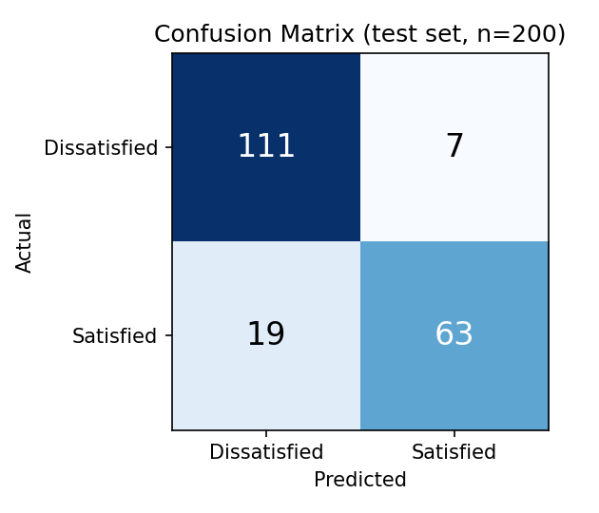
Figure 3.7: Confusion Matrix on the test set
Out of 200 test customers, 111 Dissatisfied and 63 Satisfied customers were classified correctly (174 correct, accuracy 87%). Seven Dissatisfied customers were wrongly predicted as Satisfied and 19 Satisfied customers were wrongly predicted as Dissatisfied.

Report 6: Feature Importance (Top 8)
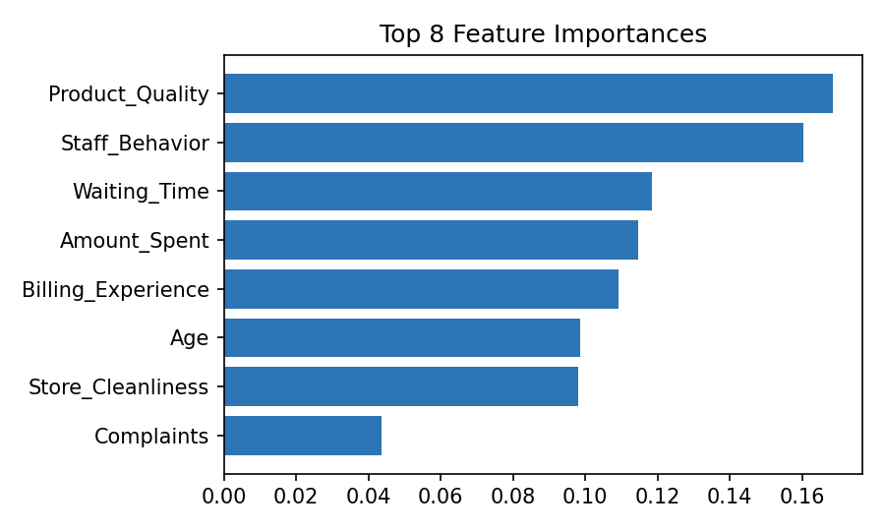
Figure 3.8: Feature importances from the Random Forest
Product quality (16.8%) and staff behaviour (16.0%) are the two most influential factors, followed by waiting time (11.9%), amount spent (11.5%) and billing experience (10.9%). The number of complaints has a comparatively small influence (4.4%).

Chapter 4: Coding

4.1 Algorithms

Algorithm 1: Model Training (train_model.py)
- Start.
- Read customer_satisfaction.csv into a pandas DataFrame.
- Separate the features X (all columns except Satisfaction) and the target y (Satisfaction).
- Identify categorical columns (Gender, Shopping_Frequency); all remaining columns are numeric.
- Build a ColumnTransformer: One-Hot Encode the categorical columns (unknown categories ignored) and pass numeric columns unchanged.
- Create a Pipeline: preprocessor → RandomForestClassifier(n_estimators = 250, class_weight = "balanced", random_state = 42).
- Split the data into 80% training and 20% testing with stratification on y.
- Fit the pipeline on the training data.
- Predict on the test data and compute accuracy, classification report and confusion matrix.
- Save the trained pipeline to models/customer_satisfaction_model.pkl using joblib.
- Stop.

Algorithm 2: Random Forest Classification
- Given training set of n records, create T = 250 bootstrap samples (random sampling with replacement).
- For each sample, grow a decision tree; at every split consider only a random subset of features and choose the split that gives the best Gini impurity reduction.
- Grow each tree fully (or until stopping criteria are met) without pruning.
- For a new customer, pass the record through all T trees; each tree votes for Satisfied or Dissatisfied.
- The final prediction is the majority class; the confidence is the fraction (average probability) of trees voting for that class.
Gini impurity of a node: Gini = 1 − Σ pᵢ², where pᵢ is the proportion of records of class i in that node. A pure node has Gini = 0.
class_weight="balanced" automatically weights classes inversely to their frequency (591 Dissatisfied vs 409 Satisfied) so that the minority class is not ignored.

Algorithm 3: Prediction in the Web Application (app.py)
- Load the model and dataset once using Streamlit caching.
- Display the dashboard metrics from the dataset.
- Collect user inputs through widgets and build a one-row DataFrame with exactly the same column names as the training data.
- On button click, call model.predict() and model.predict_proba().
- Find the probability of the predicted class from model.classes_ and convert it to a percentage.
- Show a green success box for Satisfied or a red error box for Dissatisfied, with the confidence metric.
- Show distribution and average-rating charts and the sample dataset.

4.2 Code Snippets

Snippet 1: train_model.py – Data preparation, pipeline and training
import pandas as pd
import joblib
from sklearn.model_selection import train_test_split
from sklearn.compose import ColumnTransformer
from sklearn.pipeline import Pipeline
from sklearn.preprocessing import OneHotEncoder
from sklearn.ensemble import RandomForestClassifier
from sklearn.metrics import accuracy_score, classification_report, confusion_matrix

df = pd.read_csv("dataset/customer_satisfaction.csv")

X = df.drop("Satisfaction", axis=1)
y = df["Satisfaction"]

categorical = ["Gender", "Shopping_Frequency"]
numeric = [c for c in X.columns if c not in categorical]

preprocessor = ColumnTransformer([
("cat", OneHotEncoder(handle_unknown="ignore"), categorical),
("num", "passthrough", numeric)
])

model = Pipeline([
("preprocessor", preprocessor),
("classifier", RandomForestClassifier(
n_estimators=250,
random_state=42,
class_weight="balanced"
))
])

X_train, X_test, y_train, y_test = train_test_split(
X, y, test_size=0.20, random_state=42, stratify=y
)

model.fit(X_train, y_train)
pred = model.predict(X_test)

print("Accuracy:", round(accuracy_score(y_test, pred), 4))
print("\nClassification Report:\n", classification_report(y_test, pred))
print("\nConfusion Matrix:\n", confusion_matrix(y_test, pred))

joblib.dump(model, "models/customer_satisfaction_model.pkl")
print("\nModel saved to models/customer_satisfaction_model.pkl")

Snippet 2: app.py – Loading model and dashboard metrics (lines 1–35)
import streamlit as st
import pandas as pd
import joblib
import os

st.set_page_config(page_title="Grocery Customer Satisfaction AI", page_icon="🛒", layout="wide")

MODEL_PATH = "models/customer_satisfaction_model.pkl"
DATA_PATH = "dataset/customer_satisfaction.csv"

@st.cache_resource
def load_model():
return joblib.load(MODEL_PATH)

@st.cache_data
def load_data():
return pd.read_csv(DATA_PATH)

model = load_model()
df = load_data()

st.title("🛒 Grocery Store Customer Satisfaction AI")
st.caption("Python + Machine Learning | Random Forest Classification")

col1, col2, col3 = st.columns(3)
with col1:

Snippet 3: app.py – Input collection, prediction and charts
st.metric("Total Customers", len(df))
with col2:
st.metric("Satisfied", int((df["Satisfaction"] == "Satisfied").sum()))
with col3:
st.metric("Satisfaction Rate", f"{(df['Satisfaction'].eq('Satisfied').mean()*100):.1f}%")

st.divider()
st.subheader("🔮 Predict Customer Satisfaction")

left, right = st.columns(2)

with left:
age = st.number_input("Customer Age", min_value=18, max_value=100, value=25)
gender = st.selectbox("Gender", ["Male", "Female", "Other"])
freq = st.selectbox("Shopping Frequency", ["Daily", "Weekly", "Monthly", "Rarely"])
amount = st.number_input("Amount Spent (₹)", min_value=0, max_value=100000, value=2000, step=100)
quality = st.slider("Product Quality", 1, 5, 4)

with right:
staff = st.slider("Staff Behavior", 1, 5, 4)
clean = st.slider("Store Cleanliness", 1, 5, 4)
waiting = st.number_input("Waiting Time (minutes)", min_value=0, max_value=180, value=10)
billing = st.slider("Billing Experience", 1, 5, 4)
complaints = st.number_input("Number of Complaints", min_value=0, max_value=20, value=0)

input_df = pd.DataFrame([{
"Age": age,
"Gender": gender,
"Shopping_Frequency": freq,
"Amount_Spent": amount,
"Product_Quality": quality,
"Staff_Behavior": staff,
"Store_Cleanliness": clean,
"Waiting_Time": waiting,
"Billing_Experience": billing,
"Complaints": complaints
}])

if st.button("Predict Satisfaction", type="primary", use_container_width=True):
prediction = model.predict(input_df)[0]
probabilities = model.predict_proba(input_df)[0]
classes = model.classes_
prob = probabilities[list(classes).index(prediction)] * 100

if prediction == "Satisfied":
st.success(f"😊 Prediction: {prediction}")
else:
st.error(f"☹️ Prediction: {prediction}")

st.metric("Model Confidence", f"{prob:.1f}%")

st.divider()
st.subheader("📊 Customer Data Analysis")

a, b = st.columns(2)
with a:
st.write("### Satisfaction Distribution")
st.bar_chart(df["Satisfaction"].value_counts())
with b:
st.write("### Average Ratings")
rating_cols = ["Product_Quality", "Staff_Behavior", "Store_Cleanliness", "Billing_Experience"]
st.bar_chart(df[rating_cols].mean())

st.write("### Sample Dataset")
st.dataframe(df.head(20), use_container_width=True)

Snippet 4: LAUNCH_PROJECT.bat – One-click launcher (core commands)
python -m pip install -r requirements.txt :: [1/3] install packages
python train_model.py :: [2/3] train the model
python -m streamlit run app.py :: [3/3] start web app

Snippet 5: requirements.txt
pandas>=2.0
numpy>=1.24
scikit-learn>=1.3
joblib>=1.3
streamlit>=1.30
matplotlib>=3.7
seaborn>=0.12

Chapter 5: Limitations of Proposed System
- The dataset is synthetic (generated for demonstration), so the 87% accuracy reflects the patterns in that data and may differ on real customers.
- The model uses only structured, numeric and categorical data; written reviews and comments are not analysed.
- Prediction is binary (Satisfied / Dissatisfied); a neutral or multi-level satisfaction scale is not supported.
- The model has lower recall for the Satisfied class (0.77), so about one in four satisfied customers may be predicted as dissatisfied.
- Data is entered manually in the web form; there is no connection to billing software or live store data.
- Records are not stored by the application, so a history of predictions cannot be viewed later.
- The app runs locally on a single machine, has no login or role-based access and supports a single store only.
- The model is trained once and is not updated automatically when new data arrives.
- Input and trained-model file paths are relative, so the application must be started from the project folder, with the dataset/ and models/ folders present.

Chapter 6: Proposed Enhancements
- Replace synthetic data with real survey data collected with customer consent and compare multiple algorithms (Logistic Regression, SVM, Gradient Boosting, XGBoost) with cross-validation and hyper-parameter tuning.
- Add a database (MySQL / SQLite) following the ERD, so customers, feedback and predictions are stored and history reports can be generated.
- Integrate NLP-based sentiment analysis of text reviews and complaints.
- Add explainable AI (SHAP / LIME) to show why a particular customer was predicted dissatisfied and to suggest corrective actions.
- Provide batch prediction by uploading a CSV file and downloading results; add dashboards with trend charts by date, branch and product category.
- Add user authentication with roles (Manager, Staff, Admin) and multi-store support.
- Connect with billing / POS software and automate data collection through QR-code feedback forms.
- Deploy on the cloud (Streamlit Community Cloud, Docker, AWS) with periodic automatic retraining and a mobile-friendly interface.
- Add email / SMS alerts when high-value customers are predicted to be dissatisfied.

Chapter 7: Conclusion
The mini project “Grocery Store Customer Satisfaction AI” demonstrates how machine learning can convert routine shopping and service data into actionable insight for a grocery store. A Random Forest classifier, built inside a scikit-learn Pipeline and trained on 1,000 customer records, predicts customer satisfaction with 87% accuracy on unseen data, with precision of 0.85 (Dissatisfied) and 0.90 (Satisfied).
The feature-importance analysis shows that product quality and staff behaviour are the strongest drivers of satisfaction, followed by waiting time, spending and billing experience. These findings give management clear priorities: maintain product quality, train staff and reduce queue time.
The Streamlit interface makes the model usable by non-technical staff through a simple form, instant prediction with confidence and a visual dashboard, while the one-click batch launcher makes installation easy. Although limited by its synthetic dataset and local deployment, the system provides a solid, extensible foundation. With real data, a database and the enhancements proposed in Chapter 6, it can grow into a practical customer-experience analytics tool for retail businesses.
Through this project the author gained practical experience in data preprocessing, supervised learning, model evaluation, UML-based system design and web application development using Python.

Chapter 8: Bibliography

Books and Research Papers
- Breiman, L. (2001). “Random Forests.” Machine Learning, 45(1), 5–32.
- Pedregosa, F. et al. (2011). “Scikit-learn: Machine Learning in Python.” Journal of Machine Learning Research, 12, 2825–2830.
- Géron, A. (2022). Hands-On Machine Learning with Scikit-Learn, Keras & TensorFlow (3rd ed.). O’Reilly Media.
- McKinney, W. (2010). “Data Structures for Statistical Computing in Python.” Proceedings of the 9th Python in Science Conference, 56–61.
- Parasuraman, A., Zeithaml, V. A., & Berry, L. L. (1988). “SERVQUAL: A Multiple-Item Scale for Measuring Consumer Perceptions of Service Quality.” Journal of Retailing, 64(1), 12–40.
- Han, J., Kamber, M., & Pei, J. (2011). Data Mining: Concepts and Techniques (3rd ed.). Morgan Kaufmann.
- Booch, G., Rumbaugh, J., & Jacobson, I. (2005). The Unified Modeling Language User Guide (2nd ed.). Addison-Wesley.

Online Documentation
- scikit-learn documentation – https://scikit-learn.org/stable/
- Streamlit documentation – https://docs.streamlit.io
- pandas documentation – https://pandas.pydata.org/docs/
- Python documentation – https://docs.python.org/3/
- joblib documentation – https://joblib.readthedocs.io

