Assignment Questions

- Data Cleaning Questions:

- How many missing values exist in the dataset, and in which columns?
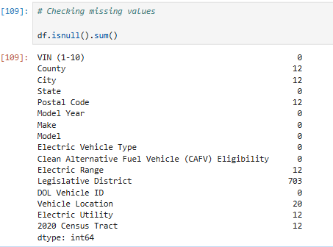

- How should missing or zero values in the Base MSRP and Electric Range columns be handled?
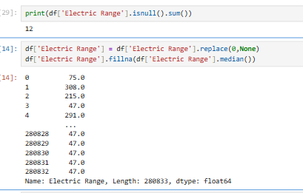

- Are there duplicate records in the dataset? If so, how should they be managed?
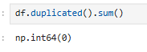

- How can VINs be anonymized while maintaining uniqueness?
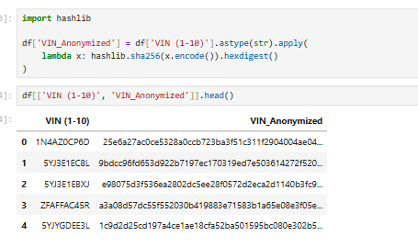

- How can Vehicle Location (GPS coordinates) be cleaned or converted for better readability?
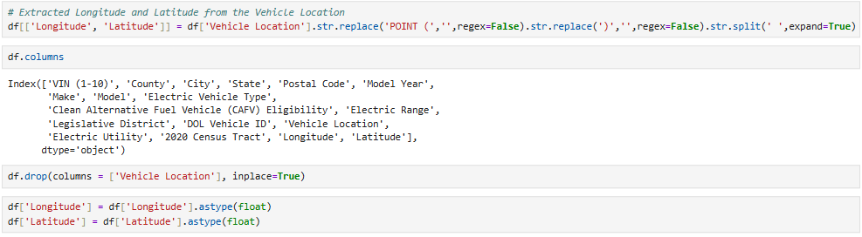

- Data Exploration Questions:

- What are the top 5 most common EV makes and models in the dataset?
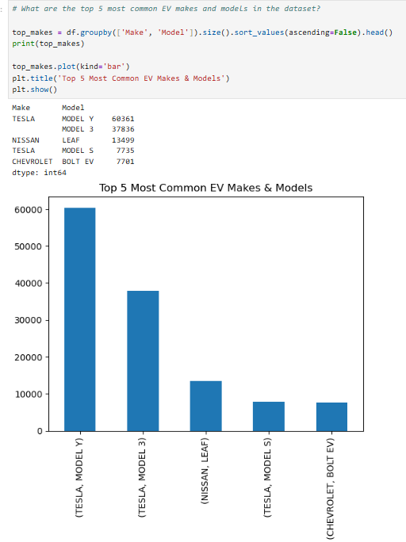

- What is the distribution of EVs by county? Which county has the most registrations?
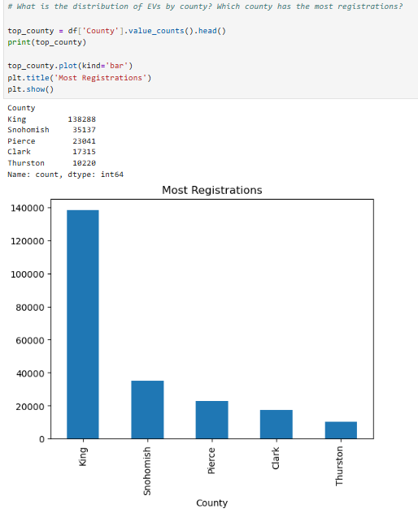

- How has EV adoption changed over different model years?

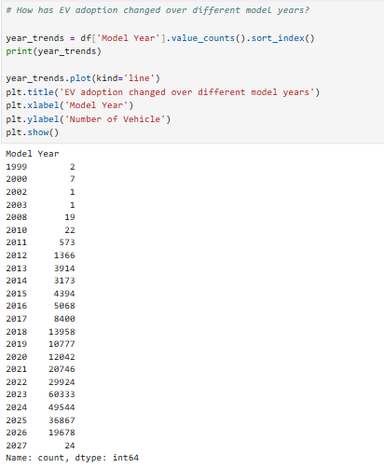
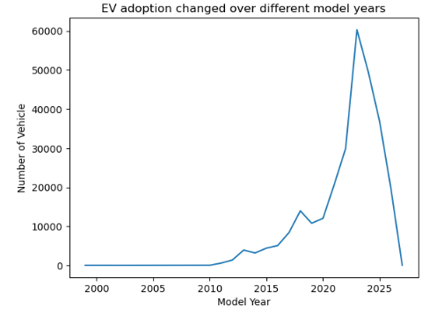
- What is the average electric range of EVs in the dataset?

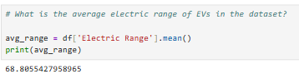

- What percentage of EVs are eligible for Clean Alternative Fuel Vehicle (CAFV) incentives?
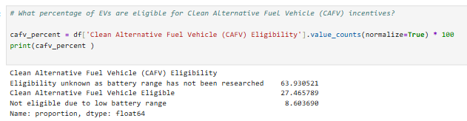

- How does the electric range vary across different makes and models?
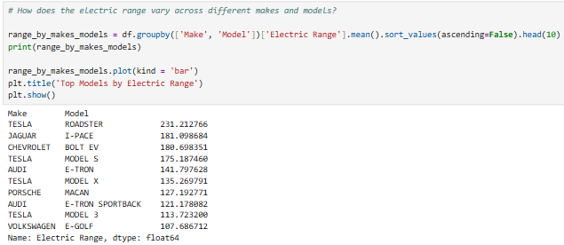
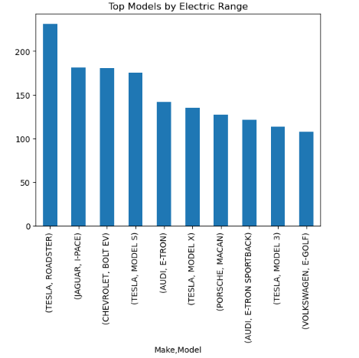

- Are there any regional trends in EV adoption (e.g., urban vs. rural areas)?
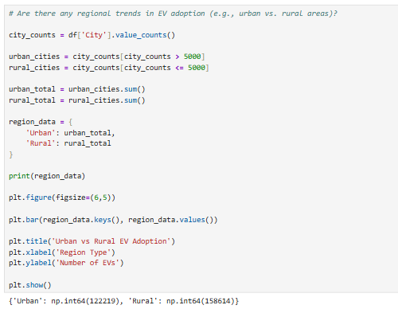
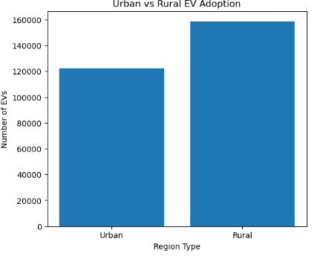

3. Data Visualization Questions:
- Create a bar chart showing the top 5 EV makes and models by count.
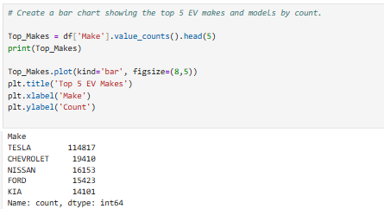
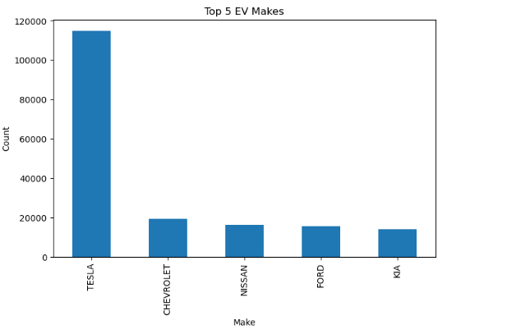

- Use a heatmap or choropleth map to visualize EV distribution by county.
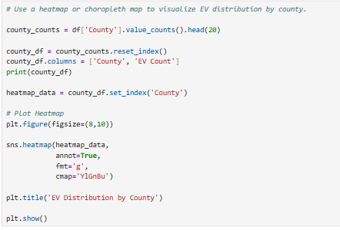
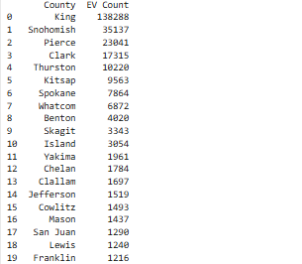
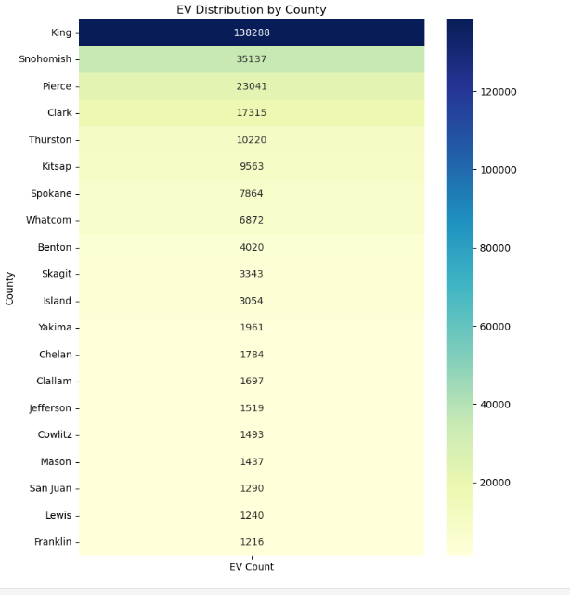

- Create a line graph showing the trend of EV adoption by model year.



- Plot a pie chart showing the proportion of CAFV-eligible vs. non-eligible EVs.
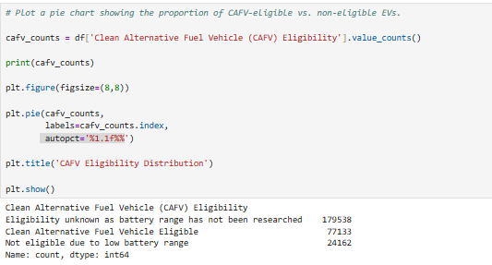
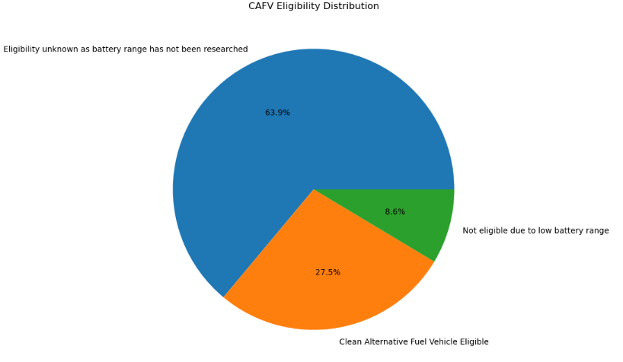
- Use a geospatial map to display EV registrations based on vehicle location.
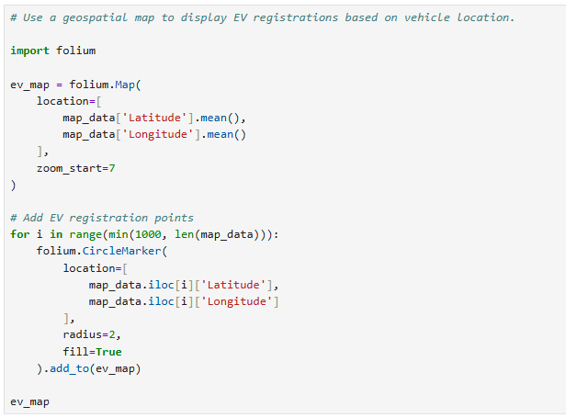
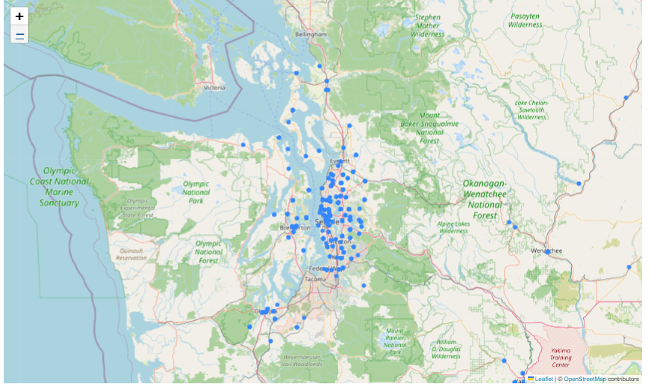

4. Linear Regression Model Questions:
- How can we use Linear Regression to predict the Electric Range of a vehicle?
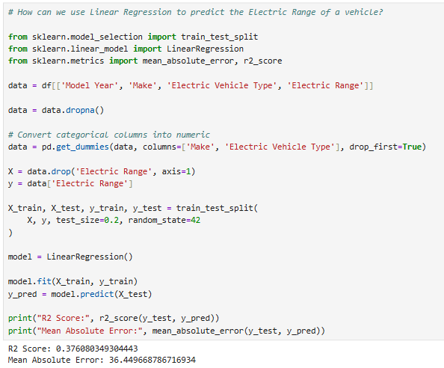

- How do we handle categorical variables like Make and Model in regression analysis?
- Convert categorical columns into numerical format using One-Hot Encoding
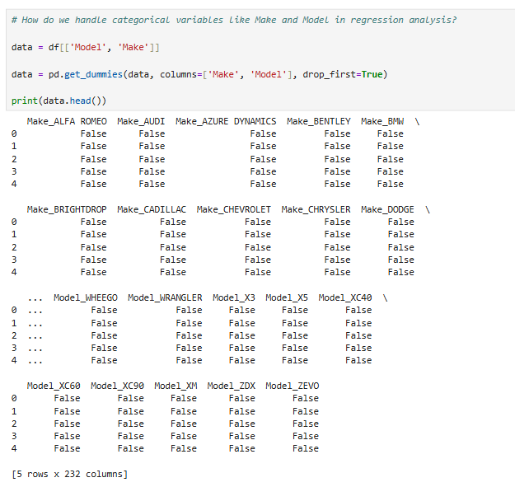
- What is the R² score of the model, and what does it indicate about prediction accuracy?

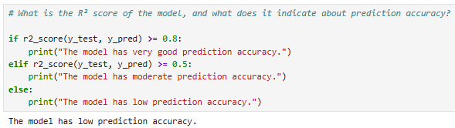

- What steps are needed to improve the accuracy of the Linear Regression model?

1. Handle missing values properly
2. Remove outliers from the dataset
3. Use more relevant features for prediction
4. Encode categorical variables correctly
5. Normalize or scale numerical data
6. Increase training data size

- Can we use this model to predict the range of new EV models based on their specifications?

Yes, we can use the trained Linear Regression model to predict the Electric Range of new EV models based on their specifications like:
Model Year
Make
EV Type
Other features used during training

