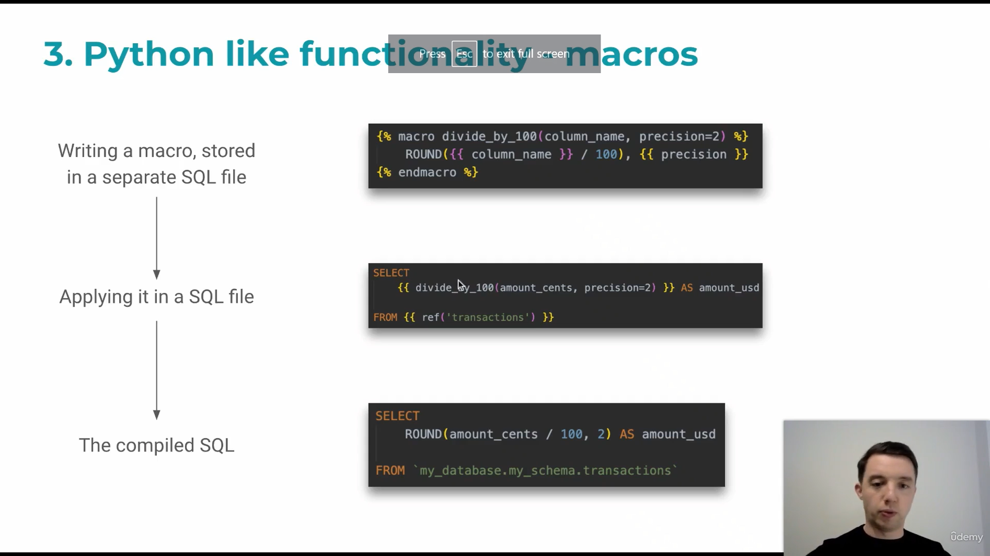

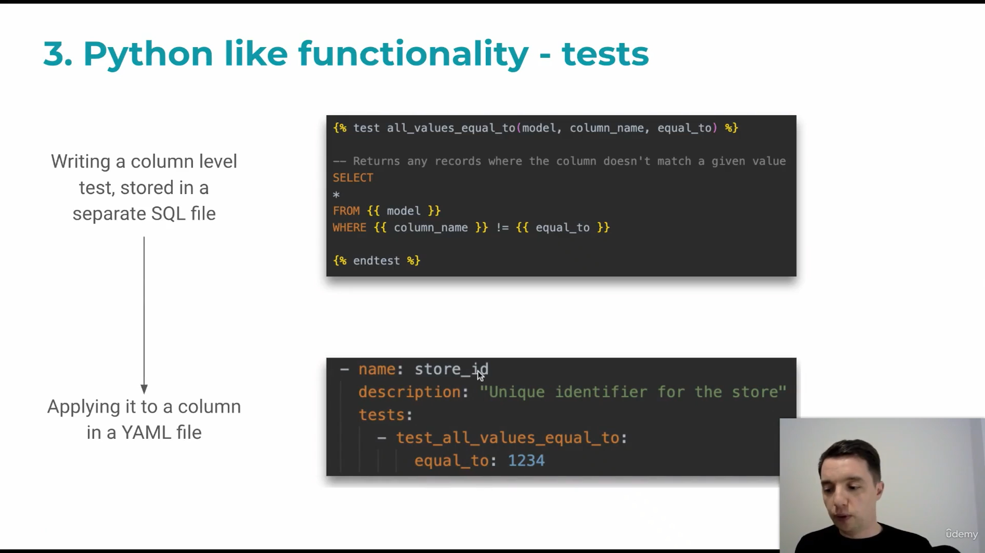

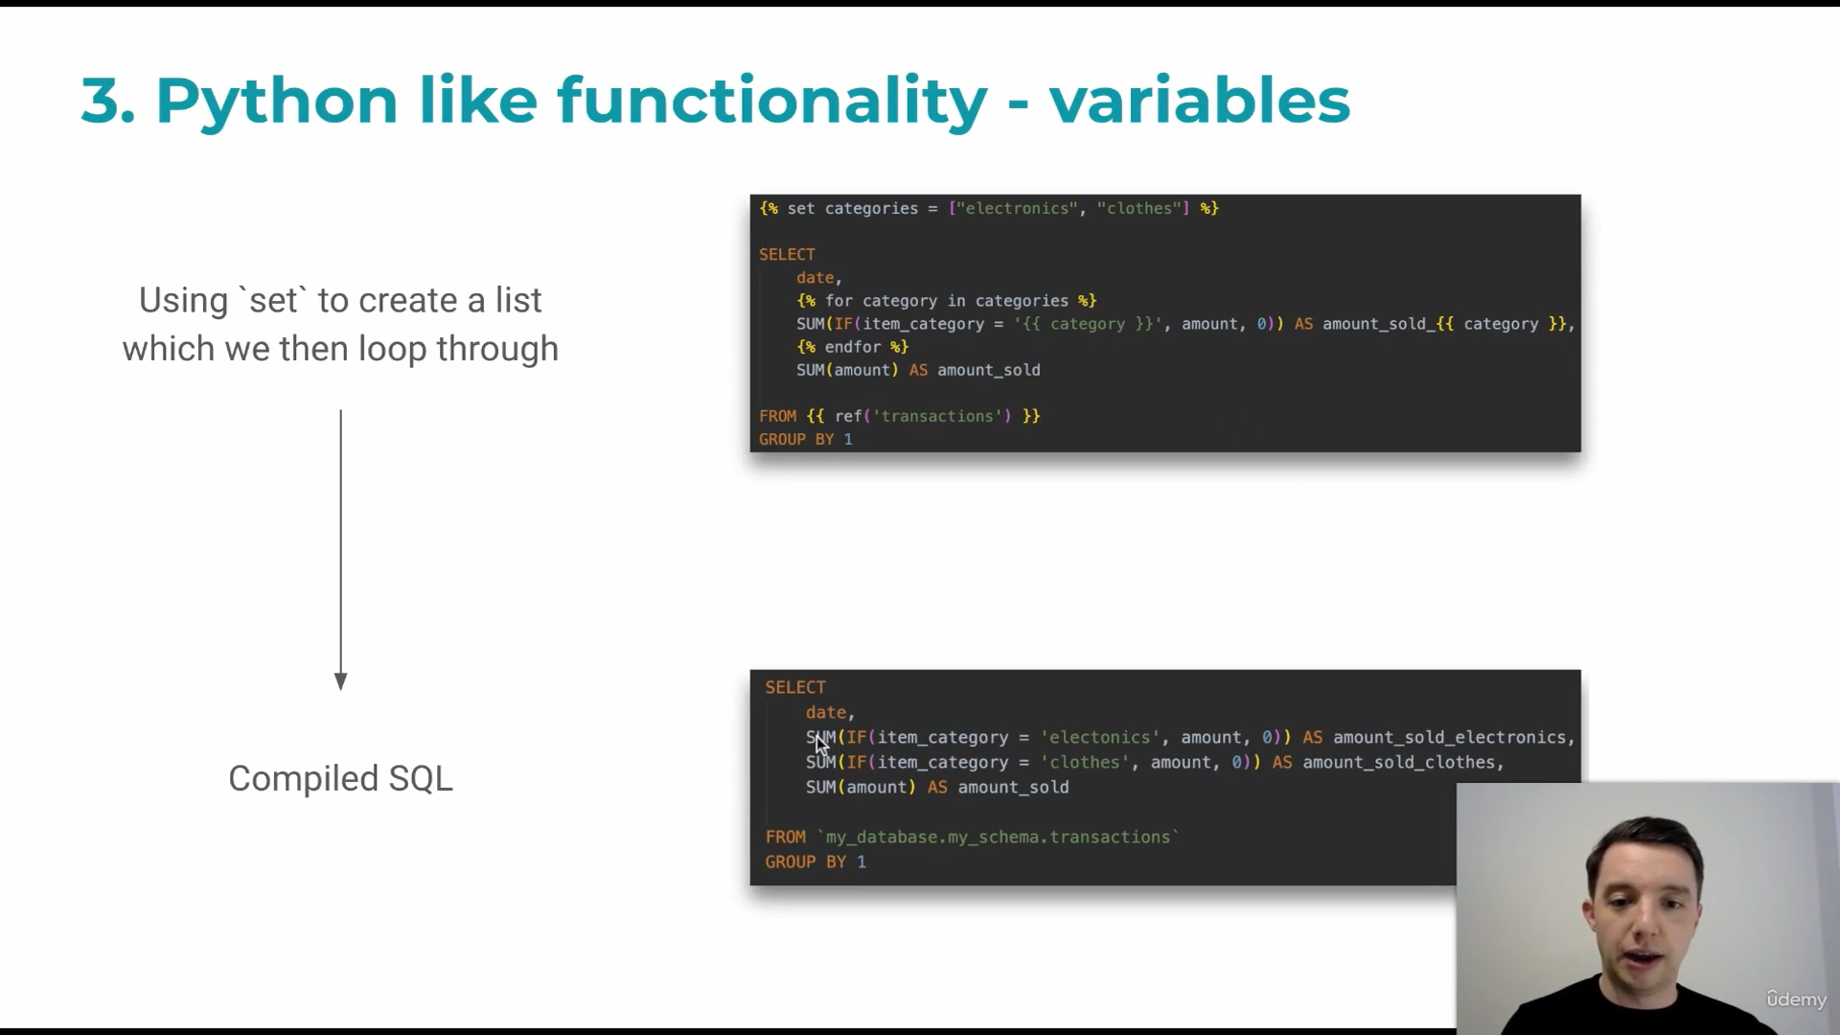

Databricks

Spark

Postgresql

Bigquery

Redshift

Snowflake

Starbust and Trino

Vs code extensions

Better ninja

Dbt power user

Darcula theme for pycharm

Yaml

Add to git ignore