

1. Download vechile sales data -> https://github.com/shashank-mishra219/Hive-Class/blob/main/sales_order_data.csv

**-->sales_order_data.csv**

**In local path - /home/cloudera/sidd/Challenge/sales_order_data.csv**

2. Store raw data into hdfs location

**$ hadoop fs -put /home/cloudera/sidd/Challenge/sales_order_data.csv /sidd/challenge/**

3. Create a internal hive table "sales_order_csv" which will store csv data sales_order_csv .. make sure to skip header row while creating table

**hive> create table sales_order_csv**

**(**

**ORDERNUMBER int,QUANTITYORDERED int,PRICEEACH int,ORDERLINENUMBER int,**

**SALES int,STATUS string,QTR_ID int,MONTH_ID int,YEAR_ID int,PRODUCTLINE string,**

**MSRP int,PRODUCTCODE string,PHONE string,CITY string,STATE string,POSTALCODE int,**

**COUNTRY string,TERRITORY string,CONTACTLASTNAME string,CONTACTFIRSTNAME string,**

**DEALSIZE string**

**)**

**row format delimited**

**fields terminated by ','**

**TBLPROPERTIES(“skip.header.line.count” = “1”);**

4. Load data from hdfs path into "sales_order_csv"

**hive> load data inpath '/sidd/challenge/sales_order_data.csv' into table sales_order_csv;**

**hive> set hive.cli.print.header = true;**

**to show headers in result of select statement.**



5. Create an internal hive table which will store data in ORC format "sales_order_orc"

**hive>**

**create table sales_order_orc**

(**ORDERNUMBER int,QUANTITYORDERED int,PRICEEACH int,ORDERLINENUMBER int,**

**SALES int,STATUS string,QTR_ID int,MONTH_ID int,YEAR_ID int,PRODUCTLINE string,**

**MSRP int,PRODUCTCODE string,PHONE string,CITY string,STATE string,POSTALCODE int,**

**COUNTRY string,TERRITORY string,CONTACTLASTNAME string,CONTACTFIRSTNAME string,**

**DEALSIZE string**

**)**

**stored as ORC;**

6. Load data from "sales_order_csv" into "sales_order_orc"

**hive> from sales_order_csv insert overwrite table sales_order_orc select *;**

**or**

**hive> insert overwrite table sales_order_orc select * from sales_order_csv;**

7. Perform below menioned queries on "sales_order_orc" table :

a. Calculatye total sales per year

**hive> select year_ID as year,sum(sales) as Total_Sales from sales_order_csv group by year_ID ;**

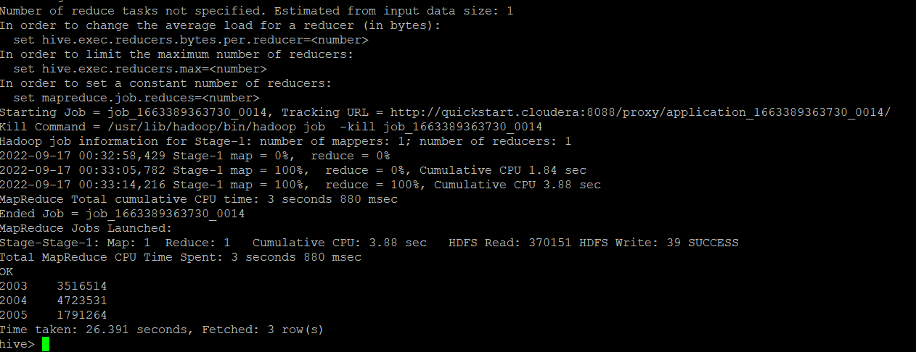



b. Find a product for which maximum orders were placed

**hive> select PRODUCTLINE from (select PRODUCTLINE ,sum(QUANTITYORDERED) max from sales_order_csv group by PRODUCTLINE order by max desc limit 1) a ;**

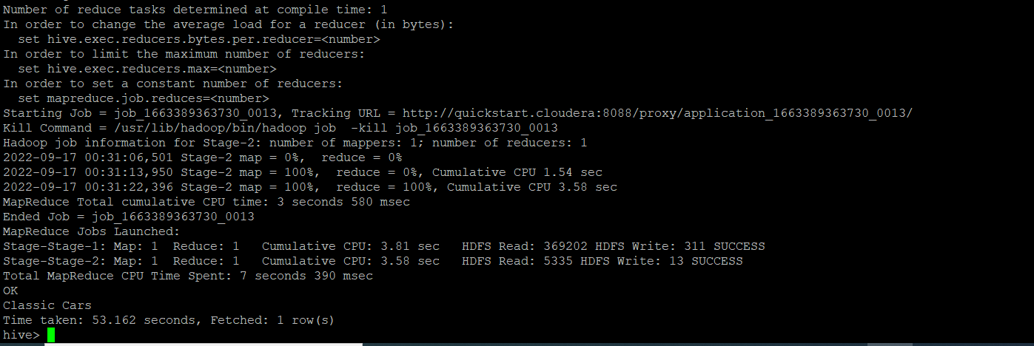

c. Calculate the total sales for each quarter

**hive> select sum(sales) as Total_sales,QTR_ID from sales_order_csv group by QTR_ID order by QTR_ID;**

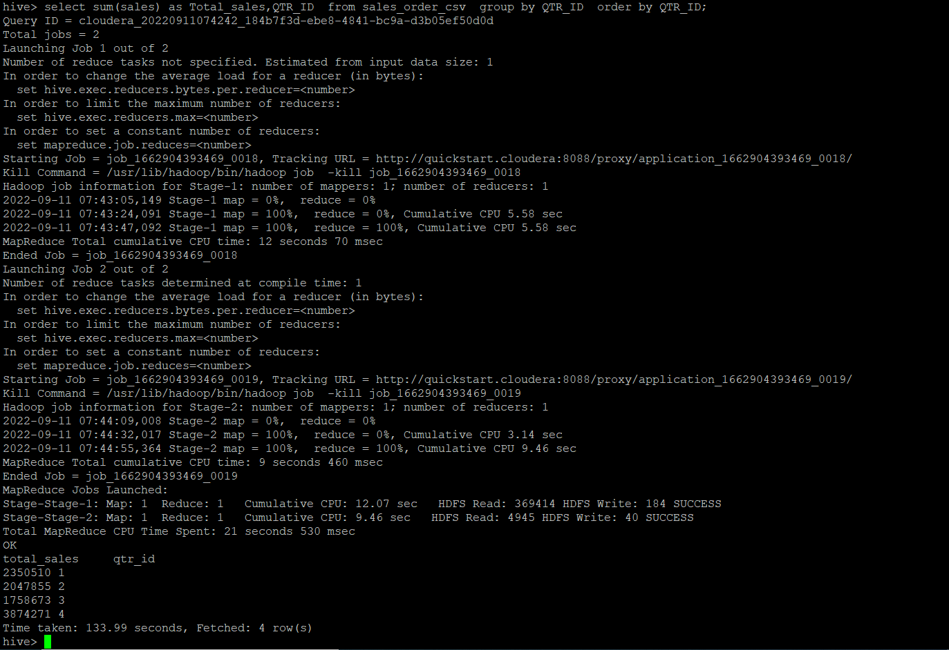

d. In which quarter sales was minimum

**hive> select sum(sales) as sales_order, qtr_id from sales_order_orc group by qtr_id order by sales_order limit 1;**

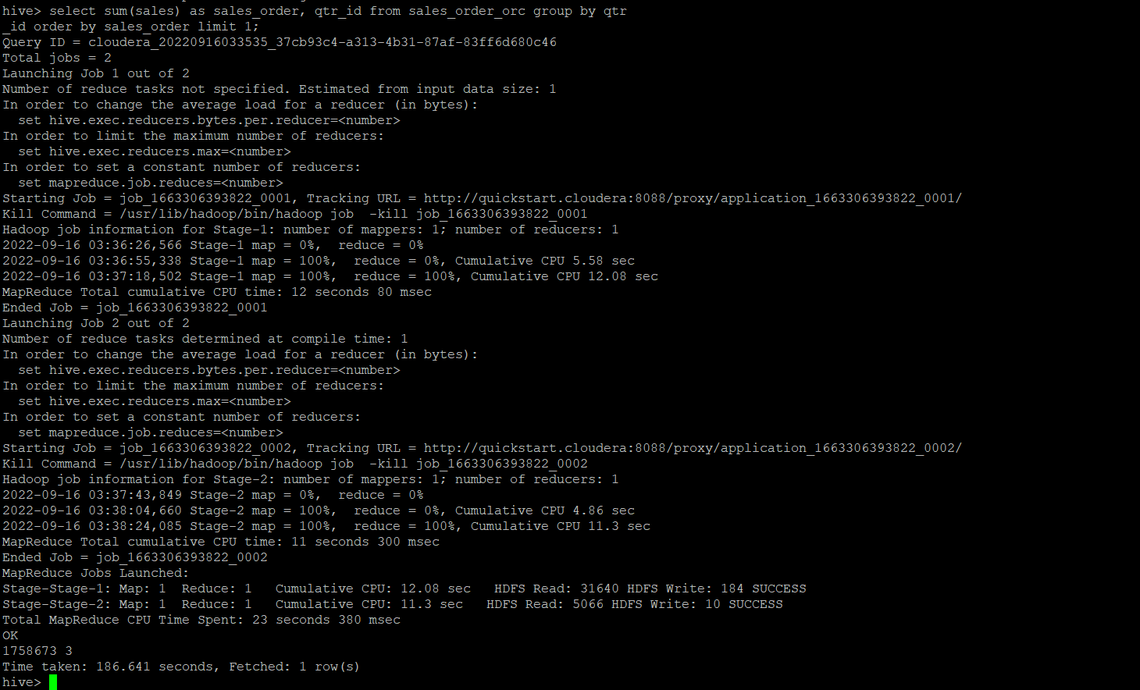

e. In which country sales was maximum and in which country sales was minimum

**hive> select s1.COUNTRY as Country_max_sales from sales_order_csv s1 where s1.sales in (select max(s2.sales) from sales_order_csv s2);**

**hive> select s1.COUNTRY as Country_min_sales from sales_order_csv s1 where s1.sales in (select min(s2.sales) from sales_order_csv s2);**



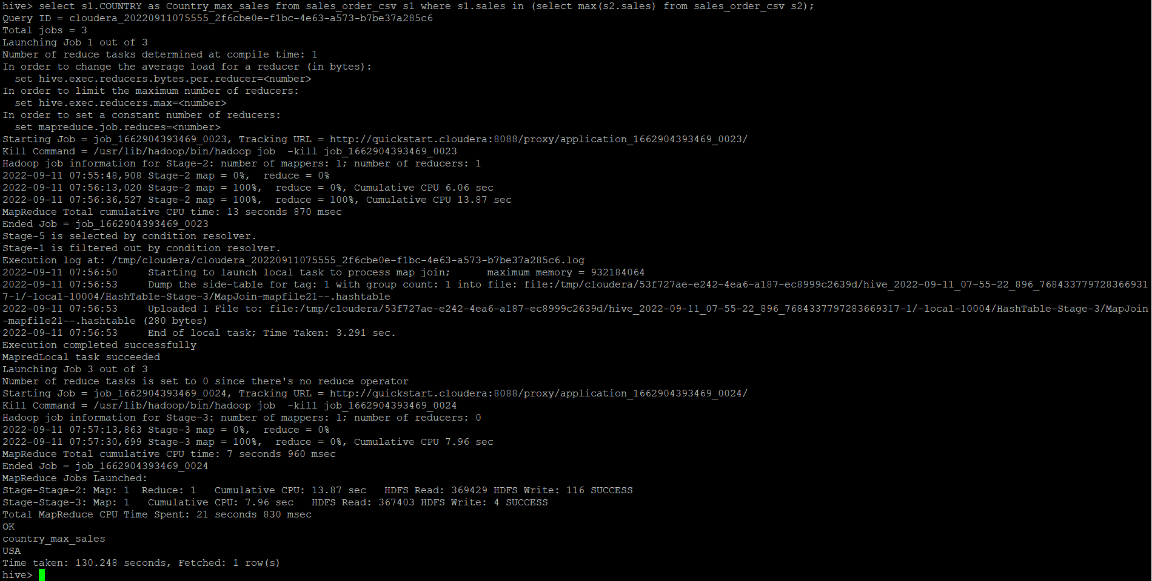

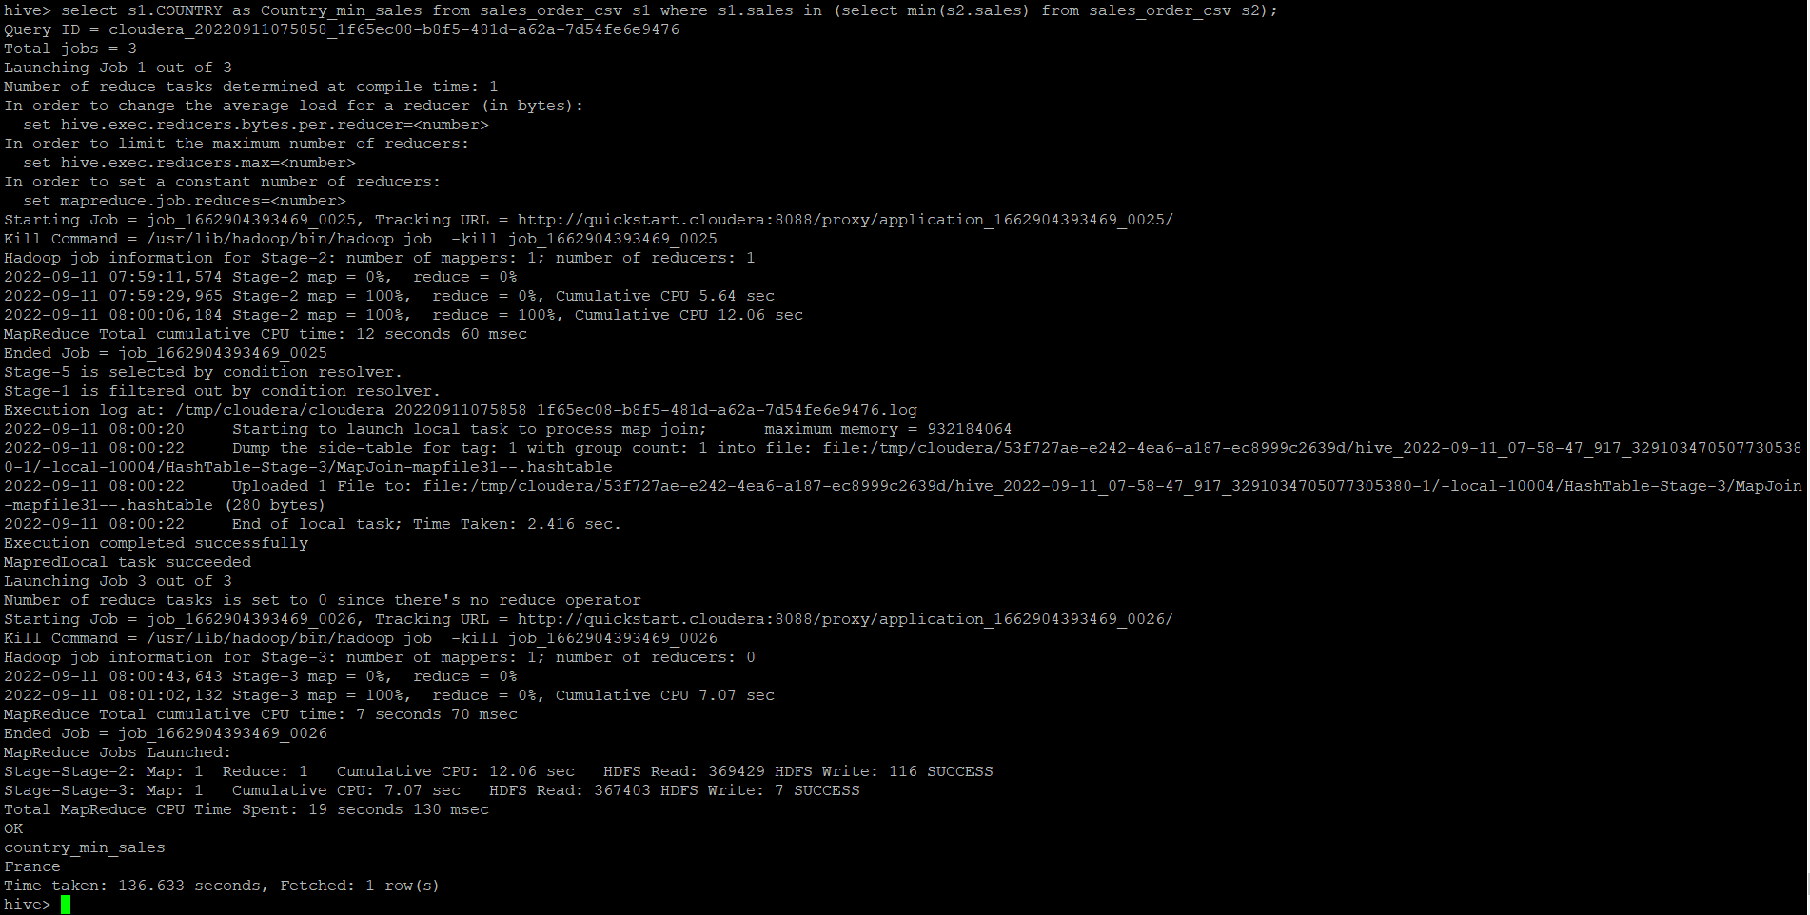

**Hive> select A.country,A.sales from (select country,sales,rank() over (order by sales) rnk_min,rank() over(order by sales desc) rnk_max from sales_order_orc)A where rnk_min = 1 or rnk_max =1 order by sales;**



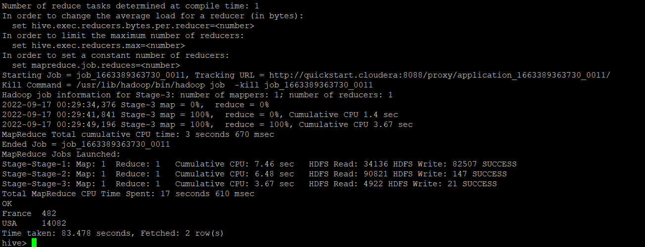

f. Calculate quartelry sales for each city

**hive>select quartelry_sales,city from (select sum(s.sales) as quartelry_sales,s.QTR_ID,s.city from sales_order_csv s group by s.QTR_ID,s.city)a;**

h. Find a month for each year in which maximum number of quantities were sold.

**Hive> select month_id,year_id,QUANTITYORDERED from (select distinct month_id,year_id,QUANTITYORDERED ,dense_rank() over(partition by year_id order by QUANTITYORDERED desc) as rnk from sales_order_csv)a where a.rnk = 1;**

