1. Write a shell script to print the numbers from 1 to 10.

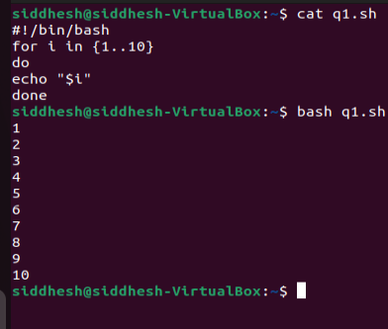

1. Write a shell script to ask the user for their name and print a greeting message.

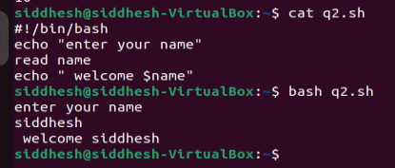

1. Write a shell script to check if a file exists in the current directory and print a message accordingly.

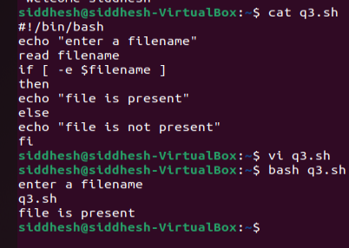

1. Write a shell script to calculate the sum of two numbers entered by the user.

++

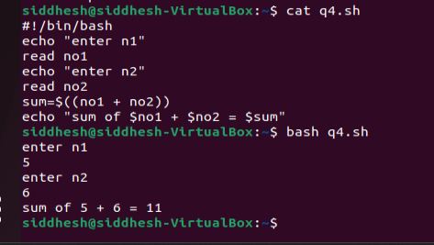

1. Write a shell script to find the largest number among three numbers entered by the user.

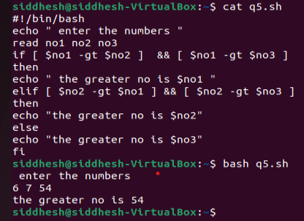

1. Write a shell script to check if a number is odd or even

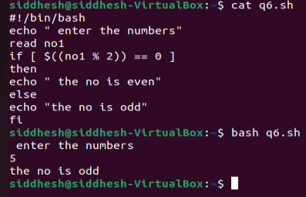

1. Write a shell script to display the contents of a file line by line.