DR VISHWANATH KARAD MIT - WORLD PEACE UNIVERSITY
Department of Computer Engineering and Technology
DBMS MINI PROJECT REPORT
on
FOOD WASTE MANAGEMENT SYSTEM
Course: Database Management Systems
Submitted by
Name | Roll No. | PRN
Vinit Patil | 14 | 1262252115
Siddhesh Patil | 20 | 1262252207
Under the guidance of
Anuradha Nagare
October 2026

ABSTRACT
Large quantities of edible food are discarded every day by hotels, restaurants and households, while many shelters and care homes struggle to feed the people they serve. This project presents a Food Waste Management System, a database-driven web application that connects food donors with NGOs and beneficiaries. The backend is a MySQL database of five normalised tables (Donor, Food, NGO, Beneficiary and Delivery), designed up to Third Normal Form with cascading foreign keys. A trigger automatically reduces food stock when a delivery is created, and a stored procedure validates the stock before a delivery is accepted. Two user roles, Admin and Normal, are enforced with DCL privileges. A Flask-based front end with input validation supports adding, searching, editing and deleting food items and tracking deliveries.

Table of Contents
Abstract i
List of Abbreviations iii
List of Figures iv
List of Tables v
1. Introduction 1
1.1 Motivation 1
1.2 Objectives 1
2. Problem Definition 1
3. Tools and Technologies Used 1
4. Database Design (ER Diagram) 2
4.1 Requirements Analysis and Entities 2
4.2 Relationships 3
4.3 ER Diagram 3
5. Normalization Details 4
5.1 Rough Design (Before Normalization) 4
5.2 Functional Dependencies 4
5.3 First Normal Form (1NF) 4
5.4 Second Normal Form (2NF) 4
5.5 Third Normal Form (3NF) 4
6. Database Schema 5
7. DDL (Data Definition Language) 7
8. DML (Data Manipulation Language) with Results 8
8.1 Insertion of Data 8
8.2 Updation of Data 10
8.3 Deletion of Data 10
8.4 Searching and Retrieval of Data 10
9. DCL (Data Control Language) 13
10. Triggers 15
11. PL/SQL Procedure / Function 16
12. Frontend GUI Screenshots 17
12.1 Login 17
12.2 Food Management (Admin) 18
12.3 Deliveries 21
12.4 Normal User 22
12.5 Validation Summary 22
13. Conclusion 22
14. References 23

List of Abbreviations
Abbreviation | Full form
1NF / 2NF / 3NF | First / Second / Third Normal Form
BCNF | Boyce-Codd Normal Form
CRUD | Create, Read, Update, Delete
CSS | Cascading Style Sheets
DBMS | Database Management System
DCL | Data Control Language
DDL | Data Definition Language
DML | Data Manipulation Language
ER | Entity-Relationship
FD | Functional Dependency
FK | Foreign Key
GUI | Graphical User Interface
HTML | HyperText Markup Language
IEEE | Institute of Electrical and Electronics Engineers
NGO | Non-Governmental Organisation
PK | Primary Key
PRN | Permanent Registration Number
SQL | Structured Query Language
URL | Uniform Resource Locator

List of Figures
Figure 1: Entity-Relationship (ER) diagram of the Food Waste Management System 3
Figure 2: Relational schema with primary keys and foreign key relationships 5
Figure 3: The five tables created in the food_donation database 8
Figure 4: Food table after inserting the sample data (SELECT * FROM Food) 9
Figure 5: MySQL denying an UPDATE on the Food table to normal_user 14
Figure 6: Food stock before the delivery (Chapati and Sabzi = 50) 15
Figure 7: Food stock after CALL AddDelivery(3, 1, 1, 10) (Chapati and Sabzi = 40) 16
Figure 8: Stored procedure rejecting a delivery larger than the stock (MySQL error 1644) 17
Figure 9: Login page 17
Figure 10: Food list as seen by the Admin 18
Figure 11: Searching for food 18
Figure 12: Food list after adding a new item 19
Figure 13: Data validation: expiry date before today is rejected 19
Figure 14: Food list after editing a quantity 20
Figure 15: Confirmation before deleting a food item 20
Figure 16: Delivery created successfully 21
Figure 17: Delivery rejected by the stored procedure 21
Figure 18: Edit form opened by the Normal user (saving is refused by MySQL) 22

List of Tables
Table 1: Tools and technologies used in the project 2
Table 2: Entities and their purpose 2
Table 3: Relationships between the entities 3
Table 4: Result of normalization: relations, keys and functional dependencies 5
Table 5: Donor table (stores food donors) 6
Table 6: Food table (stores surplus food items) 6
Table 7: NGO table (stores NGOs) 6
Table 8: Beneficiary table (stores receiving shelters and homes) 6
Table 9: Delivery table (stores deliveries) 7
Table 10: Privileges of the Admin and Normal users 14
Table 11: Front-end and database validation rules 22

1. Introduction

1.1 Motivation
Hotels, restaurants and households throw away large amounts of edible food every day, while shelters and care homes often struggle to arrange meals. Managing donations by phone or on paper leads to lost records, double collection and food reaching people after its expiry date. A database system keeps every donor, food item, NGO, beneficiary and delivery in one consistent place and enforces the rules automatically, which motivated this project.

1.2 Objectives
- To design a normalised relational database (up to 3NF) for managing surplus food donation and delivery.
- To keep data consistent using primary keys, foreign keys with cascading updates and deletes, a trigger and a stored procedure.
- To provide Admin and Normal users with different privileges using DCL commands.
- To build a web front end with data validation for inserting, updating, deleting and searching data.

2. Problem Definition
A large amount of surplus food from hotels, restaurants, households and other food donors is wasted every day, while many people are in need of food. There is a need for a database system that can efficiently manage and distribute this surplus food.
The proposed Food Waste Management System stores information about Donors, Food, NGOs, Beneficiaries and Deliveries. Donors can register surplus food, NGOs can collect the available food and distribute it to beneficiaries, and deliveries can be tracked to ensure proper transportation.
The system helps to:
- Reduce unnecessary food wastage.
- Connect food donors with NGOs.
- Maintain details of available surplus food.
- Track food collection and delivery.
- Maintain beneficiary records.
- Improve the efficient distribution of surplus food to people in need.
The main entities identified from this problem statement are Donor, Food, NGO, Beneficiary and Delivery.

3. Tools and Technologies Used
The project uses MySQL as the backend, as required by the course specification, and a Python web application as the front end. Table below lists the tools used.
Table 1: Tools and technologies used in the project
Tool / Technology | Purpose
MySQL Community Server 8.4 | Backend relational database: tables, constraints, trigger, stored procedure, users and privileges
MySQL Workbench | Client used to run the SQL scripts and test queries
Python 3 | Programming language of the front-end application
Flask | Python web framework that connects web pages to the database
mysql-connector-python | Python driver used by Flask to run SQL and call the stored procedure
HTML and CSS | Web pages, forms and styling; built-in browser validation (required, min, date limits)
Google Chrome | Browser used to run and test the application
draw.io (diagrams.net) | Initial ER and functional dependency sketches
GitHub | Hosting of the source code and SQL scripts: github.com/siddheshpatilnew/food-donation-dbms

4. Database Design (ER Diagram)

4.1 Requirements Analysis and Entities
From the problem definition, five entities were identified. Each entity became one table, and every table has a single-attribute surrogate primary key generated automatically by the database.
Table 2: Entities and their purpose
Entity | Purpose | Main attributes
Donor | Hotel, restaurant or household that donates surplus food | donor_id, donor_name, phone, email, address, donor_category
Food | A surplus food item registered by a donor | food_id, donor_id, food_name, quantity, food_type, expiry_date, status
NGO | Organisation that collects food and transports it | ngo_id, ngo_name, phone, email, address
Beneficiary | Shelter or home that receives the food | beneficiary_id, beneficiary_name, phone, address, people_count
Delivery | Record of a quantity of food sent by an NGO to a beneficiary | delivery_id, food_id, ngo_id, beneficiary_id, delivery_date, quantity, delivery_status

4.2 Relationships
Table 3: Relationships between the entities
Relationship | Entities | Cardinality | Meaning
DONATES | Donor - Food | 1 : M | One donor can donate many food items; each food item belongs to one donor
DELIVERED IN | Food - Delivery | 1 : M | One food item can be sent in many deliveries (in parts); each delivery carries one food item
HANDLES | NGO - Delivery | 1 : M | One NGO can handle many deliveries; each delivery is handled by one NGO
RECEIVES | Beneficiary - Delivery | 1 : M | One beneficiary can receive many deliveries; each delivery goes to one beneficiary

4.3 ER Diagram
Figure below shows the ER diagram. Delivery is the associative entity that links Food, NGO and Beneficiary, which is why it holds three foreign keys. All relationships are one-to-many.
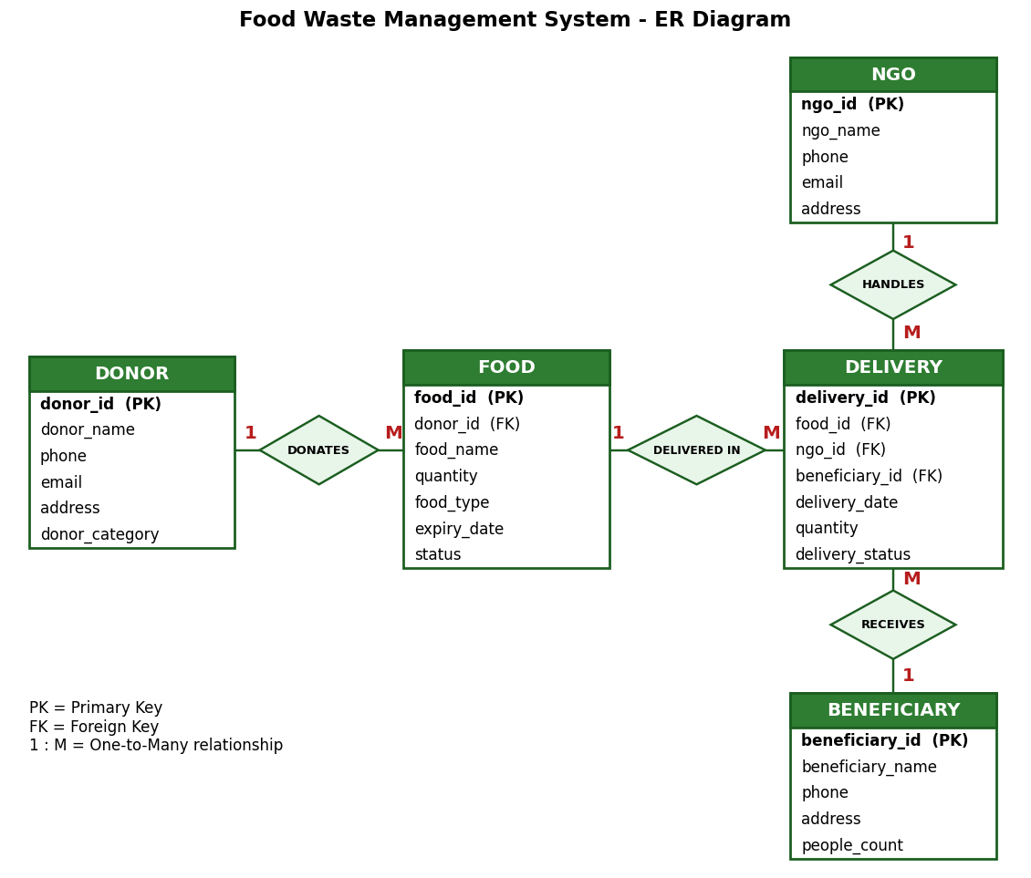
Figure 1: Entity-Relationship (ER) diagram of the Food Waste Management System

5. Normalization Details

5.1 Rough Design (Before Normalization)
A first rough design kept everything in one relation, FoodDelivery, with delivery_id as the primary key:
FoodDelivery(delivery_id, delivery_date, delivery_quantity, delivery_status,
food_id, food_name, quantity, food_type, expiry_date, food_status,
donor_id, donor_name, donor_phone, donor_email, donor_address, donor_category,
ngo_id, ngo_name, ngo_phone, ngo_email, ngo_address,
beneficiary_id, beneficiary_name, beneficiary_phone, beneficiary_address, people_count)

This design repeats donor, NGO and beneficiary details in every delivery row. It causes insertion anomalies (a donor cannot be stored until a delivery exists), update anomalies (changing an NGO's phone number needs many row updates) and deletion anomalies (deleting the last delivery of a food item loses the food and donor details).

5.2 Functional Dependencies
delivery_id -> delivery_date, delivery_quantity, delivery_status,
food_id, ngo_id, beneficiary_id
food_id -> food_name, quantity, food_type, expiry_date, food_status, donor_id
donor_id -> donor_name, donor_phone, donor_email, donor_address, donor_category
ngo_id -> ngo_name, ngo_phone, ngo_email, ngo_address
beneficiary_id -> beneficiary_name, beneficiary_phone, beneficiary_address, people_count

5.3 First Normal Form (1NF)
A relation is in 1NF if all attributes are atomic and there are no repeating groups. Every column here holds a single value, and a delivery of several foods is stored as several rows, so the relation is in 1NF.

5.4 Second Normal Form (2NF)
A relation is in 2NF if it is in 1NF and no non-key attribute depends on part of a composite key. The key delivery_id is a single attribute, so there is no partial dependency and the relation is in 2NF. The redundancy that remains comes from transitive dependencies, removed next.

5.5 Third Normal Form (3NF)
A relation is in 3NF if it is in 2NF and no non-key attribute depends on another non-key attribute (no transitive dependency). In FoodDelivery we have delivery_id -> food_id and food_id -> food_name (and similarly for donor, NGO and beneficiary). These transitive dependencies are removed by decomposing the relation into five relations, one for each determinant.
In every resulting relation, each non-key attribute depends only on the primary key, and every determinant is a candidate key, so all five relations are in 3NF (and also in BCNF). The foreign keys food_id, donor_id, ngo_id and beneficiary_id keep the relations connected and let the original data be recovered by joins without loss.
Table 4: Result of normalization: relations, keys and functional dependencies
Relation | Primary key | Foreign keys | Functional dependency | Normal form
Donor | donor_id | - | donor_id -> donor_name, phone, email, address, donor_category | 3NF
Food | food_id | donor_id | food_id -> donor_id, food_name, quantity, food_type, expiry_date, status | 3NF
NGO | ngo_id | - | ngo_id -> ngo_name, phone, email, address | 3NF
Beneficiary | beneficiary_id | - | beneficiary_id -> beneficiary_name, phone, address, people_count | 3NF
Delivery | delivery_id | food_id, ngo_id, beneficiary_id | delivery_id -> food_id, ngo_id, beneficiary_id, delivery_date, quantity, delivery_status | 3NF

6. Database Schema
Figure below shows the relational schema obtained by converting the ER diagram. The arrows point from each foreign key to the primary key it references. Foreign keys are defined with ON DELETE CASCADE and ON UPDATE CASCADE, so that deleting or changing a parent row automatically deletes or updates the dependent child rows.
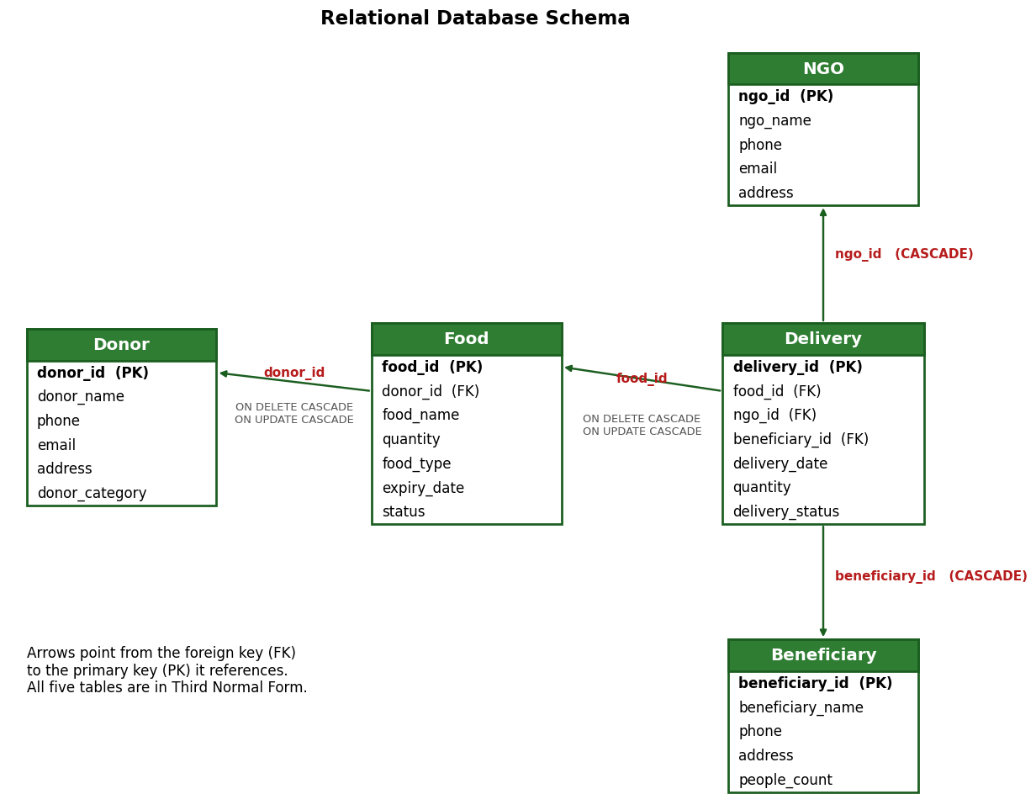
Figure 2: Relational schema with primary keys and foreign key relationships
Table 5: Donor table (stores food donors)
Column | Data type | Constraints
donor_id | INT | PRIMARY KEY, AUTO_INCREMENT
donor_name | VARCHAR(100) | NOT NULL
phone | VARCHAR(15)
email | VARCHAR(100)
address | VARCHAR(200)
donor_category | VARCHAR(50) | Hotel, Restaurant or Household

Table 6: Food table (stores surplus food items)
Column | Data type | Constraints
food_id | INT | PRIMARY KEY, AUTO_INCREMENT
donor_id | INT | FOREIGN KEY -> Donor(donor_id), ON DELETE CASCADE, ON UPDATE CASCADE
food_name | VARCHAR(100) | NOT NULL
quantity | INT | CHECK (quantity >= 0)
food_type | VARCHAR(50)
expiry_date | DATE
status | VARCHAR(30) | DEFAULT 'Available'

Table 7: NGO table (stores NGOs)
Column | Data type | Constraints
ngo_id | INT | PRIMARY KEY, AUTO_INCREMENT
ngo_name | VARCHAR(100) | NOT NULL
phone | VARCHAR(15)
email | VARCHAR(100)
address | VARCHAR(200)

Table 8: Beneficiary table (stores receiving shelters and homes)
Column | Data type | Constraints
beneficiary_id | INT | PRIMARY KEY, AUTO_INCREMENT
beneficiary_name | VARCHAR(100) | NOT NULL
phone | VARCHAR(15)
address | VARCHAR(200)
people_count | INT | Number of people served

Table 9: Delivery table (stores deliveries)
Column | Data type | Constraints
delivery_id | INT | PRIMARY KEY, AUTO_INCREMENT
food_id | INT | FOREIGN KEY -> Food(food_id), ON DELETE CASCADE, ON UPDATE CASCADE
ngo_id | INT | FOREIGN KEY -> NGO(ngo_id), ON DELETE CASCADE, ON UPDATE CASCADE
beneficiary_id | INT | FOREIGN KEY -> Beneficiary(beneficiary_id), ON DELETE CASCADE, ON UPDATE CASCADE
delivery_date | DATE
quantity | INT | CHECK (quantity > 0)
delivery_status | VARCHAR(30) | DEFAULT 'In Transit'

7. DDL (Data Definition Language)
The following script (database.sql) creates the database food_donation and its five tables with all primary key, foreign key, NOT NULL, CHECK and DEFAULT constraints.
DROP DATABASE IF EXISTS food_donation;
CREATE DATABASE food_donation;
USE food_donation;

CREATE TABLE Donor (
donor_id INT PRIMARY KEY AUTO_INCREMENT,
donor_name VARCHAR(100) NOT NULL,
phone VARCHAR(15),
email VARCHAR(100),
address VARCHAR(200),
donor_category VARCHAR(50)
);

CREATE TABLE NGO (
ngo_id INT PRIMARY KEY AUTO_INCREMENT,
ngo_name VARCHAR(100) NOT NULL,
phone VARCHAR(15),
email VARCHAR(100),
address VARCHAR(200)
);

CREATE TABLE Beneficiary (
beneficiary_id INT PRIMARY KEY AUTO_INCREMENT,
beneficiary_name VARCHAR(100) NOT NULL,
phone VARCHAR(15),
address VARCHAR(200),
people_count INT
);

CREATE TABLE Food (
food_id INT PRIMARY KEY AUTO_INCREMENT,
donor_id INT,
food_name VARCHAR(100) NOT NULL,
quantity INT CHECK (quantity >= 0),
food_type VARCHAR(50),
expiry_date DATE,
status VARCHAR(30) DEFAULT 'Available',
FOREIGN KEY (donor_id) REFERENCES Donor(donor_id)
ON DELETE CASCADE ON UPDATE CASCADE
);

CREATE TABLE Delivery (
delivery_id INT PRIMARY KEY AUTO_INCREMENT,
food_id INT,
ngo_id INT,
beneficiary_id INT,
delivery_date DATE,
quantity INT CHECK (quantity > 0),
delivery_status VARCHAR(30) DEFAULT 'In Transit',
FOREIGN KEY (food_id) REFERENCES Food(food_id)
ON DELETE CASCADE ON UPDATE CASCADE,
FOREIGN KEY (ngo_id) REFERENCES NGO(ngo_id)
ON DELETE CASCADE ON UPDATE CASCADE,
FOREIGN KEY (beneficiary_id) REFERENCES Beneficiary(beneficiary_id)
ON DELETE CASCADE ON UPDATE CASCADE
);

After running the script, the SHOW TABLES command lists the five tables, as shown below.
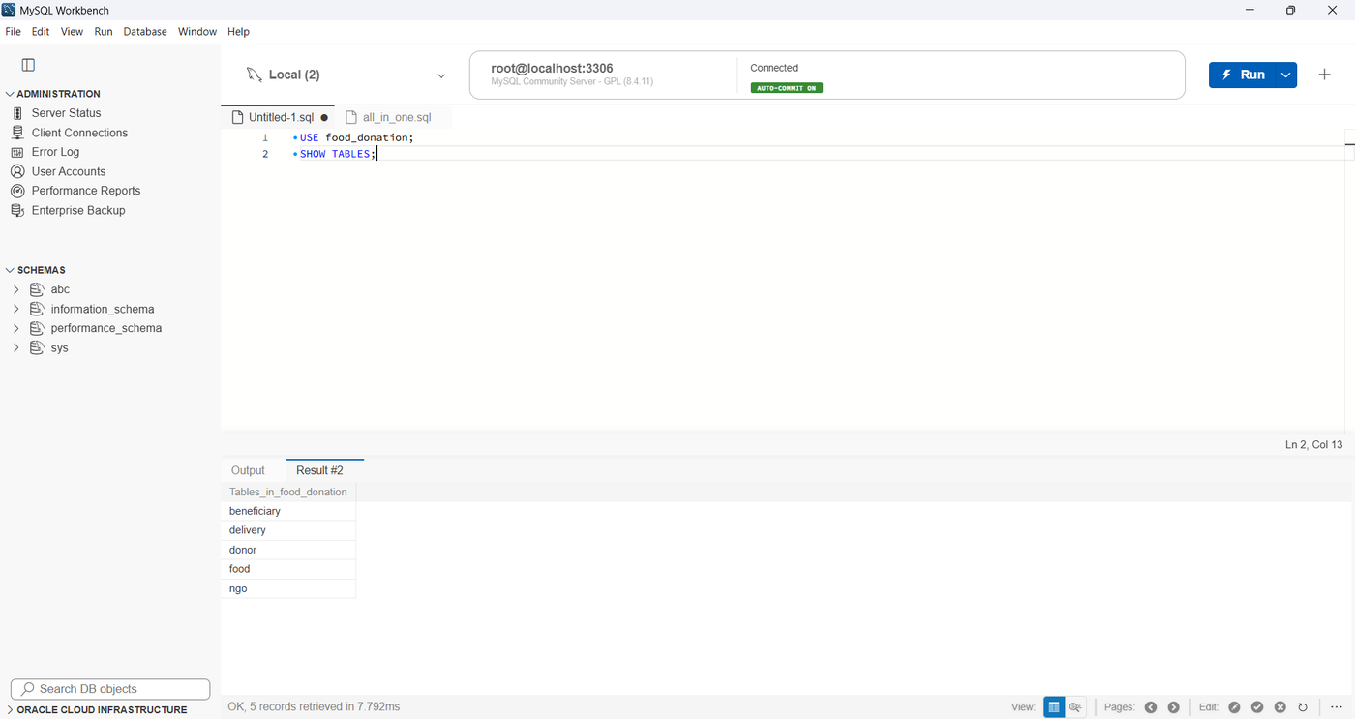
Figure 3: The five tables created in the food_donation database

8. DML (Data Manipulation Language) with Results
The four basic operations required by the specification are implemented and demonstrated: insertion, updation, deletion and searching of data. Query results shown in this chapter were obtained on the sample data set described below.

8.1 Insertion of Data
Sample data is inserted into the four master tables using the script data.sql. The primary keys are generated automatically.
USE food_donation;

INSERT INTO Donor (donor_name, phone, email, address, donor_category) VALUES
('Taj Hotel', '9876543210', 'taj@gmail.com', 'Mumbai', 'Hotel'),
('Food Corner Restaurant', '9876543211', 'foodcorner@gmail.com', 'Pune', 'Restaurant'),
('Aditya Household', '9876543212', 'aditya@gmail.com', 'Pune', 'Household'),
('Grand Restaurant', '9876543213', 'grand@gmail.com', 'Mumbai', 'Restaurant');

INSERT INTO NGO (ngo_name, phone, email, address) VALUES
('Helping Hands NGO', '9000000001', 'helpinghands@gmail.com', 'Pune'),
('Food For All', '9000000002', 'foodforall@gmail.com', 'Mumbai'),
('Care Foundation', '9000000003', 'care@gmail.com', 'Nashik');

INSERT INTO Beneficiary (beneficiary_name, phone, address, people_count) VALUES
('Hope Shelter', '8000000001', 'Pune', 50),
('Children Care Home', '8000000002', 'Mumbai', 35),
('Old Age Home', '8000000003', 'Nashik', 40);

INSERT INTO Food (donor_id, food_name, quantity, food_type, expiry_date, status) VALUES
(1, 'Rice and Dal', 100, 'Cooked Food', '2026-11-24', 'Available'),
(2, 'Vegetable Biryani', 80, 'Cooked Food', '2026-11-23', 'Available'),
(3, 'Chapati and Sabzi', 50, 'Cooked Food', '2026-11-23', 'Available'),
(4, 'Bread and Sandwiches', 60, 'Bakery', '2026-11-25', 'Available');

The Food table after the insertion is shown below.
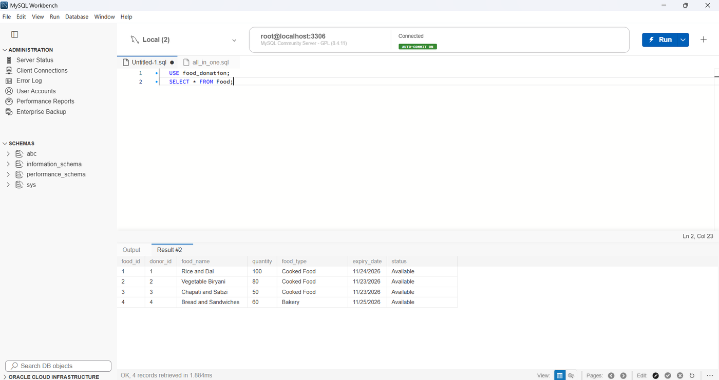
Figure 4: Food table after inserting the sample data (SELECT * FROM Food)
Deliveries are inserted by calling the stored procedure AddDelivery(food_id, ngo_id, beneficiary_id, quantity), described in Chapter 11. For each call, the trigger described in Chapter 10 reduces the stock of the delivered food item automatically:
CALL AddDelivery(1, 1, 1, 50); -- Rice and Dal
CALL AddDelivery(2, 2, 2, 40); -- Vegetable Biryani
CALL AddDelivery(3, 1, 1, 30); -- Chapati and Sabzi
CALL AddDelivery(4, 3, 3, 20); -- Bread and Sandwiches

A test row is also inserted into Food, to be deleted in Section 8.3:
INSERT INTO Food (donor_id, food_name, quantity, food_type, expiry_date, status)
VALUES (4, 'Test Food', 20, 'Cooked Food', '2026-11-25', 'Available');

8.2 Updation of Data
Existing rows are changed with UPDATE statements. Foreign key values changed in a parent table are propagated to child tables because of ON UPDATE CASCADE.
UPDATE Delivery SET delivery_status = 'Delivered' WHERE delivery_id IN (1, 2, 4);
UPDATE Food SET quantity = 70 WHERE food_id = 2;
UPDATE Food SET status = 'Collected' WHERE food_id = 1;
UPDATE Delivery SET delivery_status = 'Delivered' WHERE delivery_id = 3;

8.3 Deletion of Data
A row is removed with DELETE. Because of ON DELETE CASCADE, deleting a food item also deletes its delivery records, and deleting a donor deletes that donor's food items (and through them the related deliveries), so that no orphan records are left.
DELETE FROM Food WHERE food_name = 'Test Food';

8.4 Searching and Retrieval of Data
The queries below cover selection, filtering, sorting, aggregate functions, grouping, joins (inner, left, full outer and multi-table), LIKE and HAVING. Each query is followed by its result.
Query 1: All food items
SELECT * FROM Food;
Result:
food_id | donor_id | food_name | quantity | food_type | expiry_date | status
1 | 1 | Rice and Dal | 50 | Cooked Food | 2026-11-24 | Collected
2 | 2 | Vegetable Biryani | 70 | Cooked Food | 2026-11-23 | Available
3 | 3 | Chapati and Sabzi | 20 | Cooked Food | 2026-11-23 | Available
4 | 4 | Bread and Sandwiches | 40 | Bakery | 2026-11-25 | Available

Query 2: All deliveries
SELECT * FROM Delivery;
Result:
delivery_id | food_id | ngo_id | beneficiary_id | delivery_date | quantity | delivery_status
1 | 1 | 1 | 1 | 2026-10-23 | 50 | Delivered
2 | 2 | 2 | 2 | 2026-10-23 | 40 | Delivered
3 | 3 | 1 | 1 | 2026-10-23 | 30 | Delivered
4 | 4 | 3 | 3 | 2026-10-23 | 20 | Delivered

Query 3: Searching: food that is available
SELECT *
FROM Food
WHERE status = 'Available';
Result:
food_id | donor_id | food_name | quantity | food_type | expiry_date | status
2 | 2 | Vegetable Biryani | 70 | Cooked Food | 2026-11-23 | Available
3 | 3 | Chapati and Sabzi | 20 | Cooked Food | 2026-11-23 | Available
4 | 4 | Bread and Sandwiches | 40 | Bakery | 2026-11-25 | Available

Query 4: Sorting: food by quantity (highest first)
SELECT *
FROM Food
ORDER BY quantity DESC;
Result:
food_id | donor_id | food_name | quantity | food_type | expiry_date | status
2 | 2 | Vegetable Biryani | 70 | Cooked Food | 2026-11-23 | Available
1 | 1 | Rice and Dal | 50 | Cooked Food | 2026-11-24 | Collected
4 | 4 | Bread and Sandwiches | 40 | Bakery | 2026-11-25 | Available
3 | 3 | Chapati and Sabzi | 20 | Cooked Food | 2026-11-23 | Available

Query 5: Total quantity of food
SELECT SUM(quantity) AS Total_Food
FROM Food;
Result:
Total_Food
180

Query 6: GROUP BY: total quantity per food type
SELECT food_type,
SUM(quantity) AS Total_Quantity
FROM Food
GROUP BY food_type;
Result:
food_type | Total_Quantity
Bakery | 40
Cooked Food | 140

Query 7: INNER JOIN: food with its donor
SELECT Food.food_id, Food.food_name,
Food.quantity, Donor.donor_name
FROM Food
INNER JOIN Donor
ON Food.donor_id = Donor.donor_id;
Result:
food_id | food_name | quantity | donor_name
1 | Rice and Dal | 50 | Taj Hotel
2 | Vegetable Biryani | 70 | Food Corner Restaurant
3 | Chapati and Sabzi | 20 | Aditya Household
4 | Bread and Sandwiches | 40 | Grand Restaurant

Query 8: LEFT JOIN: all food, with donor if any
SELECT Food.food_id, Food.food_name,
Donor.donor_name
FROM Food
LEFT JOIN Donor
ON Food.donor_id = Donor.donor_id;
Result:
food_id | food_name | donor_name
1 | Rice and Dal | Taj Hotel
2 | Vegetable Biryani | Food Corner Restaurant
3 | Chapati and Sabzi | Aditya Household
4 | Bread and Sandwiches | Grand Restaurant

Query 9: FULL OUTER JOIN (LEFT JOIN UNION RIGHT JOIN)
SELECT Food.food_id, Food.food_name, Donor.donor_name
FROM Food
LEFT JOIN Donor ON Food.donor_id = Donor.donor_id
UNION
SELECT Food.food_id, Food.food_name, Donor.donor_name
FROM Donor
LEFT JOIN Food ON Donor.donor_id = Food.donor_id;
Result:
food_id | food_name | donor_name
1 | Rice and Dal | Taj Hotel
2 | Vegetable Biryani | Food Corner Restaurant
3 | Chapati and Sabzi | Aditya Household
4 | Bread and Sandwiches | Grand Restaurant

Query 10: Multi-table INNER JOIN: complete delivery details
SELECT Delivery.delivery_id, Food.food_name,
NGO.ngo_name, Beneficiary.beneficiary_name,
Delivery.quantity, Delivery.delivery_date,
Delivery.delivery_status
FROM Delivery
INNER JOIN Food ON Delivery.food_id = Food.food_id
INNER JOIN NGO ON Delivery.ngo_id = NGO.ngo_id
INNER JOIN Beneficiary
ON Delivery.beneficiary_id = Beneficiary.beneficiary_id;
Result:
delivery_id | food_name | ngo_name | beneficiary_name | quantity | delivery_date | delivery_status
1 | Rice and Dal | Helping Hands NGO | Hope Shelter | 50 | 2026-10-23 | Delivered
2 | Vegetable Biryani | Food For All | Children Care Home | 40 | 2026-10-23 | Delivered
3 | Chapati and Sabzi | Helping Hands NGO | Hope Shelter | 30 | 2026-10-23 | Delivered
4 | Bread and Sandwiches | Care Foundation | Old Age Home | 20 | 2026-10-23 | Delivered

Query 11: LIKE: donors whose name contains 'Restaurant'
SELECT *
FROM Donor
WHERE donor_name LIKE '%Restaurant%';
Result:
donor_id | donor_name | phone | email | address | donor_category
2 | Food Corner Restaurant | 9876543211 | foodcorner@gmail.com | Pune | Restaurant
4 | Grand Restaurant | 9876543213 | grand@gmail.com | Mumbai | Restaurant

Query 12: HAVING: food types with total quantity above 50
SELECT food_type,
SUM(quantity) AS Total_Quantity
FROM Food
GROUP BY food_type
HAVING SUM(quantity) > 50;
Result:
food_type | Total_Quantity
Cooked Food | 140

9. DCL (Data Control Language)
Two types of users are created, Admin and Normal, and privileges are given with the GRANT command. The Admin user has full control of the database. The Normal user can only view all data, add new food items and create deliveries (through the stored procedure); it cannot update or delete anything.
DROP USER IF EXISTS 'admin_user'@'localhost';
DROP USER IF EXISTS 'normal_user'@'localhost';

CREATE USER 'admin_user'@'localhost' IDENTIFIED BY 'Admin@123';
CREATE USER 'normal_user'@'localhost' IDENTIFIED BY 'Normal@123';

GRANT ALL PRIVILEGES ON food_donation.* TO 'admin_user'@'localhost';

GRANT SELECT ON food_donation.* TO 'normal_user'@'localhost';
GRANT INSERT ON food_donation.Food TO 'normal_user'@'localhost';
GRANT EXECUTE ON PROCEDURE food_donation.AddDelivery TO 'normal_user'@'localhost';

FLUSH PRIVILEGES;

Table 10: Privileges of the Admin and Normal users
Operation | admin_user | normal_user
SELECT (view and search all tables) | Allowed | Allowed
INSERT into Food (add food) | Allowed | Allowed
EXECUTE AddDelivery (create delivery) | Allowed | Allowed
UPDATE (edit food, mark delivery delivered) | Allowed | Denied
DELETE (delete food) | Allowed | Denied
DDL (create, alter, drop objects) | Allowed | Denied

The web application uses these accounts directly: when a person logs in as admin, the application connects to MySQL as admin_user; when a person logs in as user, it connects as normal_user. The privileges are therefore enforced by MySQL itself and not only by hiding buttons on the page. The Normal user can still create deliveries because a stored procedure runs with the rights of its definer, so the user needs only the EXECUTE privilege and no direct INSERT right on the Delivery table.
Figure below shows the result when the Normal user opens the edit page of a food item (by typing its address) and presses Save: MySQL refuses the UPDATE.
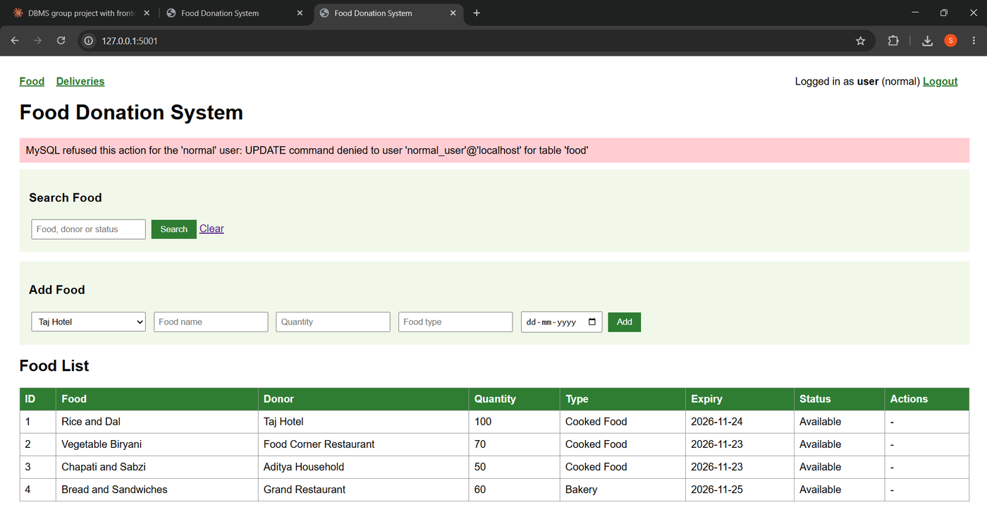
Figure 5: MySQL denying an UPDATE on the Food table to normal_user

10. Triggers
The trigger after_delivery_insert fires automatically after every new row is inserted into Delivery. It subtracts the delivered quantity from the stock of the corresponding food item and sets the status of the food to Delivered when its stock reaches zero. In this way the stock is always correct, whichever program inserts the delivery.
DELIMITER //

CREATE TRIGGER after_delivery_insert
AFTER INSERT ON Delivery
FOR EACH ROW
BEGIN
UPDATE Food
SET quantity = quantity - NEW.quantity,
status = IF(quantity = 0, 'Delivered', status)
WHERE food_id = NEW.food_id;
END//

DELIMITER ;

Testing the trigger: the Food table is displayed, a delivery of 10 units of Chapati and Sabzi (food_id 3) is created, and the table is displayed again. The stock of Chapati and Sabzi falls from 50 to 40 without any other statement. (Vegetable Biryani shows 70 in the second figure because 10 units of it had already been delivered earlier through the web page.)
Figure 6: Food stock before the delivery (Chapati and Sabzi = 50)
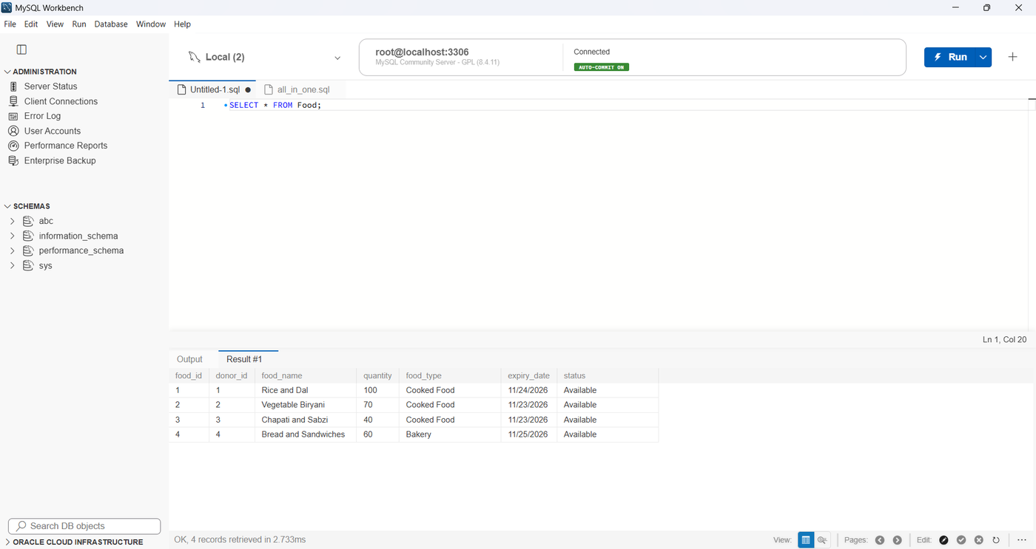
Figure 7: Food stock after CALL AddDelivery(3, 1, 1, 10) (Chapati and Sabzi = 40)

11. PL/SQL Procedure / Function
MySQL stored programs use a procedural extension of SQL that is similar to PL/SQL. The stored procedure AddDelivery(food, NGO, beneficiary, quantity) first reads the available stock of the food item. If the food item does not exist, or the requested quantity is more than the stock, it stops with an error message using SIGNAL; otherwise it inserts the delivery with today's date and the status In Transit, which then fires the trigger of Chapter 10.
DELIMITER //

CREATE PROCEDURE AddDelivery(
IN p_food_id INT,
IN p_ngo_id INT,
IN p_beneficiary_id INT,
IN p_qty INT
)
BEGIN
DECLARE stock INT;

SELECT quantity INTO stock FROM Food WHERE food_id = p_food_id;

IF stock IS NULL THEN
SIGNAL SQLSTATE '45000' SET MESSAGE_TEXT = 'Food item not found';
ELSEIF p_qty > stock THEN
SIGNAL SQLSTATE '45000' SET MESSAGE_TEXT = 'Not enough stock available';
ELSE
INSERT INTO Delivery (food_id, ngo_id, beneficiary_id, delivery_date, quantity, delivery_status)
VALUES (p_food_id, p_ngo_id, p_beneficiary_id, CURDATE(), p_qty, 'In Transit');
END IF;
END//

DELIMITER ;

Testing the procedure with a quantity (500) larger than the available stock gives the error "Not enough stock available" and no delivery is created:
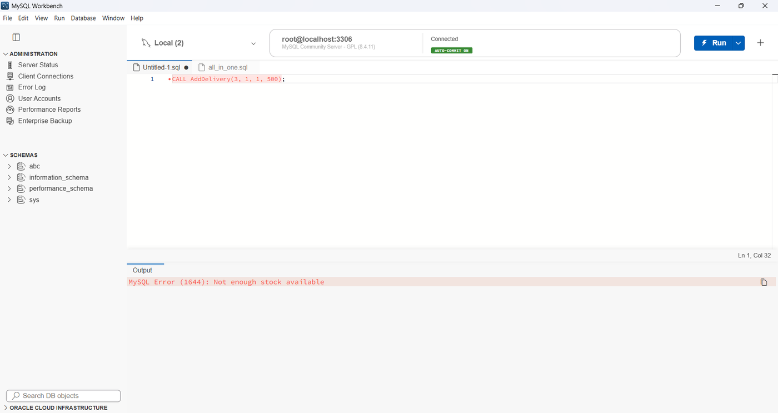
Figure 8: Stored procedure rejecting a delivery larger than the stock (MySQL error 1644)

12. Frontend GUI Screenshots
The front end is a Flask web application with HTML pages. It runs on the local machine at http://127.0.0.1:5001 and connects to MySQL using the privileges of the logged-in user. The source code is available at github.com/siddheshpatilnew/food-donation-dbms.

12.1 Login
Every page requires login. The Admin logs in as admin and the Normal user as user.
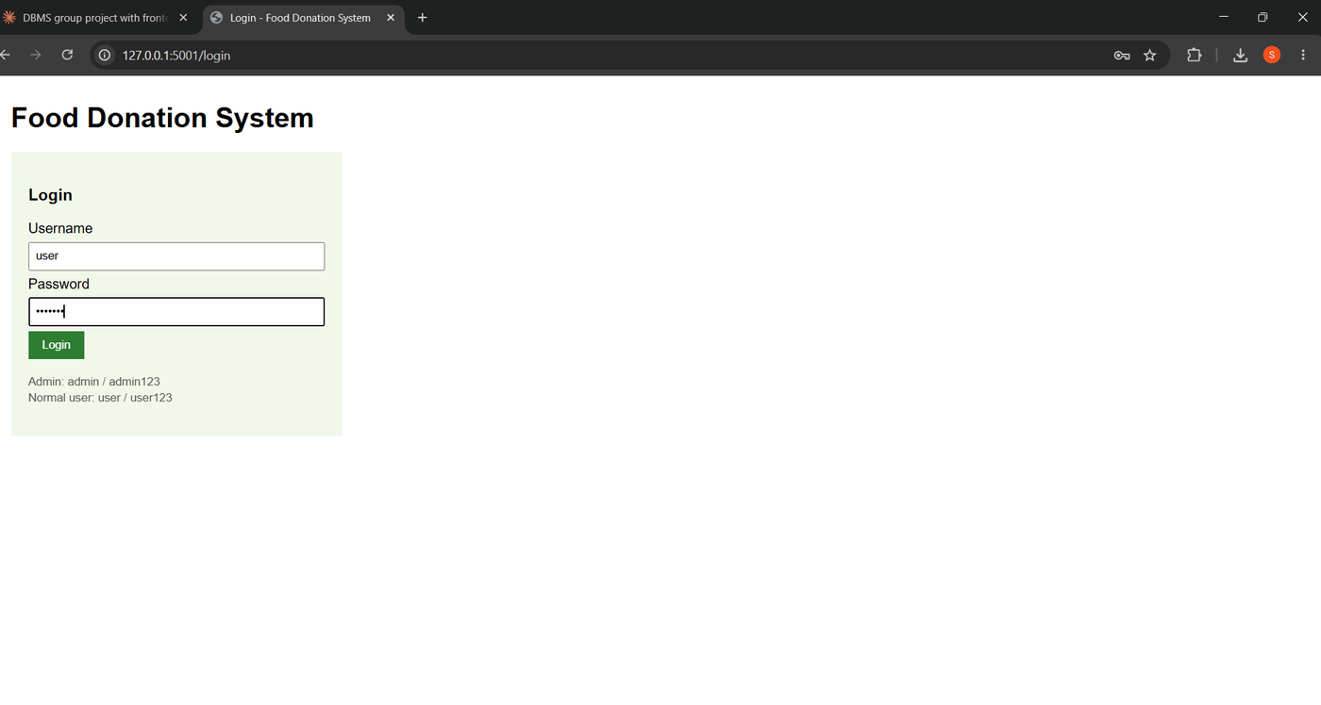
Figure 9: Login page

12.2 Food Management (Admin)
The Admin sees the complete food list with Search and Add Food forms and with Edit and Delete buttons on every row.
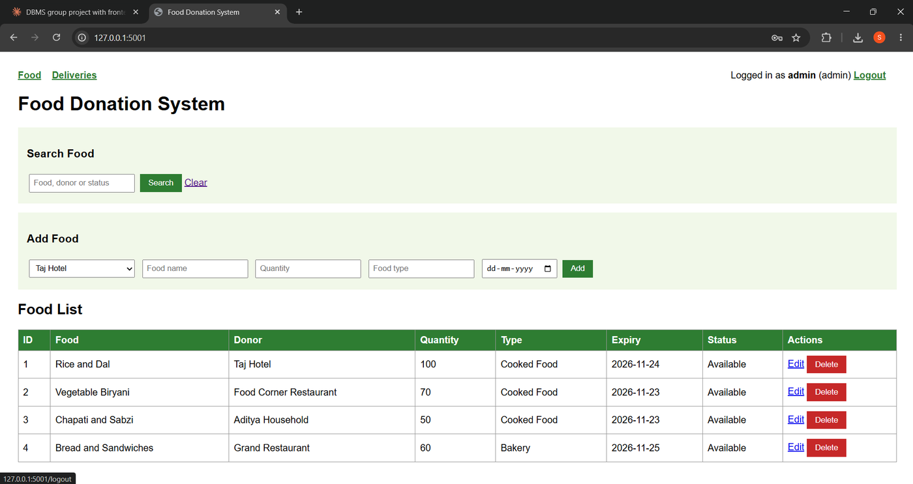
Figure 10: Food list as seen by the Admin
Searching. Typing a food name, donor name or status shows only the matching rows (here, the search word Biryani).
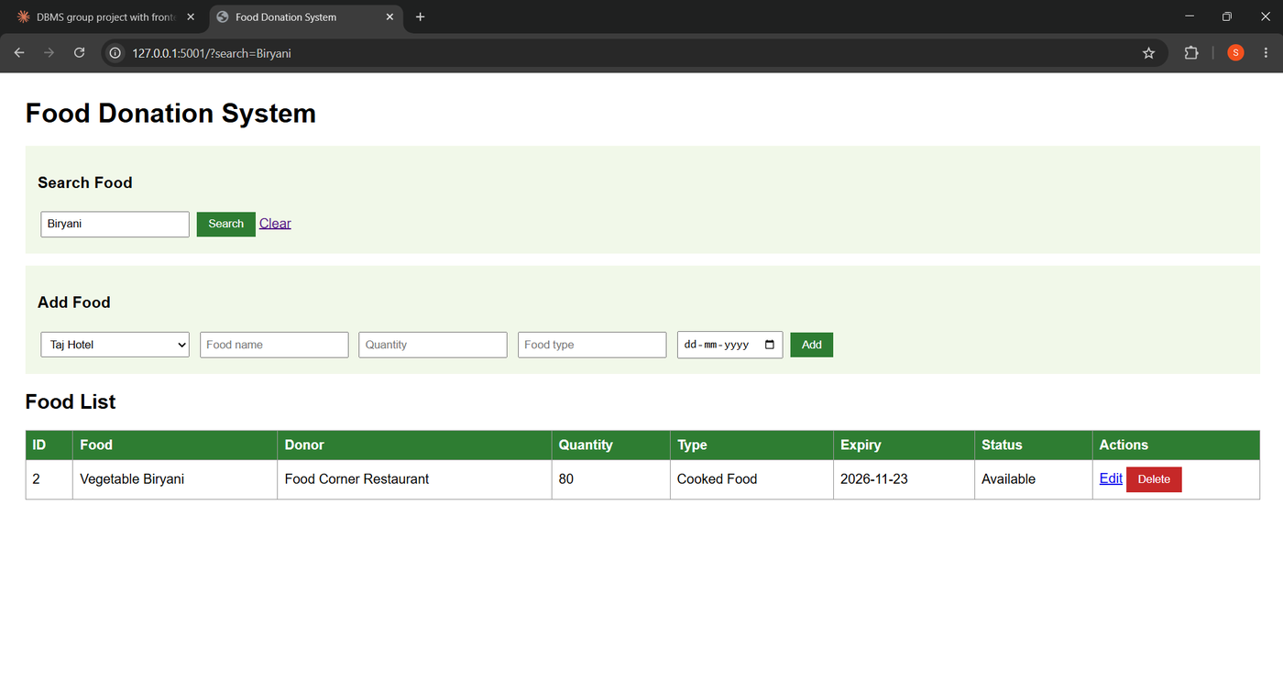
Figure 11: Searching for food
Insertion. A new food item is added with the Add Food form; the new row (Fruit Salad) appears in the list.
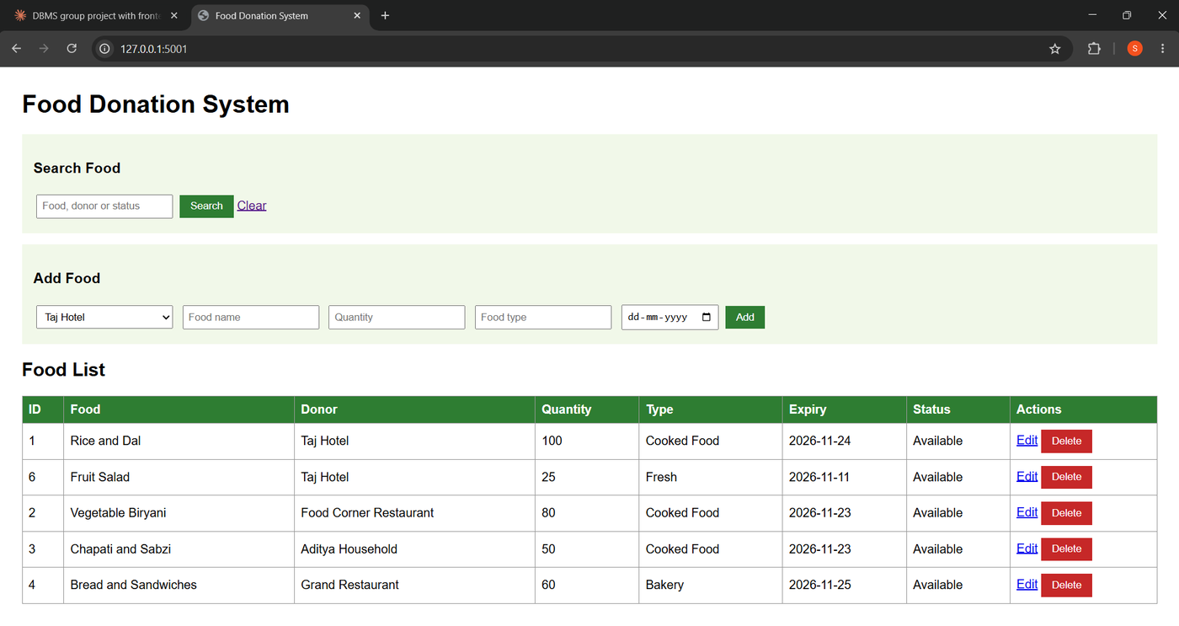
Figure 12: Food list after adding a new item
Validation. The form checks the data before it is sent to the database. In the example below the expiry date is in the past, so the browser blocks the form and shows a message.
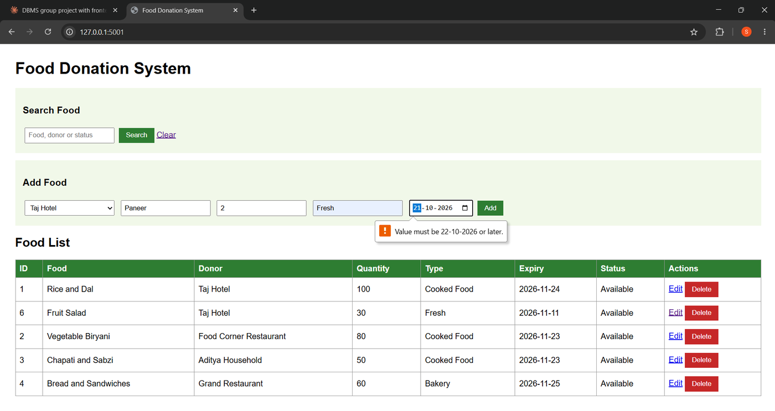
Figure 13: Data validation: expiry date before today is rejected
Updation. The Edit link opens a form filled with the current values. After changing the quantity of Fruit Salad from 25 to 30 and pressing Save, the list shows the new value.
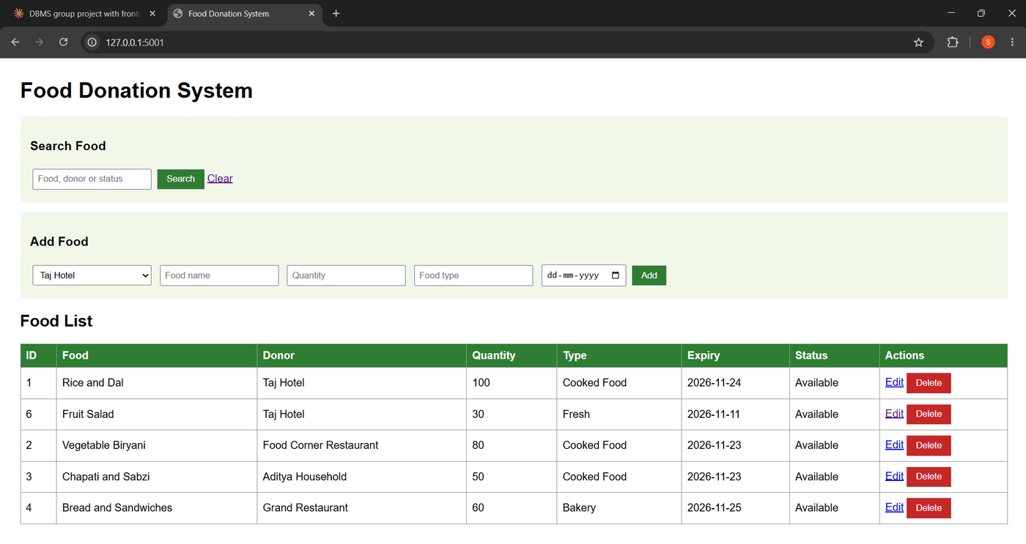
Figure 14: Food list after editing a quantity
Deletion. The Delete button asks for confirmation before the row is removed.
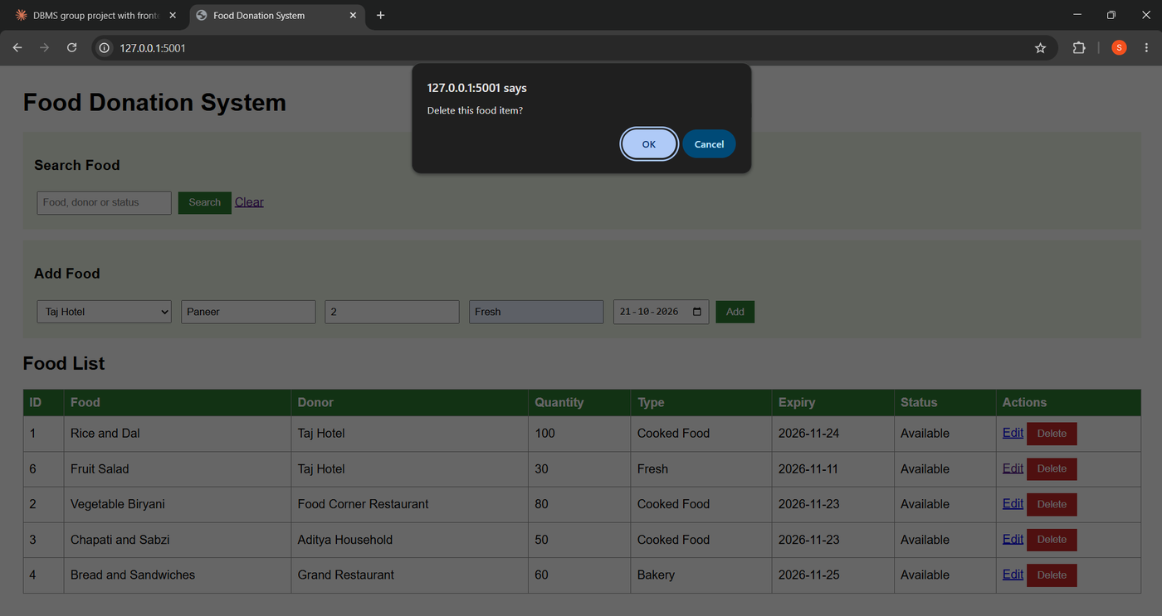
Figure 15: Confirmation before deleting a food item

12.3 Deliveries
The Deliveries page lets a user choose a food item, an NGO, a beneficiary and a quantity. The page calls the stored procedure AddDelivery; the trigger then reduces the stock.
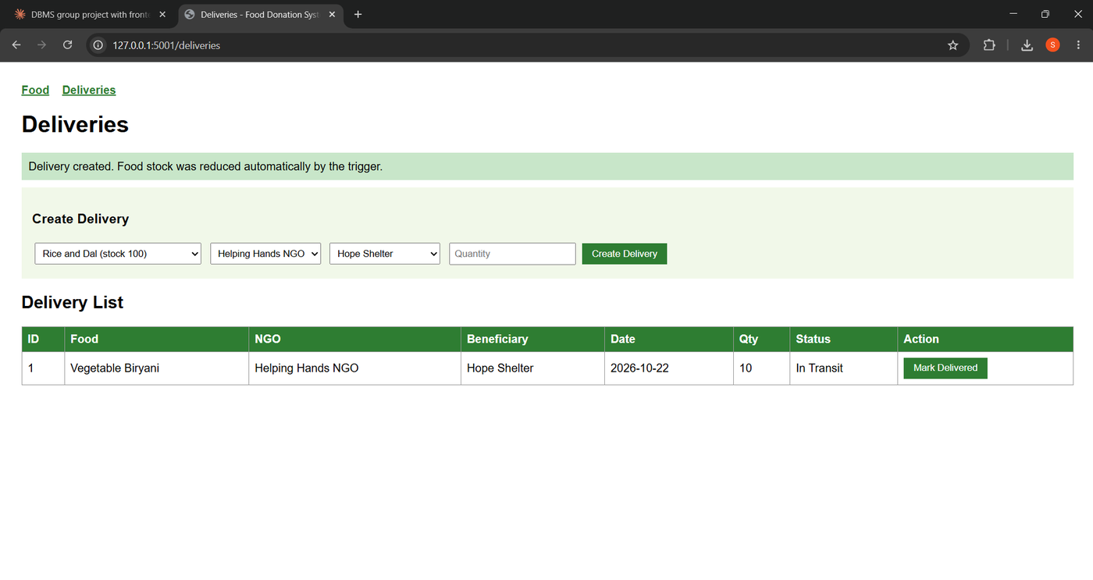
Figure 16: Delivery created successfully
If the quantity is more than the stock, the procedure rejects the delivery and the page shows the message from MySQL.
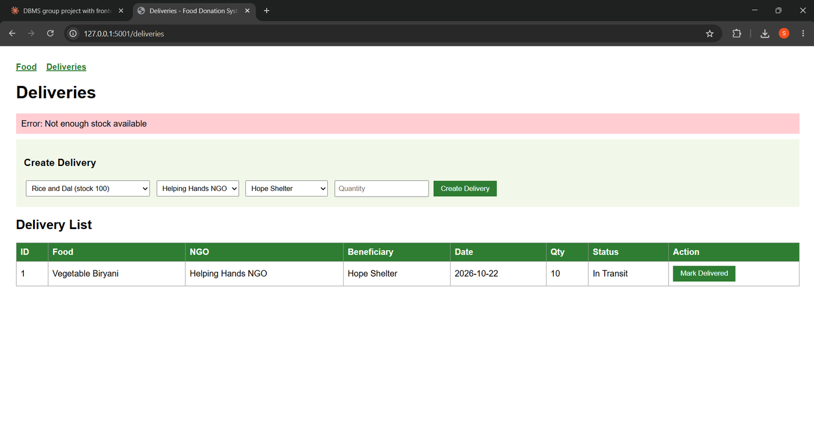
Figure 17: Delivery rejected by the stored procedure

12.4 Normal User
When logged in as the Normal user, the Edit and Delete buttons are not shown. If the user opens an edit address directly, the form is displayed (viewing is allowed) but saving it is refused by MySQL, as shown in Figure 5.
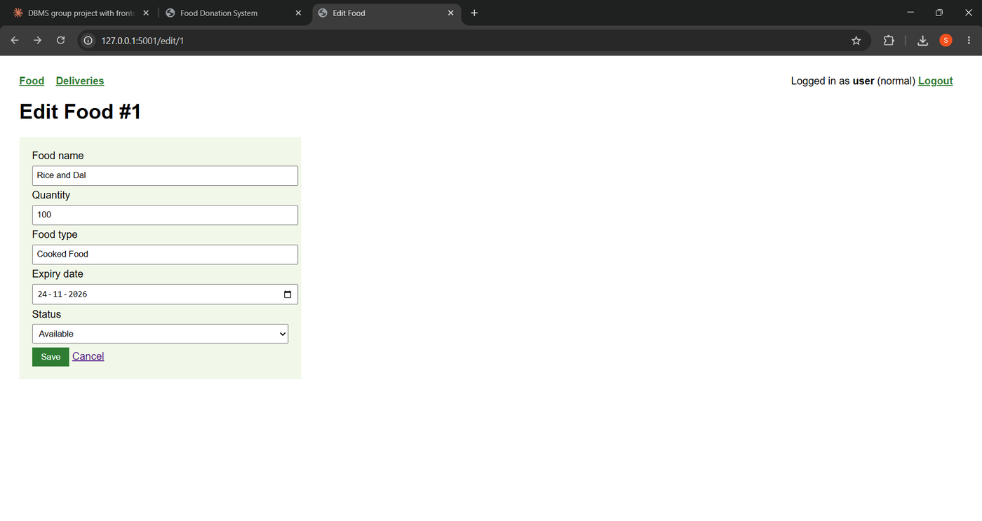
Figure 18: Edit form opened by the Normal user (saving is refused by MySQL)

12.5 Validation Summary
Table 11: Front-end and database validation rules
Field | Rule | Enforced by
Donor, food name, food type | Required (cannot be empty) | HTML required attribute; NOT NULL for names
Quantity (add food) | Number, at least 1 | HTML min and type attributes; CHECK (quantity >= 0)
Expiry date | Required, cannot be before today | HTML date input with min attribute
Delivery quantity | Number, at least 1, not more than the stock | HTML min attribute; procedure AddDelivery; CHECK (quantity > 0)
Delete | Asks for confirmation | JavaScript confirm dialog
Login | Wrong username or password is rejected | Flask login check
Privileges | Normal user cannot update or delete | MySQL GRANT (DCL)

13. Conclusion
The Food Waste Management System shows how a well-designed relational database can support a real social need. The data was analysed and normalised into five tables in Third Normal Form, converted from the ER diagram into a schema with primary keys and cascading foreign keys, and implemented in MySQL. Insertion, updation, deletion and searching work correctly and keep the data consistent. The trigger and the stored procedure move the stock logic into the database, which guarantees correct stock whichever program is used, and the DCL privileges separate the powers of the Admin and the Normal user. The Flask front end with validation makes all of this usable by non-technical people.
Future scope. The system can be extended with automatic alerts for food close to expiry, matching of donors to the nearest NGO, a registration page for new donors and NGOs, password hashing and a separate users table, and a mobile application.

14. References
[1] R. Elmasri and S. B. Navathe, Fundamentals of Database Systems, 7th ed. Hoboken, NJ, USA: Pearson, 2016.
[2] A. Silberschatz, H. F. Korth, and S. Sudarshan, Database System Concepts, 7th ed. New York, NY, USA: McGraw-Hill, 2019.
[3] E. F. Codd, "A relational model of data for large shared data banks," Commun. ACM, vol. 13, no. 6, pp. 377-387, Jun. 1970.
[4] Oracle Corporation, "MySQL 8.4 Reference Manual." [Online]. Available: https://dev.mysql.com/doc/refman/8.4/en/. [Accessed: Oct. 22, 2026].
[5] Pallets, "Flask Documentation." [Online]. Available: https://flask.palletsprojects.com/. [Accessed: Oct. 22, 2026].
[6] Oracle Corporation, "MySQL Connector/Python Developer Guide." [Online]. Available: https://dev.mysql.com/doc/connector-python/en/. [Accessed: Oct. 22, 2026].
[7] V. Patil and S. Patil, "Food Donation DBMS - project source code and SQL scripts." [Online]. Available: https://github.com/siddheshpatilnew/food-donation-dbms. [Accessed: Oct. 23, 2026].

