**Practical 1**

**Installation of virtualbox and cloudera**

**Steps:-**

https://www.virtualbox.org/wiki/Downloads

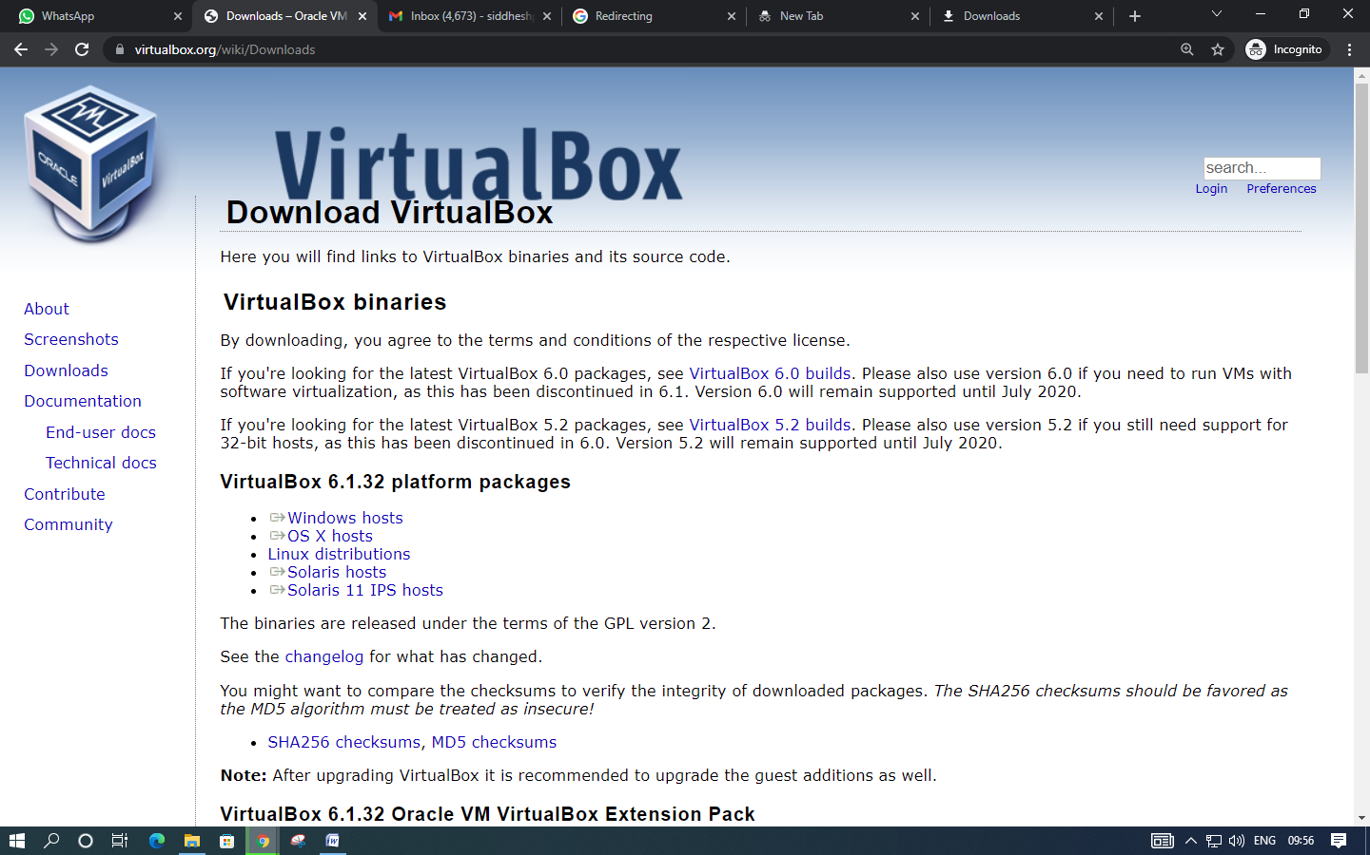

Open virtual box

then go to file

Select import appliance option

Click on folder icon to select ovf file

Select cloudera quickstart vm.ovf file

Click next

Click import in appliance settings window

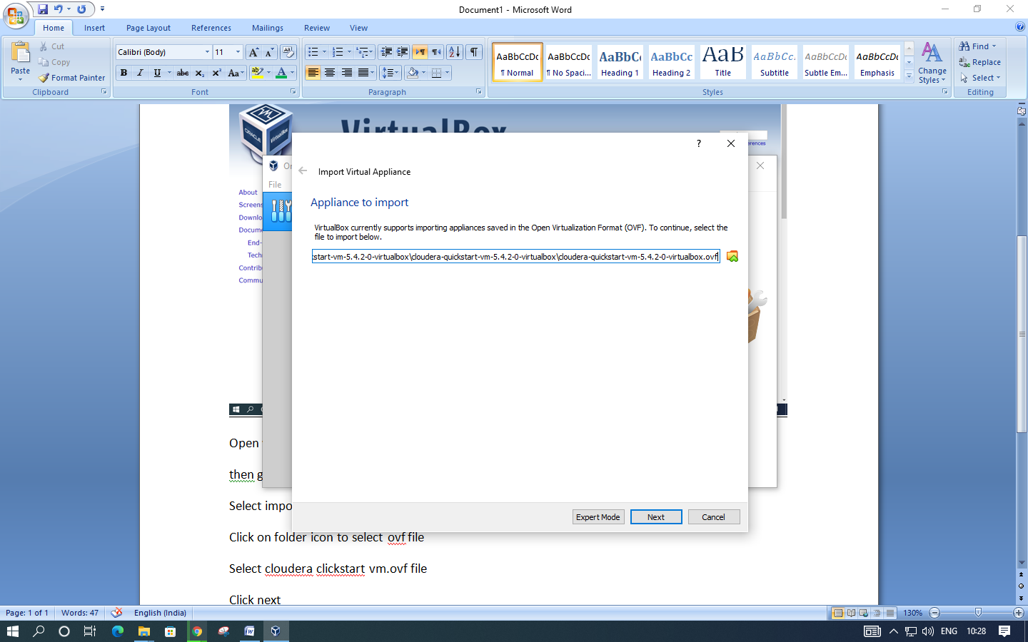

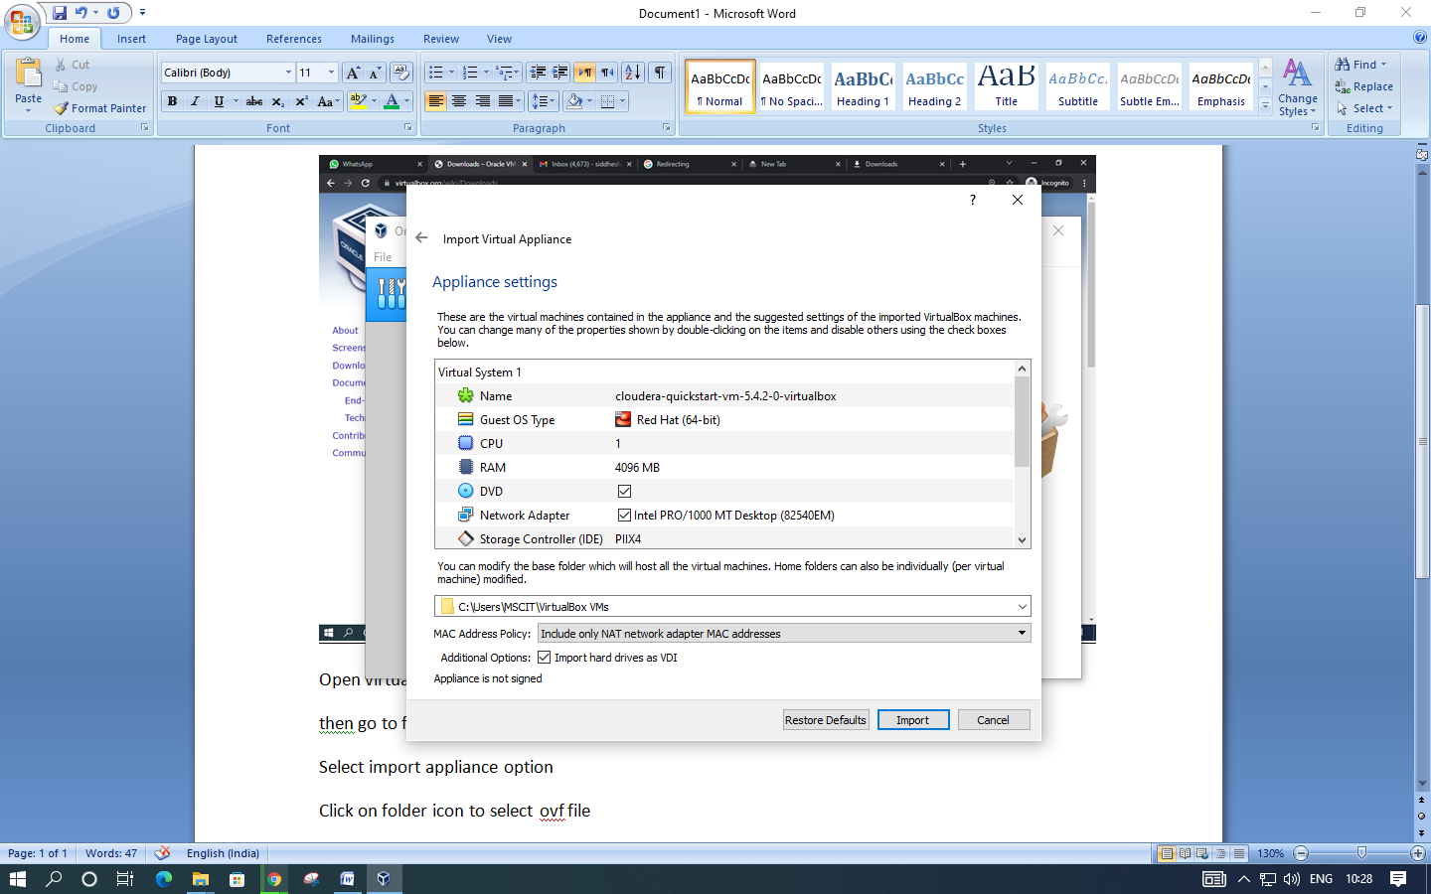

Launch cloudera virtual machine

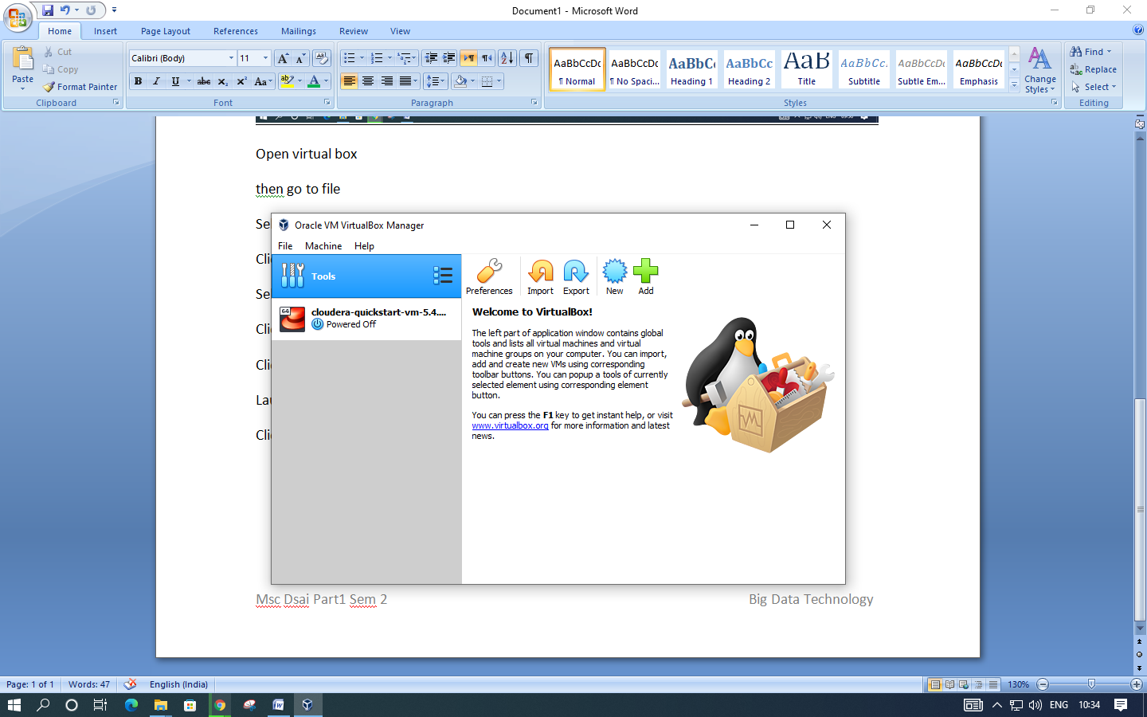

Click start

