**Name :** Siddhesh Surve **Emp ID :** 206340

**Project :** Calculator App

**Tools/ Technologies Used :** Springboot, Jenkins, Docker

**(A) : Springboot Project :**

1. Created initial springboot maven project zip.

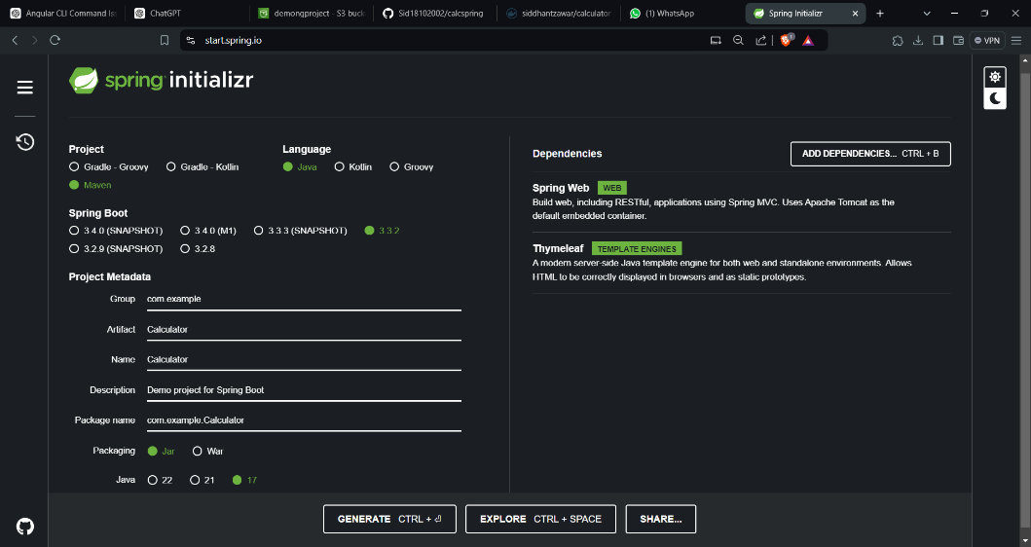

2. Importing Maven project to Eclipse

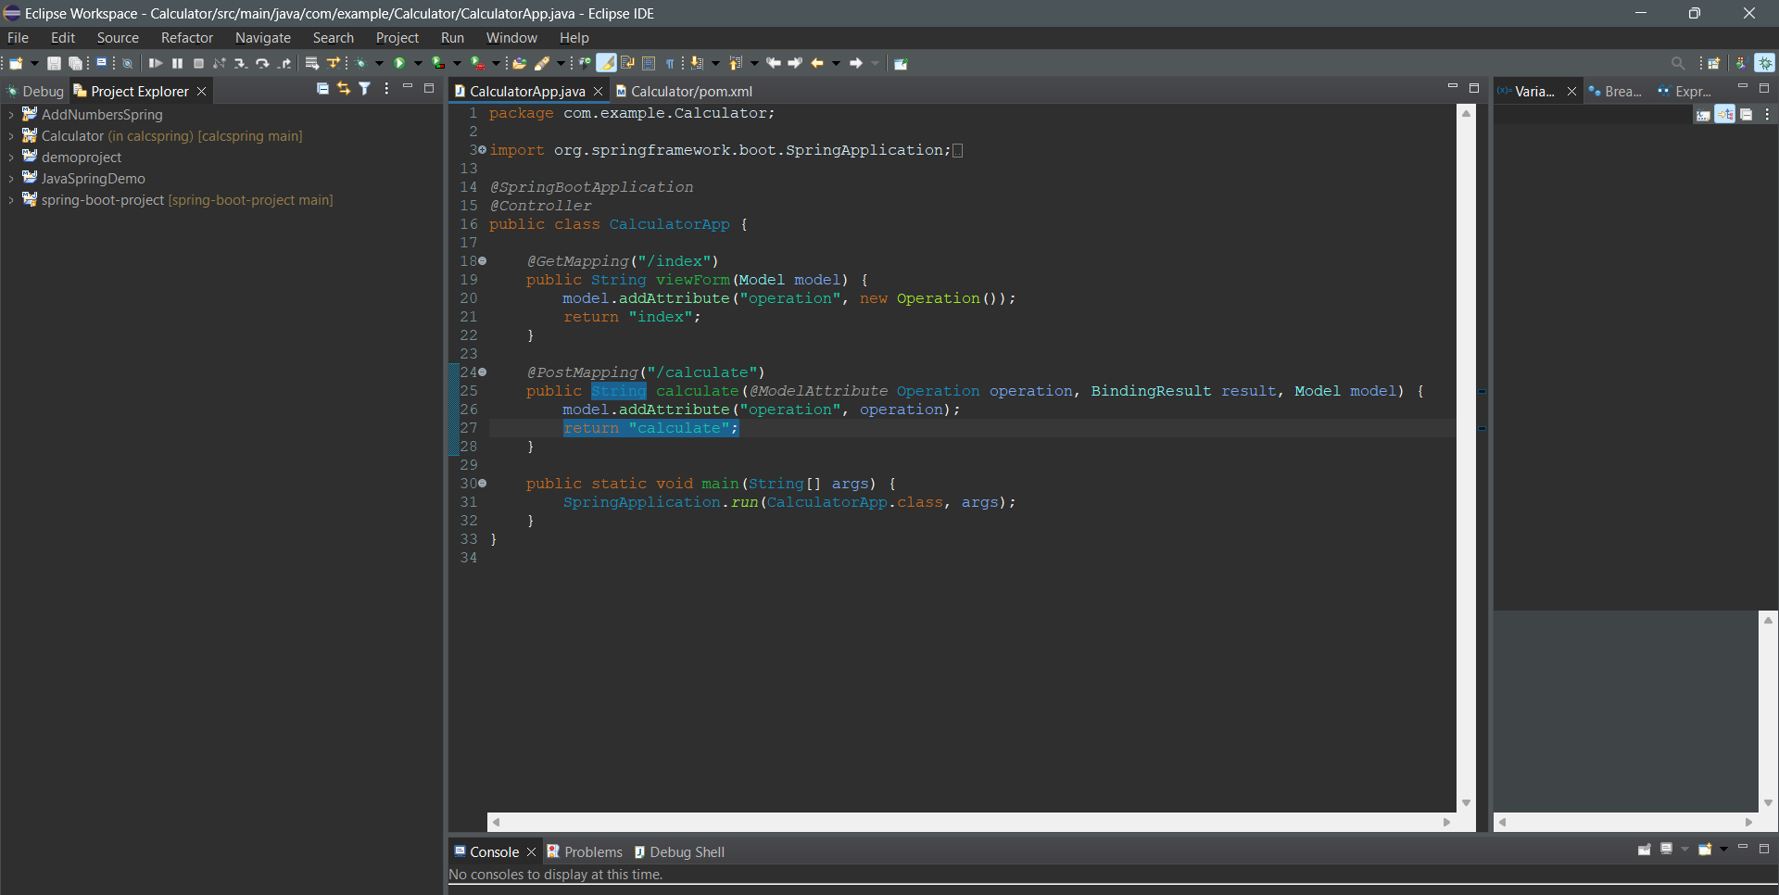

(index.html)

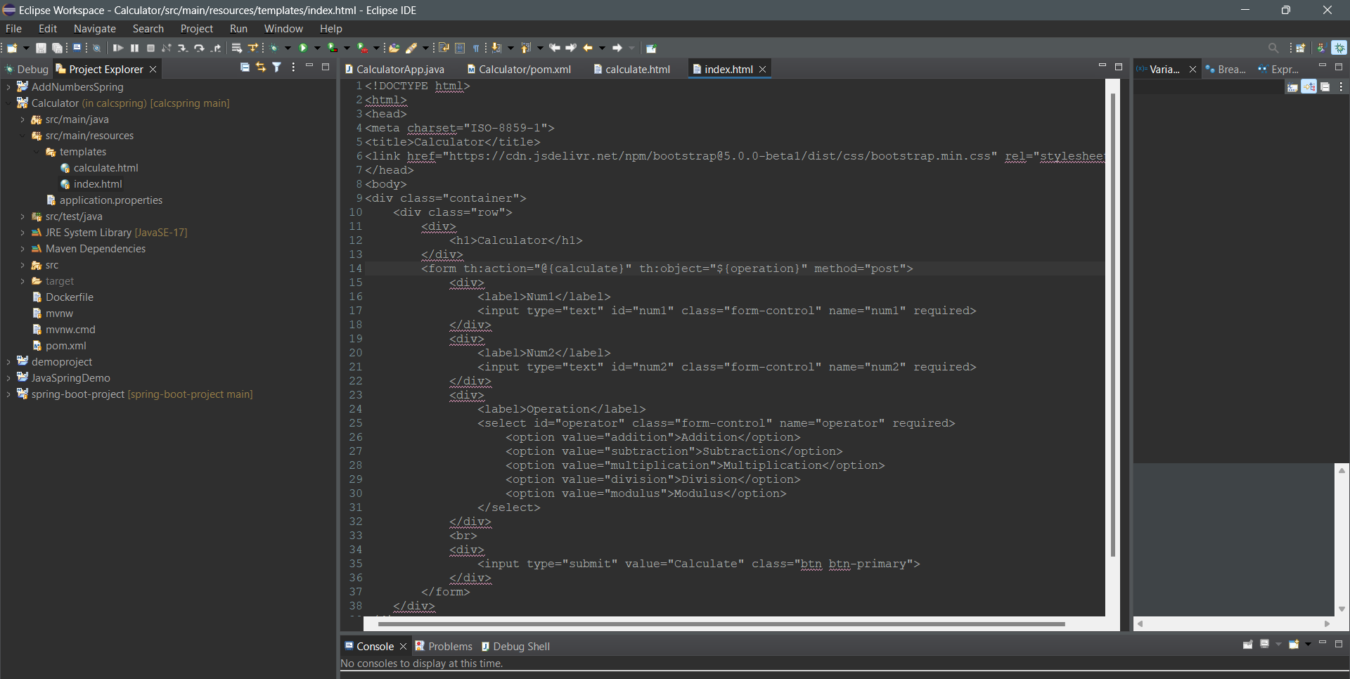

(calculator.html)

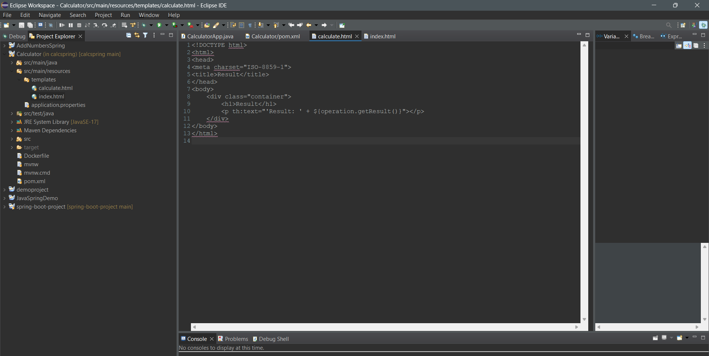

(application.properties) : Setting Server Port number

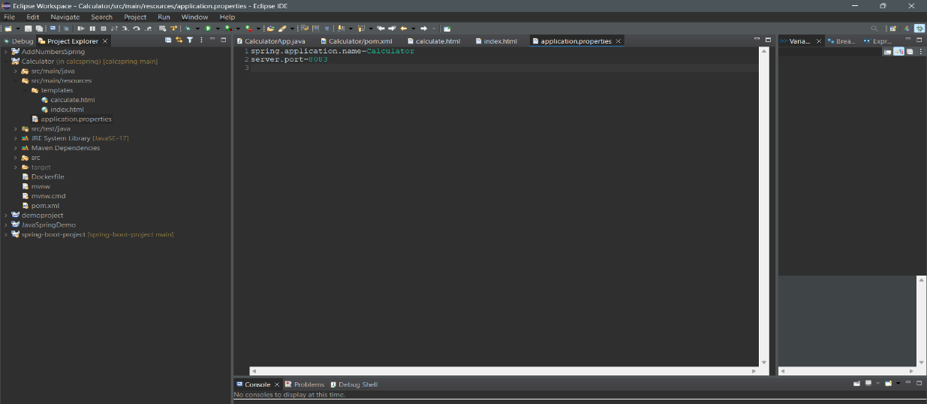

3. Project pushed to github :

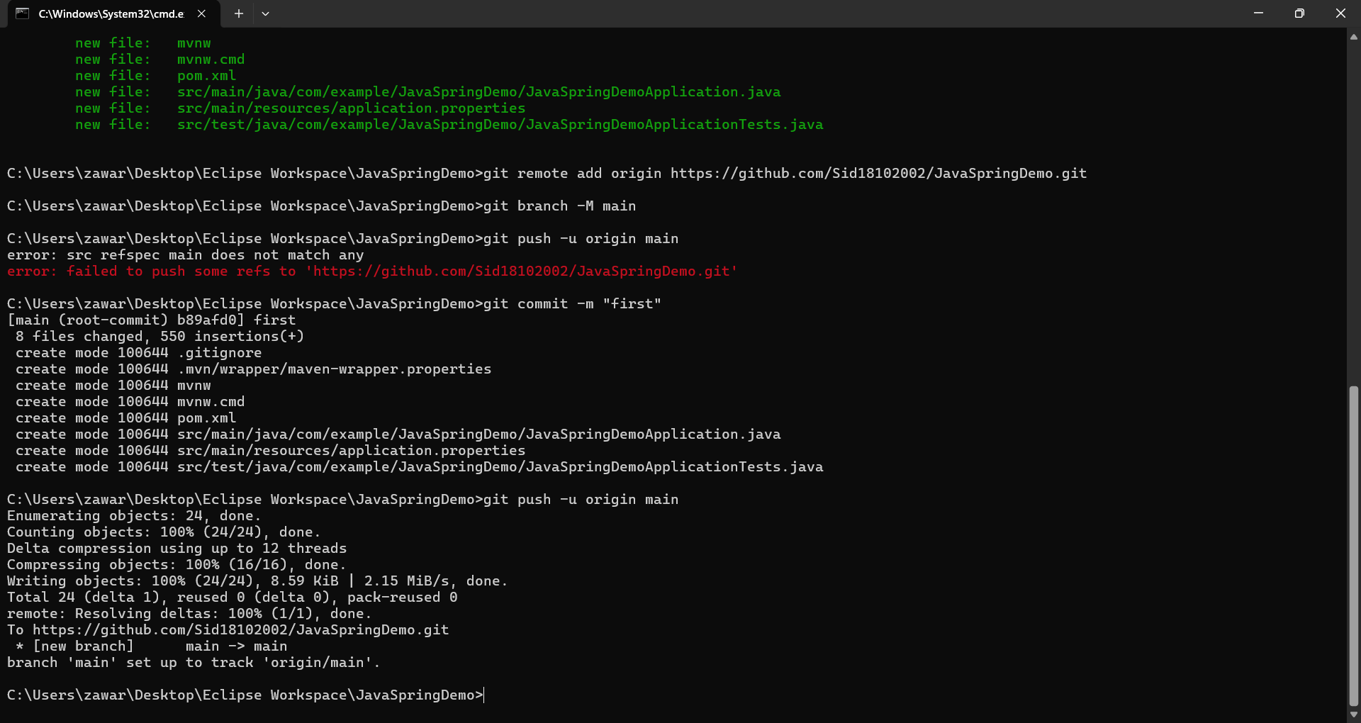

**(B) Jenkins Setup :**

1. Creating account :

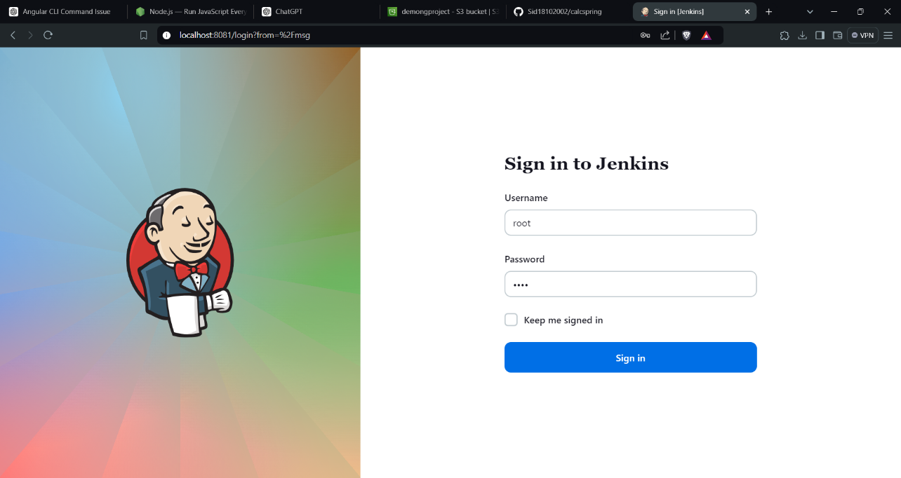

2. Select project type as Freestyle project

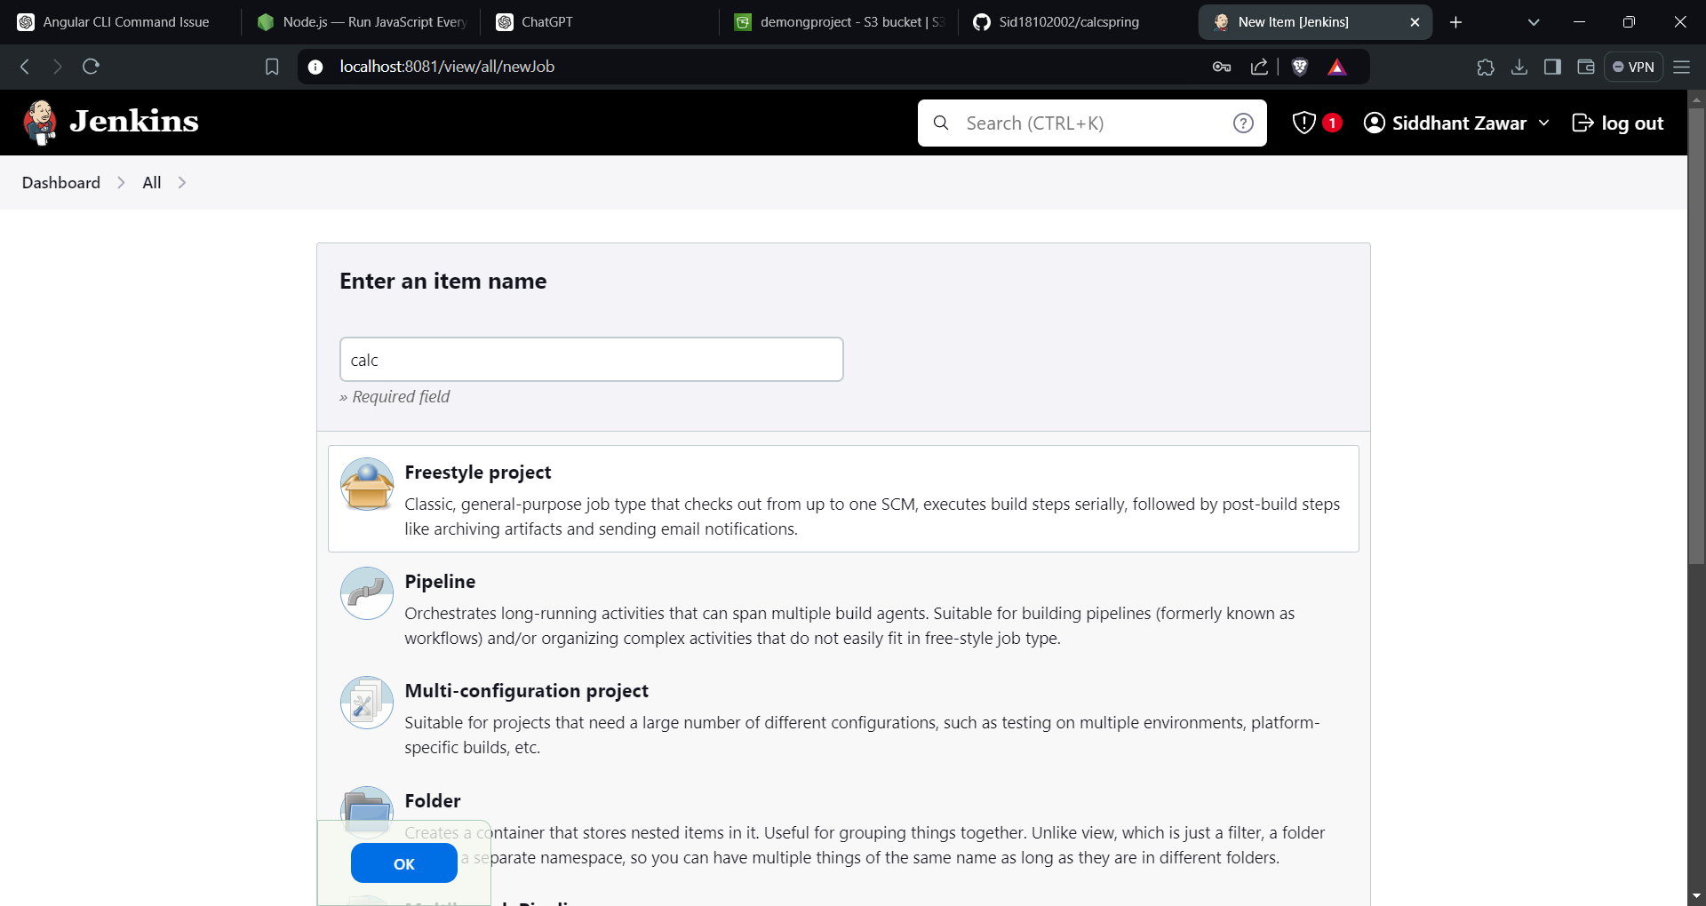

3. Project Configuration :

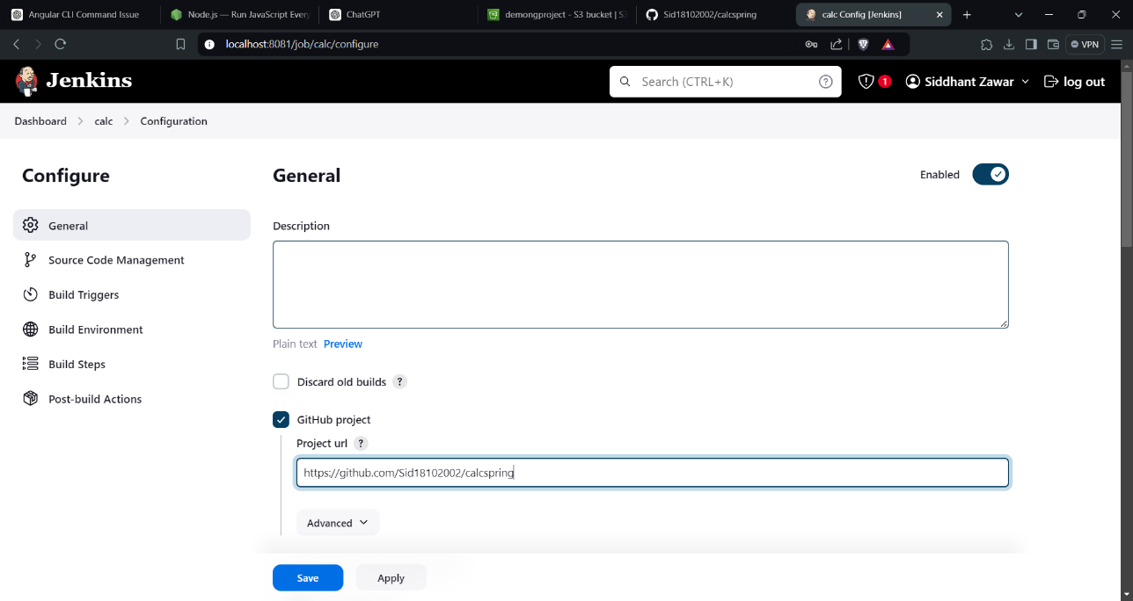

(added github details to Jenkins)

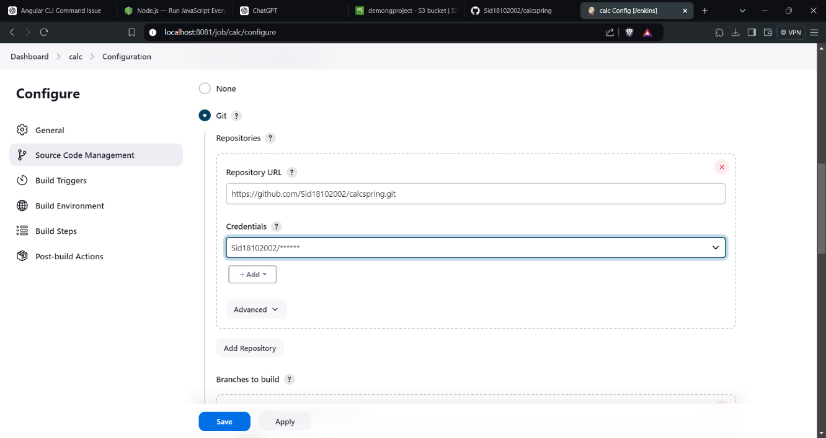

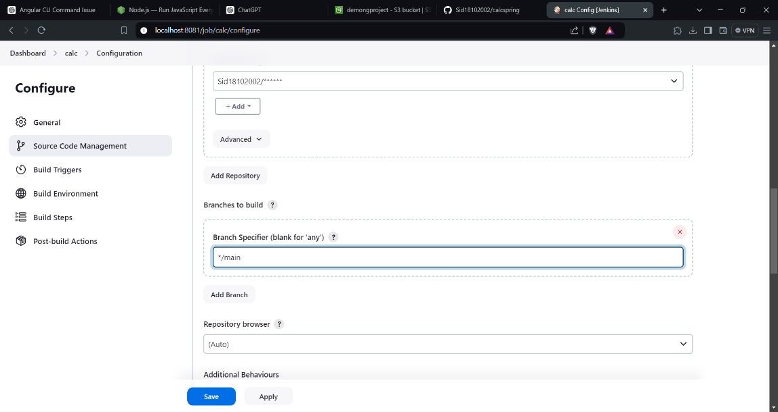

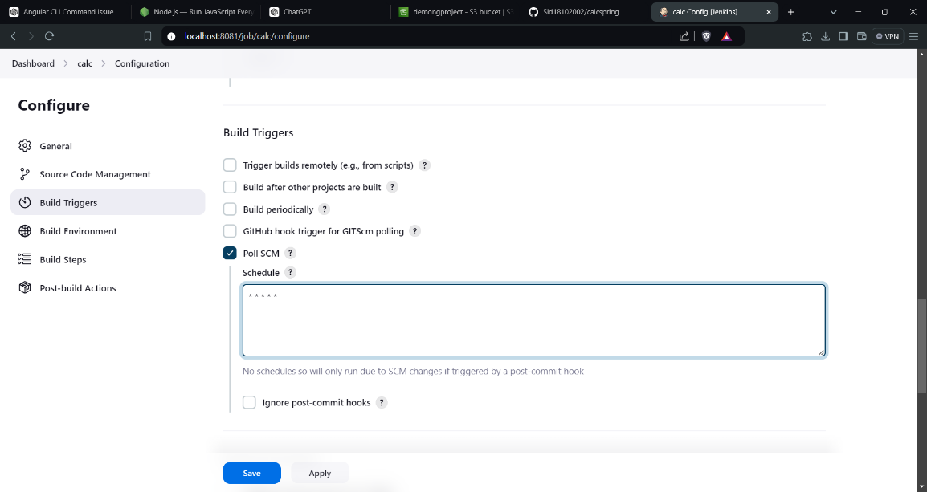

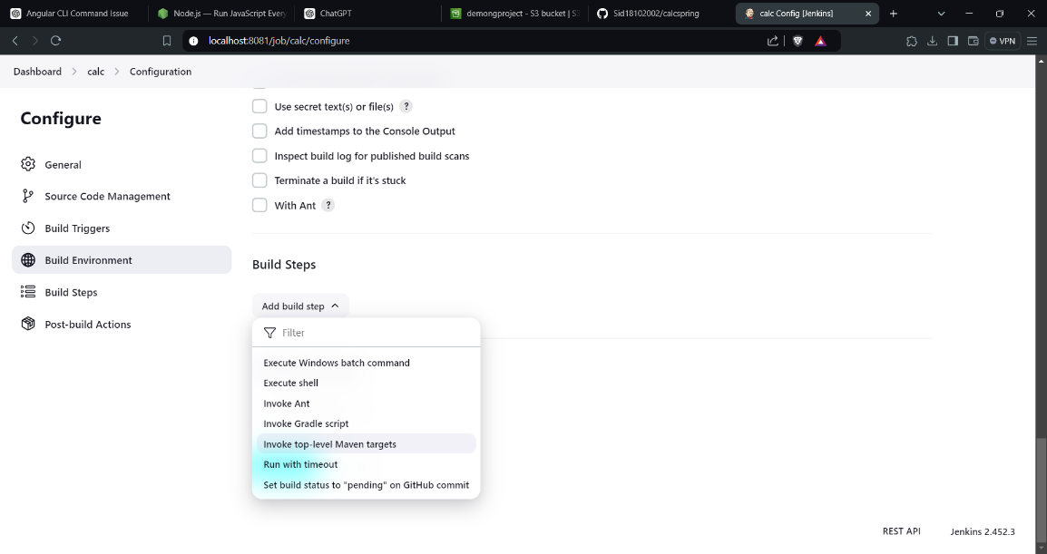

(Project Build successfully)

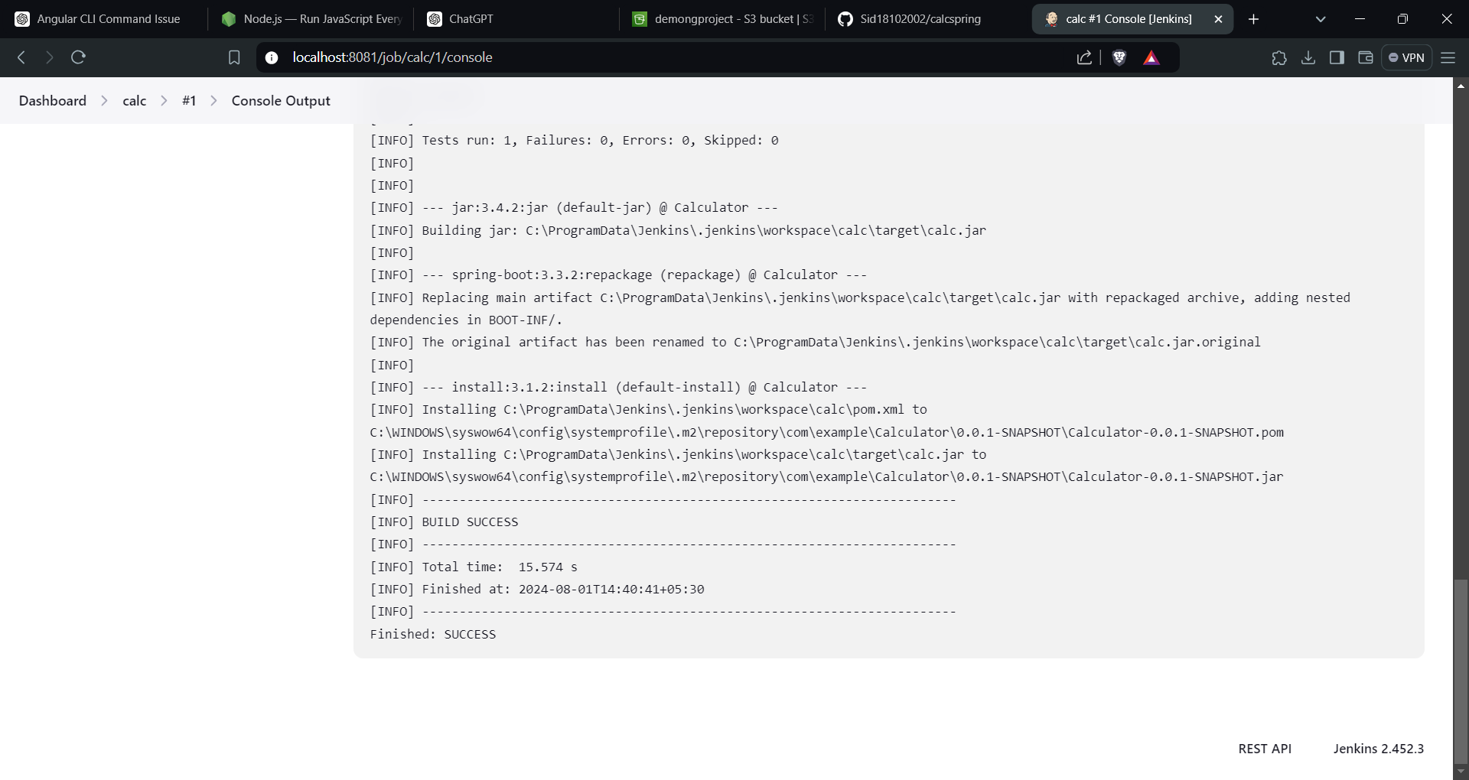

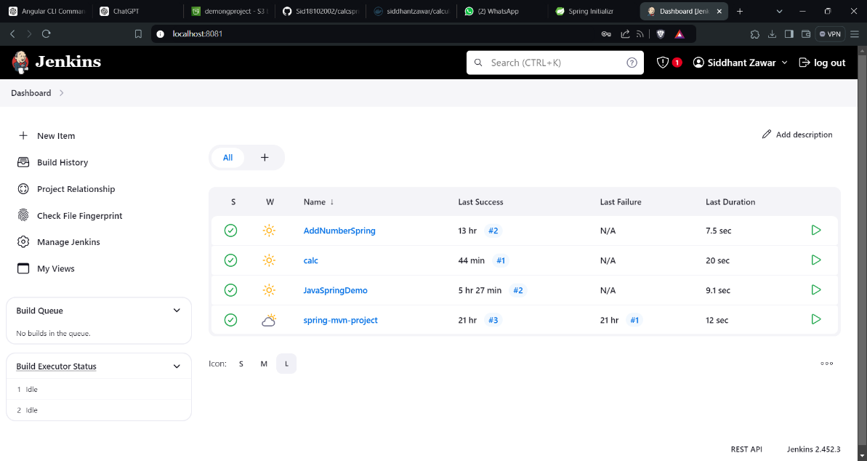

**(C) Creation of JAR File of Springboot project :**

1. In pom.xml use <finalName> tag to select customized filename for your jar file

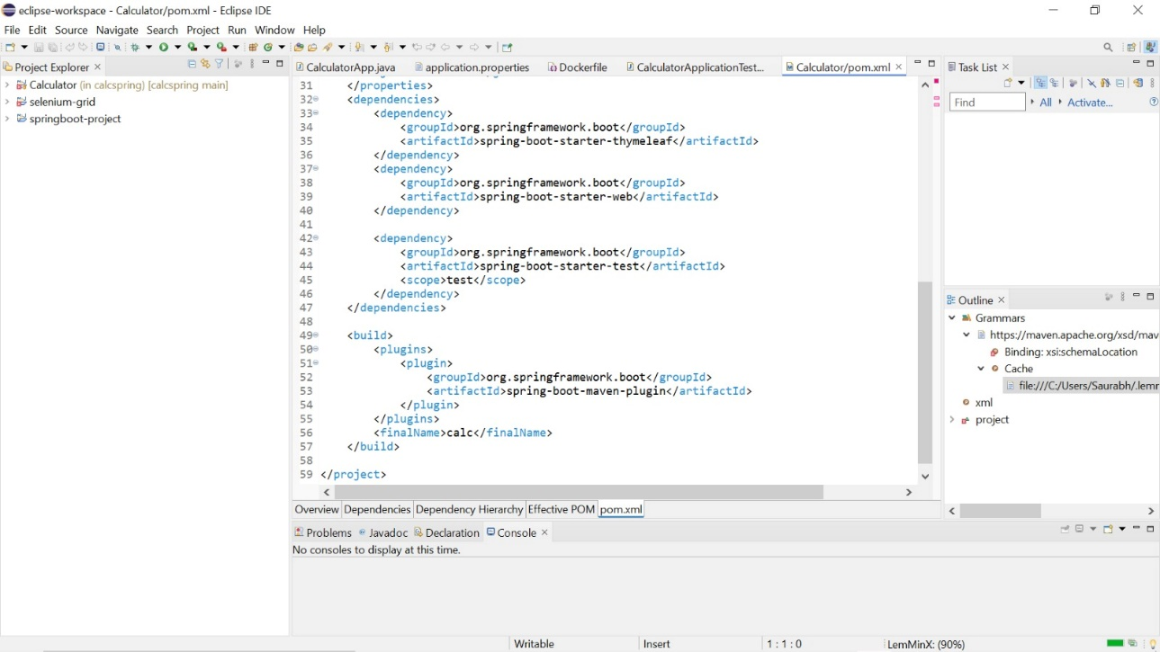

2. Create ‘Dockerfile’ in your project and insert all used dependencies in it

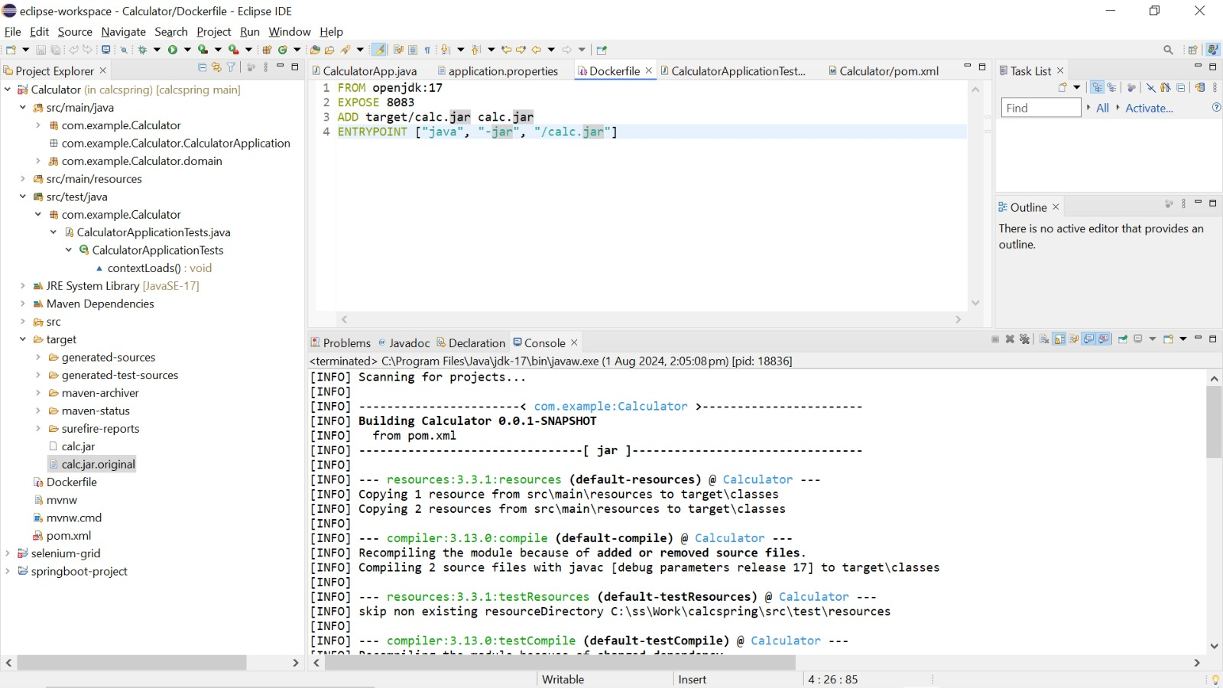

3. Then use ‘maven install’ command by right clicking project folder 🡪 run as 🡪maven install

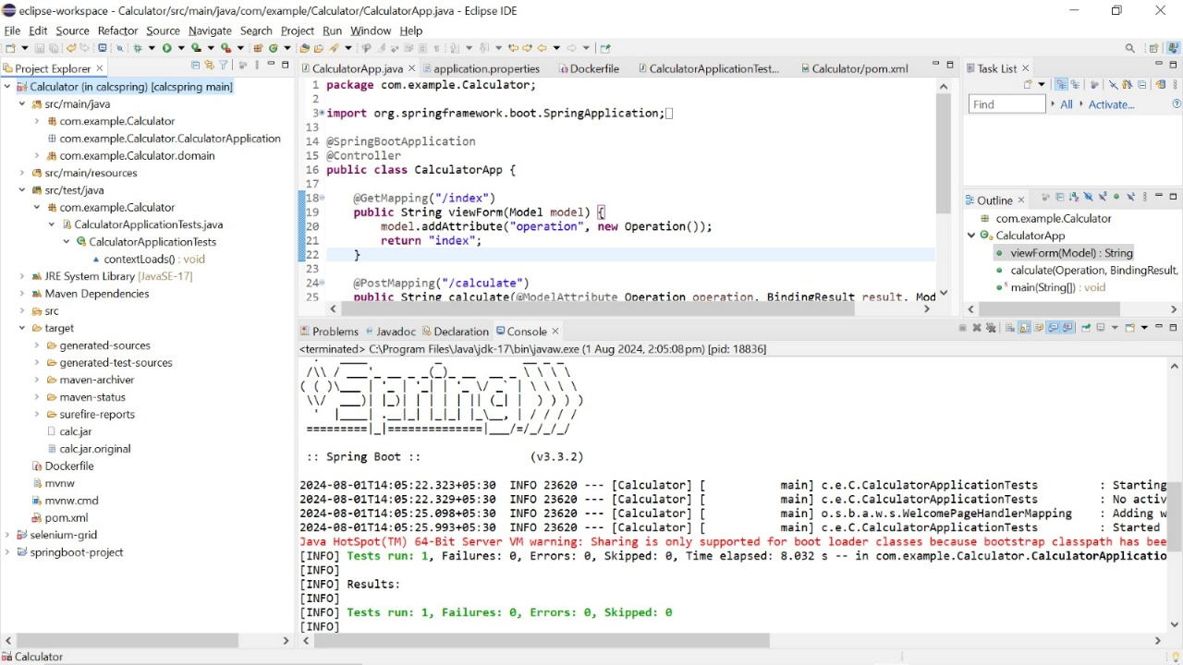

4. JAR file is created under target folder :

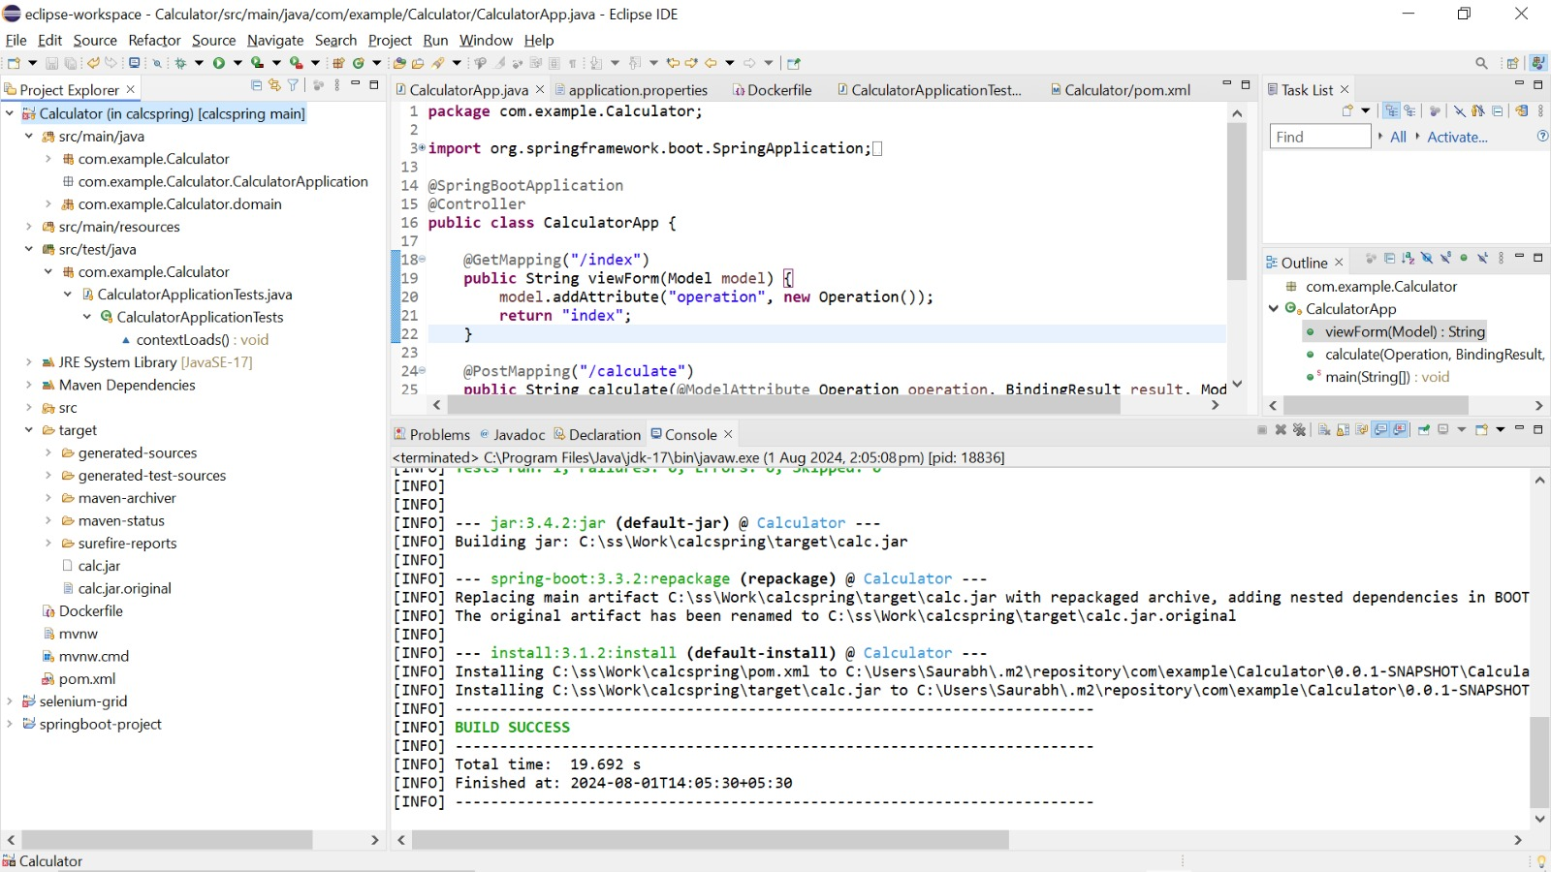

**(D) Docker Setup :**

1. Created a repository on Dockerhub

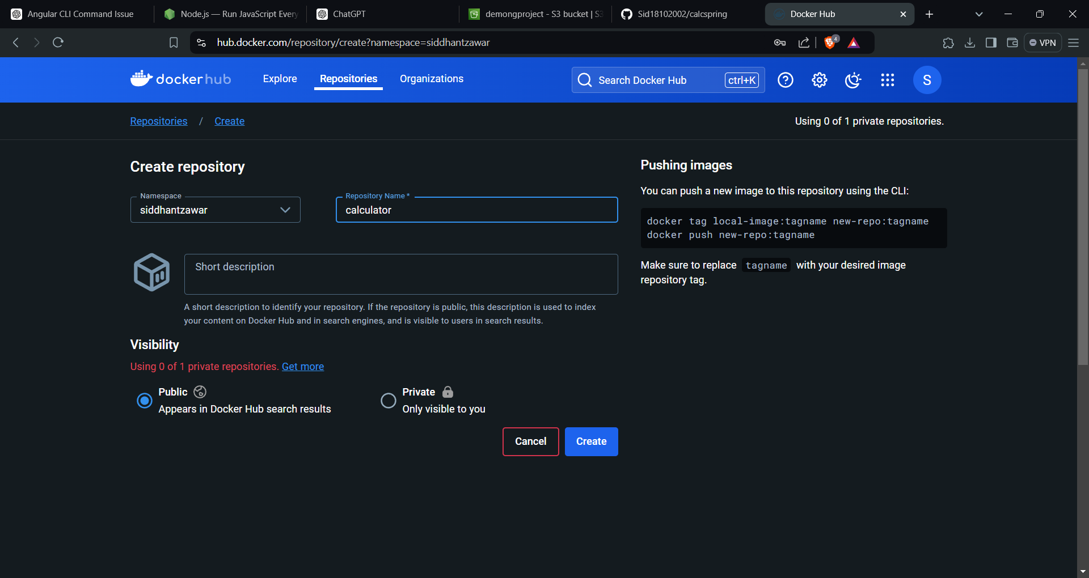

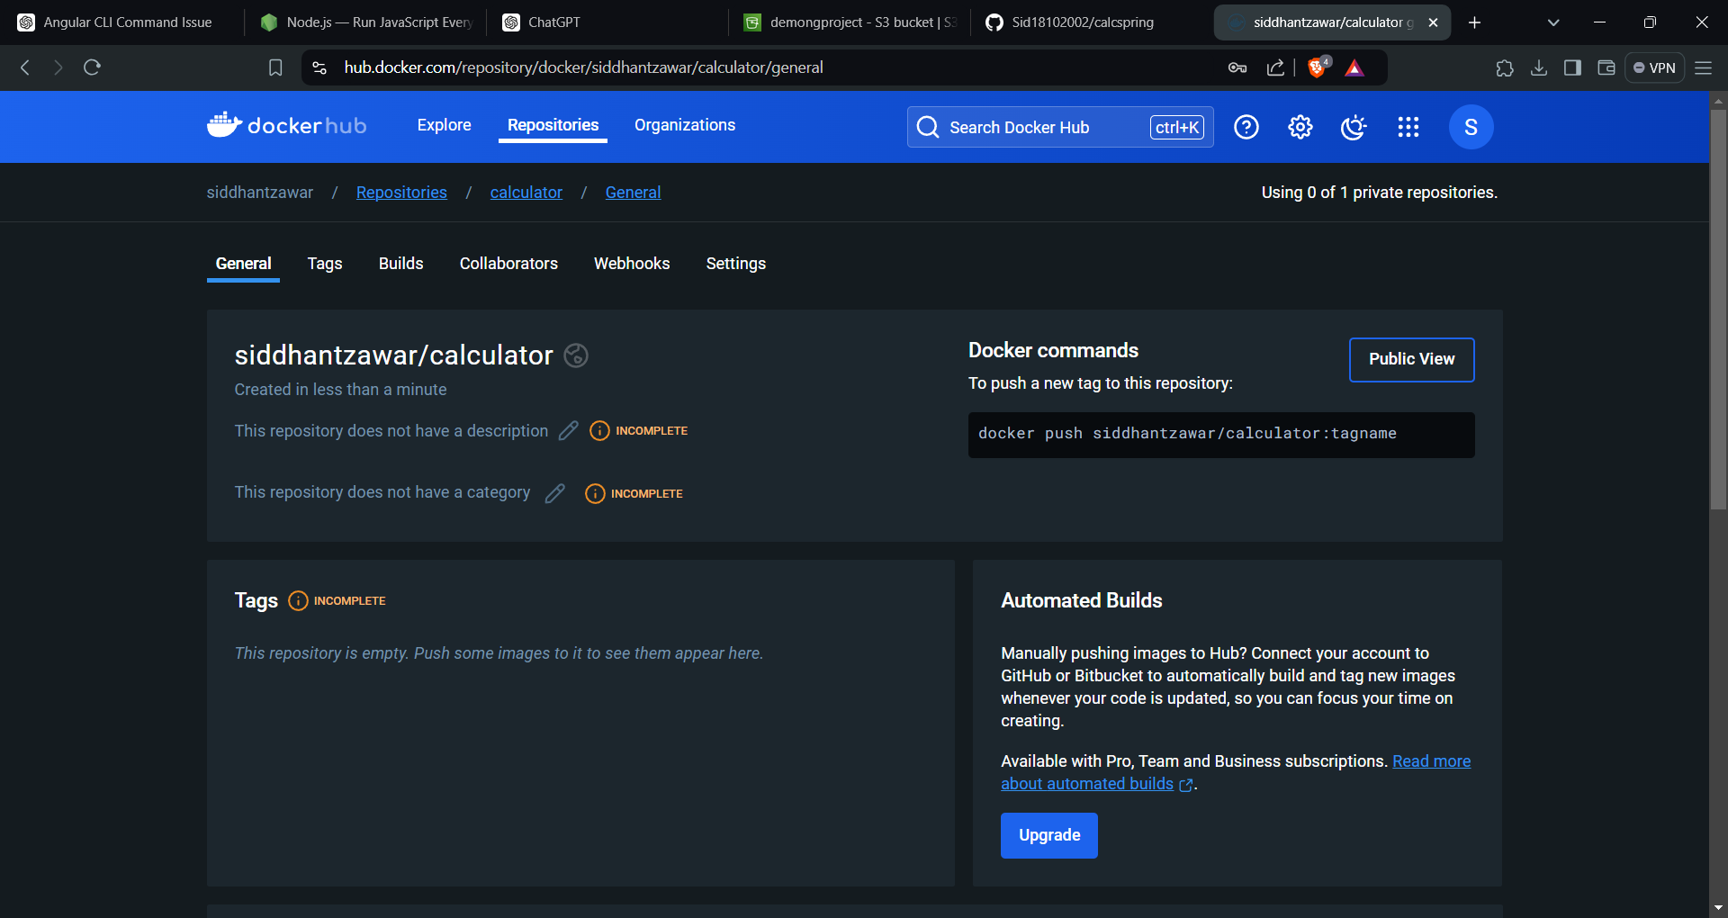

2. Built docker image

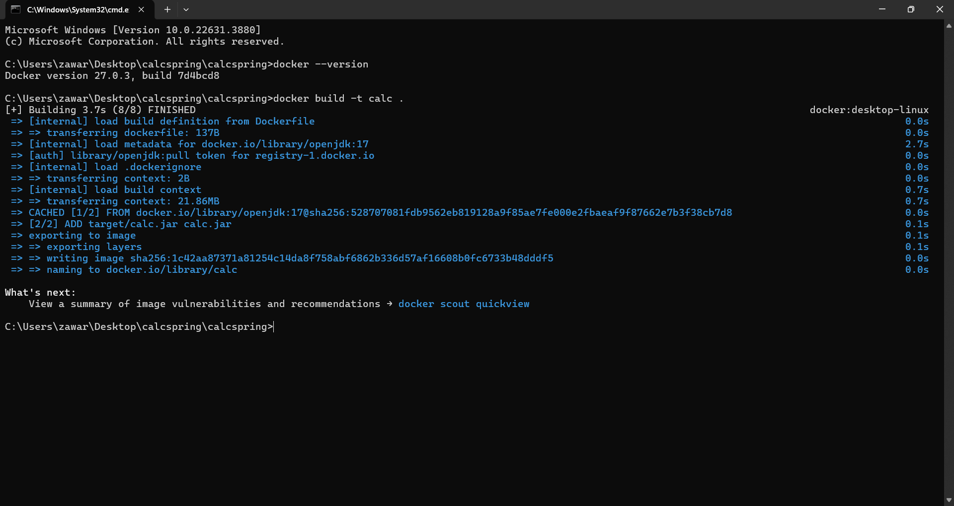

3. Running docker container from the specific image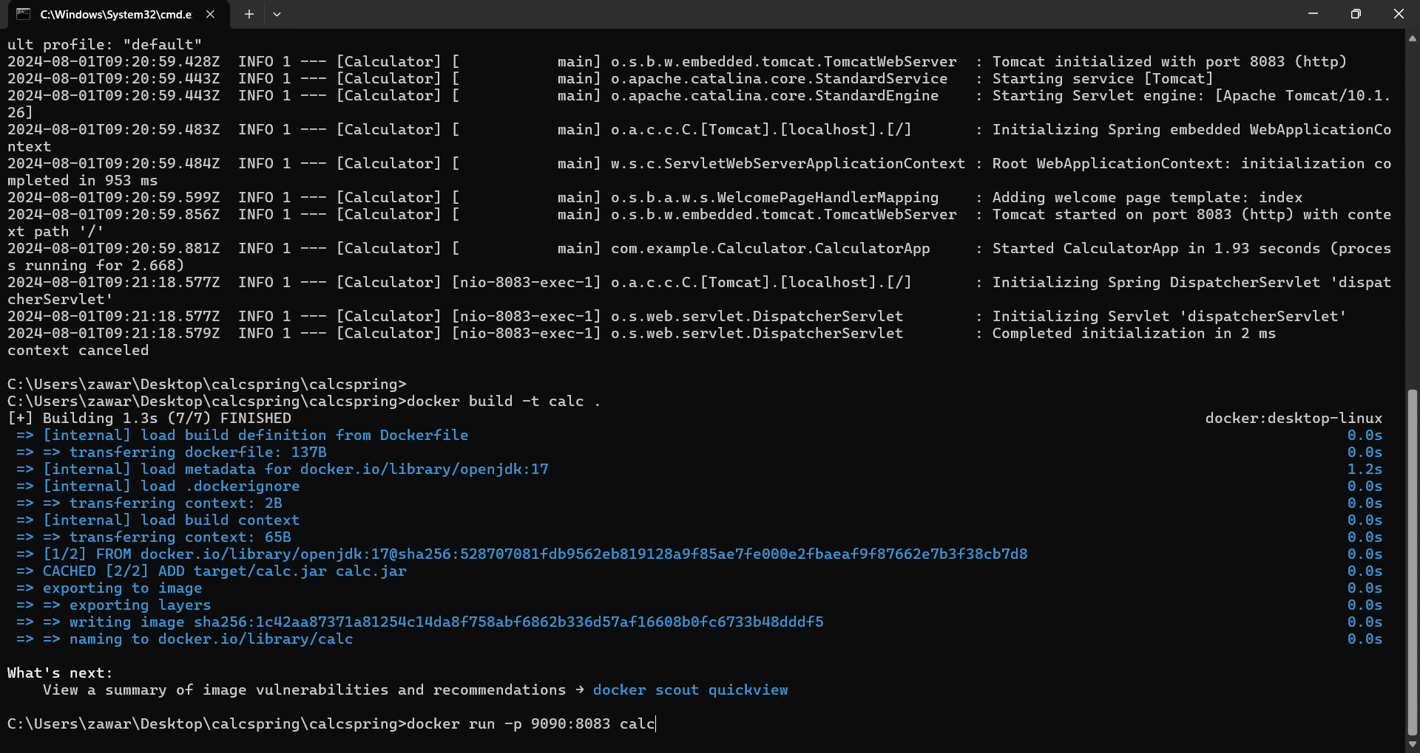

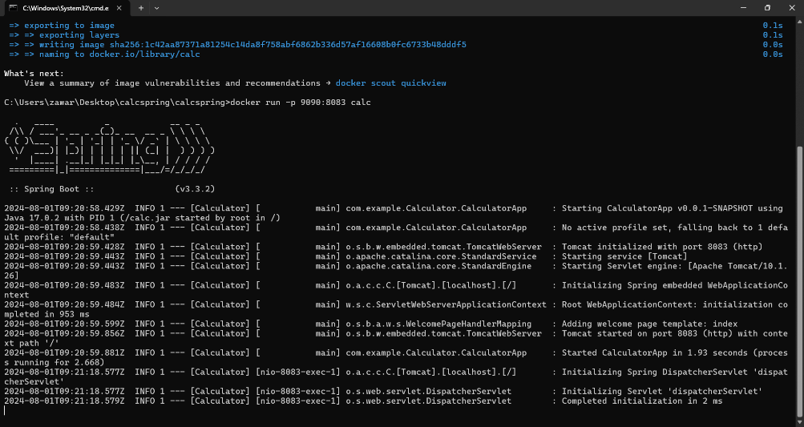

4. Pushed tagged image to docker registry

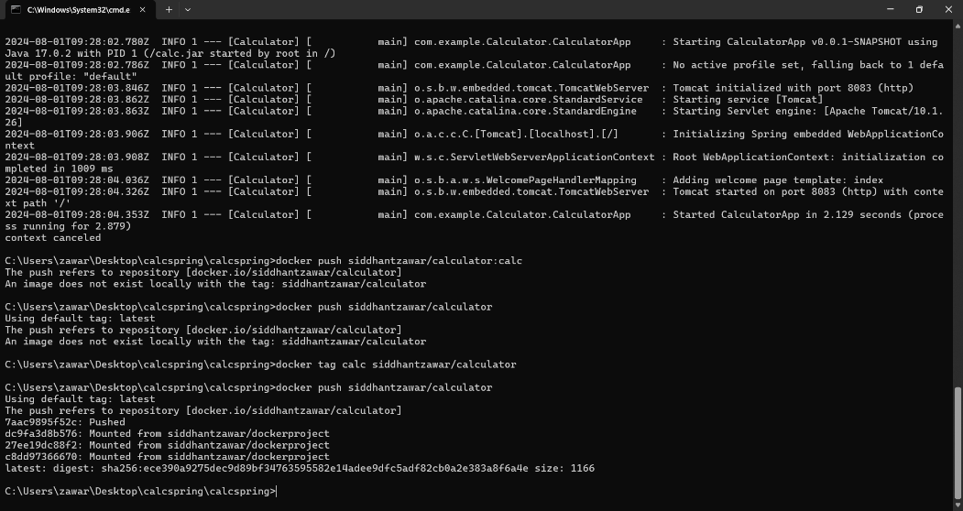

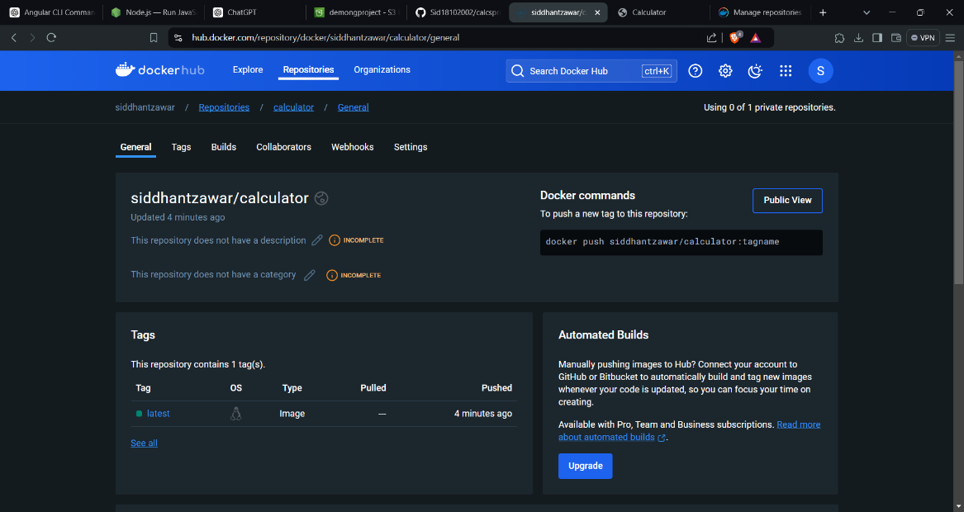

**(D) Final output :**

