The assignment objective is to confirm the established formula for finding out the number of hashes/throws required before fill collision occurs, and all bins/slots are full. The relationship is as follows:

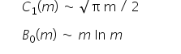

The relationship is tested by developing separate chaining hash table algorithm.

It can thus be observed from the results that the values found out by actual results closely match the value that is found according to the formula. It helps us to understand the behavior of separate chaining implementation of hash table.

We thus can confirm the above stated results with the help of following results:

