Name: Siddhesh Nitin Wani

Register Number: 211039007

1:

;ADD NIBBLE N4 AND N0 FORM MEMORY LOCATION 40000004 AND STORE RESULT IN 4000000C

AREA NIBBLE, CODE, READONLY

ENTRY

MAIN

LDR R1,Value1 ;loading address value

LDR R2, [R1] ;loading address to R2

AND R2,#0x0000000F ;Masking nibble 0

MOV R3, R2; storing nibble 0 to R3

LDR R2, [R1] ;loading address to R2

AND R2,#0x000F0000 ;Masking nibble 4

MOV R4, R2 ;storing nibble 4 to R4

MOV R5, R2, LSR #16 ;shfint nibble 4 to lsb

ADD R3,R5 ;adding both values

LDR R6,Value2 ;loading address value

STR R3, [R6] ;loading address to R2

Value1 DCD &40000004

Value2 DCD &4000000C

END

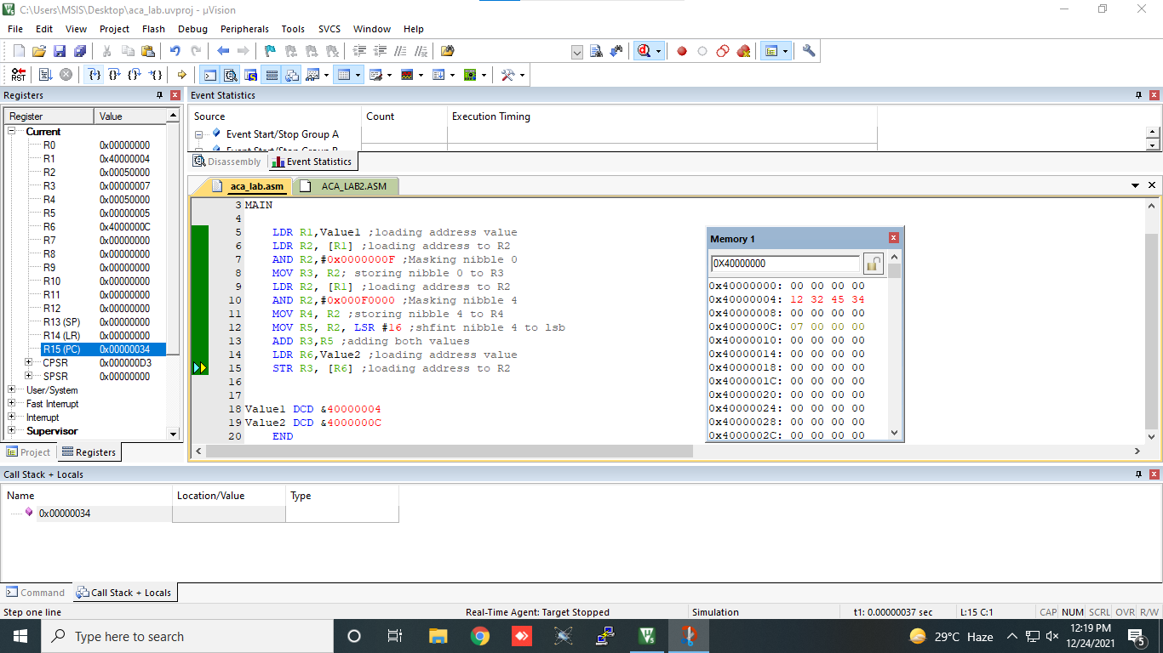

2: ;Implement ASM program consider the number in 4000000c,add the array only if possitive and store in 40000000

;Implement ASM program consider the number in 4000000c,add the array only if possitive and store in 40000000

AREA SECOND,CODE,READONLY

ENTRY

START

LDR R0,VALUE;Get the address of value

LDR R4,RESULT;get the address of result

LDR R1,[R0];load the fist value of array to r1

MOV R2,&4;add the number of array elements

MOV R3, #0X00 ; SUM = 0

LOOP SUB R2,R2,#1;since 1 number is already fetched we decrement

CMP R2,#0;compare the size

BLT STOP;if size is less than zero stop execution

CMP R1,#0;then compare the element

BLT NEXT;if element is less than 0 ie if its negative fetch the next element

ADD R3,R3,R1;then add

STR R3,[R4];store the result in 40000000

B NEXT;fetch next element

;B LOOP

NEXT LDR R1,[R0,#4]!;fetch the next element.ie auto increment

B LOOP;start the loop again

STOP B STOP

VALUE DCD &4000000C

RESULT DCD &40000000

END

