DAY-1:

Tasks
1.
Create a table listing 3 types of printers, 2 types of scanners, and 2 types of webcams, and for each, write one real-life use case (for example: 'Inkjet printer – printing college assignments').
Device | Type | Real-life Use Case
Printer | Inkjet Printer | Printing college assignments and colorful photos
Printer | Laser Printer | Printing a large number of documents quickly
Printer | Dot Matrix Printer | Printing bills, invoices, and multi-part forms
Scanner | Flatbed Scanner | Scanning documents, ID cards, and photos
Scanner | Sheet-fed Scanner | Scanning multiple pages quickly
Webcam | Built-in Webcam | Attending online classes and video meetings
Webcam | External USB Webcam | Online classes, video calls, and streaming

2.
Draw a labeled diagram showing how a typical home printer connects to a laptop or PC, including the connection interface used (USB, Wi-Fi, or Bluetooth).
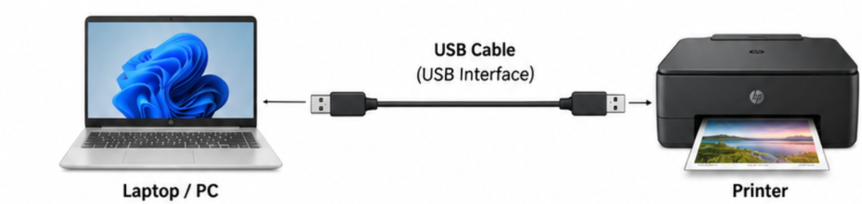
3.
List three different connection interfaces (such as USB, Wi-Fi, Bluetooth) used by peripherals like printers, scanners, and webcams, and for each, name one advantage and one disadvantage.<br><br><em><strong>Hint:</strong> Think about speed, convenience, and compatibility.</em>

Connection Interface | Advantage | Disadvantage
USB | Fast and reliable connection | Requires a physical cable
Wi-Fi | Wireless and convenient; no cable is needed | Depends on network stability
Bluetooth | Wireless and easy to pair | Shorter range and can be slower than USB

4.
Pick any one device you use at home or college (printer, scanner, or webcam). Write step-by-step instructions for how you would connect it to your computer, including what cable or wireless method you would use and any setup steps required.
Steps followed:
- Check the printer: Make sure the printer is properly assembled, has paper, and has enough ink or toner.
- Connect the printer: Connect the printer to the computer using a USB cable.
- Switch on the printer: Turn on the printer and wait for it to initialize.
- Install the driver: Windows will usually detect the printer and automatically install the required driver. If it does not, download the correct driver from the printer manufacturer's official website.
- Open printer settings: Go to Settings → Devices → Printers & scanners.
- Add the printer: Click Add a printer or scanner and select the connected printer when it appears.
- Set as default printer: Select the printer and choose Manage → Set as default, if required.
- Print a test page: Open the printer settings and select Print a test page.
- Check the result: Make sure the test page prints correctly without errors.

