**Batch: _____C2___________ Roll No: ______16010122257__________**

**Exp No: 4**

|  |
| --- |
| **Title:**  Write in detail the implementation Process |

**______________________________________________________________________**

**Objective:** To understand the implementation process of the project. **______________________________________________________________________**

**Expected Outcome of Experiment:**

|  |  |
| --- | --- |
| **Course Outcome** | **After successful completion of the course, students should be able to** |
| CO 4 | Implement and test the design as per the mentioned specifications. |

**______________________________________________________________________**

**Books/ Journals/ Websites referred:**

1. "Learning Management Systems and Instructional Design: Best Practices in Online Education" by Linda V. Knight
2. "Practical Learning Analytics: A Beginner's Guide to Understanding, Designing, and Implementing Learning Analytics" by Huzefa Rangwala and Eyal Dimant
3. "Educational Technology Research and Development" - Publishes research on the design, development, and evaluation of educational technology tools, including LMSs.
4. Learning Management System (LMS) Society - Community-driven website providing information, resources, and discussions related to LMS design and implementation.

**______________________________________________________________________**

**Introduction:**

The implementation stage is crucial in the project lifecycle as it involves translating the design document into a functional system. This stage bridges the gap between theoretical design concepts and practical system development. It requires meticulous attention to detail, adherence to coding standards, and effective collaboration among team members. The implementation process lays the foundation for the actual deployment and usage of the Learning Management System (LMS), ensuring that it meets the specified requirements and objectives.

**Implementation details:**

***“Students are supposed to write the backend and frontend all details about the database name and attributes, fields etc.”***

**Functions Implemented:**

Major and minor functions detailed in the design document are translated into code during the implementation phase. These functions include user authentication, course creation and management, communication tools, assessment features, result analysis, progress tracking, administrative tasks, and data management. Each function is developed according to the specified requirements, ensuring compatibility and integration with other system components.

**User interface:**

**Implementation method: *Write the way you have implemented different modules and put the screenshots after implementation***

The user interface implementation involves creating visually appealing and user-friendly interfaces for educators and learners to interact with the Learning Management System. This includes designing and coding frontend modules using HTML, CSS, JavaScript, and Bootstrap. Screenshots are captured after the implementation to document the interface design and functionality.

Identify Usage of Tools, Library Functions, APIs/Packages:

During implementation, various tools, library functions, APIs, and packages are utilized to solve specific problems and enhance system functionality. For example:

Visual Studio Code is used as the primary application development tool for coding frontend and backend components.

For backend development :in PHP.

Database management tools such as phpMyAdmin are utilized for managing the database schema and data.

APIs for authentication services or communication protocols may be integrated to enhance system security and functionality.

Additionally, standard coding practices and design patterns are followed to ensure maintainability, scalability, and performance of the Learning Management System.



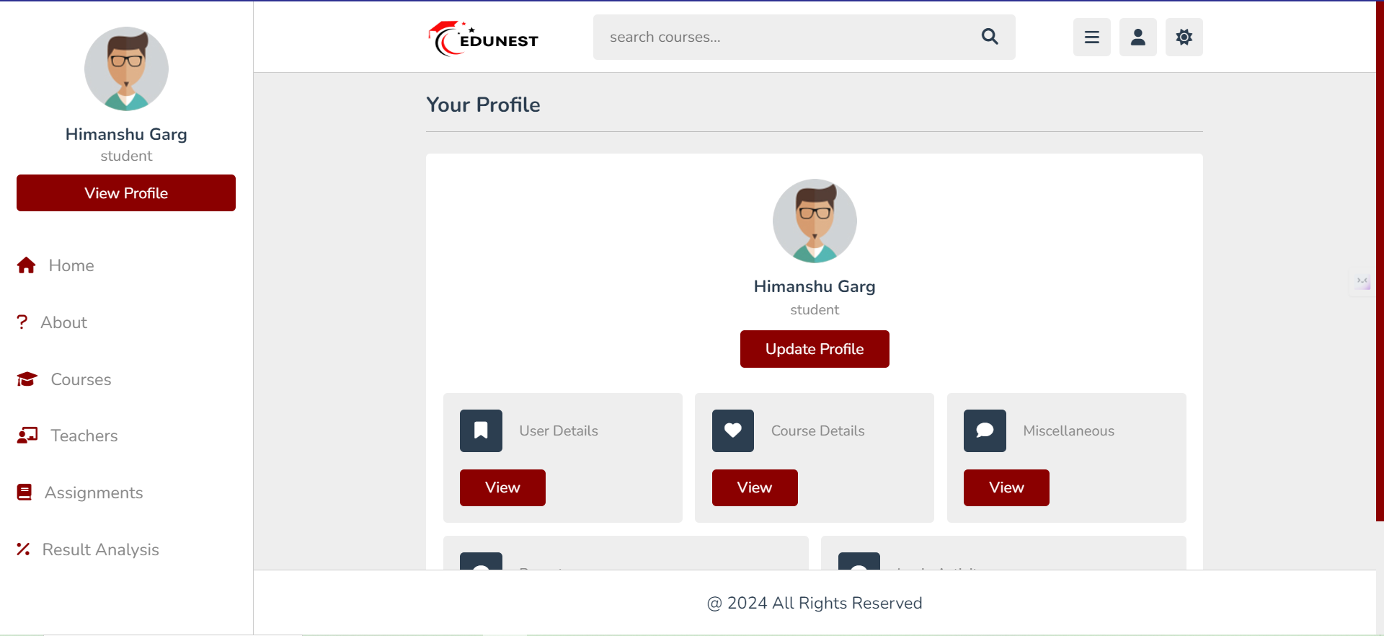

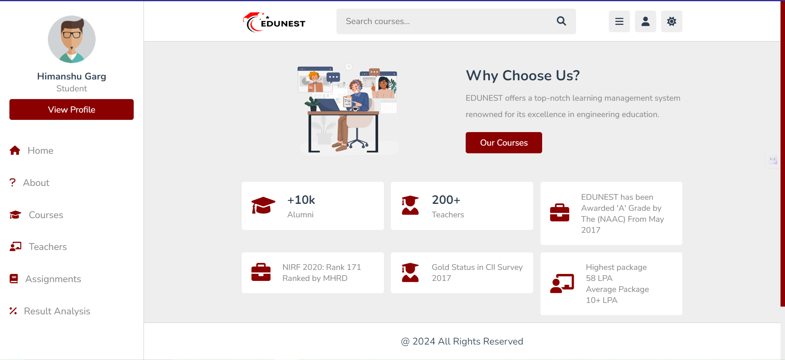

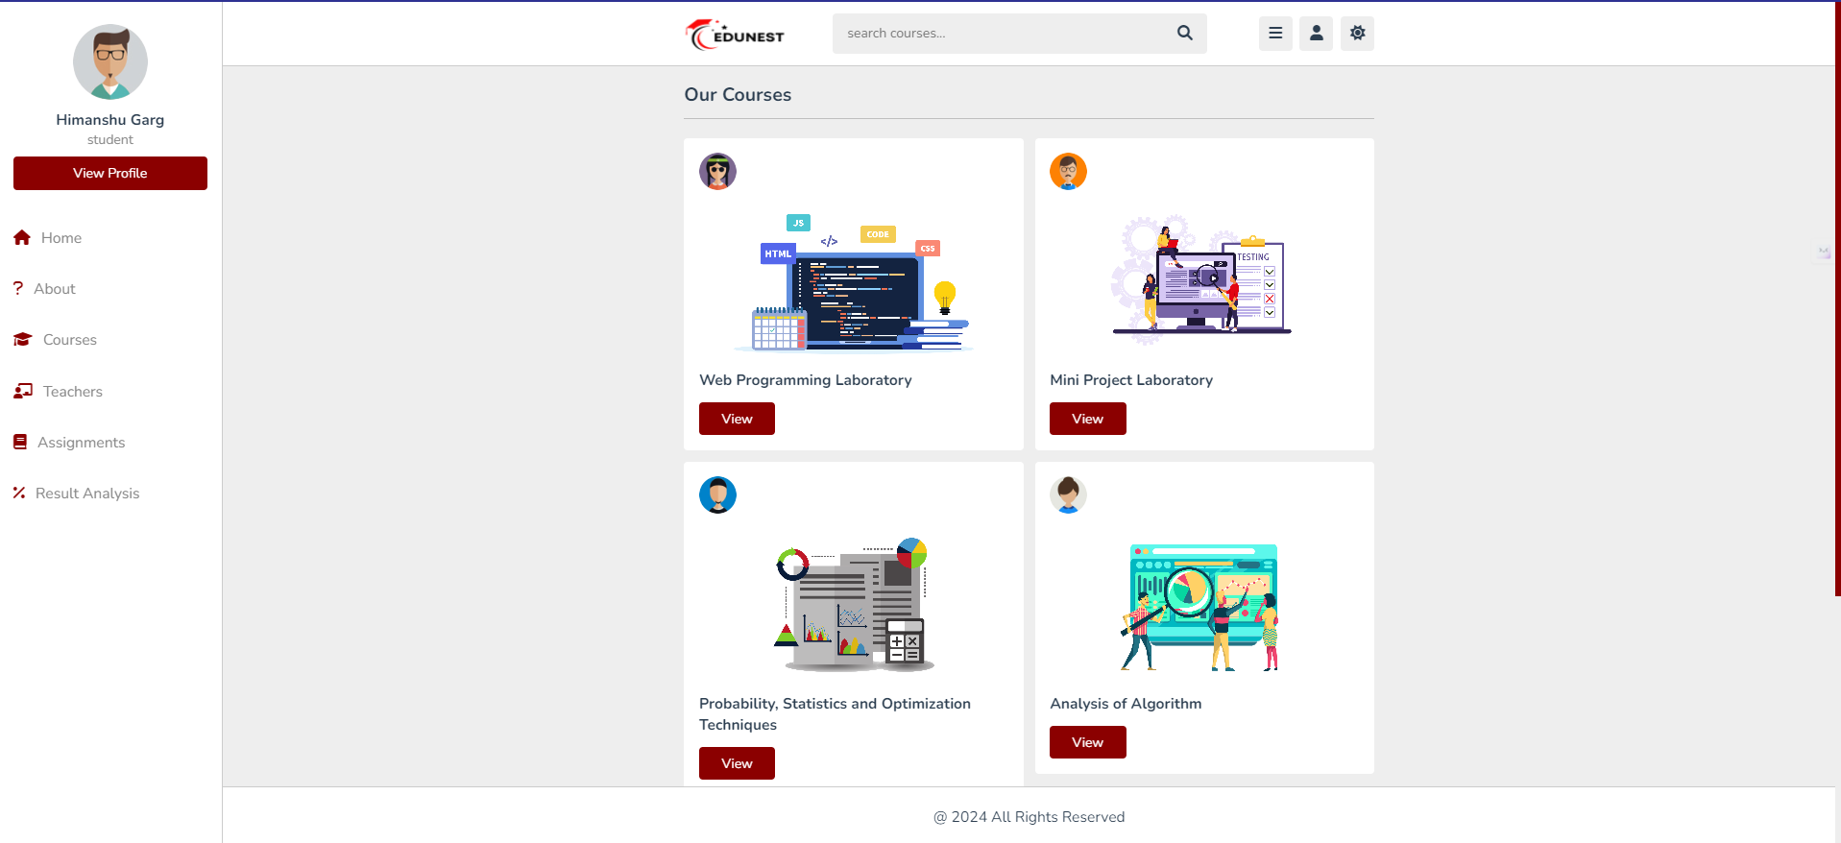

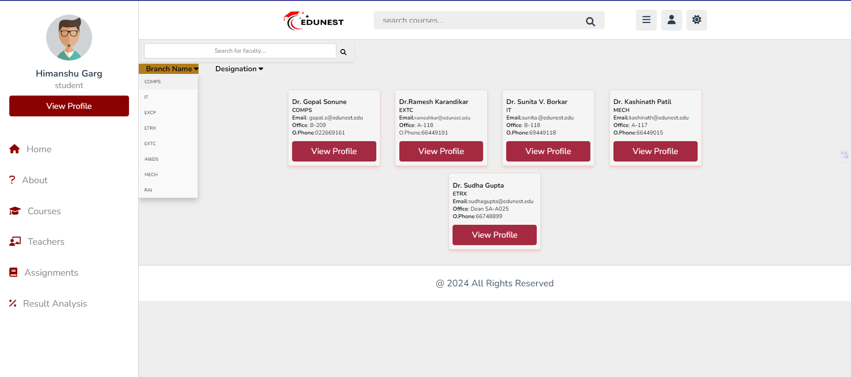

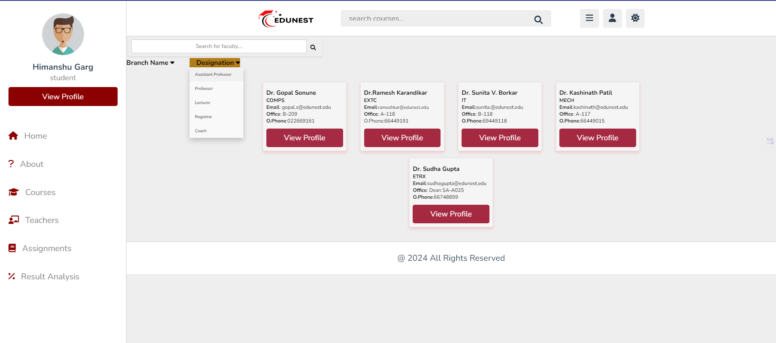



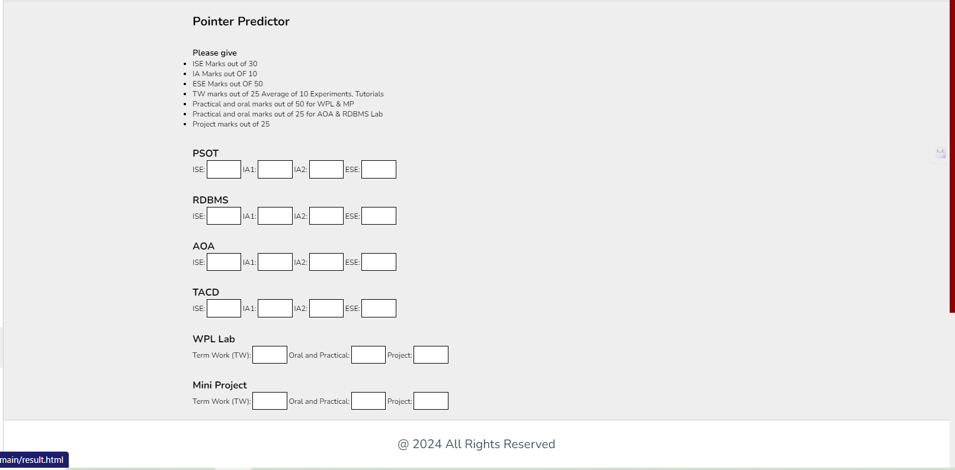

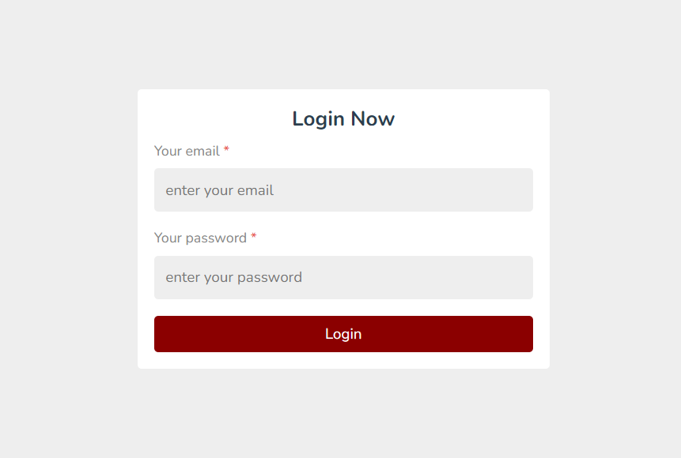

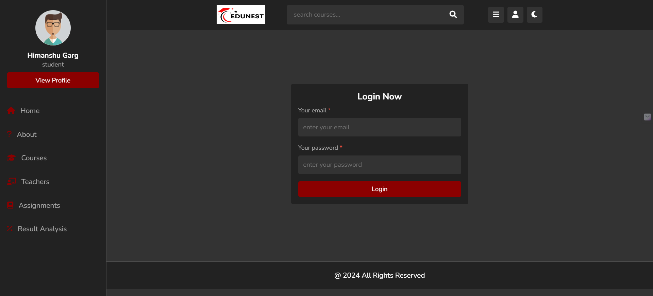

**Conclusion:** The implementation process of the Learning Management System (LMS) marks a significant milestone in the project lifecycle. It involves translating the design specifications into functional code, ensuring that the system meets the intended objectives and requirements. The successful implementation of the LMS underscores the importance of effective project management, teamwork, and technical proficiency in delivering a robust educational technology solution.