### **Name: Siddhi Vijay Gvahane Roll NO:71**

### **Q1. Create a new book record (POST)**

Create an API endpoint **/books** that allows adding a new book to the library.

* Input: JSON object with book details.
* Example Request Body:

{  
 "title": "Web Frameworks",  
 "author": "Rajkamal Sangole",  
 "genre": "Technology",  
 "publishedYear": 2021  
}

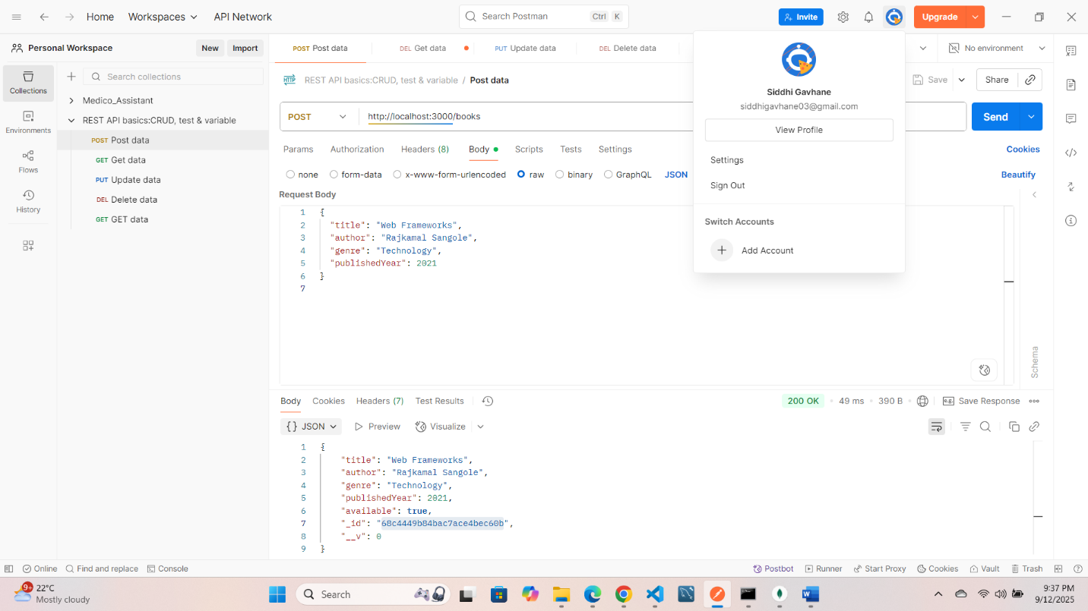

### **Q2. Fetch all books (GET)**

Create an API endpoint **/books** to retrieve all books from the collection.

* Test in Postman by sending a GET request to /books.

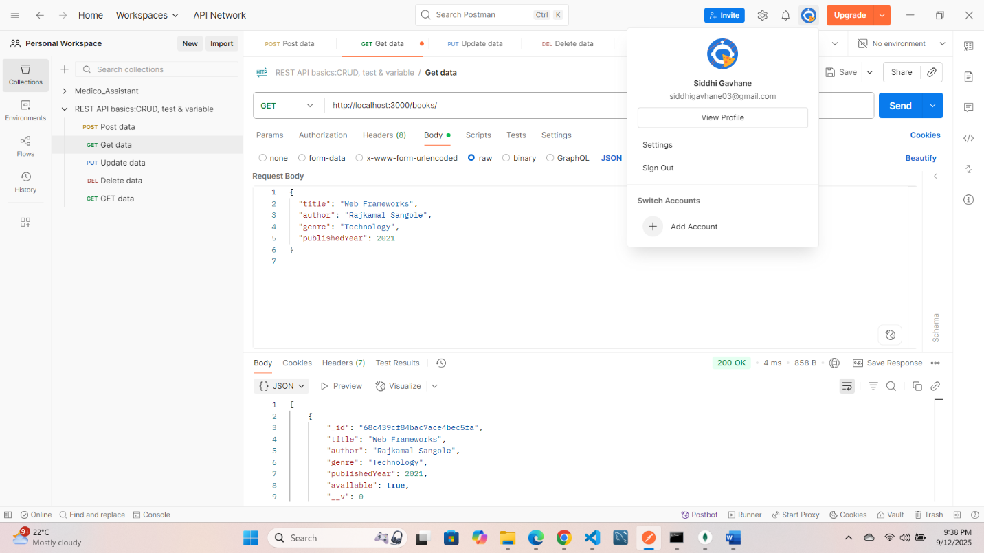

### **Q3. Fetch a single book by ID (GET)**

Create an API endpoint **/books/:id** to fetch details of a single book using its MongoDB _id.

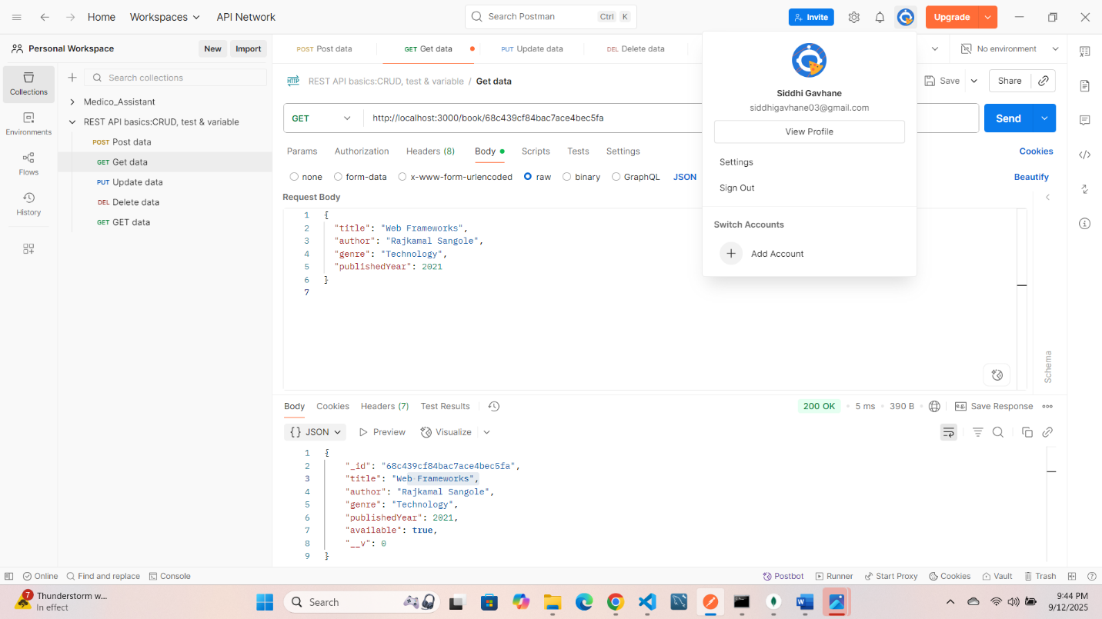

### **Q4. Update book availability (PUT)**

Create an API endpoint **/books/:id** that allows updating whether a book is available or not.

* Example Request Body:

{  
 "available": false  
}

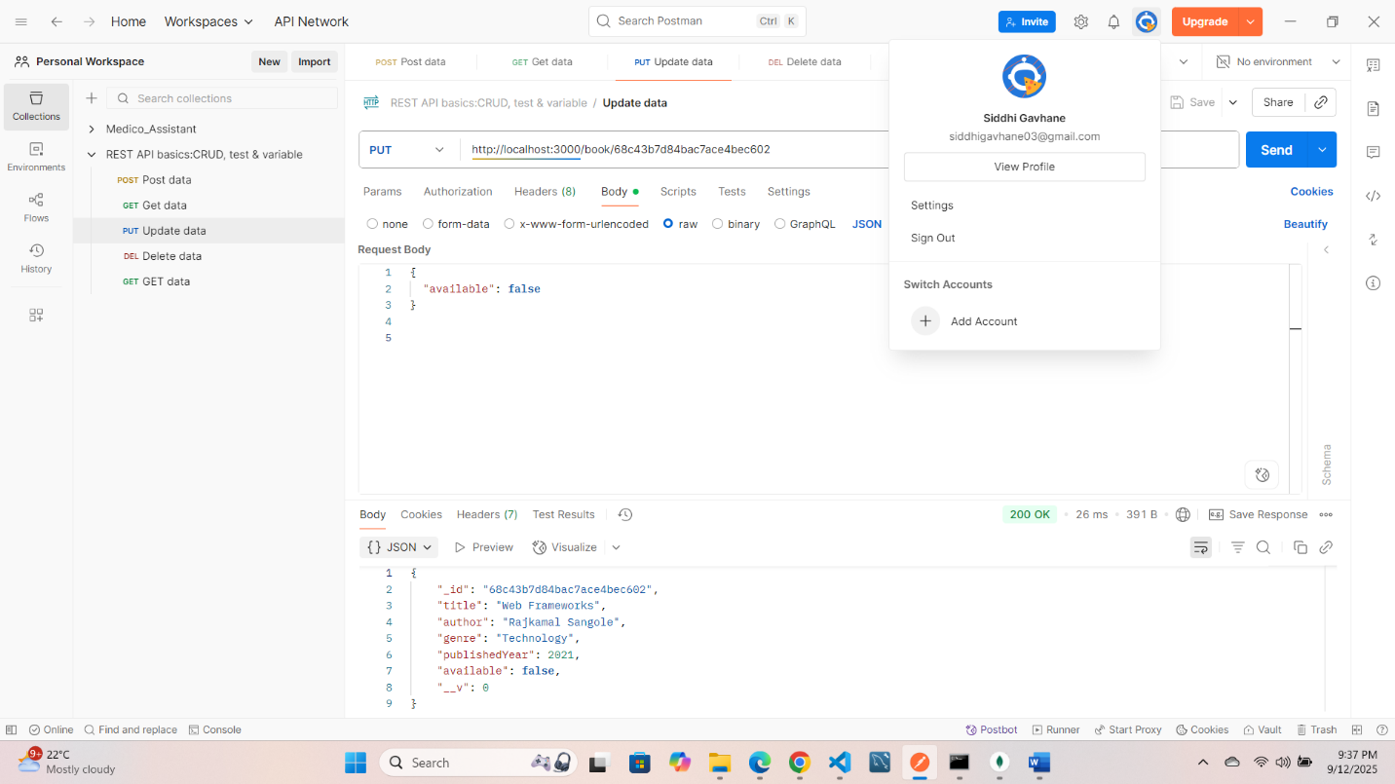

### **Q5. Delete a book record (DELETE)**

Create an API endpoint **/books/:id** to delete a book from the library by its _id.

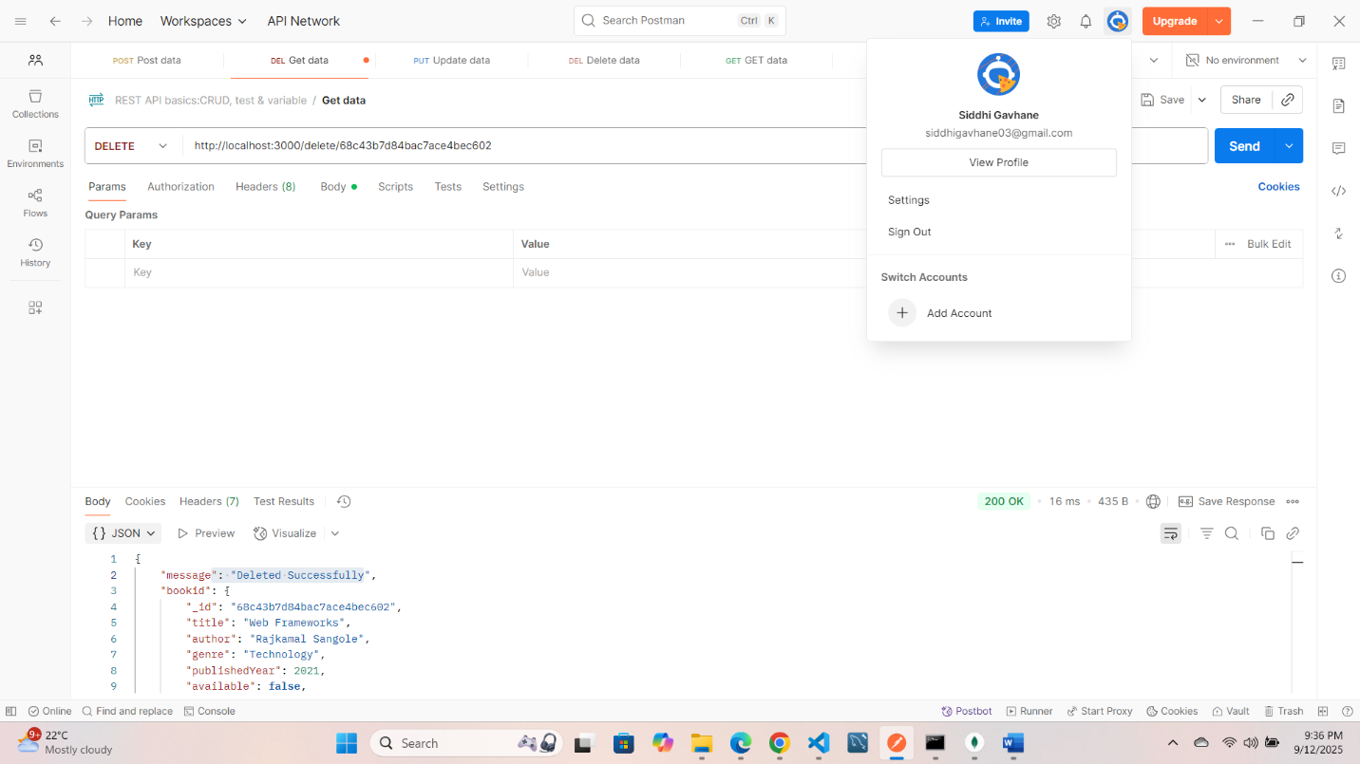

### **Q6. Fetch books by author name**

Create an API endpoint **/books/author/:name** to fetch all books written by a specific author.

