Service Desk Onboarding/Offboarding Bot – College Project Guide

1. Project Overview
Goal: Build a secure, role-based onboarding/offboarding chatbot system for students, using Python (FastAPI) and Auth0 for identity management.
Features:
- Auth0 authentication and JWT token validation
- Role-based access control (admin, manager, requester)
- Approval workflow for onboarding/offboarding requests
- Python backend (FastAPI)
- Frontend integration (React/HTML for simulation)
- Audit logging and notification simulation

2. Project Folder Structure
service-desk-bot/
├── backend/
│ ├── app/
│ │ ├── __init__.py
│ │ ├── main.py # FastAPI entrypoint
│ │ ├── routes/
│ │ │ ├── __init__.py
│ │ │ ├── requests.py # API routes
│ │ ├── services/
│ │ │ ├── __init__.py
│ │ │ ├── workflow.py # Workflow logic
│ │ │ ├── approval.py # Role-based approval logic
│ │ │ └── notifications.py # Email / message simulation
│ │ ├── auth/
│ │ │ ├── __init__.py
│ │ │ ├── auth0.py # JWT verification
│ │ └── models/
│ │ ├── __init__.py
│ │ ├── database.py # DB connection
│ │ ├── schemas.py # Pydantic models
│ │ └── tables.py # SQLAlchemy tables
│ └── requirements.txt
├── frontend/
│ ├── index.html # Simple HTML frontend
│ ├── app.js # JS for calling FastAPI
├── README.md
└── .env # Store Auth0 secrets locally (never commit)

3. Backend Setup – FastAPI + Auth0 Template
requirements.txt:
fastapi
uvicorn
python-jose[cryptography]
requests
sqlalchemy
pydantic
psycopg2-binary
python-dotenv

auth/auth0.py (JWT Validation)
from jose import jwt
import requests
from fastapi import HTTPException, Security
from fastapi.security import HTTPBearer
AUTH0_DOMAIN = 'YOUR_AUTH0_DOMAIN'
API_AUDIENCE = 'https://servicedesk.api'
ALGORITHMS = ['RS256']
security = HTTPBearer()
def verify_jwt(token: str):
jwks_url = f'https://{AUTH0_DOMAIN}/.well-known/jwks.json'
jwks = requests.get(jwks_url).json()
unverified_header = jwt.get_unverified_header(token)
rsa_key = {}
for key in jwks['keys']:
if key['kid'] == unverified_header['kid']:
rsa_key = {
'kty': key['kty'],
'kid': key['kid'],
'use': key['use'],
'n': key['n'],
'e': key['e'],
}
try:
payload = jwt.decode(
token,
rsa_key,
algorithms=ALGORITHMS,
audience=API_AUDIENCE,
issuer=f'https://{AUTH0_DOMAIN}/'
)
return payload
except Exception as e:
raise HTTPException(status_code=401, detail='Invalid token')

services/approval.py (Role-Based Logic)
ROLE_APPROVALS = {
'requester': ['manager'],
'manager': ['admin'],
'admin': []
}
def get_approvers(role):
return ROLE_APPROVALS.get(role, [])
def can_approve(user_role, request_role):
approvers = get_approvers(request_role)
return user_role in approvers

services/workflow.py (Workflow Example)
from .approval import can_approve
from .notifications import notify_user
def process_request(request_data, user_role):
request_type = request_data['type'] # onboarding/offboarding
target_role = request_data['role']
if can_approve(user_role, target_role):
status = 'Provisioned' if request_type == 'onboarding' else 'Deactivated'
notify_user(request_data['user_email'], status)
return {'status': status, 'message': 'Action completed'}
else:
return {'status': 'Pending', 'next_approvers': get_approvers(target_role)}

routes/requests.py (API Endpoint)
from fastapi import APIRouter, Depends
from ..auth.auth0 import verify_jwt, security
from ..services.workflow import process_request
router = APIRouter()
@router.post('/request')
def create_request(request_data: dict, token: str = Depends(security)):
payload = verify_jwt(token.credentials)
user_role = payload.get('role')
result = process_request(request_data, user_role)
return result

main.py
from fastapi import FastAPI
from app.routes import requests
app = FastAPI(title='Service Desk Bot API')
app.include_router(requests.router)

Frontend Example (index.html + app.js)
index.html:
<!DOCTYPE html>
<html>
<head>
<title>Service Desk Bot</title>
</head>
<body>
<h2>Onboarding / Offboarding Request</h2>
<form id='requestForm'>
User Email: <input type='email' id='userEmail' /><br>
Role: <input type='text' id='role' /><br>
Type: <select id='type'>
<option value='onboarding'>Onboarding</option>
<option value='offboarding'>Offboarding</option>
</select><br>
<button type='submit'>Submit</button>
</form>
<pre id='result'></pre>
<script src='app.js'></script>
</body>
</html>
app.js:
const form = document.getElementById('requestForm');
form.addEventListener('submit', async (e) => {
e.preventDefault();
const token = prompt('Enter Auth0 JWT token');
const data = {
user_email: document.getElementById('userEmail').value,
role: document.getElementById('role').value,
type: document.getElementById('type').value
};
const res = await fetch('http://localhost:8000/request', {
method: 'POST',
headers: {
'Authorization': `Bearer ${token}`,
'Content-Type': 'application/json'
},
body: JSON.stringify(data)
});
const result = await res.json();
document.getElementById('result').textContent = JSON.stringify(result, null, 2);
});

End-to-End Flow
User → Frontend Form → Auth0 Login → JWT Token → Send Request with JWT → Backend verifies JWT → Role-based approval check → Process workflow (provision / deactivate) → Notify user → Update audit logs

Next Steps
- Add database logging (SQLAlchemy models)
- Add simulated email notifications using Python smtplib
- Add multiple approval steps (manager → admin)
- Expand role matrix (requester, manager, admin)
- Deploy backend + frontend on localhost or free cloud (Render/Heroku)

Technical Architecture Diagram
Below is the technical architecture diagram of the Service Desk Chatbot system, showing the flow from user frontend to Auth0 authentication, FastAPI backend, role-based approvals, notifications, and database logging.

Technical Architecture Diagram
Below is the technical architecture diagram of the Service Desk Chatbot system.
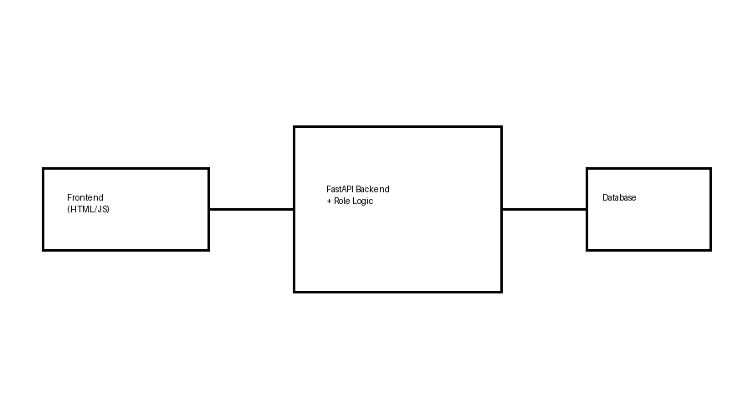
Figure 1: Technical Architecture of Service Desk Chatbot

