SIDDHI SINGH

17BIT0028

**WEB TECHNOLOGIES**

**LAB CAT - 2**

<!DOCTYPE html>

<html>

<head>

<title>17BIT0028</title>

<head>

<style>

#formtable{

border-collapse: collapse;

width: 1200px;

display: none;

}

#formtable,.headings,.headings td,#contents td{

border: 2px solid black;

}

#formField{

display: none;

}

</style>

</head>

<body>

<script type="text/javascript">

function showtable()

{

var bForm = document.forms["myform"];

var Name=bForm["fullname"].value;

if(Name==NUll)

{

document.write("Required")

}

var URL= bForm["url"].value;

var email= bForm["email"].value;

var phnno= bForm["phn"].value;

var emailid = document.forms["myform"]["emailid"].value;

var phnoV=document.forms["myform"]["phn"].value;

var phnoR = /[0-9]{10}/;

var nameR = /[A-Za-z]\s[a-zA-Z]{1,30}/;

var emailR = /^[\w-\.]+@([\w-]+\.)+[\w-]{2,4}$/;

if(!nameR.test(name))

{

alert("Invalid name.Name can only have alphabets ");

return false;

}

else if(!emailR.test(emailid))

{

alert("Invalid Email-Id");

return false;

}

else if(!phnoR.test(phnoV))

{

alert("Invalid Phone number. Should only have 10 digits");

return false;

}

else

{

return true;

}

}

document.getElementById("gtable").style.display="table";

document.getElementById("nameSpace").innerHTML=Name;

document.getElementById("urlSpace").innerHTML=URL;

document.getElementById("emailSpace").innerHTML=email;

document.getElementById("phoneSpace").innerHTML=phnno;

</script>

<form method="post" name="Form5">

<table cellspacing="4.5">

<tr><td>UserName : </td>

<td><input type="text" name="fullname"/></td></tr>

<tr><td>URL : </td>

<td><input type="text" name="url"></td></tr>

<tr><td>Email:</td>

<td><input type="text" name="email"/></td></tr>

<tr><td>Phone Number:</td>

<td><input type="text" name="phn"/></td></tr></td></tr>

<tr><td><input type="button" name="submitButton" value="Submit" onclick ="showtable()"></td></tr>

</table>

</form>

<table id="formtable">

<tr class = "headings">

<td>Name</td>

<td >URL</td>

<td>Email Id</td>

<td>Phone Number</td></tr>

<tr id ="contents">

<td id="nameSpace"></td>

<td id="urlSpace"></td>

<td id ="emailSpace"></td>

<td id ="phoneSpace">

</td></tr>

</table>

<h1 id="formField"></h1>

</body>

</html>

output 2

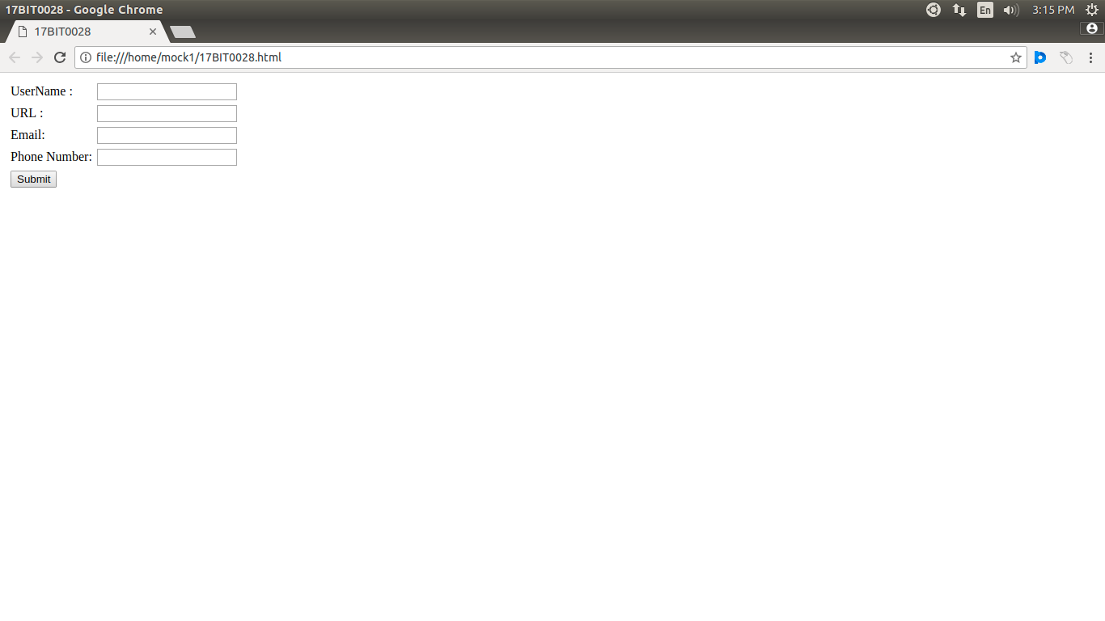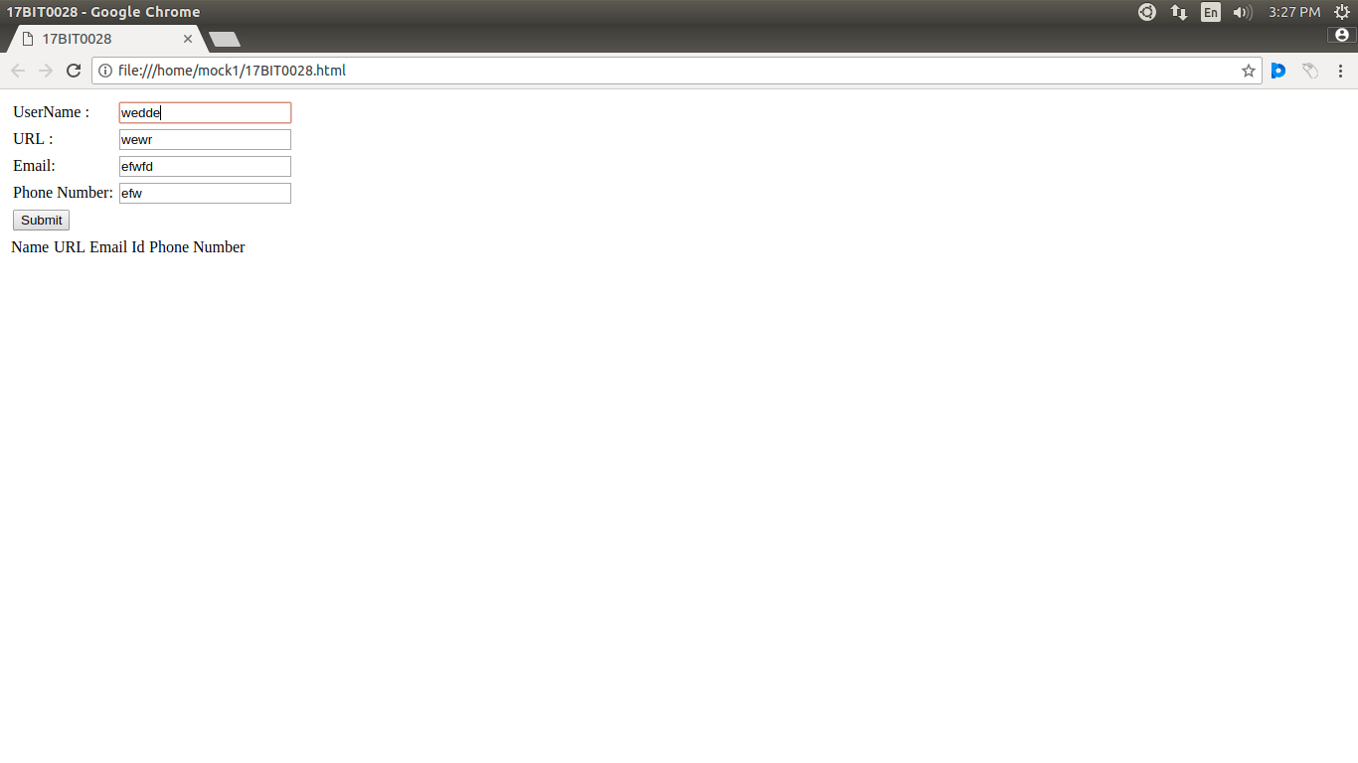

output1