**LAB CAT 2**

**DBMS**

**SIDDHI SINGH, 17BIT0028**

**QUES 1**

**create table STUDENT(regno varchar(10) primary key,sname varchar(30), class varchar(5), major varchar(30));**

**Table created.**

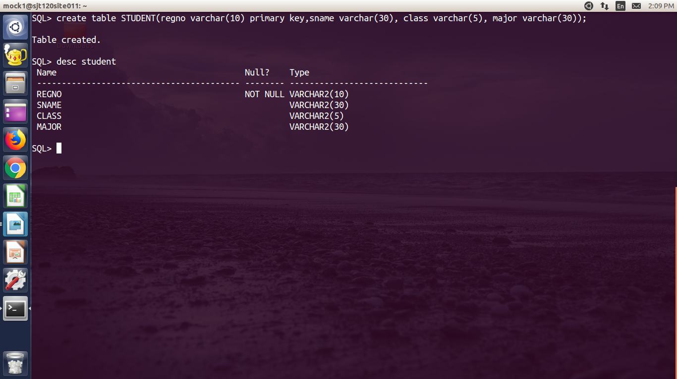

**create table course(courseid varchar(10) primary key, cname varchar(10), credithours number(3), department varchar(30));**

**Table created.**

**create table STUDENT(regno varchar(10) primary key,sname varchar(30), class varchar(5), major varchar(30));**

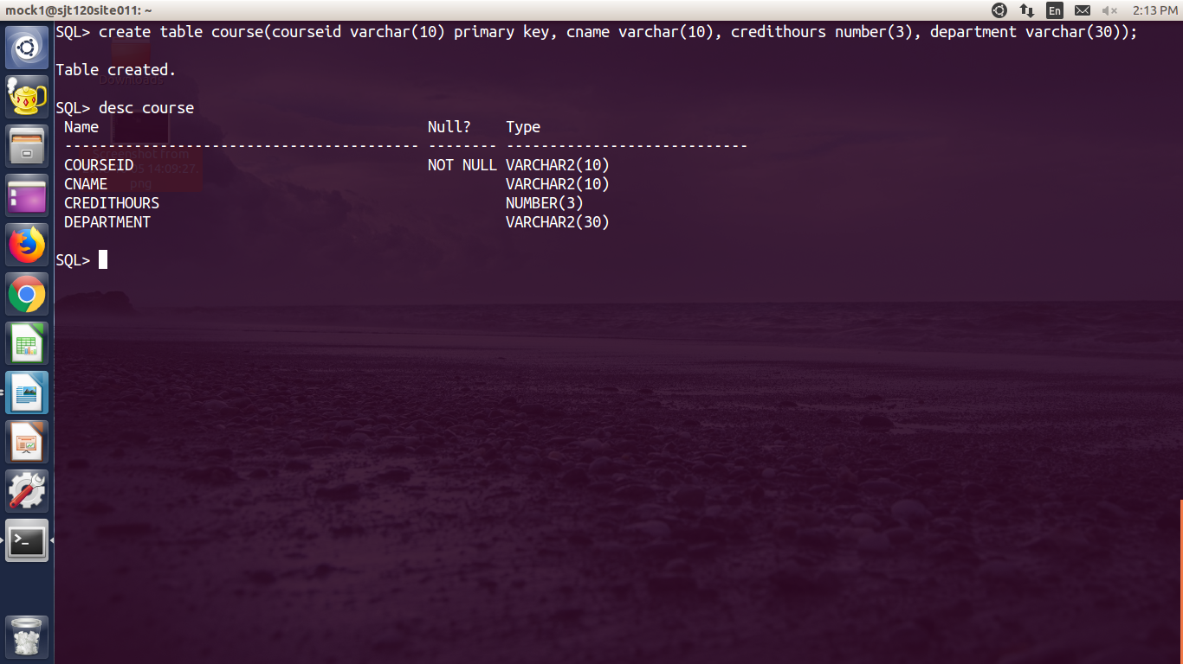

**create table section(sectionid number(5), cid constraint s_fk references course, semester varchar(15), year number(4), instructor varchar(30), constraint s_pk primary key(sectionid,courseid));**

**Table created.**

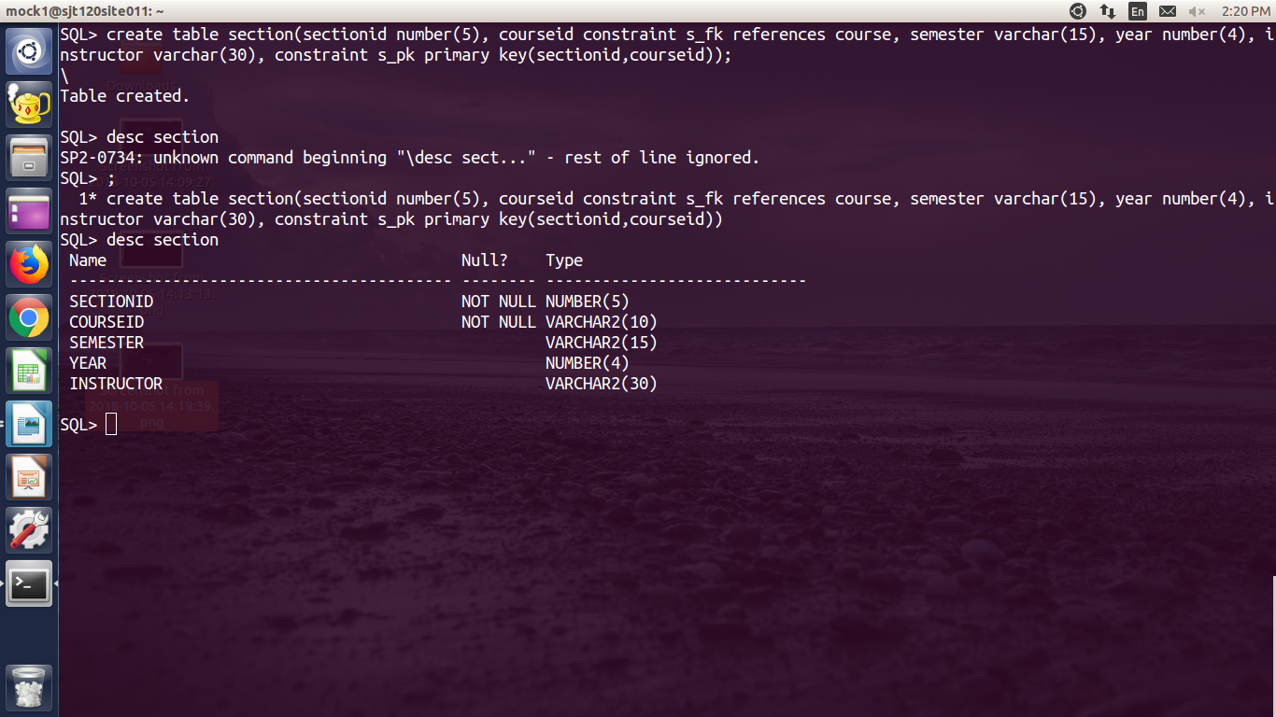

**QUES 2**

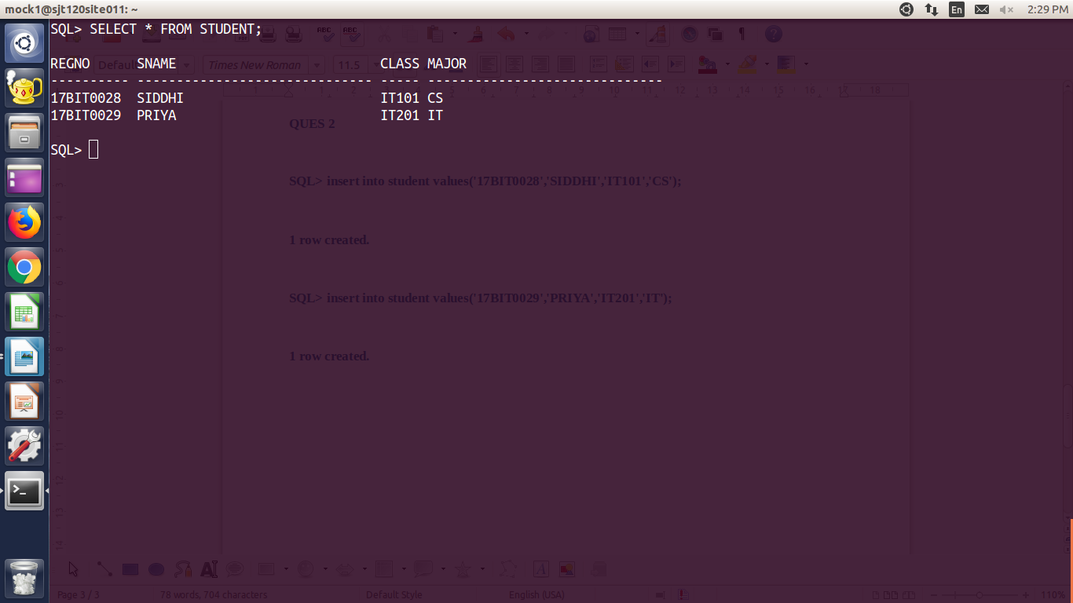

**insert into student values('17BIT0028','SIDDHI','4','CS');**

**insert into student values('17BIT0021','KSHITIJ','2','IT');**

**insert into course values('CSE2001', 'DBMS','22','CS');**

**insert into course values('ITE2001', 'DCCN','10','IT');**

**insert into SECTION values(1001, 'CSE2001','WINTER',2016, 'KING');**

**insert into SECTION values(1002, 'ITE2001','FALL',2017, 'JOHN');**

**QUES 3**

**a. select sname from STUDENT where major='CS';**

**b. s****elect cname from COURSE where courseid in (select courseid from SECTION where instructor=”Professor King” and year in (2016,2017));**

**c. select sum(sectionid), sectionid, courseid, semester, year from SECTION where instructor=”king”;**

**d. select sname from student where class='4'**

**union all**

**select * from course where**

**e. select credithours, department section join course on course.courseid = section.cid where department=”IT” and instructor=”king”;**

**f. select sum(c.credithours) from COURSE c, STUDENT s where(c.department='IT' and s.instructor='Professor King');**

select distinct (sname) from STUDENT

minus

select sname from STUDENT where sectionid in (select sectionid from SECTION where instructor=”Professor King”);

**(added sectionid as a foreign key in STUDENT)**