**ASSESSMENT-9**

**Name: Siddhi Singh** **Reg No.: 17BIT0028**

**Disk Scheduling Algorithms:**

**1) FCFS**

Code:

#include<stdio.h>

#define m 100

int main()

{

int n,h,sum=0,i,s[m],ele[m];

printf("Enter the number of locations:");

scanf("%d",&n);

printf("Enter the head location:");

scanf("%d",&h);

printf("Enter the elements in the queue:");

for(i=0;i<n;i++)

{

scanf("%d",&ele[i]);

}

for(i=0;i<n;i++)

{

s[i]=h-ele[i];

if(s[i]<0)

{

s[i]=ele[i]-h;

}

h=ele[i];

sum+=s[i];

}

printf("Total cylinders:%d",sum);

}

OUTPUT:

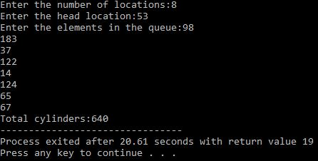

**2) SSTF**

Code:

#include<stdio.h>

#define m 100

int main()

{

int n,h,temp,c=0,i,j,ele[m],t[m];

printf("Enter the number of locations:");

scanf("%d",&n);

printf("Enter the head location:");

scanf("%d",&h);

printf("Enter the elements in the queue:\n");

for(i=0;i<n;i++)

{

scanf("%d",&ele[i]);

}

for(i=0;i<n;i++)

{

t[i]=abs(h-ele[i]);

}

for(i=0;i<n;i++)

{

for(j=i+1;j<n;j++)

{

if(t[i]>t[j])

{

temp=t[i];

t[i]=t[j];

t[j]=temp;

temp=ele[i];

ele[i]=ele[j];

ele[j]=temp;

}

}

}

for(i=0;i<n;i++)

{

c+=abs(h-ele[i]);

h=ele[i];

}

printf("Total Cylinders:%d",c);

}

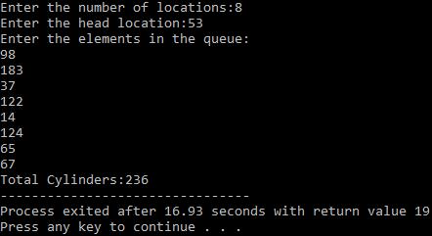

**3) SCAN**

Code:

#include<stdio.h>

#define m 100

int main()

{

int i,j,a,n,max,sum,temp,h,ele[m];

printf("Enter the number of locations:");

scanf("%d",&n);

printf("Enter the head location:");

scanf("%d",&h);

printf("Enter the locations:\n");

for(i=0;i<n;i++)

{

scanf("%d",&ele[i]);

}

for(i=0;i<n;i++)

{

for(j=i+1;j<n;j++)

{

if(ele[i]>ele[j])

{

temp=ele[i];

ele[i]=ele[j];

ele[j]=temp;

}

}

}

for(i=0;i<n;i++)

{

if(h>ele[i])

{

a=i;

}

}

printf("%d--->",h);

for(i=a;i>=0;i--)

{

printf("%d--->",ele[i]);

}

printf("0--->");

for(i=a+1;i<n-1;i++)

{

printf("%d--->",ele[i]);

}

printf("%d",ele[n-1]);

max=ele[n-1];

sum=h+max;

printf("\nTotal cylinder movement:%d",sum);

}

Output:

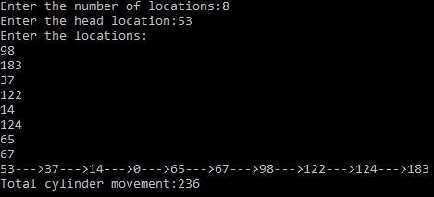

**4) C-SCAN**

Code:

#include<stdio.h>

#define m 100

int main()

{

int temp,a,i,j,max,sum=0,n,h,ele[m];

printf("Enter the maximum limit:");

scanf("%d",&max);

printf("Enter the number of locations:");

scanf("%d",&n);

printf("Enter the head location:");

scanf("%d",&h);

printf("Enter the locations:\n");

for(i=0;i<n;i++)

{

scanf("%d",&ele[i]);

}

for(i=0;i<n;i++)

{

for(j=i+1;j<n;j++)

{

if(ele[i]>ele[j])

{

temp=ele[i];

ele[i]=ele[j];

ele[j]=temp;

}

}

}

for(i=0;i<n;i++)

{

if(h>ele[i])

{

a=i;

break;

}

}

printf("%d--->",h);

for(i=a+2;i<n;i++)

{

printf("%d--->",ele[i]);

}

printf("%d--->0--->",max);

for(i=0;i<=a;i++)

{

printf("%d--->",ele[i]);

}

printf("%d",ele[a+1]);

sum=2*max-h+ele[a+1];

printf("\nTotal movement of cylinders:%d",sum);

}

Output:

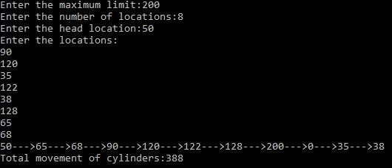

**File Allocation Algorithms:**

**1) Sequential**

#include<stdio.h>

int main()

{

int n,i,j,b[20],sb[20],t[20],x,c[20][20];

printf("Enter no.of files:");

scanf("%d",&n);

for(i=0;i<n;i++)

{

printf("Enter no. of blocks occupied by file%d",i+1); scanf("%d",&b[i]);

printf("Enter the starting block of file%d",i+1);

scanf("%d",&sb[i]);

t[i]=sb[i];

for(j=0;j<b[i];j++)

c[i][j]=sb[i]++;

}

printf("Filename\tStart block\tlength\n");

for(i=0;i<n;i++)

printf("%d\t\t%d\t\t%d\n",i+1,t[i],b[i]);

printf("Enter file name:");

scanf("%d",&x);

printf("File name is:%d",x);

printf("length is:%d",b[x-1]);

printf("blocks occupied:");

for(i=0;i<b[x-1];i++)

printf("%4d",c[x-1][i]);

}

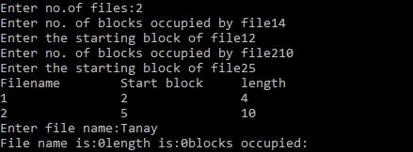

**2) Indexed**

#include<stdio.h>

int main()

{

int n,i,j,b[20],sb[20],t[20],x,c[20][20];

printf("Enter no.of files:");

scanf("%d",&n);

for(i=0;i<n;i++)

{

printf("Enter no. of blocks occupied by file%d",i+1); scanf("%d",&b[i]);

printf("Enter the starting block of file%d",i+1);

scanf("%d",&sb[i]);

t[i]=sb[i];

for(j=0;j<b[i];j++)

c[i][j]=sb[i]++;

}

printf("Filename\tStart block\tlength\n");

for(i=0;i<n;i++)

printf("%d\t\t%d\t\t%d\n",i+1,t[i],b[i]);

printf("Enter file name:");

scanf("%d",&x);

printf("File name is:%d",x);

printf("length is:%d",b[x-1]);

printf("blocks occupied:");

for(i=0;i<b[x-1];i++)

printf("%4d",c[x-1][i]);

}

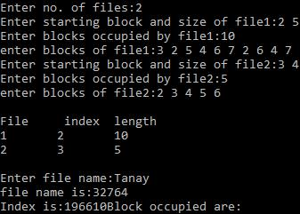

**3) Indexed**

#include<stdio.h>

struct file

{

char fname[10];

int start,size,block[10];

}f[10];

int main()

{

int i,j,n;

printf("Enter no. of files:");

scanf("%d",&n);

for(i=0;i<n;i++)

{

printf("Enter file name:");

scanf("%s",&f[i].fname);

printf("Enter starting block:");

scanf("%d",&f[i].start);

f[i].block[0]=f[i].start;

printf("Enter no.of blocks:");

scanf("%d",&f[i].size);

printf("Enter block numbers:");

for(j=1;j<=f[i].size;j++)

{

scanf("%d",&f[i].block[j]);

}

}

printf("File\tstart\tsize\tblock\n");

for(i=0;i<n;i++)

{

printf("%s\t%d\t%d\t",f[i].fname,f[i].start,f[i].size);

for(j=1;j<=f[i].size-1;j++)

printf("%d--->",f[i].block[j]);

printf("%d",f[i].block[j]);

printf("\n");

}

}

