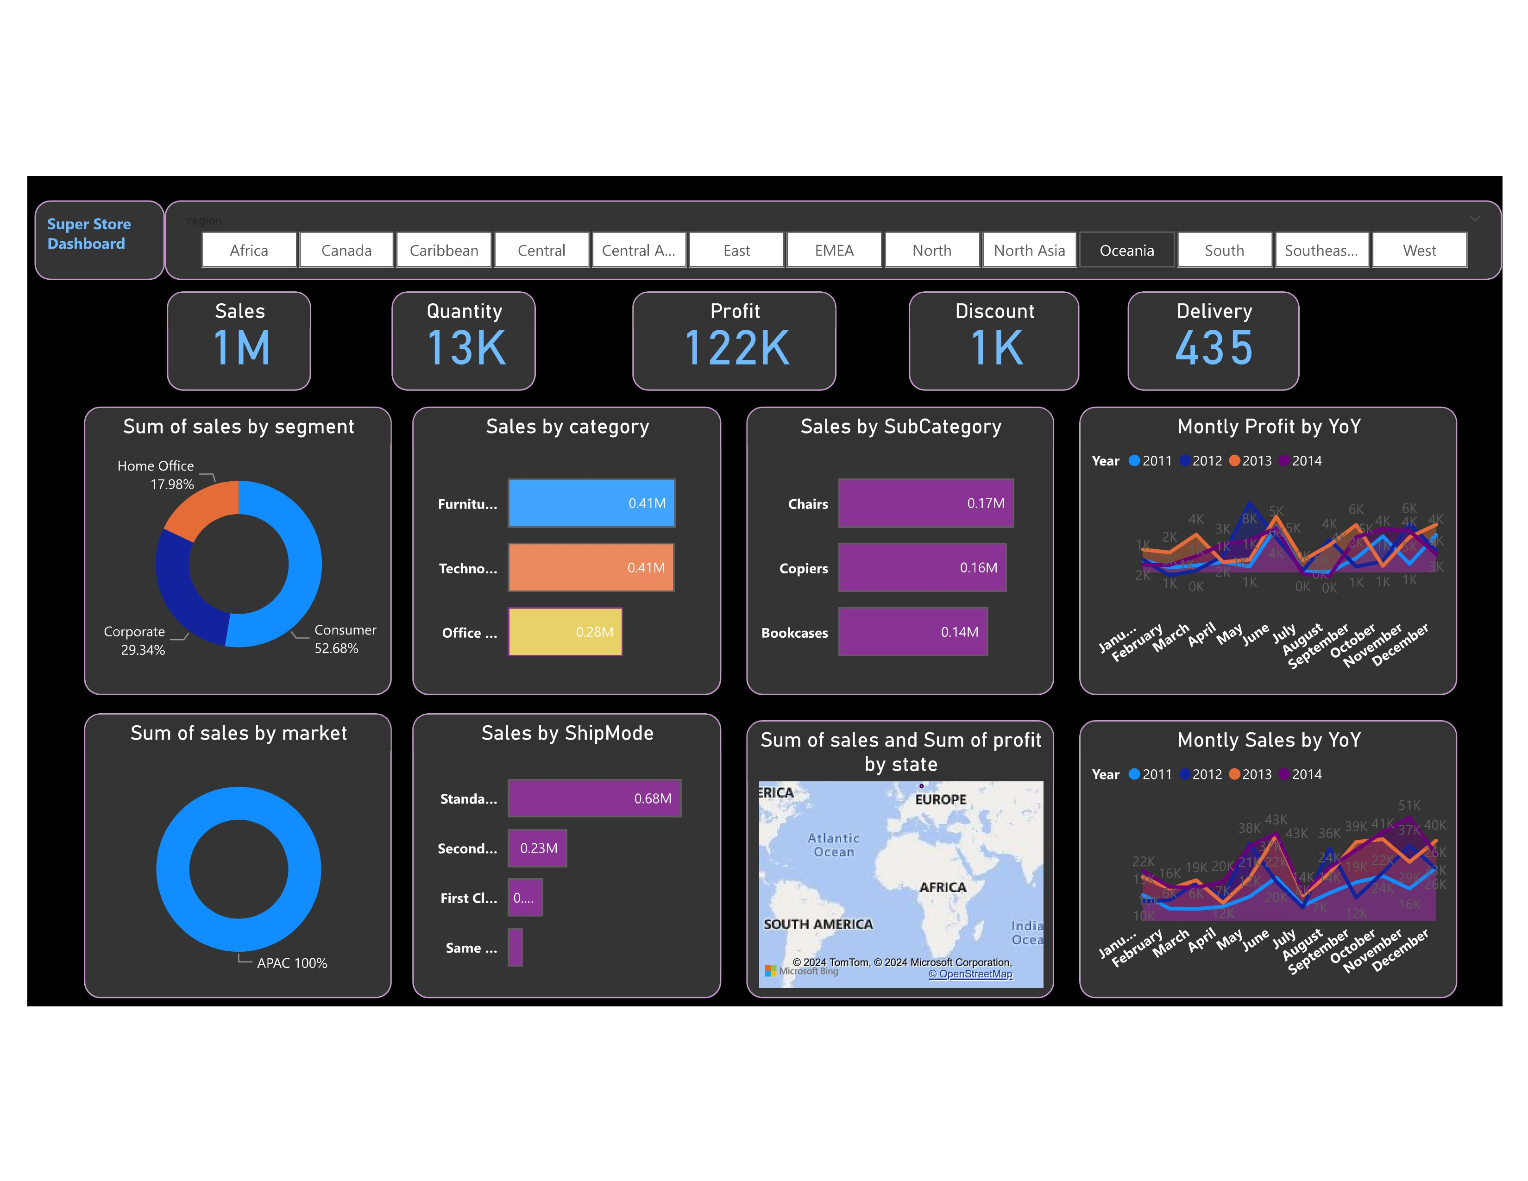



|  |
| --- |
|  |
| OK  2011 2012 2013 2014 2015 |

Ask a question about your data

Try one of these to get started

|  |
| --- |
| maximum sale |

