Academic Year 2025-26
FY MCA- SEM II
IT21 Java Programming
Assessment 3: SET- A2

Date: 05/05/2026 Roll No:2501080
Time: 90 Mins Name: Siddhi Joshi
Marks: 50 mks

Q.1 Develop a Student Management System using Java Swing to perform CRUD operations. The system should provide the following features:
  - Add new student details (name, roll number, course)
  - Display all student records using a JTable
  - Update existing student details (e.g., modify name or course)
[25 mks]
Code:

package question2;

import java.awt.*;
import javax.swing.*;
import javax.swing.border.EmptyBorder;
import javax.swing.table.DefaultTableModel;
import java.awt.event.ActionListener;
import java.awt.event.ActionEvent;
import java.sql.*;
import java.util.Vector;

public class StudentManagement extends JFrame {

private JPanel contentPane;
private JTextField txtName, txtRoll, txtCourse;
private JTable table;
private DefaultTableModel tableModel;

String url = "jdbc:mysql://localhost:3306/RegistrationForm";
String dbUser = "root";
String dbPass = "root";

public static void main(String[] args) {
EventQueue.invokeLater(() -> {
try {
StudentManagement frame = new StudentManagement();
frame.setVisible(true);
} catch (Exception e) {
e.printStackTrace();
}
});
}

public StudentManagement() {
setTitle("Student Management System");
setDefaultCloseOperation(JFrame.EXIT_ON_CLOSE);
setBounds(100, 100, 800, 500);
contentPane = new JPanel();
contentPane.setBorder(new EmptyBorder(5, 5, 5, 5));
setContentPane(contentPane);
contentPane.setLayout(new BorderLayout(10, 10));

JPanel inputPanel = new JPanel();
inputPanel.setPreferredSize(new Dimension(250, 400));
inputPanel.setLayout(null);
contentPane.add(inputPanel, BorderLayout.WEST);

JLabel lblName = new JLabel("Name:");
lblName.setBounds(10, 30, 80, 25);
inputPanel.add(lblName);

txtName = new JTextField();
txtName.setBounds(90, 30, 140, 25);
inputPanel.add(txtName);

JLabel lblRoll = new JLabel("Roll No:");
lblRoll.setBounds(10, 70, 80, 25);
inputPanel.add(lblRoll);

txtRoll = new JTextField();
txtRoll.setBounds(90, 70, 140, 25);
inputPanel.add(txtRoll);

JLabel lblCourse = new JLabel("Course:");
lblCourse.setBounds(10, 110, 80, 25);
inputPanel.add(lblCourse);

txtCourse = new JTextField();
txtCourse.setBounds(90, 110, 140, 25);
inputPanel.add(txtCourse);

JButton btnAdd = new JButton("Add");
btnAdd.setBounds(10, 160, 100, 30);
inputPanel.add(btnAdd);

JButton btnUpdate = new JButton("Update");
btnUpdate.setBounds(130, 160, 100, 30);
inputPanel.add(btnUpdate);

JButton btnDelete = new JButton("Delete");
btnDelete.setBounds(10, 200, 100, 30);
inputPanel.add(btnDelete);

JButton btnClear = new JButton("Clear");
btnClear.setBounds(130, 200, 100, 30);
inputPanel.add(btnClear);

tableModel = new DefaultTableModel(new String[]{"ID", "Name", "Roll No", "Course"}, 0);
table = new JTable(tableModel);
JScrollPane scrollPane = new JScrollPane(table);
contentPane.add(scrollPane, BorderLayout.CENTER);

btnAdd.addActionListener(e -> {
try (Connection con = DriverManager.getConnection(url, dbUser, dbPass)) {
String sql = "INSERT INTO students (name, roll_no, course) VALUES (?, ?, ?)";
PreparedStatement pst = con.prepareStatement(sql);
pst.setString(1, txtName.getText());
pst.setString(2, txtRoll.getText());
pst.setString(3, txtCourse.getText());
pst.executeUpdate();
updateTable();
clearFields();
} catch (SQLException ex) { ex.printStackTrace(); }
});

});

btnUpdate.addActionListener(e -> {
int row = table.getSelectedRow();
if (row != -1) {
String id = tableModel.getValueAt(row, 0).toString();
try (Connection con = DriverManager.getConnection(url, dbUser, dbPass)) {
String sql = "UPDATE students SET name=?, roll_no=?, course=? WHERE id=?";
PreparedStatement pst = con.prepareStatement(sql);
pst.setString(1, txtName.getText());
pst.setString(2, txtRoll.getText());
pst.setString(3, txtCourse.getText());
pst.setString(4, id);
pst.executeUpdate();
updateTable();
} catch (SQLException ex) { ex.printStackTrace(); }
}
});

updateTable();
}

private void updateTable() {
try (Connection con = DriverManager.getConnection(url, dbUser, dbPass)) {
String sql = "SELECT * FROM students";
Statement st = con.createStatement();
ResultSet rs = st.executeQuery(sql);
tableModel.setRowCount(0);
while (rs.next()) {
tableModel.addRow(new Object[]{rs.getInt("id"), rs.getString("name"), rs.getString("roll_no"), rs.getString("course")});
}
} catch (SQLException ex) { ex.printStackTrace(); }
}

private void clearFields() {
txtName.setText("");
txtRoll.setText("");
txtCourse.setText("");
}
}

Database:
CREATE DATABASE RegistrationForm;
USE RegistrationForm;

CREATE TABLE student(
roll INT PRIMARY KEY,
name VARCHAR(50),
course VARCHAR(50)
);

Output:
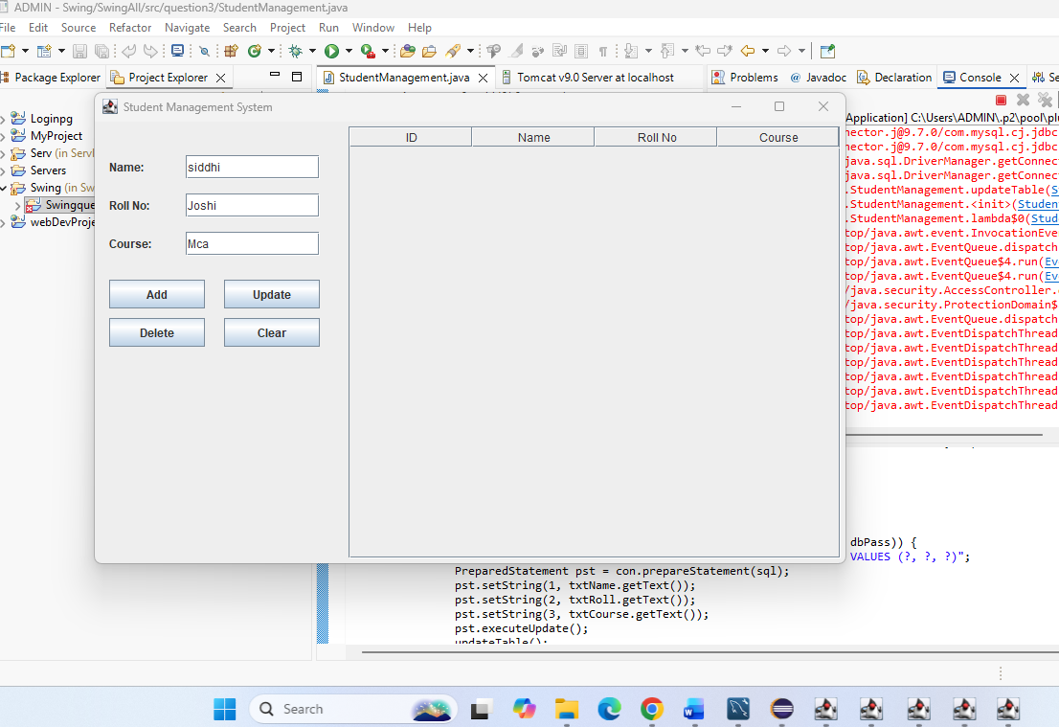

Q.2 Create a simple login form using JSP and Servlet.
  - JSP: Front-end form for username and password.
  - Servlet: Validate credentials (hardcoded or DB check), and redirect to a welcome page. [25 mks]

Mysql
CREATE DATABASE simplelogindb;
USE simplelogindb;
CREATE TABLE users (
username VARCHAR(50) PRIMARY KEY,
password VARCHAR(50)
);

INSERT INTO users VALUES ('admin', 'admin123');
INSERT INTO users VALUES ('student', 'student123');

login.jsp
<%@ page language="java" contentType="text/html; charset=UTF-8"
pageEncoding="UTF-8"%>
<!DOCTYPE html>
<html>
<head>
<meta charset="UTF-8">
<title>Simple Login Form</title>
</head>
<body>
<h2>Login Form</h2>
<%
String error = request.getParameter("error");
if(error != null){
%>
<p style="color:red;">Invalid Username or Password!</p>
<%
}
%>
<form action="LoginServlet" method="post">
Username:
<input type="text" name="username" required>
<br><br>
Password:
<input type="password" name="password" required>
<br><br>
<input type="submit" value="Login">
</form>
</body>
</html>

welcome.jsp
<%@ page language="java" contentType="text/html; charset=UTF-8"
pageEncoding="UTF-8"%>
<!DOCTYPE html>
<html>
<head>
<meta charset="UTF-8">
<title>Welcome Page</title>
</head>
<body>
<h2>Login Successful!</h2>
<%
String username = request.getParameter("username");
if(username != null){
%>
<h3>Welcome, <%= username %>!</h3>
<%
}
%>
</body>
</html>

error.jsp
<%@ page language="java" contentType="text/html; charset=UTF-8"
pageEncoding="UTF-8"%>
<!DOCTYPE html>
<html>
<head>
<meta charset="UTF-8">
<title>Login Failed</title>
</head>
<body>
<h2 style="color:red;">Login Failed!</h2>
<p>Invalid username or password.</p>
<a href="login.jsp">Try Again</a>
</body>
</html>

LoginServlet.java
import java.io.IOException;
import java.sql.Connection;
import java.sql.DriverManager;
import java.sql.PreparedStatement;
import java.sql.ResultSet;
import java.sql.SQLException;

import javax.servlet.RequestDispatcher;
import javax.servlet.ServletException;
import javax.servlet.annotation.WebServlet;
import javax.servlet.http.HttpServlet;
import javax.servlet.http.HttpServletRequest;
import javax.servlet.http.HttpServletResponse;

@WebServlet("/LoginServlet")
public class LoginServlet extends HttpServlet {
private static final long serialVersionUID = 1L;
protected void doPost(HttpServletRequest request, HttpServletResponse response)
throws ServletException, IOException {
try {
Class.forName("com.mysql.cj.jdbc.Driver");
String jdbcUrl = "jdbc:mysql://localhost:3306/simplelogindb";
String dbUsername = "root";
String dbPassword = "root";

Connection connection = DriverManager.getConnection(jdbcUrl, dbUsername, dbPassword);
String username = request.getParameter("username");
String password = request.getParameter("password");
String sql = "SELECT * FROM users WHERE username=? AND password=?";
PreparedStatement ps = connection.prepareStatement(sql);
ps.setString(1, username);
ps.setString(2, password);
ResultSet rs = ps.executeQuery();
if (rs.next()) {
response.sendRedirect("welcome.jsp?username=" + username);
} else {
response.sendRedirect("error.jsp");
}
rs.close();
ps.close();
connection.close();

} catch (ClassNotFoundException e) {
e.printStackTrace();
} catch (SQLException e) {
e.printStackTrace();
}
}
}

Evaluation Details:

Question | Marks | Remarks
Q1
Q2
TOTAL (50 M)

Name & Signature of the Faculty:

