Pipeline_4Stage: SimpleRISC Extended, 4-Stage Pipeline
IF, OF, EX_MA, RW | forwarding, stalls and flushes | 32-bit ISA with float and fcvt

1. Overview
- Stages: 1 IF (fetch), 2 OF (decode + operand fetch), 3 EX_MA (execute + memory access), 4 RW (register write).
- In-order, one instruction enters per cycle. Instructions are 32 bits wide; PC advances by 4 per instruction (byte-addressed). Instruction memory is separate from data memory.
- Registers: 16 x 32-bit, r14 = SP, r15 = ra. Integers and floats (IEEE-754 binary32) share them. 2 read ports; 2 write ports (port 1: rd or ra, port 2: SP).
- Branches: predicted not-taken, resolved in EX_MA. A taken branch, call or ret costs 2 bubbles.
- Data hazards: solved by forwarding. There is no load-use stall because data memory is read inside EX_MA. The only data-related stall is a multi-cycle EX unit (exBusy).
- Exceptions are precise. The only exception source is stack overflow/underflow on push and pop. Optional extension, off by default: runtime stack memory protection (protect trap) adds a second precise exception, cause 2, for ld / st that would corrupt the stack and for ALU writes that move SP outside the stack.
- Opcodes and instruction meanings: see SimpleRISC_Extended_ISA.docx. Opcodes 10111 and 11000 are unused (decode as nop).
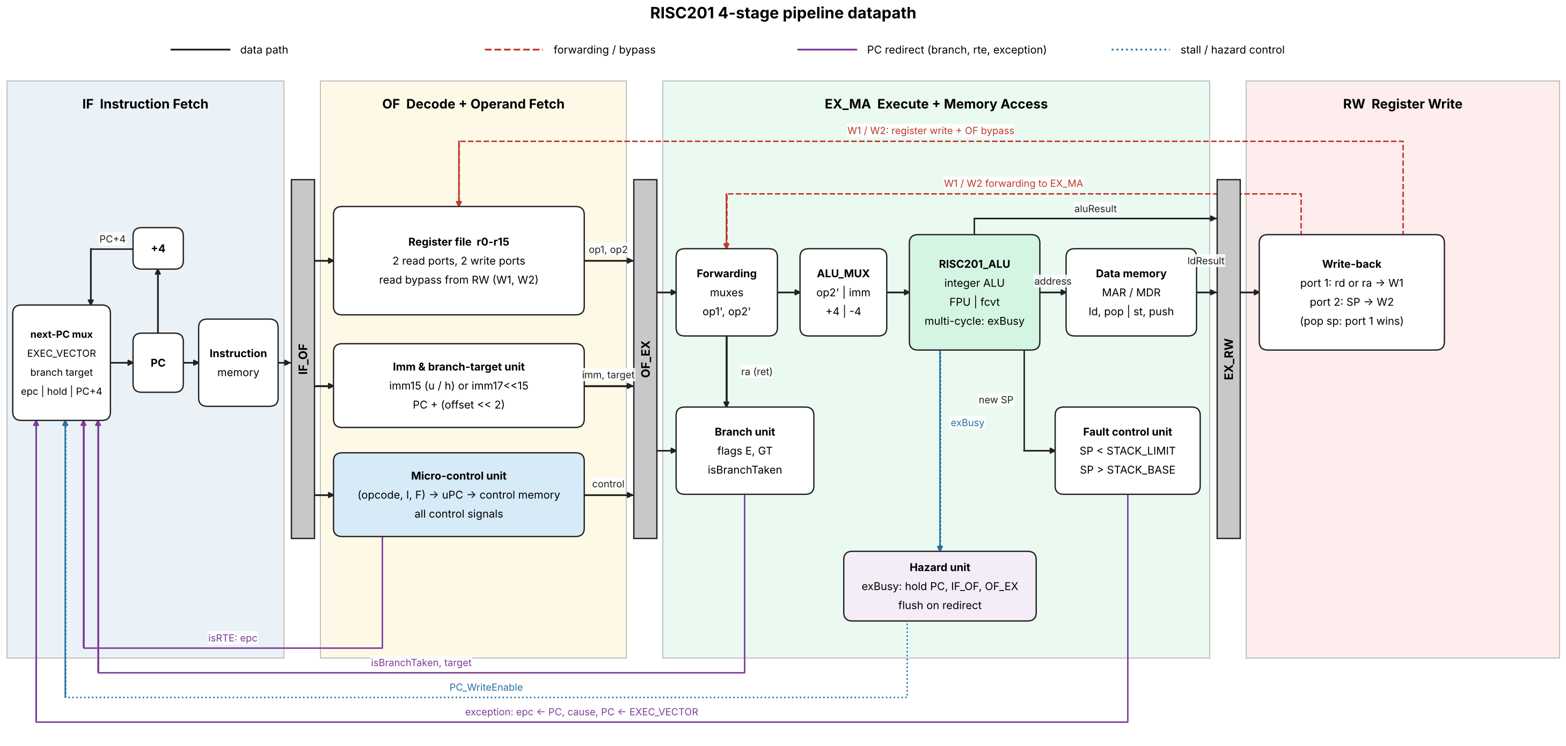
Figure 1. RISC201 4-stage pipeline datapath: pipeline latches, forwarding and bypass paths (red), PC redirects for branches, rte and exceptions (purple) and stall control (blue).

Instruction fields (bit 32 = MSB)
Format | opcode | I | F | rd | rs1 | Rest
Register (I=0) | [31:27] | [26] | [25] | [24:21] | [20:17] | rs2 [16:13], [12:0] unused
Immediate, F=0 | [31:27] | [26]=1 | [25]=0 | [24:21] | [20:17] | modifier [16:15], imm15 [14:0]
Immediate, F=1 | [31:27] | [26]=1 | [25]=1 | [24:21] | [20:17] | imm17 [16:0] = top 17 bits of a binary32 float
Branch / call | [31:27] | - | - | - | - | offset [26:0] (signed)

2. Pipeline latches
Every latch has a WriteEnable and a valid bit. A bubble is a latch loaded with valid = 0 and all control signals 0 (it behaves as a nop).
Latch | Contents
IF_OF | PCinst, instruction[31:0], valid
OF_EX | PCinst, op1, op2, imm, branchTarget, src1Addr, src2Addr, useSrc1, useSrc2, writeAddr (rd), all control signals, valid
EX_RW | PCinst, aluResult (ALU/FPU/fcvt result, or SP+/-4), ldResult (loaded data), writeAddr, control signals (isWb, isWb2, isLd, isPop, isPush, isCall, isHalt), valid

Other state: PC, flags {E, GT} (written only by cmp), epc, cause, halted.

3. Stage-by-stage description

Stage 1: IF (Instruction Fetch)
- Read the 32-bit instruction from Instruction Memory at PC. Compute PC + 4.
- Choose the next PC. Priority from highest to lowest: isExc gives EXEC_VECTOR; isBranchTaken (from EX_MA) gives branchTarget; isRTE (from OF) gives epc; if PC_WriteEnable = 0 the PC holds; otherwise PC + 4.
- Write {PCinst, instruction} into IF_OF. If the fetched instruction must be killed (a flush is active), write a bubble instead.

Stage 2: OF (Operand Fetch, includes decode)
- Decode: the Micro-Control Unit (MCU) reads opcode, I and F and generates all control signals (section 6). isFloat = F for the instructions that have a float form.
- Choose register addresses: src1Addr = rs1, or ra if isRet, or SP (r14) if isPush or isPop. src2Addr = rs2, or rd if isSt or isPush (the store data). useSrc1 / useSrc2 say whether the instruction really reads them.
- Imm & Branch unit: builds imm (F=0: 15-bit with u/h modifier; F=1: {imm17, 15'b0}) and branchTarget = PCinst + (offset << 2) for b, beq, bgt, call.
- Read the register file with src1Addr, src2Addr to get op1, op2. Bypass: if RW is writing the same register this cycle (port 1 or port 2), use the RW write data instead of the register-file value.
- rte: assert isRTE (next PC = epc, kill the instruction being fetched). halt: assert isHalt (freeze PC, kill the instruction being fetched). Both take effect only when OF is not stalled and the instruction is not being flushed.
- Write OF_EX (or a bubble if OF is flushed).

Stage 3: EX_MA (Execute and Memory Access)
- Forwarding muxes: for each operand choose OF_EX.op or the RW write data W1 / W2 (section 4.1). Call the results op1' and op2'.
- ALU_MUX picks the second operand: op2', imm, +4 (pop) or -4 (push). If isFloat the FPU is used instead of the integer ALU; if isfcvt the int/float converter is used (direction = isFloat). Output: ALU.Result. If the unit needs more than one cycle it asserts exBusy (section 4.2).
- Flags: cmp (integer or float) writes flags.E and flags.GT at the end of the cycle.
- Branch decision: isBranchTaken = isUBranch | isCall | isRet | (isBeq & flags.E) | (isBgt & flags.GT). Target = branchTarget, except ret which uses op1' (= ra). A taken branch flushes the instructions in IF and OF.
- Fault Control Unit: for push, overflow if ALU.Result < STACK_LIMIT; for pop, overflow if ALU.Result > STACK_BASE. On overflow: isOverflow = 1, isExc = 1, epc <- PCinst, cause <- overflow, PC <- EXEC_VECTOR, IF and OF are flushed, and this instruction writes nothing (all write enables are gated with !isExc).
- Memory access: MAR <- ALU.Result (for pop, MAR <- op1', the old SP). ld / pop: MDR <- Mem[MAR], giving ldResult. st / push: Mem[MAR] <- op2' when !isExc & (isSt | isPush).
- Write EX_RW (or a bubble if isExc or exBusy).

Stage 4: RW (Register Write)
- Write port 1: data = ldResult if isLd | isPop, PCinst + 4 if isCall, else aluResult. Address = ra if isCall, else writeAddr (rd). Enable = isWb. Result is the bus W1.
- Write port 2: address = SP (r14), data = aluResult (SP-4 for push, SP+4 for pop). Enable = isWb2 (isPush | isPop). Result is the bus W2.
- If pop sp is executed (rd = SP), the loaded value (port 1) wins over SP+4.
- W1 and W2 feed the forwarding muxes in EX_MA and the bypass in OF.
- When a halt reaches RW, set halted = 1; the processor stops after all older instructions have written back.

4. Hazard handling

4.1 Forwarding
Only one older instruction can still be unwritten when an operand is needed, and it is always in RW. Two forwarding points are enough:
Path | Used when | Covers
RW write data (W1/W2) to EX_MA operand muxes | Producer is directly ahead of the consumer | ALU, FPU, fcvt, ld, pop (rd and SP), push (SP), call (ra)
RW write data (W1/W2) to OF register read (bypass) | Producer is two instructions ahead | Same results as above

Rule, for each source k in {1, 2} of the instruction in EX_MA (all conditions use the EX_RW latch):
for k in {1, 2}: // useSrc_k, src_kAddr come from the OF_EX latch
m1 = EX_RW.valid && EX_RW.isWb && useSrc_k && src_kAddr == dest1
m2 = EX_RW.valid && EX_RW.isWb2 && useSrc_k && src_kAddr == 14
m2 = m2 && !(EX_RW.isWb && dest1 == 14) // pop sp: port 2 is not used, port 1 wins
op_k' = m1 ? W1 : m2 ? W2 : OF_EX.op_k // port 1 wins
// dest1 = ra (15) if EX_RW.isCall, else EX_RW.writeAddr
// OF does the same compare against RW for the register-file bypass

A bubble or an instruction killed by an exception has valid = 0 and never forwards. pop sp writes the loaded value (port 1) and SP+4 (port 2) to the same register r14; port 1 always wins, in the register file, in the OF bypass and in the EX_MA forwarding mux. Because W1 / W2 are taken after the RW data mux, loaded data and the call link value forward in exactly the same way as ALU results.

4.2 Stalls
- No load-use stall. ld / pop read memory in EX_MA, so the data is in RW when the next instruction reaches EX_MA and is forwarded.
- Multi-cycle EX (exBusy). When an instruction needs more than one cycle in EX_MA (mul, div, mod, float add/sub/mul/div, fcvt; latencies in section 8), exBusy = 1. Then PC_WriteEnable = 0, IF_OF_WriteEnable = 0, OF_EX_WriteEnable = 0 (IF, OF and EX_MA hold) and a bubble is written into EX_RW each cycle until the unit is done. While busy, the forwarded operands op1' / op2' are written back into OF_EX.op1 / op2, because the producer will have left RW before the unit finishes.
- Halt. After halt is decoded, fetch is frozen (PC_WriteEnable = 0) and bubbles enter IF_OF. If an older instruction redirects the PC (taken branch or exception), the halt is killed and fetch restarts.

4.3 Flushes
Event | Detected in | Instructions killed | Cost
Taken b / beq / bgt / call / ret | EX_MA | Instruction in IF and instruction in OF | 2 bubbles
Exception (isExc) | EX_MA | The faulting instruction (writes nothing), IF and OF | 2 bubbles
rte | OF | Instruction being fetched in IF | 1 bubble
halt | OF | Instruction being fetched; fetch then stops | fetch stops

Priority when events happen in the same cycle (oldest instruction wins): exception > taken branch > rte > halt > stall (exBusy). A redirect from EX_MA always overrides a stall of younger stages.

5. Instruction walk-through (every instruction can execute)
op2 = rs2 or the immediate. Result for ALU-type instructions comes out of EX_MA and is written in RW.
Instruction(s) | OF | EX_MA | RW
add sub mul div mod and or lsl lsr asr min max | read rs1, rs2/imm | ALU (FPU if F=1; mod, and, or, shifts have no float form) | port 1 <- aluResult
not mov abs neg | read rs2/imm | ALU / FPU (F=1 for mov, abs, neg) | port 1 <- aluResult
fcvt rd, rs2 | read rs2; isfcvt = 1 | converter (F=0 int to float, F=1 float to int) | port 1 <- aluResult
cmp rs1, op2 | read rs1, op2 | ALU / FPU compare, sets flags | nothing
ld rd, imm[rs1] | read rs1, build imm | address = rs1 + imm, read memory | port 1 <- ldResult
st rd, imm[rs1] | read rs1, and rd as data | address = rs1 + imm, write memory | nothing
push rd | read SP, and rd as data | SP-4, bounds check, write memory at SP-4 | port 2 <- SP-4
pop rd | read SP | bounds check on SP+4, read memory at SP | port 1 <- ldResult, port 2 <- SP+4
b beq bgt | build branchTarget | check flags, redirect PC if taken | nothing
call | build branchTarget | redirect PC | port 1: ra <- PCinst + 4
ret | read ra as op1 | redirect PC <- op1' (forwarded ra) | nothing
rte | isRTE, PC <- epc | bubble | nothing
halt | isHalt, freeze fetch | passes | set halted
nop and reserved opcodes | all controls 0 | passes | nothing

6. Control signals
Signal | Made in | Meaning
isFloat | OF | F bit. EX_MA uses the FPU. For fcvt it is the direction (0 int to float, 1 float to int).
isfcvt | OF | fcvt only. EX_MA result comes from the converter.
isPush isPop | OF | Stack access. src1 = SP, ALU adds -4 / +4, memory address and bounds check, port 2 write.
isLd isSt | OF | Data memory read / write.
isCall isRet | OF | call: link value PC+4 into ra. ret: src1 = ra, target = op1.
isBeq isBgt isUBranch | OF | Conditional / unconditional branch. Condition uses flags.E, flags.GT.
isRTE isHalt | OF | Return from exception (PC <- epc). Stop fetch, finish older instructions.
isWb isWb2 | OF | Write port 1 (rd or ra) / port 2 (SP) enable.
useSrc1 useSrc2 | OF | Which source registers the instruction reads (avoids false forwarding).
isBranchTaken | EX_MA | Redirect PC to branchTarget; flush IF and OF.
isOverflow isExc | EX_MA | Stack bounds violated / exception taken: PC <- EXEC_VECTOR, epc <- PCinst.
exBusy | EX_MA | Multi-cycle unit still working; hold IF, OF, EX_MA.
PC_WriteEnable, IF_OF_WriteEnable, OF_EX_WriteEnable | hazard logic | Freeze PC / latches during stalls and halt.
The control signals in the table below are not produced by hardwired logic. They are read from a control memory (microprogrammed control unit, Figure 2): the decoder uses opcode, I and F to look up a start address (uPC) in a dispatch table, and the microinstruction stored there gives every signal, including isFloat. Two control memories are implemented and give identical results: vertical (28 words x 16 bits, encoded fields that need decoders) and horizontal (28 words x 25 bits, one bit per signal). Each instruction is a single microinstruction, so the uPC returns to 0x00 after every instruction. An illegal microinstruction raises MicrocodeError.
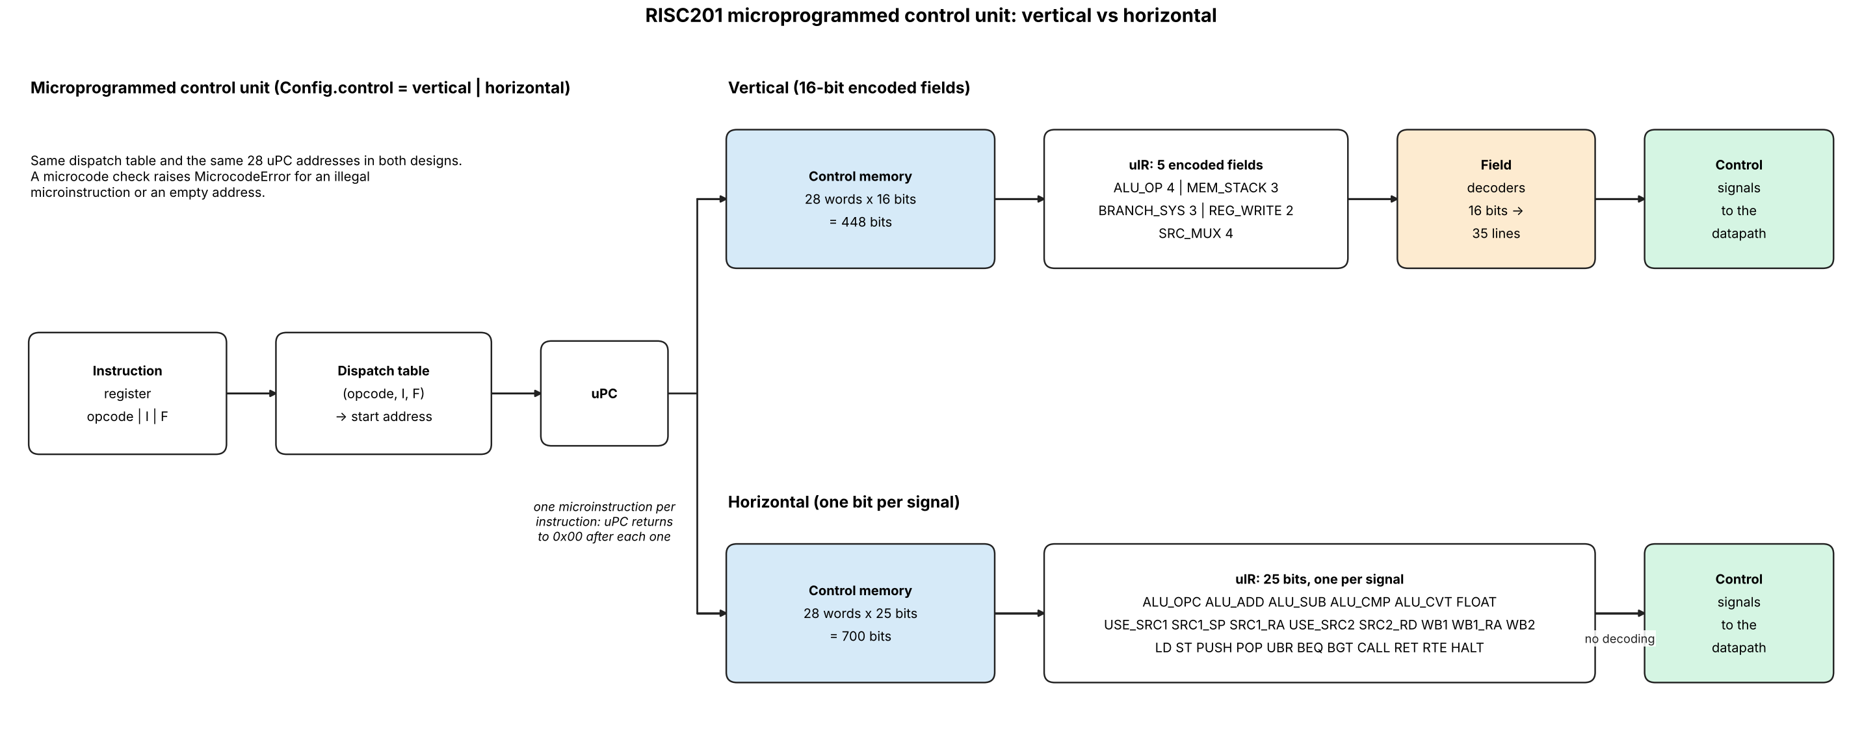
Figure 2. Microprogrammed control unit, vertical and horizontal control memory.

7. Timing examples
Dependent ALU instructions (add r1,r2,r3 then sub r4,r1,r5), no stall:
cycle: 1 2 3 4
add IF OF EX_MA RW
sub IF OF EX_MA <- r1 forwarded from RW (W1) in cycle 4

Load then use (ld r1,0[r2] then add r3,r1,r4), no stall:
ld IF OF EX_MA(read mem) RW
add IF OF EX_MA <- r1 forwarded from RW in cycle 4

Taken branch (beq at cycle 1), 2 bubbles:
beq IF OF EX_MA(taken) RW
i+1 IF OF(killed)
i+2 IF(killed)
target IF OF ...

8. Parameters (set before use)
Parameter | Value / note
EXEC_VECTOR | Address of the exception handler. Chosen by the designer.
STACK_BASE, STACK_LIMIT | Fixed constants (upper and lower bound of the stack). Chosen by the designer; see Other Modifications.
EX latency (defaults, tunable) | Simple integer ops, cmp, mov, min, max, abs, neg, float cmp/min/max/abs/neg/mov, address calculation: 1 cycle. int mul: 2. int div, mod: 8. float add/sub: 3. float mul: 3. float div: 10. fcvt: 2.

9. Other Modifications
Changes needed beyond the original design so that every instruction of the extended ISA can execute:
- Decoder fields with the F bit: the instruction path stays 32 bits wide. The decoder reads opcode [31:27], I [26], F [25], rd [24:21], rs1 [20:17], rs2 [16:13]. Integer immediates are 15 bits (modifier [16:15], imm15 [14:0], sign-extended for ld/st).
- Float unit (FPU) in EX_MA: binary32 add, sub, mul, div, compare, min, max, abs, neg, mov. The result mux selects ALU, FPU or the fcvt converter using isFloat and isfcvt. Rounding is nearest-even; subnormals flush to zero; Inf/NaN do not raise exceptions.
- Float compare: cmp with F=1 sets flags.E / flags.GT. If either operand is NaN both flags are 0, so beq and bgt are not taken.
- Float immediate: the Imm unit builds {imm17, 15'b0} when I=1 and F=1 (top 17 bits of the float: 8 mantissa bits).
- lsbase and lslim removed: the Stack_base and Stack_limit registers, their write enables (isLsBase, isLsLim) and their muxes are deleted from EX_MA. The Fault Control Unit compares against the fixed constants STACK_BASE and STACK_LIMIT. Opcodes 10111 and 11000 decode as nop.
- Two register write ports (port 1 rd/ra, port 2 SP) so pop can write both rd and SP in the same cycle. If pop sp is used, port 1 wins.
- Operand-select muxes: src1 = rs1 / ra (ret) / SP (push, pop); src2 = rs2 / rd (st, push).
- Branch offset is 27 bits (the ISA branch format); the Imm & Branch unit sign-extends it and shifts it left by 2.
- flags are written only by cmp (integer or float) and only by an instruction that is in EX_MA and valid.
- Integer divide by zero: no exception. div returns all ones (0xFFFFFFFF); mod returns the dividend. INT_MIN / -1 returns INT_MIN.
- Exception rules: epc holds the PC of the faulting instruction; rte returns to it. The handler must therefore change SP (or halt) before rte, because the stack bounds are fixed and the same push / pop would fault again. Exceptions inside the handler (nested) are not supported.
- halted flag: set when halt reaches RW; stops the clock for the pipeline.
- Reserved opcodes (10111, 11000) are treated as nop.

10. Verification
The file pipeline_sim.py (same folder as this document) models this pipeline cycle by cycle and checks it against a one-instruction-at-a-time reference model. Run it with python3 pipeline_sim.py.
- Encoding: 5000 random instructions round-trip through the 32-bit format; opcodes 10111 and 11000 decode as nop.
- Directed programs (26): hazard distances 1 to 4, load-use, push/pop chains, call/ret, cmp then branch, wrong-path stores and halt, multi-cycle EX, divide by zero, float add/sub/mul/div/min/max/abs/neg/cmp/fcvt, NaN compare, exceptions with handler and rte. Register values and cycle counts match section 4.3 and section 7.
- Random programs: 4000 programs (about 157000 instructions, 2172 with an exception) end with the same registers, memory, flags, epc, cause and retired-instruction order as the reference model.
- Mutation checks: switching off forwarding, the OF bypass, the load-use stall, operand latching during exBusy, or giving port 2 priority over port 1 for pop sp makes the random tests fail, so the tests can detect these bugs.

