Pipeline_6Stage: SimpleRISC Extended, 6-Stage Pipeline
IF, ID, OF, EX, MA, RW | forwarding, stalls and flushes | 32-bit ISA with float and fcvt

1. Overview
- Stages: 1 IF (fetch), 2 ID (decode), 3 OF (register read), 4 EX (execute), 5 MA (memory access), 6 RW (register write).
- In-order, one instruction enters per cycle. Instructions are 32 bits wide; PC advances by 4 per instruction (byte-addressed). Instruction memory is separate from data memory.
- Registers: 16 x 32-bit, r14 = SP, r15 = ra. Integers and floats (IEEE-754 binary32) share them. 2 read ports; 2 write ports (port 1: rd or ra, port 2: SP).
- Branches: predicted not-taken, resolved in EX. A taken branch, call or ret costs 3 bubbles.
- Data hazards: solved by forwarding. The only data stall is 1 cycle for load-use (ld / pop followed by an instruction that reads the loaded register), plus stalls for a multi-cycle EX unit (exBusy).
- Exceptions are precise. The only exception source is stack overflow/underflow on push and pop, detected in EX. Optional extension, off by default: runtime stack memory protection (protect trap) adds a second precise exception, cause 2, for ld / st that would corrupt the stack and for ALU writes that move SP outside the stack.
- Opcodes and instruction meanings: see SimpleRISC_Extended_ISA.docx. Opcodes 10111 and 11000 are unused (decode as nop).
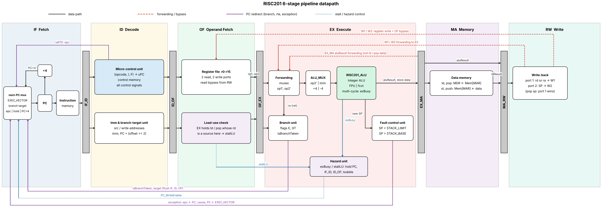
Figure 1. RISC201 6-stage pipeline datapath: pipeline latches, forwarding and bypass paths (red), PC redirects for branches, rte and exceptions (purple) and stall control (blue).

Instruction fields (bit 32 = MSB)
Format | opcode | I | F | rd | rs1 | Rest
Register (I=0) | [31:27] | [26] | [25] | [24:21] | [20:17] | rs2 [16:13], [12:0] unused
Immediate, F=0 | [31:27] | [26]=1 | [25]=0 | [24:21] | [20:17] | modifier [16:15], imm15 [14:0]
Immediate, F=1 | [31:27] | [26]=1 | [25]=1 | [24:21] | [20:17] | imm17 [16:0] = top 17 bits of a binary32 float
Branch / call | [31:27] | - | - | - | - | offset [26:0] (signed)

2. Pipeline latches
Every latch has a WriteEnable and a valid bit. A bubble is a latch loaded with valid = 0 and all control signals 0 (it behaves as a nop).
Latch | Contents
IF_ID | PCinst, instruction[31:0], valid
ID_OF | PCinst, src1Addr, src2Addr, useSrc1, useSrc2, writeAddr (rd), imm, branchTarget, all control signals, valid
OF_EX | PCinst, op1, op2, imm, branchTarget, src1Addr, src2Addr, useSrc1, useSrc2, writeAddr, control signals, valid
EX_MA | PCinst, aluResult (ALU/FPU/fcvt result, SP+/-4, or call link PC+4), op1 (pop address), op2 (store data), writeAddr, control signals, valid
MA_RW | PCinst, aluResult, ldResult, writeAddr, control signals (isWb, isWb2, isLd, isPop, isPush, isHalt), valid

Other state: PC, flags {E, GT} (written only by cmp), epc, cause, halted.

3. Stage-by-stage description

Stage 1: IF (Instruction Fetch)
- Read the 32-bit instruction from Instruction Memory at PC. Compute PC + 4.
- Choose the next PC. Priority from highest to lowest: isExc gives EXEC_VECTOR; isBranchTaken (from EX) gives branchTarget (for ret, op1'); isRTE (from ID) gives epc; if PC_WriteEnable = 0 the PC holds; otherwise PC + 4.
- Write {PCinst, instruction} into IF_ID. If the fetched instruction must be killed (a flush is active), write a bubble instead.

Stage 2: ID (Instruction Decode)
- Decode: the Micro-Control Unit (MCU) reads opcode, I and F and generates all control signals (section 6). isFloat = F for the instructions that have a float form.
- Choose register addresses: src1Addr = rs1, or ra if isRet, or SP (r14) if isPush or isPop. src2Addr = rs2, or rd if isSt or isPush (the store data). writeAddr = rd, or ra if isCall. useSrc1 / useSrc2 say whether the instruction really reads them.
- Imm & Branch unit: builds imm (F=0: 15-bit with u/h modifier; F=1: {imm17, 15'b0}) and branchTarget = PCinst + (offset << 2) for b, beq, bgt, call.
- rte: assert isRTE (next PC = epc, kill the instruction being fetched). halt: assert isHalt (freeze PC, kill the instruction being fetched). Both take effect only when ID is not stalled and the instruction is not being flushed.
- Write ID_OF (or a bubble if ID is flushed).

Stage 3: OF (Operand Fetch)
- Load-use check (section 4.2): if the instruction in EX is a ld / pop whose destination is a source of the instruction in OF, stall.
- Read the register file with src1Addr, src2Addr to get op1, op2. Bypass: if RW is writing the same register this cycle (port 1 or port 2), use the RW write data instead of the register-file value.
- Write OF_EX with op1, op2, imm, branchTarget, addresses and control signals (or a bubble if OF is flushed or a stall inserts one).

Stage 4: EX (Execute)
- Forwarding muxes: for each operand choose OF_EX.op, the EX_MA latch value, or the MA_RW write data (section 4.1). Call the results op1' and op2'.
- ALU_MUX picks the second operand: op2', imm, +4 (pop) or -4 (push). If isFloat the FPU is used instead of the integer ALU; if isfcvt the int/float converter is used (direction = isFloat). For call, aluResult = PCinst + 4. Output: aluResult. If the unit needs more than one cycle it asserts exBusy (section 4.2).
- Flags: cmp (integer or float) writes flags.E and flags.GT at the end of the cycle.
- Branch decision: isBranchTaken = isUBranch | isCall | isRet | (isBeq & flags.E) | (isBgt & flags.GT). Target = branchTarget, except ret which uses op1' (= ra). A taken branch flushes the instructions in IF, ID and OF.
- Fault Control Unit: for push, overflow if aluResult < STACK_LIMIT; for pop, overflow if aluResult > STACK_BASE. On overflow: isOverflow = 1, isExc = 1, epc <- PCinst, cause <- overflow, PC <- EXEC_VECTOR, IF, ID and OF are flushed, and the faulting instruction becomes a bubble in EX_MA (it never writes memory or registers). Older instructions in MA and RW finish normally.
- Write EX_MA (or a bubble if isExc or exBusy).

Stage 5: MA (Memory Access)
- MAR <- aluResult (for pop, MAR <- op1, the old SP).
- ld / pop: MDR <- Mem[MAR], giving ldResult.
- st / push: Mem[MAR] <- op2 (the store data).
- Write MA_RW with aluResult, ldResult, writeAddr and control signals. Other instructions pass through.

Stage 6: RW (Register Write)
- Write port 1: data = ldResult if isLd | isPop, else aluResult (this includes the call link value). Address = writeAddr (rd, or ra for call). Enable = isWb. Result is the bus W1.
- Write port 2: address = SP (r14), data = aluResult (SP-4 for push, SP+4 for pop). Enable = isWb2. Result is the bus W2.
- If pop sp is executed (rd = SP), the loaded value (port 1) wins over SP+4.
- W1 and W2 feed the forwarding muxes in EX and the bypass in OF.
- When a halt reaches RW, set halted = 1; the processor stops after all older instructions have written back.

4. Hazard handling

4.1 Forwarding
Up to three older instructions can have an unwritten result when an operand is needed. Three forwarding points cover them:
Path | Producer position | Covers
EX_MA latch to EX operand muxes | Directly ahead (now in MA) | ALU, FPU, fcvt, call link, SP result of push/pop. Not ld / pop loaded data (see 4.2).
MA_RW write data (W1/W2) to EX operand muxes | Two ahead (now in RW) | Everything, including loaded data
MA_RW write data (W1/W2) to OF register read (bypass) | Three ahead (in RW while the consumer is in OF) | Everything

Rule, for each source k in {1, 2} of the instruction in EX. The youngest matching producer wins (EX_MA before MA_RW before the register file):
for k in {1, 2}: // useSrc_k, src_kAddr come from the OF_EX latch
a1 = EX_MA.valid && EX_MA.isWb && !(EX_MA.isLd || EX_MA.isPop) && src_kAddr == EX_MA.writeAddr
a2 = EX_MA.valid && EX_MA.isWb2 && src_kAddr == 14
a2 = a2 && !(EX_MA.isWb && EX_MA.writeAddr == 14) // pop sp: port 1 wins
c1 = MA_RW.valid && MA_RW.isWb && src_kAddr == MA_RW.writeAddr
c2 = MA_RW.valid && MA_RW.isWb2 && src_kAddr == 14
c2 = c2 && !(MA_RW.isWb && MA_RW.writeAddr == 14) // pop sp: port 1 wins
op_k' = !useSrc_k ? OF_EX.op_k
: a1 ? EX_MA.aluResult : a2 ? EX_MA.aluResult // youngest producer first
: c1 ? W1 : c2 ? W2 : OF_EX.op_k
// port 1 is checked before port 2 in the same stage (matters only for "pop sp")
// a load/pop still in MA is never forwarded: stallLU has already held the consumer

A bubble or an instruction killed by an exception has valid = 0 and never forwards. pop sp writes the loaded value (port 1) and SP+4 (port 2) to the same register r14; port 1 always wins, in the register file, in the OF bypass and in the forwarding muxes. A pop sp in MA forwards nothing (its port-1 data is not ready, and port 2 is disabled); a consumer of r14 right behind it is held by stallLU.

4.2 Stalls
- Load-use stall (1 cycle). Loaded data is only ready at the end of MA, one cycle too late for the next instruction in EX. Detected in OF:
stallLU = OF_EX.valid && OF_EX.isWb && (OF_EX.isLd || OF_EX.isPop)
&& ( (ID_OF.useSrc1 && ID_OF.src1Addr == OF_EX.writeAddr)
|| (ID_OF.useSrc2 && ID_OF.src2Addr == OF_EX.writeAddr) )

When stallLU = 1: PC_WriteEnable = 0, IF_ID_WriteEnable = 0, ID_OF_WriteEnable = 0 (IF, ID and OF hold), and a bubble is written into OF_EX. One cycle later the load is in RW and its data is forwarded from W1. A pop followed by an instruction that uses only SP does not stall (SP+4 is forwarded from EX_MA).
- Multi-cycle EX (exBusy). When an instruction needs more than one cycle in EX (mul, div, mod, float add/sub/mul/div, fcvt; latencies in section 8), exBusy = 1. Then the PC and the IF_ID, ID_OF and OF_EX latches hold, and a bubble is written into EX_MA each cycle until the unit is done. While busy, the forwarded operands op1' / op2' are written back into OF_EX.op1 / op2, because the producer will have left MA/RW before the unit finishes. MA and RW keep draining. A consumer waiting in OF picks up the result by forwarding when the unit finishes.
- Halt. After halt is decoded, fetch is frozen (PC_WriteEnable = 0) and bubbles enter IF_ID. If an older instruction redirects the PC (taken branch or exception), the halt is killed and fetch restarts.

4.3 Flushes
Event | Detected in | Instructions killed | Cost
Taken b / beq / bgt / call / ret | EX | Instructions in IF, ID and OF | 3 bubbles
Exception (isExc) | EX | The faulting instruction (writes nothing), IF, ID and OF | 3 bubbles
rte | ID | Instruction being fetched in IF | 1 bubble
halt | ID | Instruction being fetched; fetch then stops | fetch stops

Priority when events happen in the same cycle (oldest instruction wins): exception > taken branch > rte > halt > stalls (exBusy, stallLU). A redirect from EX always overrides a stall of younger stages. A branch in EX and stallLU cannot happen together (EX holds only one instruction).
cmp followed directly by beq / bgt needs no stall: the flags are written at the end of the cmp's EX cycle and read in the next cycle.

5. Instruction walk-through (every instruction can execute)
op2 = rs2 or the immediate. ID decodes every instruction and OF reads registers, so only the stages that do real work are listed.
Instruction(s) | EX | MA | RW
add sub mul div mod and or lsl lsr asr min max | ALU (FPU if F=1; mod, and, or, shifts have no float form) | pass | port 1 <- aluResult
not mov abs neg | ALU / FPU (F=1 for mov, abs, neg) | pass | port 1 <- aluResult
fcvt rd, rs2 | converter (F=0 int to float, F=1 float to int); isfcvt = 1 | pass | port 1 <- aluResult
cmp rs1, op2 | ALU / FPU compare, sets flags | pass | nothing
ld rd, imm[rs1] | address = rs1 + imm | read memory | port 1 <- ldResult
st rd, imm[rs1] | address = rs1 + imm (rd is store data) | write memory | nothing
push rd | SP-4, bounds check | write memory at SP-4 | port 2 <- SP-4
pop rd | SP+4, bounds check | read memory at SP (old) | port 1 <- ldResult, port 2 <- SP+4
b beq bgt | check flags, redirect PC if taken | pass | nothing
call | redirect PC; aluResult = PCinst + 4 | pass | port 1: ra <- aluResult
ret | redirect PC <- op1' (forwarded ra) | pass | nothing
rte | acts in ID (PC <- epc); bubble afterwards | pass | nothing
halt | acts in ID (freeze fetch); passes | pass | set halted
nop and reserved opcodes | pass | pass | nothing

6. Control signals
Signal | Made in | Meaning
isFloat | ID | F bit. EX uses the FPU. For fcvt it is the direction (0 int to float, 1 float to int).
isfcvt | ID | fcvt only. EX result comes from the converter.
isPush isPop | ID | Stack access. src1 = SP, ALU adds -4 / +4, bounds check, port 2 write.
isLd isSt | ID | Data memory read / write (in MA).
isCall isRet | ID | call: link value PC+4 into ra. ret: src1 = ra, target = op1'.
isBeq isBgt isUBranch | ID | Conditional / unconditional branch. Condition uses flags.E, flags.GT.
isRTE isHalt | ID | Return from exception (PC <- epc). Stop fetch, finish older instructions.
isWb isWb2 | ID | Write port 1 (rd or ra) / port 2 (SP) enable.
useSrc1 useSrc2 | ID | Which source registers the instruction reads (avoids false forwarding and false stalls).
isBranchTaken | EX | Redirect PC to branchTarget; flush IF, ID and OF.
isOverflow isExc | EX | Stack bounds violated / exception taken: PC <- EXEC_VECTOR, epc <- PCinst.
exBusy | EX | Multi-cycle unit still working; hold IF, ID, OF, EX.
stallLU | OF | Load-use stall: hold IF, ID, OF; bubble into EX.
PC_WriteEnable, IF_ID_WriteEnable, ID_OF_WriteEnable, OF_EX_WriteEnable | hazard logic | Freeze PC / latches during stalls and halt.
The control signals in the table below are not produced by hardwired logic. They are read from a control memory (microprogrammed control unit, Figure 2): the decoder uses opcode, I and F to look up a start address (uPC) in a dispatch table, and the microinstruction stored there gives every signal, including isFloat. Two control memories are implemented and give identical results: vertical (28 words x 16 bits, encoded fields that need decoders) and horizontal (28 words x 25 bits, one bit per signal). Each instruction is a single microinstruction, so the uPC returns to 0x00 after every instruction. An illegal microinstruction raises MicrocodeError.
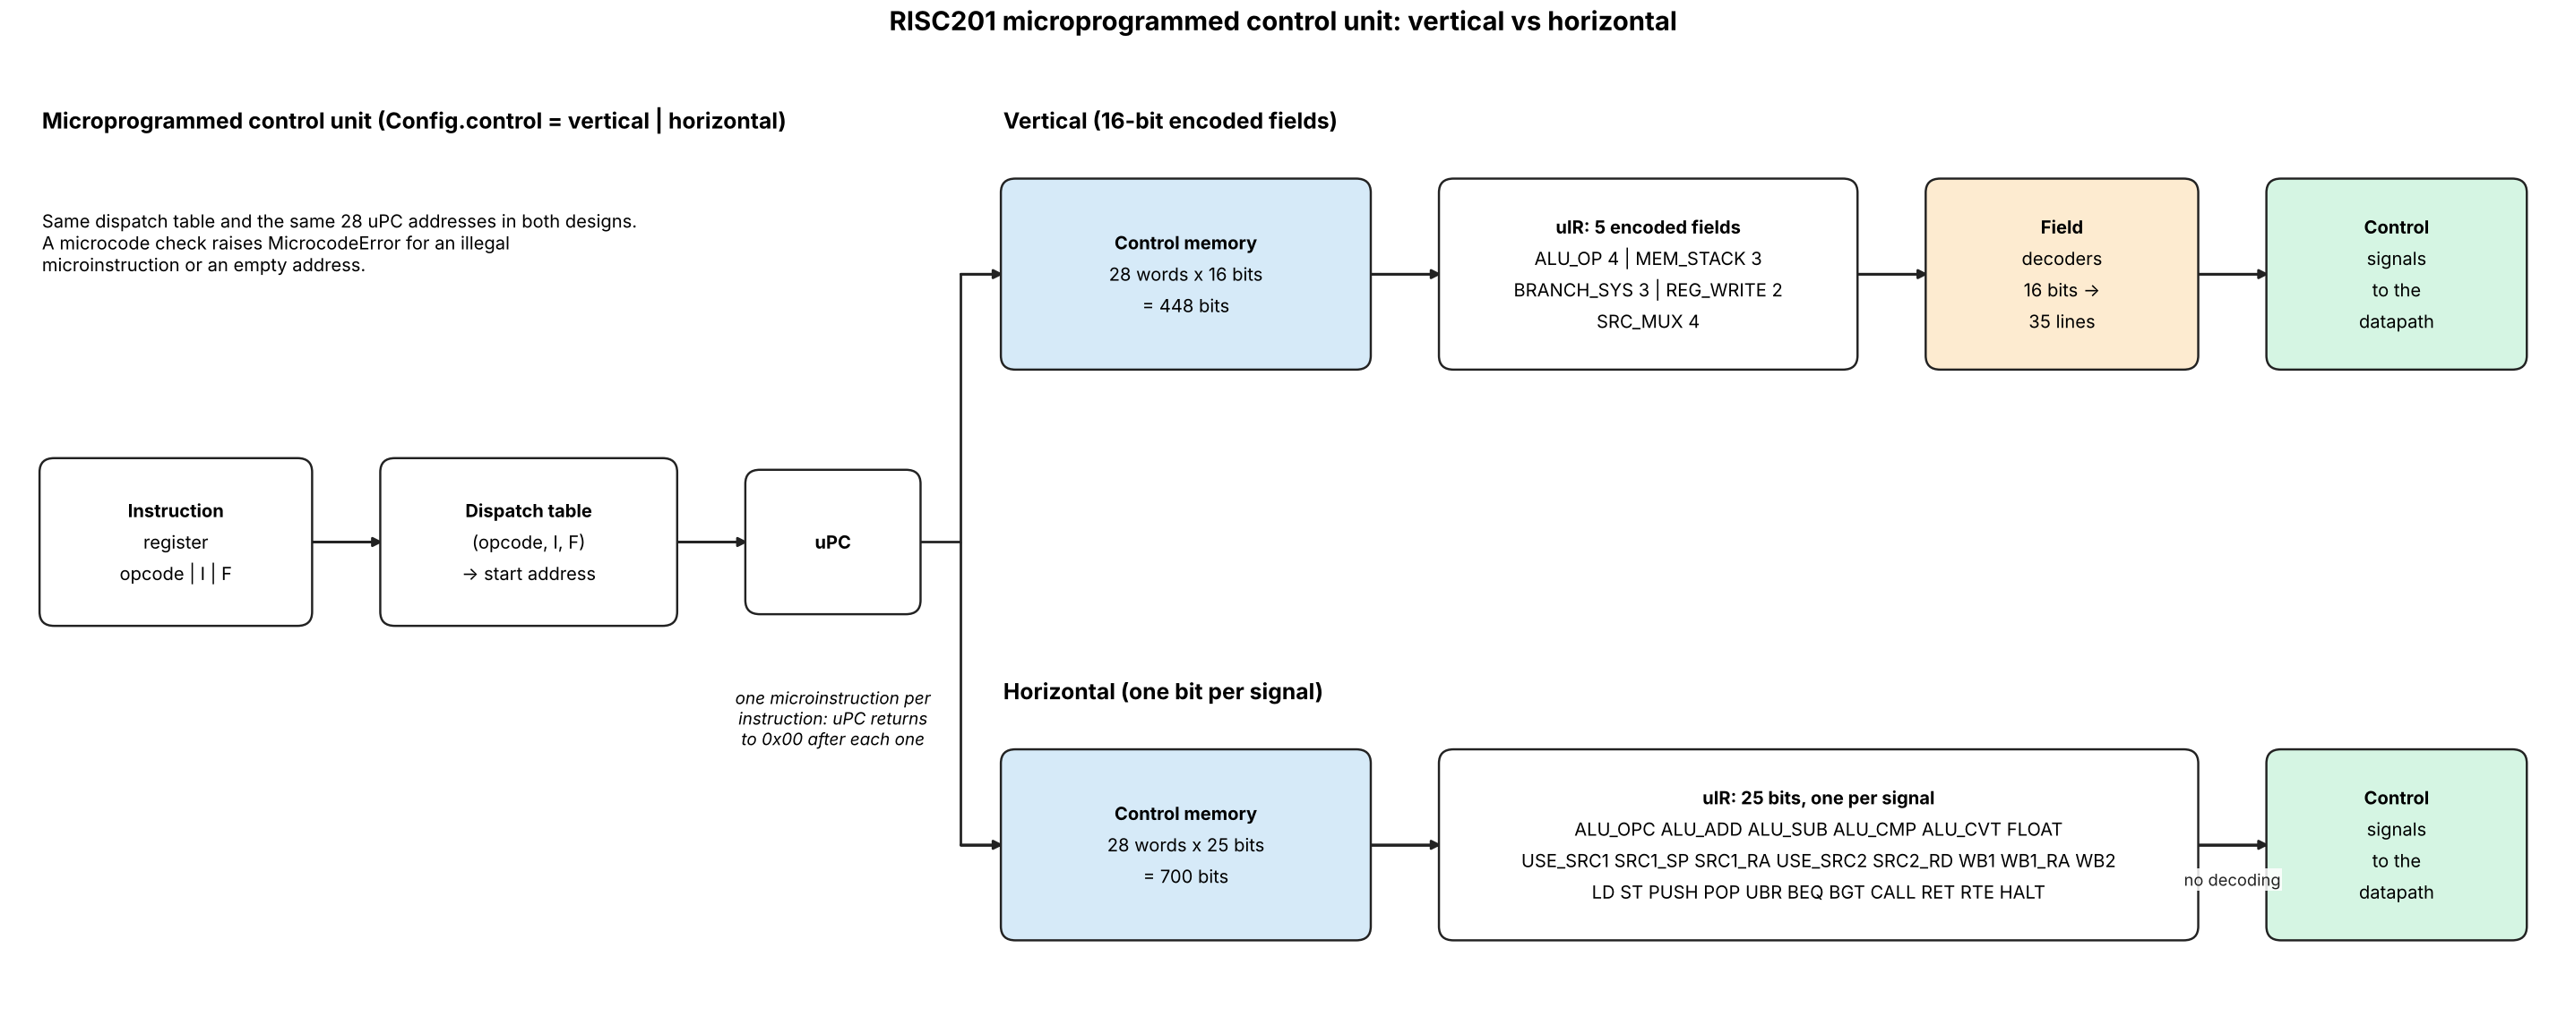
Figure 2. Microprogrammed control unit, vertical and horizontal control memory.

7. Timing examples
Dependent ALU instructions (add r1,r2,r3 then sub r4,r1,r5), no stall:
cycle: 1 2 3 4 5 6
add IF ID OF EX MA RW
sub IF ID OF EX MA <- r1 forwarded from EX_MA latch in cycle 5

Load then use (ld r1,0[r2] then add r3,r1,r4), 1 stall:
cycle: 1 2 3 4 5 6 7 8
ld IF ID OF EX MA RW
add IF ID OF OF EX MA RW <- stall in cycle 5; r1 forwarded from W1 in cycle 6

Taken branch (beq in EX at cycle 4), 3 bubbles:
beq IF ID OF EX(taken) MA RW
i+1 IF ID OF(killed)
i+2 IF ID(killed)
i+3 IF(killed)
target IF ID ...

8. Parameters (set before use)
Parameter | Value / note
EXEC_VECTOR | Address of the exception handler. Chosen by the designer.
STACK_BASE, STACK_LIMIT | Fixed constants (upper and lower bound of the stack). Chosen by the designer; see Other Modifications.
EX latency (defaults, tunable) | Simple integer ops, cmp, mov, min, max, abs, neg, float cmp/min/max/abs/neg/mov, address calculation: 1 cycle. int mul: 2. int div, mod: 8. float add/sub: 3. float mul: 3. float div: 10. fcvt: 2.

9. Other Modifications
Changes needed beyond the original design so that every instruction of the extended ISA can execute:
- Decoder fields with the F bit: the instruction path stays 32 bits wide. The decoder reads opcode [31:27], I [26], F [25], rd [24:21], rs1 [20:17], rs2 [16:13]. Integer immediates are 15 bits (modifier [16:15], imm15 [14:0], sign-extended for ld/st).
- Float unit (FPU) in EX: binary32 add, sub, mul, div, compare, min, max, abs, neg, mov. The result mux selects ALU, FPU or the fcvt converter using isFloat and isfcvt. Rounding is nearest-even; subnormals flush to zero; Inf/NaN do not raise exceptions.
- Float compare: cmp with F=1 sets flags.E / flags.GT. If either operand is NaN both flags are 0, so beq and bgt are not taken.
- Float immediate: the Imm unit builds {imm17, 15'b0} when I=1 and F=1 (top 17 bits of the float: 8 mantissa bits).
- lsbase and lslim removed: the Stack_base and Stack_limit registers, their write enables (isLsBase, isLsLim) and their muxes are deleted from EX, and these signals are removed from ID_OF and OF_EX. The Fault Control Unit compares against the fixed constants STACK_BASE and STACK_LIMIT. Opcodes 10111 and 11000 decode as nop.
- Two register write ports (port 1 rd/ra, port 2 SP). The ID-stage mux that selected SP as the single Write_Addr for push/pop is replaced by a fixed second write port to SP, so pop can write both rd and SP. If pop sp is used, port 1 wins.
- Branch target source: the target is computed in ID, carried through ID_OF and OF_EX, and sent to IF from EX (ret uses forwarded op1'). This replaces the "Branch Target from 3rd stage" label of the fetch diagram, which was copied from the 4-stage design.
- Operand-select muxes (in ID): src1 = rs1 / ra (ret) / SP (push, pop); src2 = rs2 / rd (st, push). writeAddr = rd, or ra for call.
- call link value: computed in EX (PCinst + 4) and carried in aluResult so it can be forwarded like any ALU result.
- Branch offset is 27 bits (the ISA branch format); the Imm & Branch unit sign-extends it and shifts it left by 2.
- flags are written only by cmp (integer or float) and only by an instruction that is in EX and valid.
- Integer divide by zero: no exception. div returns all ones (0xFFFFFFFF); mod returns the dividend. INT_MIN / -1 returns INT_MIN.
- Exception rules: epc holds the PC of the faulting instruction; rte returns to it. The handler must therefore change SP (or halt) before rte, because the stack bounds are fixed and the same push / pop would fault again. Exceptions inside the handler (nested) are not supported.
- halted flag: set when halt reaches RW; stops the clock for the pipeline.
- Reserved opcodes (10111, 11000) are treated as nop.

10. Verification
The file pipeline_sim.py (same folder as this document) models this pipeline cycle by cycle and checks it against a one-instruction-at-a-time reference model. Run it with python3 pipeline_sim.py.
- Encoding: 5000 random instructions round-trip through the 32-bit format; opcodes 10111 and 11000 decode as nop.
- Directed programs (26): hazard distances 1 to 4, load-use, push/pop chains, call/ret, cmp then branch, wrong-path stores and halt, multi-cycle EX, divide by zero, float add/sub/mul/div/min/max/abs/neg/cmp/fcvt, NaN compare, exceptions with handler and rte. Register values and cycle counts match section 4.3 and section 7.
- Random programs: 4000 programs (about 157000 instructions, 2172 with an exception) end with the same registers, memory, flags, epc, cause and retired-instruction order as the reference model.
- Mutation checks: switching off forwarding, the OF bypass, the load-use stall, operand latching during exBusy, or giving port 2 priority over port 1 for pop sp makes the random tests fail, so the tests can detect these bugs.

