SimpleRISC Extended ISA
32-bit instructions and IEEE-754 float support

1. Summary of changes
- Instruction width stays 32 bits (standard byte addressing, PC + 4). The new F (Float) bit sits next to the I (Immediate) bit; to make room the integer immediate shrinks from 16 to 15 bits and the float immediate is 17 bits.
- No new opcodes for float arithmetic. add, sub, mul, div (and cmp, mov, min, max, abs, neg) become float operations when F = 1.
- One new float instruction, fcvt rd, rs2, uses opcode 11111. With lsbase and lslim removed, opcodes 10111 and 11000 are free (2 spare opcodes).
- Float values live in the same 16 registers as integers, stored as raw IEEE-754 single-precision (binary32) bits. Only the instruction decides how the bits are read.
- Two new control signals for float: isFloat and isfcvt.

2. Instruction formats (32 bits, bit 31 = MSB)
Format | opcode | I | F | rd | rs1 | Remaining bits
Bits | [31:27] | [26] | [25] | [24:21] | [20:17] | [16:0]
Register (I = 0) | opcode | 0 | F | rd | rs1 | rs2 in [16:13]; [12:0] unused (0)
Immediate (I = 1, F = 0) | opcode | 1 | 0 | rd | rs1 | modifier [16:15] (u/h), imm15 [14:0]
Immediate (I = 1, F = 1) | opcode | 1 | 1 | rd | rs1 | imm17 [16:0] = top 17 bits of a binary32 float, low 15 bits are 0
Branch (b, beq, bgt, call) | opcode | — | — | — | — | offset [26:0] (27 bits, signed); no I or F bit
No operand (nop, ret, halt, rte) | opcode | 0 | 0 | 0 | 0 | all other bits 0

Field usage per instruction: cmp uses rs1 and op2 (rd unused). mov, not, abs, neg, fcvt use rd and rs2/imm (rs1 unused). push, pop use rd. ld, st use rd, imm and rs1 (I = 1, F = 0).

3. Opcode table (all instructions)
op2 means rs2 when I = 0, or the immediate when I = 1. “F=1 allowed” shows which instructions have a float version.
Opcode | Mnemonic | Operands | Operation (F = 0 unless stated) | F = 1 allowed?
00000 | add | rd, rs1, rs2/imm | rd ← rs1 + op2 | Yes (fadd)
00001 | sub | rd, rs1, rs2/imm | rd ← rs1 − op2 | Yes (fsub)
00010 | mul | rd, rs1, rs2/imm | rd ← rs1 × op2 | Yes (fmul)
00011 | div | rd, rs1, rs2/imm | rd ← rs1 ÷ op2 (quotient) | Yes (fdiv)
00100 | mod | rd, rs1, rs2/imm | rd ← rs1 mod op2 | No
00101 | cmp | rs1, rs2/imm | set flags E, GT from rs1 vs op2 | Yes (fcmp)
00110 | and | rd, rs1, rs2/imm | rd ← rs1 & op2 | No
00111 | or | rd, rs1, rs2/imm | rd ← rs1 | op2 | No
01000 | not | rd, rs2/imm | rd ← ~op2 | No
01001 | mov | rd, rs2/imm | rd ← op2 | Yes (float imm)
01010 | lsl | rd, rs1, rs2/imm | rd ← rs1 << op2 | No
01011 | lsr | rd, rs1, rs2/imm | rd ← rs1 >> op2 (logical) | No
01100 | asr | rd, rs1, rs2/imm | rd ← rs1 >> op2 (arithmetic) | No
01101 | nop | — | no operation | No
01110 | ld | rd, imm[rs1] | rd ← Mem[rs1 + imm] | No
01111 | st | rd, imm[rs1] | Mem[rs1 + imm] ← rd | No
10000 | beq | offset | if flags.E: PC ← PC + offset | No
10001 | bgt | offset | if flags.GT: PC ← PC + offset | No
10010 | b | offset | PC ← PC + offset | No
10011 | call | offset | ra ← PC + 4; PC ← PC + offset | No
10100 | ret | — | PC ← ra | No
10101 | push | rd | SP ← SP − 4; Mem[SP] ← rd | No
10110 | pop | rd | rd ← Mem[SP]; SP ← SP + 4 | No
10111 | (free) | — | unused, reserved for future use | —
11000 | (free) | — | unused, reserved for future use | —
11001 | halt | — | stop fetching; older instructions finish | No
11010 | rte | — | PC ← epc (return from exception) | No
11011 | min | rd, rs1, rs2/imm | rd ← smaller (signed) of rs1, op2 | Yes (fmin)
11100 | max | rd, rs1, rs2/imm | rd ← larger (signed) of rs1, op2 | Yes (fmax)
11101 | abs | rd, rs2 | rd ← |rs2| | Yes (fabs)
11110 | neg | rd, rs2 | rd ← 0 − rs2 | Yes (fneg)
11111 | fcvt | rd, rs2 | F=0: rd ← float(int rs2); F=1: rd ← int(float rs2) | F = direction

4. New instructions

4.1 Stack and system instructions
Instruction | What it does
push rd | SP ← SP − 4, then stores rd at Mem[SP]. Raises a fault if the new SP is below the stack limit.
pop rd | Loads rd from Mem[SP], then SP ← SP + 4. Raises a fault if SP goes above the stack base.
halt | Stops instruction fetch. Older instructions already in the pipeline finish; the pipeline write-enables are then cleared.
rte | Return from exception: PC ← epc.
min rd, rs1, rs2/imm | rd ← the smaller of the two signed values.
max rd, rs1, rs2/imm | rd ← the larger of the two signed values.
abs rd, rs2 | rd ← absolute value of rs2.
neg rd, rs2 | rd ← 0 − rs2.

4.2 Float instructions
Instruction | What it does
fcvt rd, rs2 (opcode 11111) | Convert/move between formats. F = 0: rd ← float(int rs2), rounded to nearest-even (integers above 2^24 may lose precision). F = 1: rd ← int(float rs2), truncated toward zero; out-of-range values saturate to the min/max int; NaN gives 0. I must be 0 (register form only). Here the F bit means “the source is float”, the same meaning as for other instructions.
add/sub/mul/div with F = 1 | IEEE-754 binary32 add, subtract, multiply, divide. Assembler names: fadd, fsub, fmul, fdiv (same opcodes as the integer versions).
cmp with F = 1 | Float compare. Sets flags.E and flags.GT. If either operand is NaN the result is “unordered”: both flags = 0, so beq and bgt are not taken.
mov with F = 1 | Loads a float constant. With I = 1 the 17-bit field is the top 17 bits of the float (low 15 bits are 0). With I = 0 it is a plain register copy.
min, max, abs, neg with F = 1 | Float versions. abs clears the sign bit, neg flips it. min/max use float comparison (NaN rule: if one operand is NaN, return the other).

5. Control signals
The control signals are generated by a microprogrammed control unit (Figure 1). The F bit is part of the dispatch address, so isFloat comes from the microinstruction: F = 1 selects the floating point microinstruction only for instructions that have a float form, and is ignored for all others.
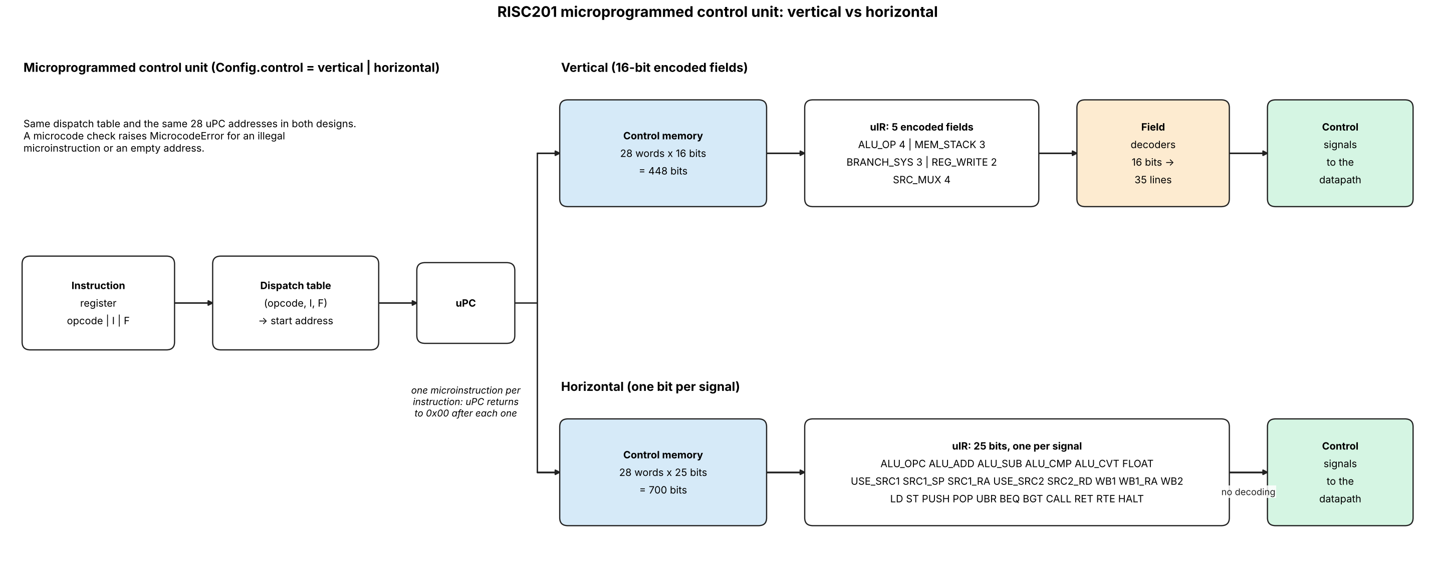
Figure 1. Microprogrammed control unit, vertical and horizontal control memory.

5.1 New for float
Signal | Meaning | Triggered by
isFloat | Copy of the F bit, generated in the OF stage and carried in the OF/EX latch. When 1 the EX stage uses the FPU instead of the integer ALU (the existing ALU-op signals still choose add/sub/mul/div/…). For fcvt it also gives the direction (0 = int→float, 1 = float→int). | F = 1 on: add, sub, mul, div, cmp, mov, min, max, abs, neg, and fcvt (when F = 1)
isfcvt | Selects the int↔float converter in EX. It overrides the normal ALU result, and isFloat then acts as the direction bit. | fcvt only (opcode 11111)

5.2 New from the stack

Signal | Meaning | Triggered by
isPush | Stack write: SP − 4 is the address, and the stack check is enabled. | push
isPop | Stack read: SP is the address, SP + 4 is written back, and the stack check is enabled. | pop
isHalt | Stops fetch; clears PCWriteEnable and the latch WriteEnables once older instructions drain. | halt
isRTE | Selects epc as the next PC in the Fetch stage. | rte
isOverflow | Raised by the Fault Control Unit when SP leaves the fixed stack bounds (limit to base). | Not opcode-triggered; checked for push and pop
isExc | Exception taken: epc saves the PC, and PC ← EXEC_VECTOR. | Fault from isOverflow (push/pop)
PCWriteEnable, WriteEnable | Per-latch and PC stall/freeze controls (not instruction-specific). | Stalls, halt, exceptions, and a busy multi-cycle FPU
ALU select signals | Choose min, max, abs, neg in the ALU (FPU when isFloat = 1). | min, max, abs, neg

6. Issues checked and decisions
Issue | Decision
Opcode space | Float needs no new opcodes, which is why the F bit works. Only fcvt takes a new opcode (11111). Opcodes 10111 and 11000 (left free by the removed lsbase/lslim) are unused, so 2 opcodes remain for future instructions.
32-bit instruction width | Fits exactly: 5 (opcode) + 1 (I) + 1 (F) + 4 + 4 + 17 = 32. Standard 32-bit instruction memory, PC advances by 4, branch offsets, call/ret and epc logic are unchanged. The cost is one bit of immediate: integer immediates are 15 bits (was 16), float immediates 17 bits (was 18). ld/st cannot access instruction memory.
Float immediates | A 15-bit immediate cannot hold a binary32 value. With I = 1 and F = 1 the 17-bit field is the top 17 bits of the float (1 sign, 8 exponent, 8 mantissa bits), padded with 15 zeros: {imm17, 15'b0}. Hardware cost: one shift. Constants that need more mantissa bits must be built with ld.
Constants with 15-bit immediates | mov modifier 00 sign-extends imm15, u zero-extends imm15 (bits 14:0), h gives imm15 << 16 (bits 30:16). Bits 15 and 31 cannot be set by one `mov`, so a full 32-bit constant needs mov h plus or/lsl steps, or an ld from memory. ld/st offsets are signed 15 bits (+/-16 KiB).
One register file for ints and floats | No type tag in registers. push, pop, ld, st and register-to-register mov just move bits, so they work on floats with F = 0.
Instructions where F = 1 is meaningless | mod, and, or, not, lsl, lsr, asr, nop, ld, st, branches, push, pop, halt, rte: the assembler must not emit F = 1; the control unit forces isFloat = 0 for them. Branch instructions have no F bit at all.
Float cmp and branches | cmp with F = 1 is required for float code to be useful (floats cannot be compared with integer cmp, since negative floats order differently). It reuses flags E and GT, so beq / bgt need no change.
fcvt special case | F here means “source type”, so isFloat = 0 for int→float. The EX stage must test isfcvt first, then isFloat. fcvt has no rs1 and I must be 0.
Rounding and special values | Round to nearest-even. Overflow gives ±Inf, x/0 gives ±Inf, 0/0 gives NaN, all without raising isExc (IEEE default). Subnormals are flushed to zero to keep the FPU small (change if you need full IEEE).
FPU latency | A single-cycle float multiply or divide would slow the clock. Either allow a multi-cycle FPU that holds the pipeline through the existing WriteEnable/PCWriteEnable stall, or accept a longer EX stage. No new ISA-level signal is needed.
Forwarding and hazards | Unchanged. Float and integer results use the same registers, the same RW write path, and the same dependency checks.
Branch offset | 27 bits, signed (same as the original SimpleRISC). branchTarget = PCinst + (sign_extend(offset[26:0]) << 2), range about +/-256 MiB.

