AI-Assisted Test Automation Project Report
Demo Web Shop Automation Framework • User Story Coverage • Final Green Execution
Introduction
This report summarizes the complete automation work done for the Demo Web Shop customer order placement user story. The goal was to make the framework easy to understand, stable to execute, and useful for release regression.
The project is complete. The final full suite executed 31 tests with 31 passed, 0 failed, 0 errors, and 0 skipped.
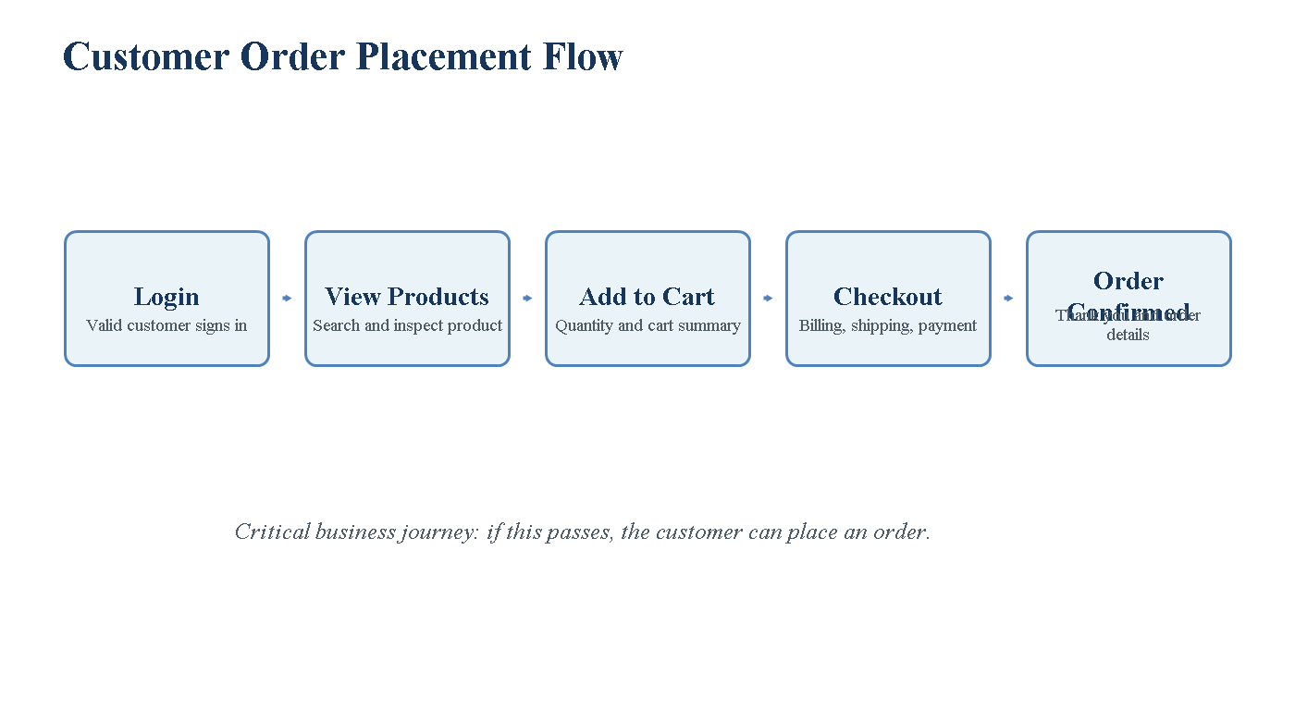
Project at a Glance
Area | Summary
Framework | Maven, Selenium WebDriver, TestNG, Java, Page Object Model, Excel, Log4j, Extent Reports
Main User Story | Login, view product, add to cart, checkout, and place order
Final Result | 31 passed, 0 failed, 0 skipped
Execution Command | mvn -q test "-Dheadless=true"
Final Runtime | 681.1 seconds

Framework Architecture
The existing hybrid framework was preserved. The improvements focused on stability, reusable flows, data-driven execution, logging, screenshots, and reporting.
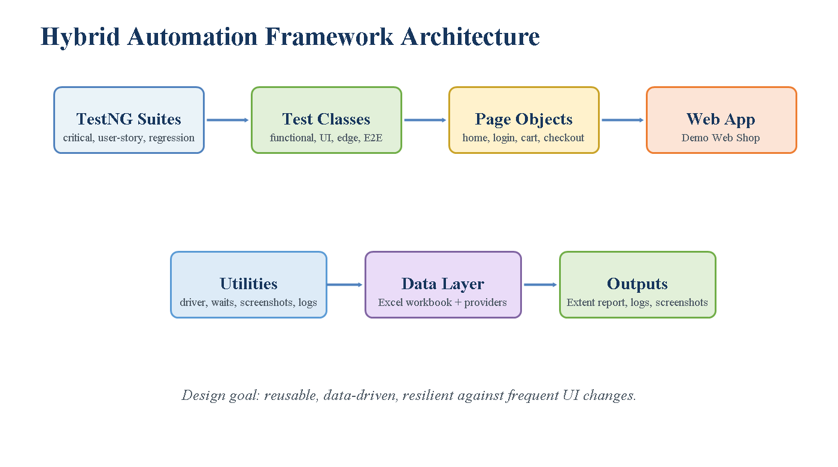
What Was Implemented
• Functional coverage for registration, login, product search, product details, cart, checkout, and order confirmation.
• UI validation for forms, inputs, buttons, links, product cards, cart summary, checkout controls, and confirmation page.
• Edge coverage for invalid login, duplicate email, mismatched password, empty search alert, and missing billing fields.
• Non-functional coverage through product search response-time validation.
• Data-driven testing with Excel workbook support.
• Screenshots on failure, Log4j logs, and Extent Reports.
AI-Generated Test Scenarios
Scenario | Type | Priority
Login with valid customer | Functional | Critical
Search and view product | Functional/UI | Critical
Add product to cart | Functional | Critical
Complete checkout and confirm order | Functional | Critical
Invalid login and duplicate registration | Edge | High
Empty search alert and missing billing data | Edge/UI | High
Product discovery response time | Non-functional | Medium

Bugs and Observations Logged
These observations were found while automating the external Demo Web Shop application. The application behavior still exists, but the automation now handles it gracefully.
Bug / Observation | Steps to Reproduce | Actual Result | Automation Handling
Empty search uses browser alert | Open home page; keep search empty; click Search | Browser alert appears instead of inline validation | Alert is accepted and validated
Checkout sections are dynamic | Add product; start checkout; click Next through steps | Buttons and sections appear dynamically | Step-specific waits and fallback locators added
Product/cart behavior varies by product | Search different products; add to cart; inspect cart rows | Quantity/cart behavior is inconsistent across products | Flexible cart validation and optional quantity handling added
DOB fields are not present | Open registration page; inspect form | Older tests expected DOB fields but current UI has none | DOB selection skipped when absent

Optimization and Efficiency
• Smart UI handling was added through fallback locators, explicit waits, scroll into view, and JavaScript click fallback.
• Checkout was stabilized with dedicated methods for billing, shipping, payment, payment information, and confirmation.
• Unique users are created during tests, removing dependency on fixed credentials.
• Reusable test flow utilities reduce duplicate code and improve maintainability.
• Success screenshots were disabled to reduce noise, while failure screenshots remain enabled.
Risk-Based Regression Strategy
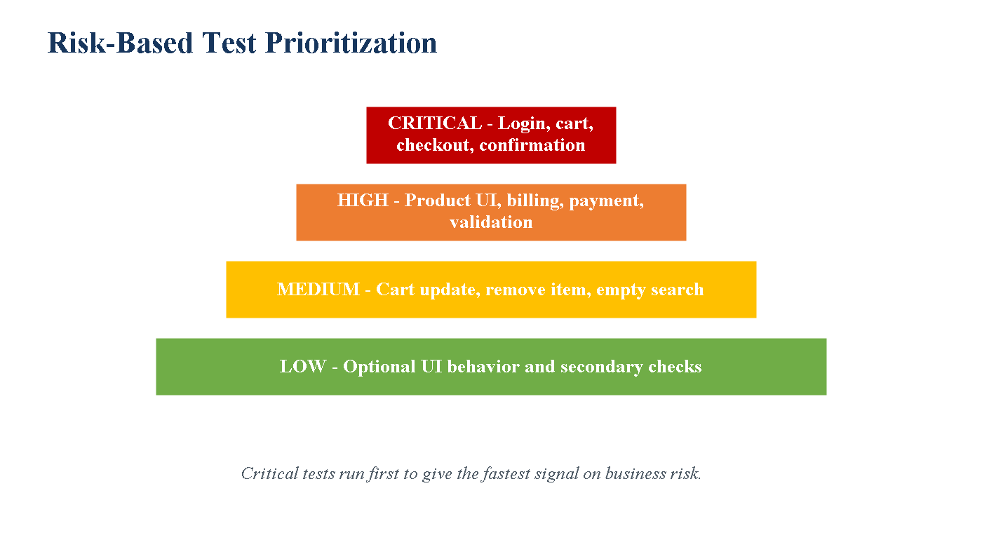
Suite | Purpose | When to Run
testng-critical.xml | Fast validation of the highest-risk order placement path | Smoke/build validation
testng-user-story.xml | Functional, UI, edge, and performance checks for the user story | User-story acceptance
testng.xml | Complete 31-test regression suite | Release regression

Manual Testing vs AI-Assisted Testing
Traditionally, test scenarios and edge cases are created manually and can take significant time. AI helped quickly expand the user story into functional, UI, edge, and non-functional scenarios, then supported risk-based prioritization and documentation.
AI did not replace QA judgment. The tester still had to execute the suite, review failures, decide which assertions were meaningful, and confirm final results.
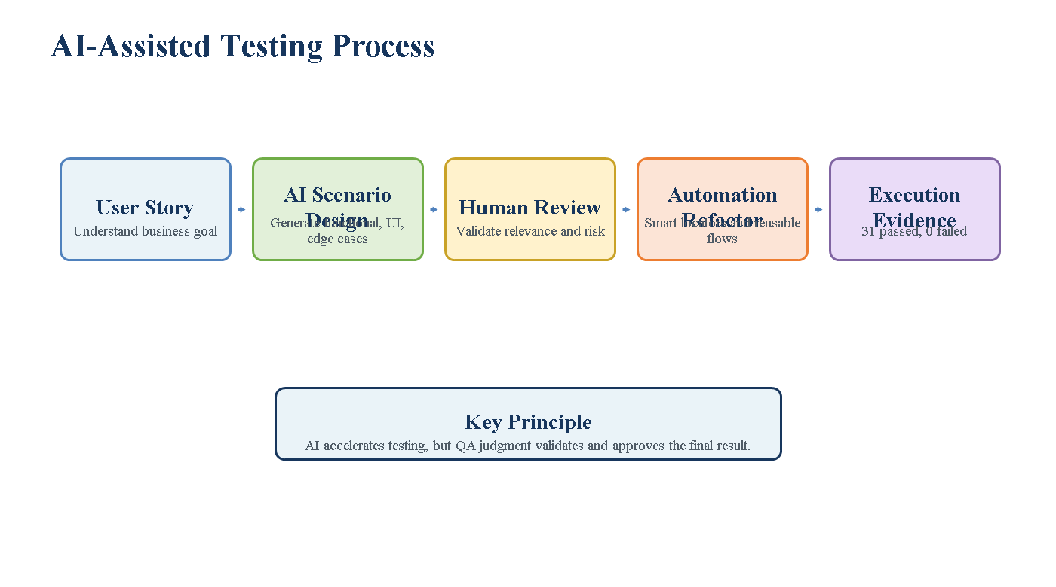
Execution Time and Final Evidence
Execution Point | Result
Before stabilization | 31 tests executed, 13 failed
After AI-assisted refactor | 31 tests executed, 0 failed
Final full suite time | 681.1 seconds
Main improvement | Stability, repeatability, and reduced debugging effort

Final command:
mvn -q test "-Dheadless=true"
Generated evidence includes Extent Report, TestNG report, TestSuite summary, Log4j logs, screenshots, and Excel test data.
Conclusion
The project is complete and working as per the user story. It validates the customer journey from login to order confirmation and includes functional, UI, edge, non-functional, data-driven, logging, reporting, and regression coverage.
Final verified result: 31 passed, 0 failed, 0 errors, 0 skipped.

