Task no : 01

1. Objective
The objective of this task is to develop a basic network packet analyzer using Python and Scapy. The tool captures and displays network packets transmitted through the system to understand network communication.

2. Tools Used
• Python 3.12
• Scapy Library
• Npcap
• Visual Studio Code
• Windows Operating System

3. Implementation
The packet analyzer was developed using Python. Scapy was used to capture live network packets and display packet information such as protocol details.

4. Code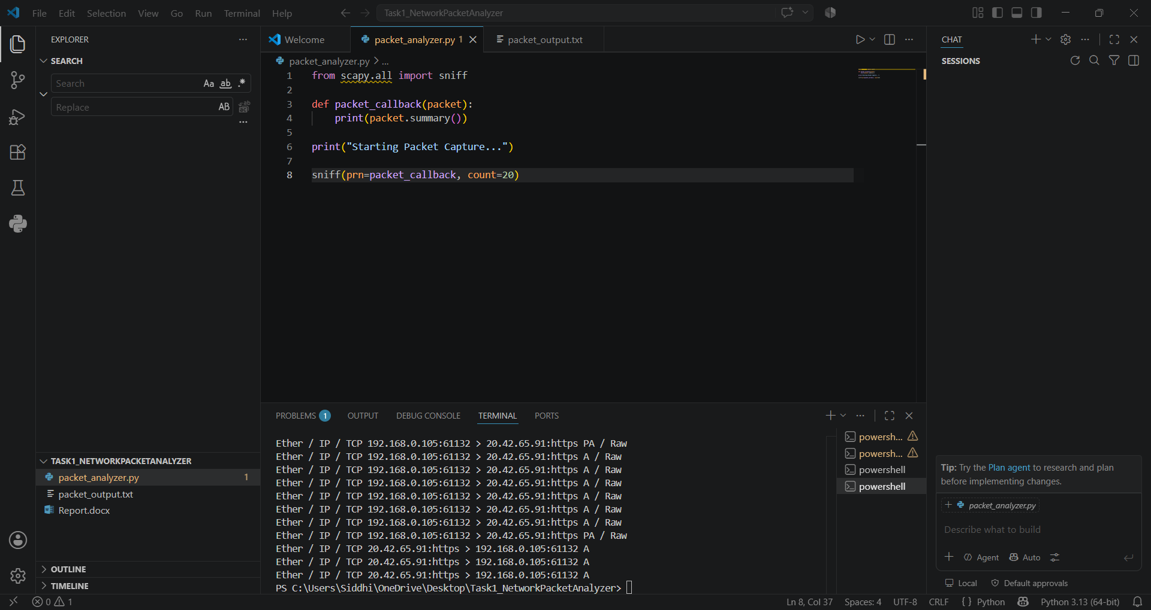

5.Output
The packet analyzer successfully captured live network traffic. The captured packets show communication between source and destination IP addresses using the TCP protocol over HTTPS.

6.Conclusion
The Network Packet Analyzer was successfully developed using Python and the Scapy library. The tool captured live network packets and displayed important information such as IP addresses, protocols, and communication details. This task provided practical knowledge about network traffic monitoring, packet capturing, and basic network analysis.

