CODSOFT Cyber Security Internship – Task 5
Submitted By: Siddhi Chaudhari
Objective
The objective of this project is to develop a Secure File Sharing System that allows users to upload and download files securely. The system helps protect files from unauthorized access and ensures secure file management.
Tools Used
- Python
- Flask
- HTML/CSS
- Visual Studio Code
Project Description
The Secure File Sharing System is a web-based application developed using Flask. It enables users to upload and download files through a simple interface. The project demonstrates secure file handling and basic access control concepts.
Features
- Secure File Upload
- Secure File Download
- User Authentication
- File Management
- User-Friendly Interface
Implementation
- Installed Flask and required libraries.
- Created the Flask application.
- Developed file upload functionality.
- Implemented file download functionality.
- Tested the application on a local server.
- Verified successful file transfer operations.
Screenshots
- Flask import
- Python Flask source code implementing secure file upload, encryption, and download functionality.
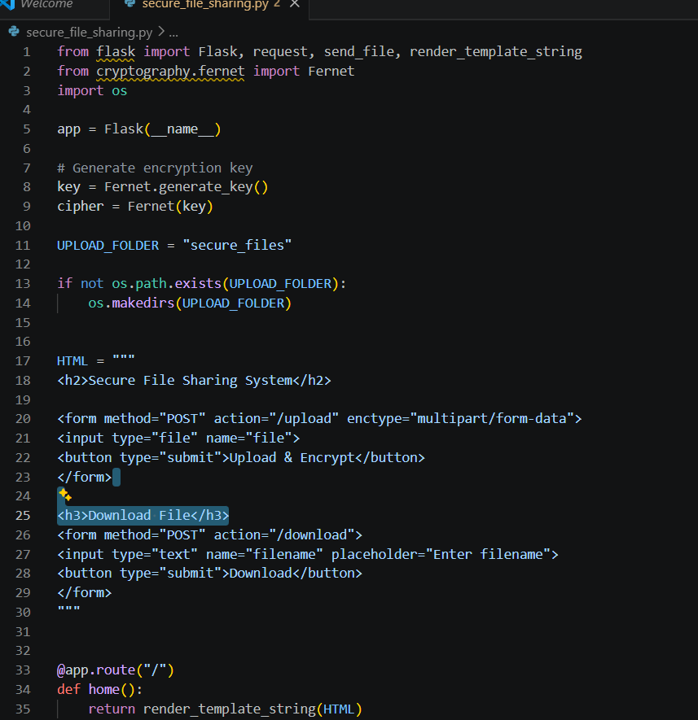
- Web Interface
- Web interface of the Secure File Sharing System displaying options for file upload and download
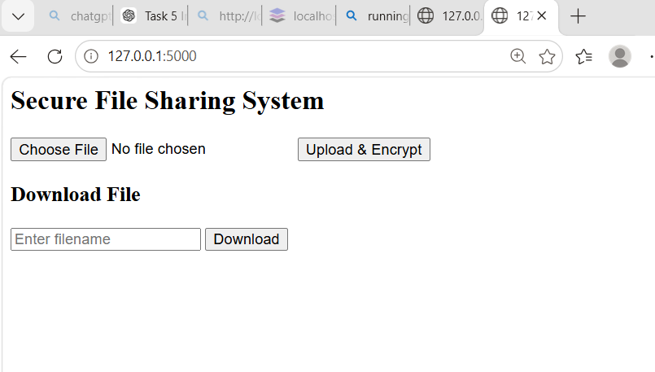

File Upload Successful
. Successful file upload and encryption confirmation displayed by the application.

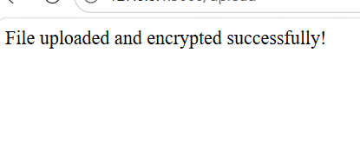
Conclusion
The Secure File Sharing System was successfully developed and tested. The project demonstrates secure file handling using Python and Flask and provides a simple platform for sharing files securely.
Learning Outcome
- Learned Flask web development.
- Learned file handling concepts.
- Improved understanding of authentication and access control.
- Gained practical cyber security project experience.

