1. Objective
The objective of this task is to perform a security review of an application source code, identify common security vulnerabilities, and suggest secure coding practices to improve application security.

2. Application Overview
The application reviewed is a simple Python-based login system. The program accepts user credentials and verifies the login details. The source code was analyzed to identify possible security weaknesses.

3. Technologies Used
- Programming Language: Python
- Code Editor: Visual Studio Code
- Security Analysis Tool: Bandit
- Operating System: Windows

4. Security Review Methodology
The following steps were performed:
- Reviewed the application source code manually.
- Checked the code for common security issues.
- Performed static code analysis using Bandit.
- Identified vulnerabilities and suggested improvements.

5. Vulnerabilities Identified
1. Hardcoded Credentials
Issue:
Username and password were directly written inside the source code.
Risk:
Anyone accessing the source code can view sensitive information.
Recommendation:
Use environment variables or a secure database to store credentials.

2. Plain Text Password Storage
Issue:
Passwords were not protected using encryption or hashing.
Risk:
Passwords can be exposed if the code or database is accessed.
Recommendation:
Use secure password hashing methods like bcrypt or Argon2.

3. Improper Input Validation
Issue:
User inputs were not properly validated.
Risk:
Attackers may provide harmful input to exploit the application.
Recommendation:
Validate and sanitize all user inputs.

4. Error Handling Issues
Issue:
Error messages may reveal unnecessary information.
Risk:
Attackers can use error details to understand the system.
Recommendation:
Implement proper exception handling and display generic error messages.

6. Static Code Analysis Using Bandit
Tool Used: Bandit
Command Executed:
python -m bandit app.py -f txt
Result:
Bandit successfully analyzed the Python application and identified areas where security improvements are required.

7. Secure Coding Recommendations
- Avoid storing sensitive information directly in source code.
- Use password hashing for user authentication.
- Implement proper input validation.
- Handle exceptions securely.
- Keep software libraries updated.
- Follow secure coding standards.

8. Screenshots
Screenshot 1: Successful Login
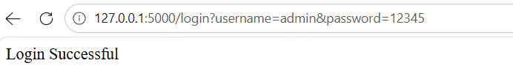
Screenshot 2: Bandit Security Scan Result
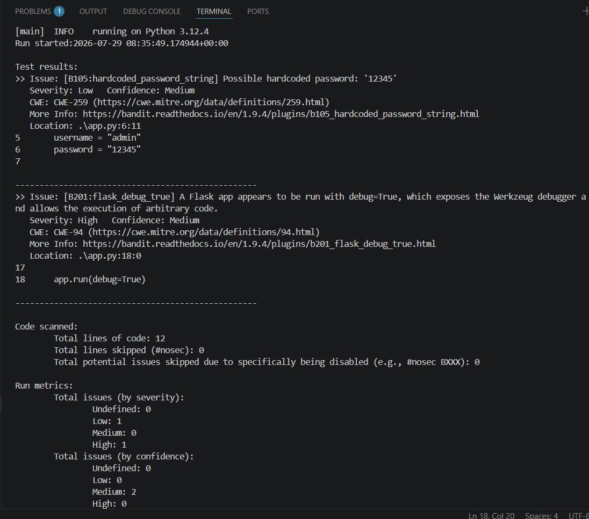

10. Conclusion
The secure code review helped identify security weaknesses in the Python application. Applying secure coding practices can improve the application's protection against common security threats.

