

# Let the GreatMoods Team

|  |
| --- |
| The GreatMoods Team Will Set Everything Up For You! Set Up Your Fundraiser! |

Let’s get you started!

* Thank You for choosing GreatMoods
* The Free Easy Online

Fundraising Program!



# Setting Up Your Fundraiser

3 Quick & Easy Steps to Start Fundraising!

## 1. The GreatMoods Team Will Set Up Your Group’s Free Fundraising Website 2. The GreatMoods Team Will Set Up Your Member’s Free Fundraising Websites 3. Members Set Up Their Friends & Family Supporters

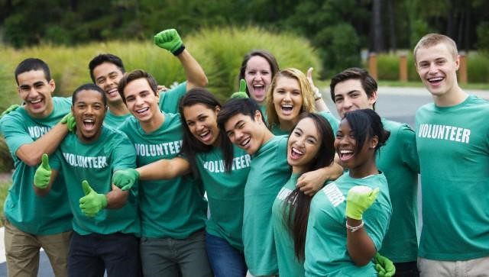

Let the Fundraising Begin!

It’s That Easy!

# Step 1 – Setting up Your Groups Website

The Fun Parts and Pieces of Your Group(s) Website:

## 1. Groups Banner, Logo or Mascot at Top of Website 2. The (Exact) Name of Your Fundraising Group or Groups 3. What Pictures do you want us to use? ie. Facebook, Existing Website, or Send us some 4. 4 to 6 Reasons for Your Groups Fundraiser 5. Each Groups Leadership Pictures & Names 6. Individual and Group Fundraising Goals



Tell the GreatMoods Team what you want and we will set everything up for you!

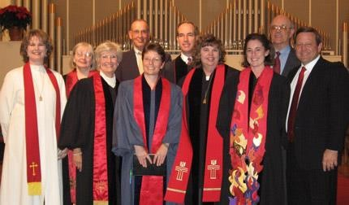

Build A Successful

Fundraising Leadership Team

The Groups Leadership Team Should Be Diverse and Include the Following:

1

. Seasoned Leaders with Vision and Experience for Planning Goals

!

2

. Youth and Energy with Tech Savvy Experience for Setup & Execution

3

. Organized Administrators for Member Name’s, Lists and Daily Management

4

. Team Leaders to Coordinate “Friends & Family” Event Driven Email Campaigns



# Step 2 – Setting up Your Members

Just Send us your Leadership & Member Spreadsheet (Spreadsheet Template Included) 1. The Fundraising Leadership Team Spreadsheet -Title, First Name, Last Name, Email & Phone 2. The Member Spreadsheet -Title (if any), First Name, Last Name & Email - Phone (optional)



The Member Websites Includes: The Groups Banner, Pictures, Reasons & Fundraising Goals

Step 3 - Setup Friends & Family Supporters

## 1. Setup your Friends & Family Contacts

1. Email Friends & Family for their Support!
2. Let the Shopping Begin at the GreatMoods Mall!



100+ Stores of over 20,000+ Products, Open 24/7/365

# PayPal Setup & Order Processing

* All Consumer Orders are Processed Through PayPal
* All Funds are Deposited Weekly into your Fundraising Groups PayPal Account on Every Product Purchased
* The GreatMoods Team can help setup your Free PayPal Account prior to when the Fundraising Begins or do so yourself by visiting <https://www.paypal.com/>
* All Transactions Can Be Viewed & Audited for Years



# **Setup Any or All Education Groups**

**Clubs & Organizations**

* 4-H • PTA/PTO/PTC
* Band • Robotics & Technology
* Booster Club • Science Club
* BPA • Scripture Study
* Chess Club • Student Council
* Choir • Theatre & Drama
* Debate • Yearbook
* DECA
* FBLA
* FFA
* Jazz Band
* JROTC
* Key Club
* Language Club
* Math Club
* National Honor Society
* Orchestra

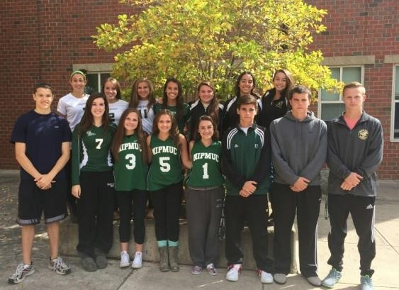

**General**

* General
* Graduation
* Senior Class
* Junior Class
* Sophomore Class
* Freshman Class
* Athletic Equipment
* Field Trips & Travel
* Library & Technology
* Playground Equipment
* Projection, Audio, Video
* Tablets, Laptops & PCs ***Athletics***
* Archery
* Badminton
* Baseball
* Basketball (B & G)
* Bowling (B & G)
* CC Running (B & G)
* CC Skiing (B & G)
* Cheerleading
* Cycling
* Danceline
* Diving (B & G)
* Field Hockey
* Figure Skating
* Football
* Golf (B & G)
* Gymnastics (B & G)
* Ice Hockey (B & G)
* Lacrosse (B & G)

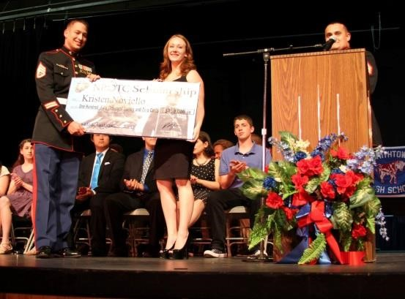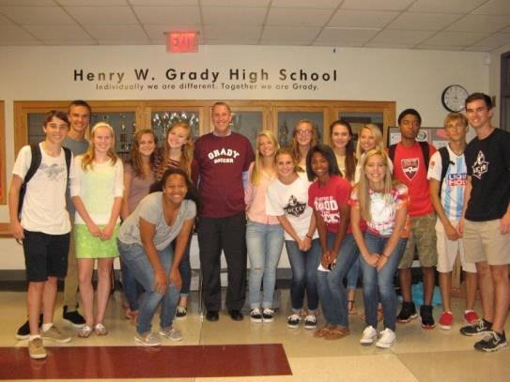

* Mountaineering
* Racquetball
* Rodeo
* Rowing
* Rugby, Boys (B & G)
* Sailing
* Ski & Snowboard (B & G)
* Soccer (B & G)
* Softball
* Swimming (B & G)
* Table Tennis
* Tennis, Boys (B & G)
* Track & Field (B & G)
* Ultimate Frisbee (B & G)
* Volleyball (B & G)
* Water Polo
* Wrestling

# **Setup Any or All Faith Based Groups**

**Main Faith Website**

* Bible Camp
* Bible Study
* Building Fund
* Choir & Band
* Christmas Giving Tree
* Faith Formation
* Festivals
* Men’s Ministry
* Missionary Funds
* All Missions
* College Missions

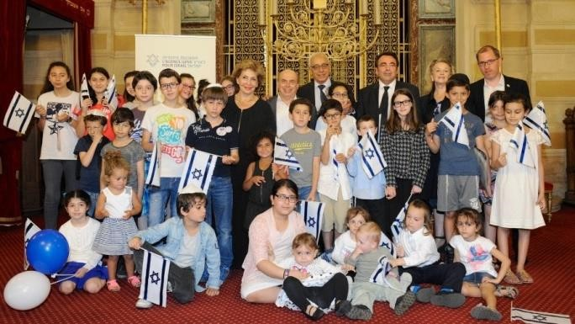

* Overseas Missions

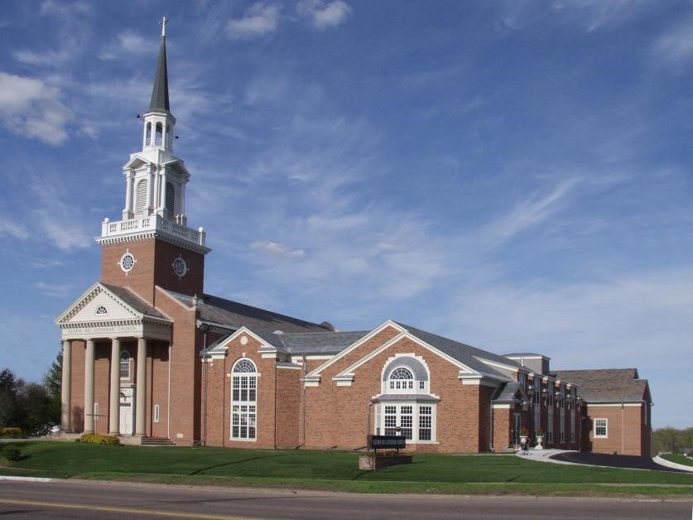

* Youth & Teen Missions
* Outreach Ministry
* Parish Fund
* Projection, Audio, Video
* Student Ministry
* Sunday School
* Tablets, Laptops & PCs
* Women’s Ministry
* Youth’s Ministry
* Other

**Setup Any or All Community Groups**

**Local & National Organizations**

•

Jaycees

•

Junior League

•

Kiwanis

•

Knights of Columbus

•

Lions Club International (LCI)

•

Masonic Service Association

•

Optimist International

•

Rotary Club

•

Shriners International

•

The American Legion

•

Veterans of Foreign Wars (VFW)

**Community Organizations**

•

Animal Shelters

•

ASPCA

•

Community Food Bank

•

Fire Department

•

Local Food Shelves

•

Local Homeless Shelters

•

Local Women’s Shelters

•

Police Department

**Youth & Sports**

•

Athletic Associations

•

Big

Brothers / Big

Sisters of

America

•

Boy Scouts

•

Girl Scouts

•

Summer Leagues

•

YMCA

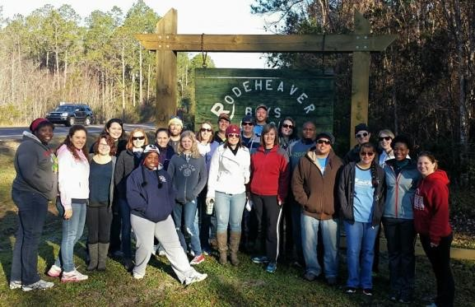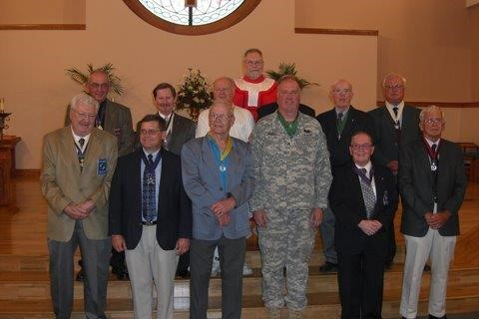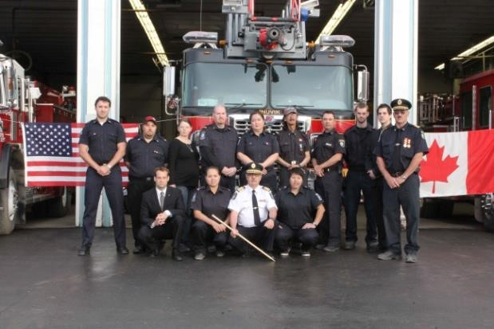

GreatMoods is excited to work with you to achieve your goals!

Please let us know if you have any questions!

Thank you!