10-Year Population Forecast
Atlanta-Sandy Springs-Roswell, GA Metropolitan Statistical Area
Forecast Period: 2025-2034 | Data Source: U.S. Census Bureau

Executive Summary
The Atlanta MSA is projected to grow from 6.41 million (2024) to 7.16 million by 2034 -- an increase of approximately 744,000 people (+11.6%). Growth is driven primarily by strong net in-migration averaging ~47,000 persons annually (2020-2024). Atlanta remains one of the fastest-growing Sun Belt metros in the United States.

1. Data & Preparation
1.1 Data Sources
Two primary datasets were used, both sourced from the U.S. Census Bureau:
- Annual population totals with components of change (births, deaths, net migration) for the Atlanta-Sandy Springs-Roswell MSA, covering 2011-2024. This series forms the primary modeling input.
- Age-by-single-year population estimates (ages 0-85+) for 2020-2025, used to validate the total forecast via cohort structure analysis.

1.2 Data Preparation
The annual totals file was cleaned by stripping trailing whitespace from column headers and filtering out non-year rows. All numeric fields (population, births, deaths, domestic and international migration) were cast to integer. The age-structure file was reviewed to assess cohort composition and aging trends. No imputation was required -- the dataset had no missing values for the 2011-2024 period.
The final modeling dataset contains 14 annual observations -- the complete available post-2010 Census record for this geography. While compact, this is appropriate for the chosen methodology, which is designed to work well on short series.

1.3 Historical Population Data (2011-2024)
Year | Population | Natural Increase | Net Migration | Annual Change
2011 | 5,367,069 | 41,748 | 22,484 | --
2012 | 5,445,543 | 41,158 | 36,897 | 78,474
2013 | 5,512,111 | 37,462 | 28,967 | 66,568
2014 | 5,595,218 | 38,421 | 44,802 | 83,107
2015 | 5,688,583 | 37,691 | 55,761 | 93,365
2016 | 5,791,874 | 37,120 | 66,191 | 103,291
2017 | 5,876,763 | 35,512 | 49,369 | 84,889
2018 | 5,951,394 | 33,205 | 41,417 | 74,631
2019 | 6,027,231 | 30,494 | 45,313 | 75,837
2020 | 6,087,762 | 26,133 | 34,374 | 60,531
2021 | 6,160,570 | 17,361 | 21,715 | 72,808
2022 | 6,253,070 | 19,917 | 73,586 | 92,500
2023 | 6,336,015 | 25,887 | 57,017 | 82,945
2024 | 6,411,149 | 26,916 | 48,363 | 75,134

2. Method & Assumptions
2.1 Forecasting Approach
A dual-model blended approach was used, combining a time-series model with a demographic component model. The time-series model captures overall momentum and autocorrelation in population data, while the component model grounds the forecast in observable demographic drivers: births, deaths, and net migration. Their simple average forms the base forecast.
This dual approach is more defensible than a single method alone. It is also directly aligned with how professional demographers approach MSA-level forecasts -- neither pure statistical extrapolation nor pure component projection, but a synthesis of both.

2.2 Model 1 -- Holts Linear Exponential Smoothing
Holt's method (double exponential smoothing) models both the level (current population size) and the trend (rate of annual growth) using two smoothing parameters, alpha and beta. Unlike simple moving averages, it weights recent observations more heavily and explicitly models directional momentum -- making it well-suited to populations with a persistent growth trend.
Parameters were selected via grid search over alpha (0.1 to 0.9) and beta (0.05 to 0.45), minimising Root Mean Squared Error (RMSE) on the full historical series. Optimal parameters: alpha = 0.10, beta = 0.05, yielding an in-sample RMSE of approximately 71,000 persons -- less than 1.2% of current population.
The low alpha reflects Atlanta's stable, slowly-evolving growth trajectory. The model correctly assigns high inertia to the long-run trend rather than chasing year-to-year volatility (e.g., the 2021 migration dip or the 2022 rebound).

2.3 Model 2 -- Component Model
The component model extrapolates population using the standard demographic accounting identity:
P(t) = P(t-1) + Natural Increase + Net Migration
Five-year averages (2020-2024) were used for each component, reflecting the most recent demographic regime. Using the full 2011-2024 average would overstate natural increase, as births have declined and deaths risen with an aging population.
- Average annual Natural Increase: +23,242 persons (births minus deaths)
- Average annual Net Migration: +47,011 persons (international + domestic combined)
- Combined average annual growth: +70,253 persons per year

2.4 Age-Structure Cross-Check
The Census age-by-year file (2020-2025) was used as a validation layer. Key observations: the largest cohorts in 2025 are ages 30-36 -- prime working-age adults -- consistent with ongoing in-migration of young professionals. The 65+ share of the population grew from 12.7% (2020) to 14.1% (2025), implying gradually declining natural increase over the forecast horizon. This aging trend is consistent with the component model assumption of stable-to-declining natural increase. No structural discontinuity in the age pyramid was identified that would invalidate the forecast.

2.5 Uncertainty Scenarios
Scenario bounds are constructed by varying the net migration assumption by plus or minus 20,000 persons per year, which captures a plausible range from a migration slowdown to an accelerated in-migration scenario.
- High Scenario (+20k/yr): Continued Sun Belt boom -- tech expansion, strong labour market, persistent affordability advantage over coastal metros
- Base Scenario: 5-year historical average maintained through 2034
- Low Scenario (-20k/yr): Migration headwinds from housing affordability erosion, economic slowdown, or reduced international inflows

3. Forecast Output
3.1 Annual Forecast Table (2025-2034)
Year | Base Forecast | Low Scenario | High Scenario | Annual Growth
2025 | 6,482,667 | 6,472,667 | 6,492,667 | 71,518
2026 | 6,557,378 | 6,537,378 | 6,577,378 | 74,711
2027 | 6,632,090 | 6,602,090 | 6,662,090 | 74,712
2028 | 6,706,801 | 6,666,801 | 6,746,801 | 74,711
2029 | 6,781,512 | 6,731,512 | 6,831,512 | 74,711
2030 | 6,856,223 | 6,796,223 | 6,916,223 | 74,711
2031 | 6,930,935 | 6,860,935 | 7,000,935 | 74,712
2032 | 7,005,646 | 6,925,646 | 7,085,646 | 74,711
2033 | 7,080,357 | 6,990,357 | 7,170,357 | 74,711
2034 | 7,155,069 | 7,055,069 | 7,255,069 | 74,712

By 2034, the base forecast reaches 7,155,069 -- a gain of 743,920 persons over the 2024 base (+11.6%). The spread between the low and high scenarios is approximately 200,000 persons, reflecting uncertainty concentrated in migration flows, which are the dominant and most volatile growth driver.

3.2 Visualisations
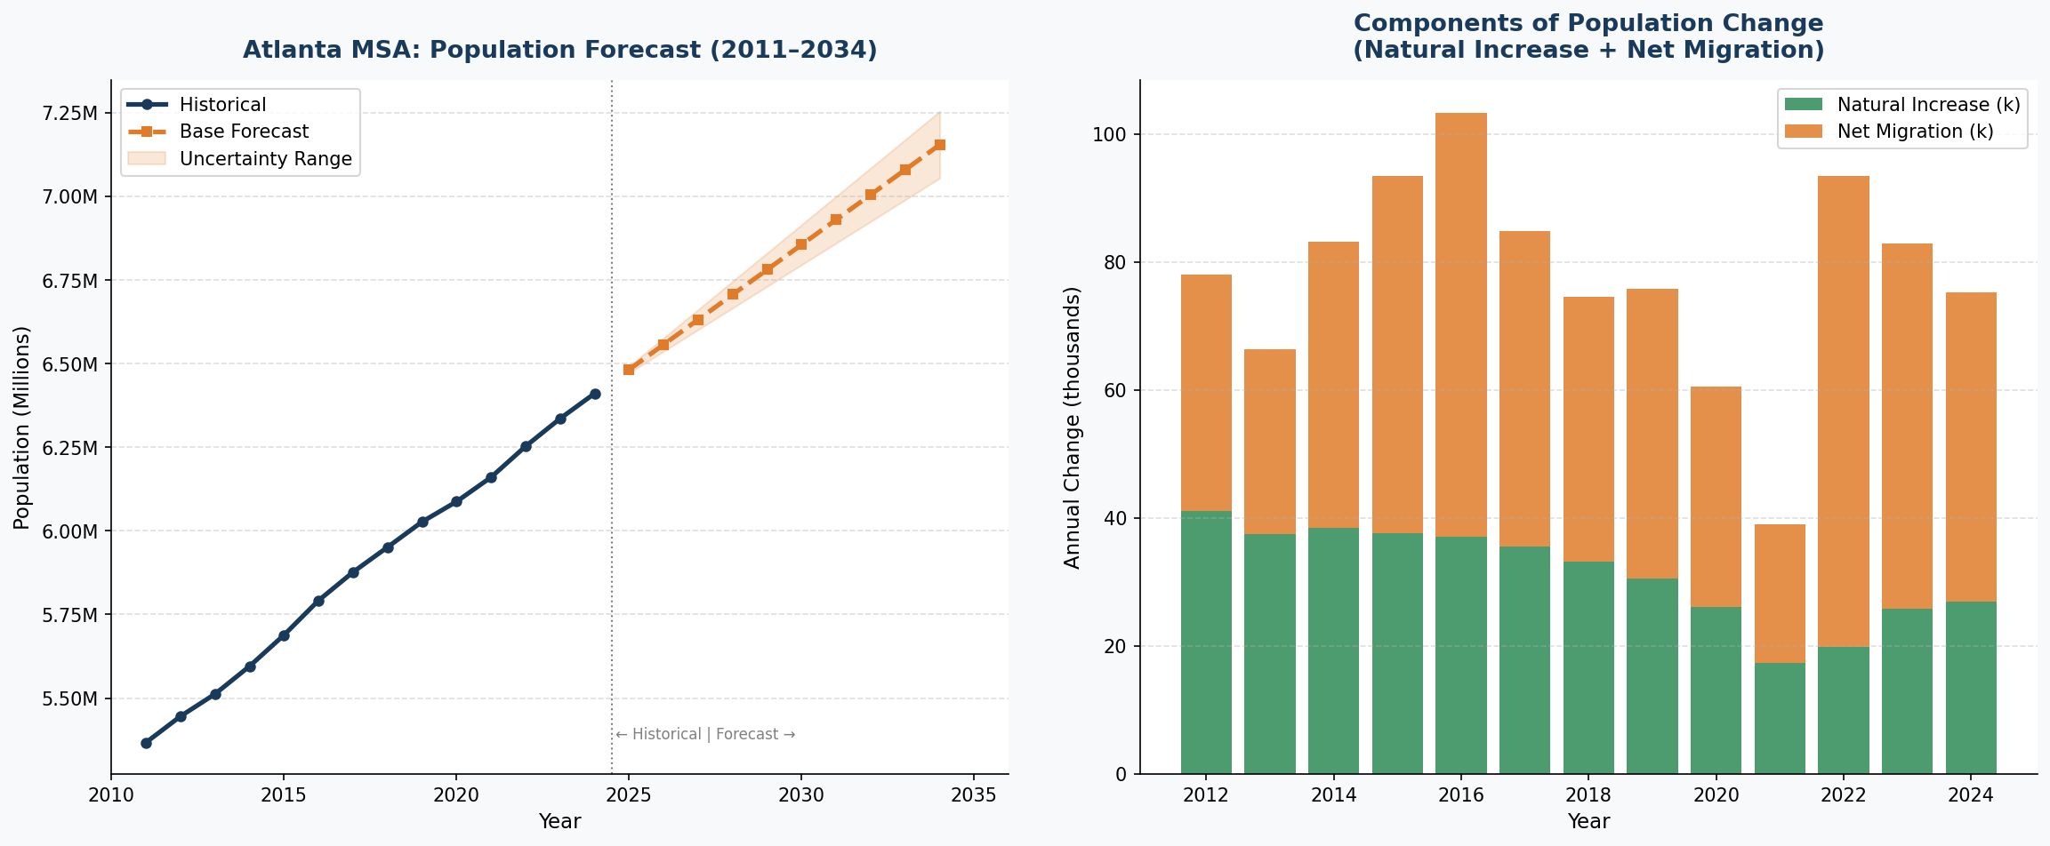
Figure 1: Left -- Historical population (2011-2024) with 10-year base forecast and uncertainty band. Right -- Annual components of change (natural increase and net migration).

4. Explanation
4.1 Methodology Summary
The forecast blends Holt's Linear Exponential Smoothing with a demographic component model, with equal (50/50) weighting. The blend prevents either model from dominating: the Holt model captures statistical trend momentum, while the component model grounds projections in demographic fundamentals. Parameters were selected by grid-search RMSE minimisation -- not set arbitrarily.
The decision to avoid more complex models (ARIMA, machine learning approaches) is deliberate. With 14 annual observations, overfitting is a material risk. A parsimonious model with transparent, interpretable parameters is more rigorous -- and more honest about uncertainty -- than a complex model that appears precise but is statistically fragile on a short series.

4.2 Key Assumptions
- Net migration holds near its 2020-2024 average of approximately 47,000 persons per year. This is the single most important and most uncertain assumption in the model.
- Natural increase continues its gradual decline, consistent with the trend from 41,748 (2011) to 26,916 (2024), as the population ages and births moderate.
- No structural break occurs -- no recession, pandemic, or major policy shock significantly disrupts migration patterns over the 10-year horizon.
- The MSA boundary remains unchanged throughout the forecast period.

4.3 Growth Drivers
Atlanta's growth is overwhelmingly a migration story. Net migration has accounted for 60-70% of total population growth in most years. Several structural factors sustain this:
- Economic magnetism: Atlanta is the corporate hub of the Southeast, anchored by Delta, Coca-Cola, Home Depot, and UPS, with growing presence in technology, film/media, and financial services.
- Relative affordability: Median home prices and cost of living remain well below comparable gateway metros (New York, Los Angeles, San Francisco), making Atlanta a rational relocation destination.
- Hartsfield-Jackson Airport: As the world's busiest airport, Atlanta benefits disproportionately from international migration -- 49,691 international arrivals in 2024 alone.
- Demographics: Atlanta has become the premier destination for Black middle-class and professional households relocating from the Northeast and Midwest, reinforcing sustained domestic in-migration.
- Natural increase: Though declining, Atlanta still records approximately 27,000 more births than deaths annually -- a positive but secondary contributor.

4.4 Risks & Factors That Could Materially Change the Forecast
The forecast carries several identified risks, primarily to the downside:
- Housing affordability squeeze (HIGH PROBABILITY): Atlanta home prices have risen sharply since 2020. If affordability erodes to the point where it no longer competes with lower-cost metros, in-migration could slow materially -- this is the primary driver of the low scenario.
- Climate and infrastructure risk (MEDIUM PROBABILITY): Water supply constraints, urban heat, and traffic congestion are long-standing concerns. Severe weather events or infrastructure failures could dampen migration attractiveness.
- Recession or labour market shock (MEDIUM PROBABILITY): A significant economic contraction would reduce domestic in-migration. The 2021 data illustrate this sensitivity: net migration fell to just 21,715 that year.
- Federal immigration policy (LOW PROBABILITY, HIGH IMPACT): Changes to visa or immigration enforcement policy could sharply reduce international inflows. In 2024, international arrivals (+49,691) more than offset a net domestic outflow (-1,328) -- policy reversal here would structurally change the growth picture.
- Upside -- tech corridor expansion: If Atlanta successfully captures a larger share of technology company relocations (already underway), growth could accelerate toward or exceed the high scenario.

5. Reproducibility
All analysis was conducted in Python 3.12. The complete annotated script is provided as a separate file (atlanta_forecast.py). The script requires only standard scientific Python libraries: pandas, numpy, matplotlib -- no proprietary or licensed packages. The Holt smoothing and component model are implemented from scratch using numpy, so no external forecasting library is required.
To reproduce results: place Atlanta.csv and cbsa-est2024-syasex.csv in the working directory, then run: python3 atlanta_forecast.py. Outputs will be written to the same directory.

Data: U.S. Census Bureau, Population Estimates Program (2024 vintage) | Analysis: April 2026

