Lab7

1.Write a program that tries to access an element outside the bounds of an array and handles the ArrayIndexOutOfBoundsException by printing a user-friendly message.

Code:

**package** hellow;

**public** **class** ArrayOutOfBoundsExample {

**public** **static** **void** main(String[] args) {

**int**[] numbers = {10, 20, 30, 40};

**try** {

// Accessing an element within the bounds

System.***out***.println(numbers[2]); // This will print 30

// Accessing an element outside the bounds

System.***out***.println(numbers[5]); // This will throw an exception

} **catch** (ArrayIndexOutOfBoundsException e) {

System.***out***.println("Error: Index is out of bounds. Please check the array 0size.");

}

}

}

Output:

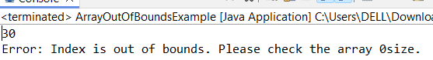

1. Write a program that attempts to divide a number by zero and handles the ArithmeticException by printing a message that division by zero is not allowed.

Code:

**package** hellow;

**public** **class** DivisionByzero {

**public** **static** **void** main(String[] args) {

**try** {

// Attempting to divide by zero

**int** result = 10 / 0;

} **catch** (ArithmeticException e) {

// Handling the ArithmeticException

System.***out***.println("Division by zero is not allowed.");

}

}

}

Output:

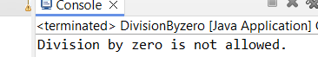

1. Write a Java program that reads an integer input from the user and throws an IllegalArgumentException if the input is negative. Display an appropriate message when the exception is caught.

Code:

**package** hellow;

**import** java.util.Scanner;

**public** **class** NegativeInputException {

**public** **static** **void** main(String[] args) {

Scanner scanner = **new** Scanner(System.***in***);

**try** {

System.***out***.print("Enter a non-negative integer: ");

**int** number = scanner.nextInt();

**if** (number < 0) {

**throw** **new** IllegalArgumentException("Input cannot be negative.");

}

// Rest of your code to process the positive number

System.***out***.println("You entered: " + number);

} **catch** (IllegalArgumentException e) {

System.***out***.println("Error: " + e.getMessage());

}

}

}

Output:

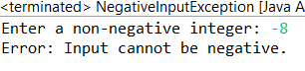

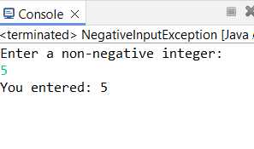

1. Create a Java method that divides two numbers and declares that it throws an ArithmeticException. Handle the exception in the main method.

Code:

**package** hellow;

**public** **class** Division {

**public** **static** **int** divide(**int** dividend, **int** divisor) **throws** ArithmeticException {

**return** dividend / divisor;

}

**public** **static** **void** main(String[] args) {

**int** numerator = 10;

**int** denominator = 0;

**try** {

**int** result = *divide*(numerator, denominator);

System.***out***.println("Result: " + result);

} **catch** (ArithmeticException e) {

System.***out***.println("Error: Division by zero is not allowed.");

}

}

}

Output:

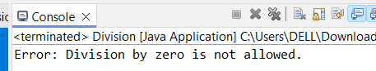

1. Define a custom exception called InvalidAgeException. Write a Java program that throws this exception if the age provided is less than 18. Handle the exception and display an appropriate message.

Code:

**package** hellow;

**import** java.util.*;

**class** AgeException **extends** Exception {

AgeException(String message) {

**super**(message);

}

}

**public** **class** InvalidAgeException {

**public** **static** **void** main(String[] args) {

**int** age;

Scanner sc = **new** Scanner(System.***in***);

**try** {

System.***out***.println("Enter age : ");

age = sc.nextInt();

**if** (age < 18) {

**throw** **new** AgeException("YOU ARE NOT ELIGIBLE");

} **else** {

System.***out***.println("You are eligible for vote");

}

} **catch** (AgeException e) {

System.***out***.println("CAUGHT AN EXCEPTION");

System.***out***.println(e.getMessage());

}

}

}

Output:

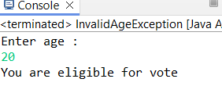

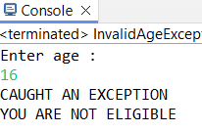

1. Write a Java program that has a method to validate a user's email address. The method should throw a custom exception Invalid Email Exception if the email does not contain @ and.. Handle the exception in the main method.

Code:

**package** hellow;

**import** java.util.Scanner;

**class** InvalidEmailException **extends** Exception {

**public** InvalidEmailException(String message) {

**super**(message);

}

}

**public** **class** EmailValidatorr {

**public** **static** **void** validateEmail(String email) **throws** InvalidEmailException {

**if** (!email.contains("@") || !email.contains(".")) {

**throw** **new** InvalidEmailException("Invalid email format");

}

}

**public** **static** **void** main(String[] args) {

Scanner scanner = **new** Scanner(System.***in***);

System.***out***.print("Enter your email: ");

String email = scanner.nextLine();

**try** {

*validateEmail*(email);

System.***out***.println("Valid email address");

} **catch** (InvalidEmailException e) {

System.***out***.println("Error: " + e.getMessage());

}

}

}

Output:

