**1:**  Write a program that takes a student's score as input and outputs the corresponding grade based on the following scale:

A: 90-100

B: 80-89

C: 70-79

D: 60-69

F: 0-59

**package** si;

**import** java.util.Scanner;

**public** **class** GR {

**public** **static** **void** main(String[] args) {

// Create a Scanner

Scanner scanner = **new** Scanner(System.***in***);

System.***out***.print("Enter the student's score: ");

**int** score = scanner.nextInt(); // Read the score from user input

// Close the scanner

scanner.close();

// Determine the grade based on the score

**char** grade;

**if** (score >= 90 && score <= 100) {

grade = 'A';

} **else** **if** (score >= 80 && score <= 89) {

grade = 'B';

} **else** **if** (score >= 70 && score <= 79) {

grade = 'C';

} **else** **if** (score >= 60 && score <= 69) {

grade = 'D';

} **else** **if** (score >= 0 && score <= 59) {

grade = 'F';

} **else** {

System.***out***.println("Invalid score entered. Score must be between 0 and 100.");

**return**;

}

}

}

Output:

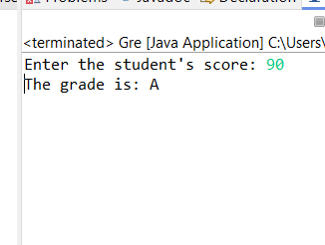

**2.** Write a program to check if a given year is a leap year. (A year is a leap year if it is divisible by 4 but not by 100, or it is divisible by 400.)

**package** si;

**import** java.util.Scanner;

**public** **class** LeapYear {

**public** **static** **void** main(String[] args) {

// Create a Scanner object to read input from the user

Scanner scanner = **new** Scanner(System.***in***);

//the user to enter a year

System.***out***.print("Enter a year: ");

**int** year = scanner.nextInt(); // Read the year from user input

// Close the scanner

scanner.close();

// Check if the year is a leap year and print the result

**if** (*isLeapYear*(year)) {

System.***out***.println(year + " is a leap year.");

} **else** {

System.***out***.println(year + " is not a leap year.");

}

}

// Method to check if a year is a leap year

**public** **static** **boolean** isLeapYear(**int** year) {

**return** (year % 4 == 0 && year % 100 != 0) || (year % 400 == 0);

}

}

Output

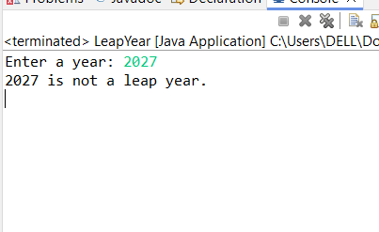

3.  Write a program that takes an integer as input and checks if it is positive, negative, or zero.

**package** si;

**import** java.util.Scanner;

**public** **class** CheckNo {

**public** **static** **void** main(String[] args) {

// Create a Scanner object

Scanner scanner = **new** Scanner(System.***in***);

// the user to enter an integer

System.***out***.print("Enter an integer: ");

**int** number = scanner.nextInt(); // Read the integer from user input

// Close the scanner to prevent resource leak

scanner.close();

// Check if the number is positive, negative, or zero and print the result

**if** (number > 0) {

System.***out***.println("The number " + number + " is positive.");

} **else** **if** (number < 0) {

System.***out***.println("The number " + number + " is negative.");

} **else** {

System.***out***.println("The number is zero.");

}

}

}

output

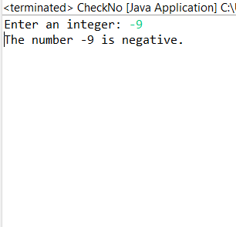

4.Write a program that prints numbers from 1 to 10 using a loop.

**package** si;

**public** **class** Loopss {

**public** **static** **void** main(String[] args) {

// for loop to print no from 1 to 10

**for** (**int** i = 1; i <= 10; i++) {

System.***out***.println(i); // Print the current value of i

}

}

// **TODO** Auto-generated method stub

}

Output

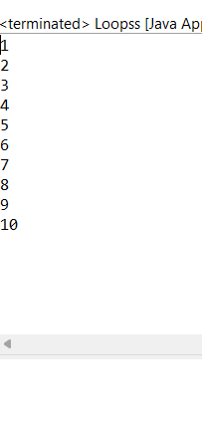

5.  Write a program that takes an integer N as input and calculates the sum of entered numbers.

**package** si;

**import** java.util.Scanner;

**public** **class** SumCal{

**public** **static** **void** main(String[] args) {

// Create a Scanner object

Scanner scanner = **new** Scanner(System.***in***);

// Prompt the user to enter the number of integers to sum

System.***out***.print("Enter the number of integers to sum (N): ");

**int** N = scanner.nextInt(); // Read the integer N from user input

**int** sum = 0; // Initialize a variable to hold the sum

// Prompt the user to enter N integers

System.***out***.println("Enter " + N + " integers:");

// Loop to read and sum N integers

**for** (**int** i = 0; i < N; i++) {

**int** number = scanner.nextInt();

sum += number; // Add the number to the sum

}

// Close the scanner

scanner.close();

// Print the sum of entered numbers

System.***out***.println("The sum of the entered numbers is: " + sum);

}

}

Output:

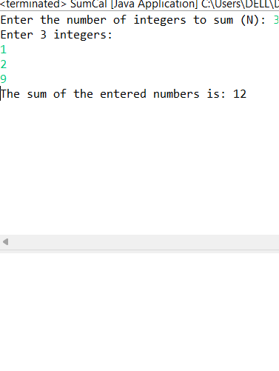

6:Write a program that takes an integer as input and prints its multiplication table up to 10.

**package** si;

**import** java.util.Scanner;

**public** **class** Multiplication{

**public** **static** **void** main(String[] args) {

// Create a Scanner object

Scanner scanner = **new** Scanner(System.***in***);

System.***out***.print("Enter an integer to print its multiplication table: ");

**int** number = scanner.nextInt(); // Read the integer from user input

// Close the scanner

scanner.close();

// Print the multiply table up to 10 for the enter no

System.***out***.println("Multiplication table for " + number + ":");

**for** (**int** i = 1; i <= 10; i++) {

System.***out***.println(number + " * " + i + " = " + (number * i));

}

}

}

Output:

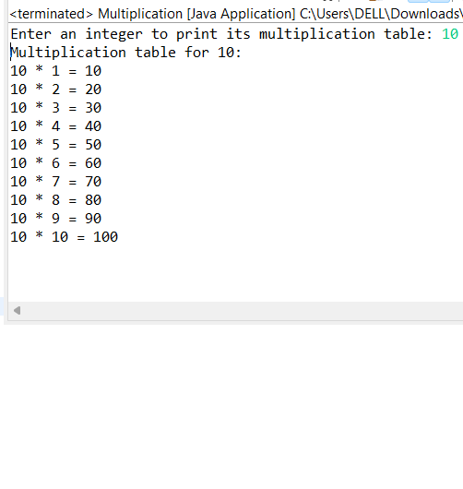

7.Write a program that takes a positive integer as input and prints its digits in reverse order.

**package** si;

**import** java.util.Scanner;

**public** **class** Reversedigi {

**public** **static** **void** main(String[] args) {

// Create a Scanner

Scanner scanner = **new** Scanner(System.***in***);

// enter a positive integer

System.***out***.print("Enter a positive integer: ");

**int** number = scanner.nextInt(); // Read the integer from user input

// Close the scanner

scanner.close();

**if** (number <= 0) {

System.***out***.println("Error: Please enter a positive integer.");

**return**; // Exit the program if the input is not positive

}

// Print the digits of the number in reverse order

System.***out***.print("Digits in reverse order: ");

**while** (number > 0) {

**int** digit = number % 10;

System.***out***.print(digit); // Print the digit

number = number / 10;

}

System.***out***.println();

}

}

Output:

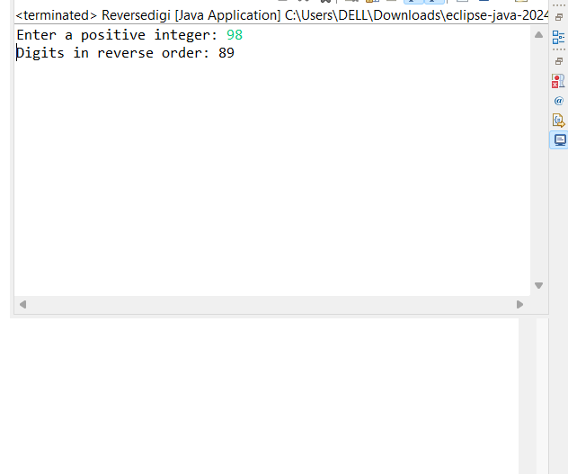

8: Create a class Animal with a method makeSound() that prints "Some generic animal sound". Create another class Dog that extends Animal and overrides the makeSound() method to print "Bark". Write a main method to demonstrate calling the makeSound() method on an Animal reference holding a Dog object.

**package** si;

//Animal class

**class** Animal {

// Method to make a generic animal sound

**public** **void** makeSound() {

System.***out***.println("Some generic animal sound");

}

}

//Dog class extending Animal

**class** Dog **extends** Animal {

@Override

**public** **void** makeSound() {

System.***out***.println("Bark");

}

}

//Main class

**public** **class** AnimalDemo {

**public** **static** **void** main(String[] args) {

// Create an Animal reference holding a Dog object

Animal myDog = **new** Dog();

myDog.makeSound();

}

}

Output:

