1.Method Overloading: Write a class Calculator with overloaded methods add(). Implement add() methods that take: - Two integers - Two double values - Three integers - A variable number of integers

Code:

**package** hellow;

**public** **class** Calculator2 {

// Method to add two integers

**public** **int** add(**int** a, **int** b) {

**return** a + b;

}

// Method to add two double values

**public** **double** add(**double** a, **double** b) {

**return** a + b;

}

// Method to add three integers

**public** **int** add(**int** a, **int** b, **int** c) {

**return** a + b + c;

}

// Method to add a variable number of integers

**public** **int** add(**int**... numbers) {

**int** sum = 0;

**for** (**int** num : numbers) {

sum += num;

}

**return** sum;

}

**public** **static** **void** main(String[] args) {

Calculator2 cal = **new** Calculator2();

// Testing the add methods

System.***out***.println("Add two integers: " + cal.add(1, 2));

System.***out***.println("Add two doubles: " + cal.add(1.5, 2.5));

System.***out***.println("Add three integers: " + cal.add(1, 2, 3));

System.***out***.println("Add variable number of integers: " + cal.add(1, 2, 3, 4));

}

// **TODO** Auto-generated method stub

}

Output:

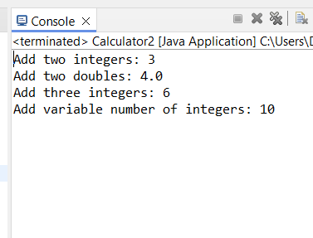

2. Super Keyword: Create a class Person with a constructor that accepts and sets name and age. - Create a subclass Student that adds a grade property and initializes name and age using the super keyword in its constructor. - Demonstrate the creation of Student objects and the usage of super to call the parent class constructor

Code:

**package** hellow;

**class** Persoon {

**protected** String name;

**protected** **int** age;

**public** Persoon(String name, **int** age) {

**this**.name = name;

**this**.age = age;

}

**public** **void** displayInfo() {

System.***out***.println("Name: " + name + ", Age: " + age);

}

}

// base Student class

**class** Studeent **extends** Persoon {

**private** String grade;

**public** Studeent(String name, **int** age, String grade) {

**super**(name, age);

**this**.grade = grade;

}

@Override

**public** **void** displayInfo() {

**super**.displayInfo(); //using super keyword

System.***out***.println("Grade: " + grade);

}

}

// main class

**public** **class** SuperKeyword {

**public** **static** **void** main(String[] args) {

Studeent student1 = **new** Studeent("chahat", 22, "A");

Studeent student2 = **new** Studeent("virat", 30, "A");

//calling methods

student1.displayInfo();

student2.displayInfo();

}

}

Output:

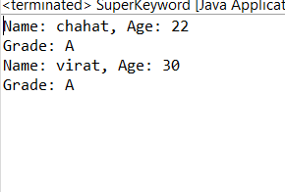

3.Super Keyword: Create a base class Shape with a method draw() that prints "Drawing Shape". - Create a subclass Circle that overrides draw() to print "Drawing Circle". - Inside the draw() method of Circle, call the draw() method of the Shape class using super.draw(). - Write a main method to demonstrate calling draw() on a Circle object.

Code:

**package** hellow;

//Shape.java

**class** Shape {

**public** **void** draw() {

System.***out***.println("jiya is Drawing Shape");

}

}

//Circle.java

**class** Circle **extends** Shape {

@Override

**public** **void** draw() {

**super**.draw(); // Call the draw() method of Shape

System.***out***.println("jiyaka is Drawing Circle");

}

}

//Main.java

**public** **class** SS {

**public** **static** **void** main(String[] args) {

Circle circle = **new** Circle();

//This will call the draw method of Circle

circle.draw();

}

}

Output:

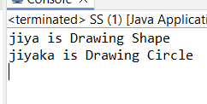

4. Write a Java Program to count the number of words in a String without using the Predefined method?

Code:

**package** hellow;

**public** **class** WordCount {

**public** **static** **int** countWords(String str) {

**if** (str == **null** || str.isEmpty()) {

**return** 0;

}

**int** Count = 0;

**boolean** isWord = **false**;

**int** endLine = str.length() - 1;

**char**[] characters = str.toCharArray();

**for** (**int** i = 0; i < characters.length; i++) {

// If the character is a letter, word = true.

**if** (Character.*isLetter*(characters[i]) && i != endLine) {

isWord = **true**;

}

// If the character isn't a letter and there have been letters before,

// count the word and set word = false.

**else** **if** (!Character.*isLetter*(characters[i]) && isWord) {

Count++;

isWord = **false**;

}

// Last word of the string; if it doesn't end with a non-letter, itcounts as a word.

**else** **if** (Character.*isLetter*(characters[i]) && i == endLine) {

Count++;

}

}

**return** Count;

}

**public** **static** **void** main(String[] args) {

String line = "Hii i am diya kohli, i am a good singer.";

**int** numberOfWords = *countWords*(line);

System.***out***.println("Sentance is : "+line);

System.***out***.println("Number of words in the string: " + numberOfWords);

}

}

Output:

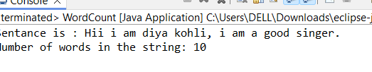

5. 5. Write a Java Program to remove all white spaces from a String?

Code:

**package** hellow;

**import** java.util.StringTokenizer;

**public** **class** RemoveWhiteSapces {

**public** **static** String removeSpaces(String str) {

**if** (str == **null** || str.isEmpty()) {

**return** str;

}

StringTokenizer token = **new** StringTokenizer(str);

StringBuilder result = **new** StringBuilder();

**while** (token.hasMoreTokens()) {

result.append(token.nextToken());

}

**return** result.toString();

}

**public** **static** **void** main(String[] args) {

String input = "Hii i am siddhi, i am a good singer.";

String noSpaces = *removeSpaces*(input);

System.***out***.println("Original string: " + input);

System.***out***.println("String without spaces: " + noSpaces);

}

}

Output:

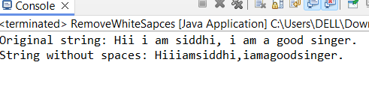

6. 6. WAP to find occurrence of given in the given string.

Code: **package** hellow;

**public** **class** WordOccurence {

**public** **static** **int** countOccurrences(String str, String word) {

// lest check first string or word is empty or not

**if** (str == **null** || word == **null** || str.isEmpty() || word.isEmpty()) {

**return** 0;

}

**int** count = 0;

**int** index = 0;

//whilw loop for finds occurance

**while** ((index = str.indexOf(word, index)) != -1) {

count++;

index += word.length();

}

**return** count;

}

**public** **static** **void** main(String[] args) {

String input = "This is a test string. This string is for testing.";

String word = "is";

**int** occurrences = *countOccurrences*(input, word);

System.***out***.println("The word \"" + word + "\" occurs " + occurrences + " timesin the given string.");

}

}

Output:

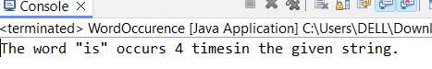

7. Write a java class to implement any 10 string methods: ● replace ● contains ● replaceAll ● indexOf ● substring ● Equals ● lastIndexOf ● startsWith ● endsWith ● EqualsIgnoreCase ● toLowerCase ● toUpperCase ● isEmpty ● Length ● split

Code:

**package** hellow;

**public** **class** StringMethodEx {

**public** **static** **void** main(String[] args) {

String str = "i am siya kohli it is my sentence.";

// using replace

String replacedStr = str.replace("World", "Java");

System.***out***.println("replace: " + replacedStr + "\n");

// using contains

**boolean** containsStr = str.contains("test");

System.***out***.println("contains: " + containsStr + "\n");

// implementing replaceAll

String replaceAllStr = str.replaceAll("is", "was");

System.***out***.println("replaceAll: " + replaceAllStr + "\n");

// implementing indexOf

**int** indexOfStr = str.indexOf("test");

System.***out***.println("indexOf: " + indexOfStr + "\n");

// implementing substring

String substringStr = str.substring(7, 12);

System.***out***.println("substring: " + substringStr + "\n");

// implementing equals

**boolean** equalsStr = str.equals("Hello, World! This is a test string.");

System.***out***.println("equals: " + equalsStr + "\n");

// implementing lastIndexOf

**int** lastIndexOfStr = str.lastIndexOf("is");

System.***out***.println("lastIndexOf: " + lastIndexOfStr + "\n");

// startsWith

**boolean** startsWithStr = str.startsWith("Hello");

System.***out***.println("startsWith: " + startsWithStr + "\n");

// implementing endsWith

**boolean** endsWithStr = str.endsWith("string.");

System.***out***.println("endsWith: " + endsWithStr + "\n");

// implementing equalsIgnoreCase

**boolean** equalsIgnoreCaseStr = str.equalsIgnoreCase("hello, world! this is a test string.");

System.***out***.println("equalsIgnoreCase: " + equalsIgnoreCaseStr + "\n");

// implementing toLowerCase

String lowerCaseStr = str.toLowerCase();

System.***out***.println("toLowerCase: " + lowerCaseStr + "\n");

// implementing toUpperCase

String upperCaseStr = str.toUpperCase();

System.***out***.println("toUpperCase: " + upperCaseStr + "\n");

// implementing isEmpty

**boolean** isEmptyStr = str.isEmpty();

System.***out***.println("isEmpty: " + isEmptyStr + "\n");

// implementing length

**int** lengthStr = str.length();

System.***out***.println("length: " + lengthStr + "\n");

// implementing split

String[] splitStr = str.split(" ");

System.***out***.print("split: ");

**for** (String s : splitStr) {

System.***out***.print(s + " | " + "\n");

}

}

}

Output:

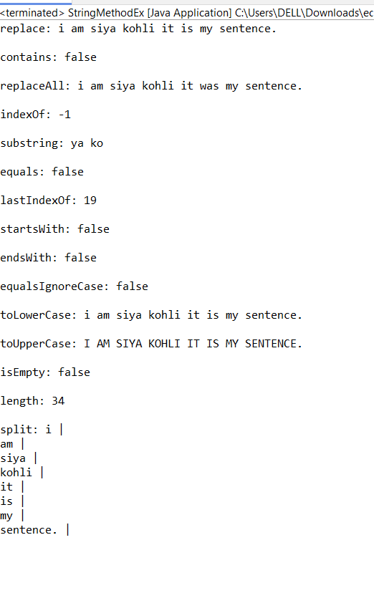

8. . Write a java program to implement string tokenizer.

Code:

**package** hellow;

**import** java.util.StringTokenizer;

**public** **class** StringToken{

**public** **static** **void** main(String[] args) {

String str = "Hello, World! I am siya kapoor";

// Create a StringTokenizer with the default delimiter (whitespace)

StringTokenizer tokenizer = **new** StringTokenizer(str);

System.***out***.println("Tokens with default delimiter (whitespace):");

**while** (tokenizer.hasMoreTokens()) {

System.***out***.println(tokenizer.nextToken());

}

// Create a StringTokenizer with a custom delimiter

String customStr = "Hello,World!This,is,a,test,string.";

StringTokenizer customTokenizer = **new** StringTokenizer(customStr, ",!");

System.***out***.println("\nTokens with custom delimiters (, and !):");

**while** (customTokenizer.hasMoreTokens()) {

System.***out***.println(customTokenizer.nextToken());

}

}

}

Output:

