**1.**

**Code:**

**package** hellow;

**import** java.util.Arrays;

**public** **class** SortArray {

**public** **static** **void** main(String[] args) {

// Initialize the arrays

**int**[] intArray = {8, 4, 3, 5, 6};

String[] stringArray = {"C", "O", "I", "P", "U"};

// Sort the integer array

Arrays.*sort*(intArray);

// Sort the string array

Arrays.*sort*(stringArray);

// Print the sorted arrays

System.***out***.println("Sorted integer array: " + Arrays.*toString*(intArray));

System.***out***.println("Sorted string array: " + Arrays.*toString*(stringArray));

}

}

Output:

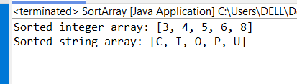

2.

Code:

**package** hellow;

**public** **class** BubbleSort {

**public** **static** **void** main(String[] args) {

// Initialize the array of integers

**int**[] array = {8, 4, 3, 5, 6};

// Call the bubbleSort method to sort the array

*bubbleSort*(array);

// Print the sorted array

System.***out***.println("Sorted array: ");

**for** (**int** num : array) {

System.***out***.print(num + " ");

}

}

// Method to implement the bubble sort algorithm

**public** **static** **void** bubbleSort(**int**[] array) {

**int** n = array.length;

// Outer loop for the number of passes

**for** (**int** i = 0; i < n - 1; i++) {

// Inner loop for each pass

**for** (**int** j = 0; j < n - 1 - i; j++) {

// Swap adjacent elements if they are in the wrong order

**if** (array[j] > array[j + 1]) {

// Swap the elements

**int** temp = array[j];

array[j] = array[j + 1];

array[j + 1] = temp;

}

}

}

}

}

Output:

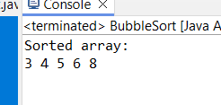

3.

Code:

**package** hellow;

**import** java.util.Scanner;

**public** **class** Primecube{

**public** **static** **void** main(String[] args) {

Scanner scanner = **new** Scanner(System.***in***);

// Initialize an array to store 10 integers

**int**[] array = **new** **int**[10];

// Input 10 elements from the user

System.***out***.println("Enter 10 integers:");

**for** (**int** i = 0; i < 10; i++) {

array[i] = scanner.nextInt();

}

// Print the cube of prime numbers in the array

System.***out***.println("Cubes of prime numbers in the array:");

**for** (**int** num : array) {

**if** (*isPrime*(num)) {

System.***out***.println("Number: " + num + ", Cube: " + (num * num * num));

}

}

scanner.close();

}

// Method to check if a number is prime

**public** **static** **boolean** isPrime(**int** num) {

// Return false for numbers less than 2

**if** (num < 2) {

**return** **false**;

}

// Check for factors other than 1 and the number itself

**for** (**int** i = 2; i <= Math.*sqrt*(num); i++) {

**if** (num % i == 0) {

**return** **false**;

}

}

**return** **true**;

}

}

Output:

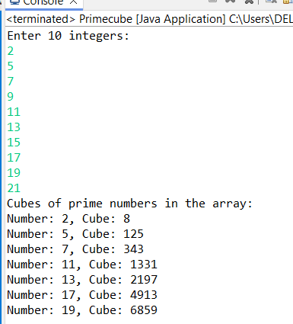

4.

**Code:**

**package** hellow;

**public** **class** Integerwrappermethod {

**public** **static** **void** main(String[] args) {

// Demonstrate parseInt method

String numberString = "123";

**int** number = Integer.*parseInt*(numberString);

System.***out***.println("The string \"" + numberString + "\" parsed as an integer is: " + number);

// Demonstrate toString method

**int** anotherNumber = 456;

String anotherNumberString = Integer.*toString*(anotherNumber);

System.***out***.println("The integer " + anotherNumber + " converted to string is: \"" + anotherNumberString + "\"");

// Demonstrate compareTo method

Integer num1 = 789;

Integer num2 = 123;

**int** comparisonResult = num1.compareTo(num2);

**if** (comparisonResult > 0) {

System.***out***.println(num1 + " is greater than " + num2);

} **else** **if** (comparisonResult < 0) {

System.***out***.println(num1 + " is less than " + num2);

} **else** {

System.***out***.println(num1 + " is equal to " + num2);

}

}

}

Output:

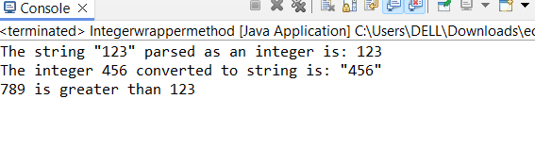

5. Write a java program to implement double wrapper class methods.(any 3 methods)

Code:

**package** hellow;

**public** **class** DoubleWrapperClass {

**public** **static** **void** main(String[] args) {

// Demonstrate parseDouble method

String doubleString = "123.45";

**double** number = Double.*parseDouble*(doubleString);

System.***out***.println("The string \"" + doubleString + "\" parsed as a double is: " + number);

// Demonstrate toString method

**double** anotherNumber = 456.78;

String anotherNumberString = Double.*toString*(anotherNumber);

System.***out***.println("The double " + anotherNumber + " converted to string is: \"" + anotherNumberString + "\"");

// Demonstrate compareTo method

Double num1 = 789.01;

Double num2 = 123.45;

**int** comparisonResult = num1.compareTo(num2);

**if** (comparisonResult > 0) {

System.***out***.println(num1 + " is greater than " + num2);

} **else** **if** (comparisonResult < 0) {

System.***out***.println(num1 + " is less than " + num2);

} **else** {

System.***out***.println(num1 + " is equal to " + num2);

}

}

}

Output:

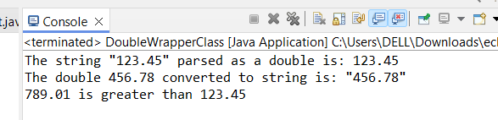

6.  Write a java program to implement float wrapper class methods.(any 3 methods)

Code:

**package** hellow;

**public** **class** Floatwrappermethod{

**public** **static** **void** main(String[] args) {

// Demonstrate parseFloat method

String floatString = "123.45f";

**float** number = Float.*parseFloat*(floatString);

System.***out***.println("The string \"" + floatString + "\" parsed as a float is: " + number);

// Demonstrate toString method

**float** anotherNumber = 456.78f;

String anotherNumberString = Float.*toString*(anotherNumber);

System.***out***.println("The float " + anotherNumber + " converted to string is: \"" + anotherNumberString + "\"");

// Demonstrate compareTo method

Float num1 = 789.01f;

Float num2 = 123.45f;

**int** comparisonResult = num1.compareTo(num2);

**if** (comparisonResult > 0) {

System.***out***.println(num1 + " is greater than " + num2);

} **else** **if** (comparisonResult < 0) {

System.***out***.println(num1 + " is less than " + num2);

} **else** {

System.***out***.println(num1 + " is equal to " + num2);

}

}

}

Output:

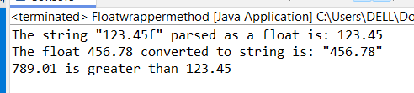

7. Write a Java program to validate email addresses using regular expressions. The email should have the format username@domain.com where username and domain can contain alphanumeric characters, dots, and hyphens.

Code:

**package** hellow;

**import** java.util.regex.Matcher;

**import** java.util.regex.Pattern;

**import** java.util.Scanner;

**public** **class** AA{

**public** **static** **void** main(String[] args) {

Scanner scanner = **new** Scanner(System.***in***);

// Define the regular expression for email validation

String emailRegex = "^[a-zA-Z0-9._%+-]+@[a-zA-Z0-9.-]+\\.[a-zA-Z]{2,6}$";

Pattern pattern = Pattern.*compile*(emailRegex);

// Prompt the user to enter an email address

System.***out***.println("Enter an email address to validate:");

String email = scanner.nextLine();

// Validate the email address

Matcher matcher = pattern.matcher(email);

**if** (matcher.matches()) {

System.***out***.println("The email address \"" + email + "\" is valid.");

} **else** {

System.***out***.println("The email address \"" + email + "\" is invalid.");

}

scanner.close();

}

}

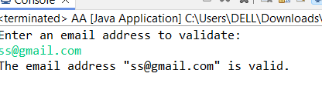

8.  Create a Java program to validate phone numbers. The format should be (xxx) xxx-xxxx where x is a digit.

Code:

**package** hellow;

**import** java.util.regex.Matcher;

**import** java.util.regex.Pattern;

**import** java.util.Scanner;

**public** **class** Phonenovalid {

**public** **static** **void** main(String[] args) {

Scanner scanner = **new** Scanner(System.***in***);

// Define the regular expression for phone number validation

String phoneRegex = "^\\(\\d{3}\\) \\d{3}-\\d{4}$";

Pattern pattern = Pattern.*compile*(phoneRegex);

// Prompt the user to enter a phone number

System.***out***.println("Enter a phone number to validate (format: (xxx) xxx-xxxx):");

String phoneNumber = scanner.nextLine();

// Validate the phone number

Matcher matcher = pattern.matcher(phoneNumber);

**if** (matcher.matches()) {

System.***out***.println("The phone number \"" + phoneNumber + "\" is valid.");

} **else** {

System.***out***.println("The phone number \"" + phoneNumber + "\" is invalid.");

}

scanner.close();

}

}

Output:

