Change request log

# Team

Team name: “***ssquare***”

Team Members: Satya Sandeep Ravipati, Siddhi Kotian

Roles : Concept Location, Impact Analysis and Validation - Satya Sandeep Ravipati, Siddhi Kotian

Actualization and Processing- Satya Sandeep Ravipati

# Change Request

Change Request #ps2. To allow the intersection of ranges during the merging operation.

# Concept Location

The following table describes the steps followed when performing concept location for this request.

|  |  |  |
| --- | --- | --- |
| Step # | Description | Rationale |
| 1 | *We ran the system* |  |
| 2 | *After entering the system, we used the search tool.* | *To find the location to be changed.* |
| 3 | *We searched for “page range”.* | *Because we identified “page range” can lead us where to change the ranges.* |
| 4 | *We tried using it after building and tried for several examples in pdfsam.* | *To verify its working accurately or not.* |
| 5 | *We inspected the classes SelectionTableRawData, PageRangesColumn, ConversionUtils, and MergeSelectionPane.* | *We noticed that these are the classes that PageRange keyword exists.* |
| 6 | *We marked the class ConversionUtils as “located”.* | *We confirmed this class had to be modified.* |

**Time spent (in minutes):** 50

# Impact Analysis

The table below describes each of the steps performed during impact analysis for this request. This includes

navigating the set of classes that are related to the located class.

|  |  |  |
| --- | --- | --- |
| Step # | Description | Rationale |
| 1 | *We made a list of classes that included a page range keyword and analyzed which class is to be modified.The classes in our list that needed inspection were SelectionTableRawData, PageRangesColumn, ConversionUtils, and MergeSelectionPane.* | *To track the classes that could be impacted by the change.* |
| 2 | *We inspected these classes and made sure that changes in them do not change the behavior of the system.* | *To track the behavior of the system.* |

**Time spent (in minutes):** 40

# Actualization

The table below describes each of the steps performed during actualization for this request.

|  |  |  |
| --- | --- | --- |
| Step # | Description | Rationale |
| 1 | *We made modifications toPageRangeSet method in ConversionUtils to validate the page range.* | *This is an important change for the required modification.* |
| 2 | *We ran all the required test cases.* | *To make sure everything works fine.* |

**Time spent (in minutes):** 40

# Validation

The table below describes each of the steps performed during validation for this request.

|  |  |  |
| --- | --- | --- |
| Step # | Description | Rationale |
| 1 | *Test case defined:*  *Inputs: 1-19,6-31*  *Expected output: 1-19,20-31* | *This is the regular expected behavior.*  *The test passed.* |
| 2 | *Test case defined:*  *Inputs: 1-20,6,6-30*  *Expected output: 1-20,21-30* | *The test passed.* |
| 3 | *Test case defined:*  *Inputs: 1-3,5-10,8-9*  *Expected output: 1-3,5-10* | *The test passed.* |

**Time spent (in minutes):** 20

# Timing

Summarize the time spent on each phase.

|  |  |
| --- | --- |
| Phase Name | Time (in minutes) |
| Concept location | 50 |
| Impact Analysis | 40 |
| Prefactoring | - |
| Actualization | 40 |
| Post Factoring | - |
| Verification | 20 |
| Total | 150 |

# Reverse engineering

**A UML class diagram of the visited classes while navigating the code in concept location.**

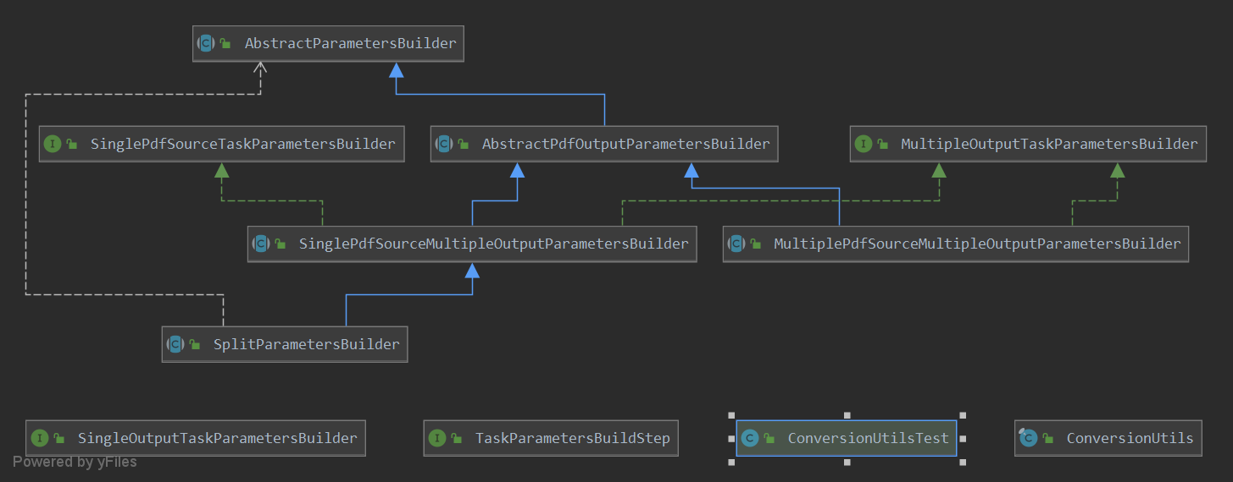

# Conclusions

Concept Location architecture and code are not very complicated for this change. The ConversionUtils class was modified.The Concept location was done by text search utility like InstaSearch. The impact analysis, actualization and validation were relatively easy. Testing was performed using multiple test cases to make sure the module works properly as requested.

Classes and methods changed:

* pdfsam-core/src/main/java/org/pdfsam/support/params/ConversionUtils.java
* static Set<PageRange>toPageRangeSet(String selection)