Change request log

# Team

Team name: “***ssquare***”

Team Members: Satya Sandeep Ravipati, Siddhi Kotian

Roles : Concept Location, Impact Analysis and Validation - Satya Sandeep Ravipati, Siddhi Kotian

Actualization and Processing- Satya Sandeep Ravipati

# Change Request

Change Request #ps3. To allow the rotation of pages with multiple PDF documents.

# Concept Location

The following table describes the steps followed when performing concept location for this request.

|  |  |  |
| --- | --- | --- |
| Step # | Description | Rationale |
| 1 | *We ran the system* |  |
| 2 | *After entering the system, we used the search tool.* | *To find the location to be changed.* |
| 3 | *We searched for “Rotate” keyword.* | *Because we identified “Rotate” can lead us where to change the rotate methods..* |
| 4 | *We tried using it after building and tried for several examples in pdfsam.* | *To verify its working accurately or not.* |
| 5 | *We inspected the classes RotateModule, RotateOptionsPane, RotateParametersBuilder, RotateSelectionPane.* | *We noticed that these are the classes that contain our given keyword.* |
| 6 | *We marked the class “RotateParametersBuilder” as “located”.* | *We confirmed this class had to be modified.* |

**Time spent (in minutes):** 50

# Impact Analysis

The table below describes each of the steps performed during impact analysis for this request. This includes

navigating the set of classes that are related to the located class.

|  |  |  |
| --- | --- | --- |
| Step # | Description | Rationale |
| 1 | *We made a list of classes that included rotate keywords and analyzed which class is to be modified.The classes in our list that needed inspection were RotateModule, RotateOptionsPane, RotateParametersBuilder, RotateSelectionPane.* | *To track the classes that could be impacted by the change.* |
| 2 | *We inspected these classes and made sure that changes in them do not change the behavior of the system.* | *To track the behavior of the system.* |

**Time spent (in minutes):** 40

# Actualization

The table below describes each of the steps performed during actualization for this request.

|  |  |  |
| --- | --- | --- |
| Step # | Description | Rationale |
| 1 | *We made modifications to the addInput method in RotateParametersBuilder to validate the page range.* | *This is an important change for the required modification.* |
| 2 | *Odd: Got the starting and ending offset numbers for pagination and add new page range for end offset value.* | *To make sure Even cases work fine.* |
| 3 | *Even: Got the starting and ending offset numbers for pagination and add new page range for end offset value.* | *To make sure Odd cases work fine.* |
| 5 | *All pages: Rotating all the pages for the list of pages given.* | *To make sure All pages cases work fine.* |
| 5 | *We ran all the required test cases.* | *To make sure everything works fine.* |

**Time spent (in minutes):** 40

# Validation

The table below describes each of the steps performed during validation for this request.

|  |  |  |
| --- | --- | --- |
| Step # | Description | Rationale |
| 1 | *Test case defined: Even*  *pdf page length: 21*  *Inputs: 1-20 and 90 degree clockwise*  *Expected output: 1-21 with even pages rotated 90 degree clockwise between 1-20.* | *This is the regular expected behavior.*  *The test passed.* |
| 2 | *Test case defined: Odd*  *pdf page length: 15*  *Inputs: 1-10 and 90 degree clockwise*  *Expected output: 1-15 with odd pages rotated 90 degree clockwise between 1-10.* | *The test passed.* |
| 3 | *Test case defined: All pages*  *pdf page length: 7*  *Inputs: 1-5and 90 degree clockwise*  *Expected output: 1-7 with pages from 1-5 rotated 90 degree clockwise.* | *The test passed.* |

**Time spent (in minutes):** 20

# Timing

Summarize the time spent on each phase.

|  |  |
| --- | --- |
| Phase Name | Time (in minutes) |
| Concept location | 50 |
| Impact Analysis | 40 |
| Prefactoring | - |
| Actualization | 40 |
| Post Factoring | - |
| Verification | 20 |
| Total | 150 |

# Reverse engineering

A UML class diagram of the visited classes while navigating the code in concept location.

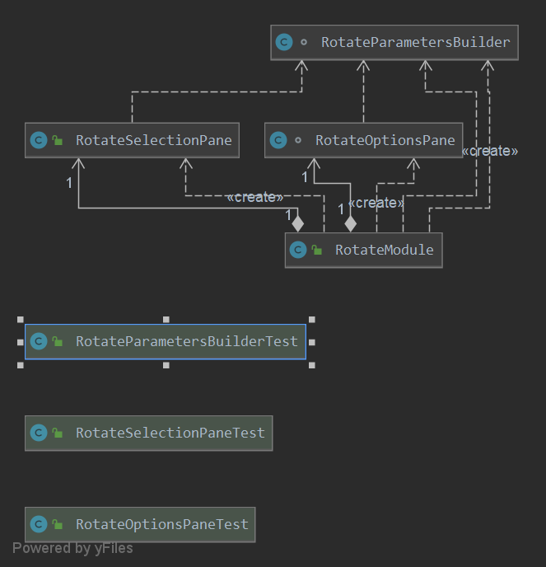

# Conclusions

The main challenge in resolving this issue is to understand how to modify the code without changing the behavior.For this change, concept location was not too difficult, and its architecture and code are not very complicated, though there was no documentation for the code and comments were not provided. The RotateParametersBuilder class was modified without changing its behavior.The Concept location was done by text search utility like InstaSearch and grep. The impact analysis, actualization and validation were relatively easy. Testing was performed using multiple test cases to make sure the module works properly as requested.

Classes and methods changed:

* pdfsam-rotate\src\main\java\org\pdfsam\rotate\RotateParametersBuilder.java
* void addInput(PdfSource<?> source, Set<PageRange> pageSelection)