**Name: Siddhi Khadye**

**Roll No:37**

**Batch:I2**

**Experiment No:- 1**

**Aim:** Prepare detailed statement of problem for the selected case study and identify

suitable process model for the same with justification.

**Resources Used:** MS Office

**Theory :**

The project is designed with the thought of outlining a new framework for the street lights that don't devour immense measure of power and light up vast zone with high intensity. Smart Street lights framework is an essential piece of the smart city which represents 10-40% of aggregate power utilizations which is a discriminating attentiveness toward general society powers.

Even in daytime when there is no requirement of street lights, it is frequently seen that these lights remain ON violating the energy conservation rule. This continuous lighting pollutes the environment as well as increases the tariff of the electricity.

So a vital and productive vitality advancements are to be executed for monetary and social security. Therefore the design and controlling of street lighting is an important area of work for maintaining safe transportation in our daily life. A microcontroller based system have been developed where a LDR sensor is used to indicate a day/night time and the infrared (IR) sensors to detect the movement on the street. The intensity of street light is controlled by software . This will reduce the energy consumption of today’s world by significant value.

**Algorithm / Activity Diagram/ Procedure:**

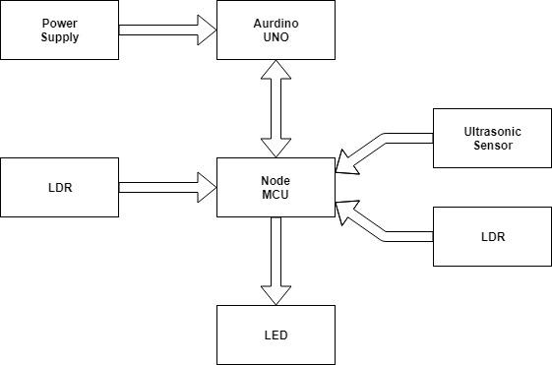

**Input:** Meeting with faculty in-charge and team members

**Output:**

Problem Definition document

**Problem Statement:**

Currently, in the whole world, enormous electric energy is consumed by the street lights. This System is mainly designed to reduce energy consumption. It will reduce electricity usage by monitoring the intensity of light also will turn on the LED’s only when required.

Also thousands of patients die in ambulance as they could not reach hospital on time because of heavy traffic on the road resulting in the ambulances got stuck in traffic jams. Additionally many accidents are due to potholes

**LO:**

Prepare detailed statement of problem for the selected case study and identify suitable process model for the same with justification.

**Conclusion:**

The proposed streetlight automation system is a cost effective and the safest way to reduce power consumption. It helps us to get rid of today's world problems of manual switching and most importantly, primary cost and maintenance can be decreased easily. The LED consumes less energy with cool-white light emission and has a better life than high energy consuming lamps. This system can be easily implemented in street lights, smart cities, home automation, agriculture field monitoring, timely automated lights, parking lights of hospitals, malls, airport, universities and industries etc